ASSIGNMENT_1
Shashank Raj
25SCS1003001227 – (2CSE_14)

Screenshot of:
- java -version
- javac -version
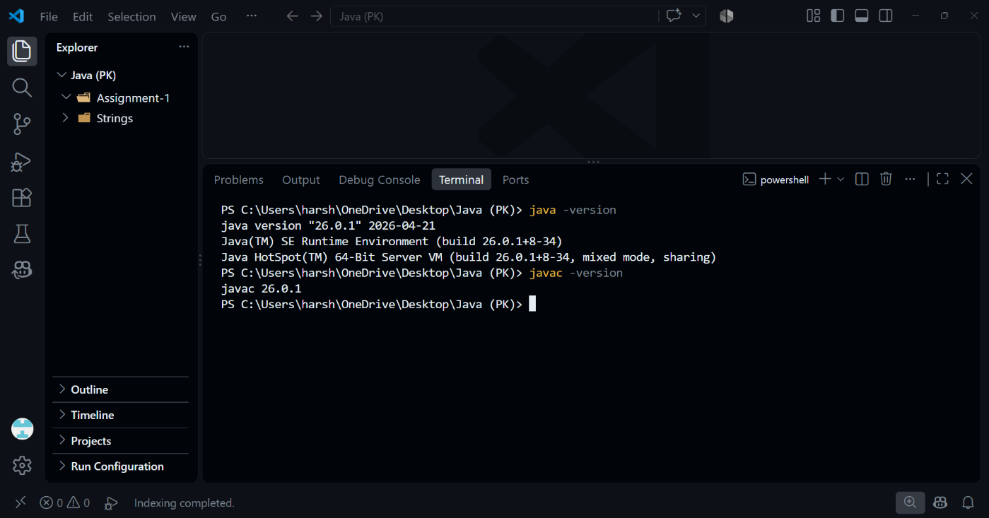

What is JDK?
JDK (Java Development Kit) is a software package used to develop Java applications. It includes the Java compiler (javac), JVM, Java Runtime Environment (JRE), libraries, and development tools. Developers use the JDK to write, compile, debug, and run Java programs.

What is JVM?
JVM (Java Virtual Machine) is a part of the Java platform that executes Java bytecode. It converts bytecode into machine instructions, allowing Java programs to run on different operating systems. JVM also manages memory, security, and program execution efficiently.

What is JRE?
JRE (Java Runtime Environment) is a software package required to run Java applications. It includes the JVM, Java class libraries, and supporting files. JRE does not contain development tools like the Java compiler. It provides everything needed to execute Java programs.

Difference between JDK, JRE, and JVM.
JDK is used to develop Java programs and includes JRE and development tools. JRE is used to run Java programs and includes JVM and libraries. JVM executes Java bytecode and enables platform independence. Thus, JDK is for development, JRE for execution, and JVM for running bytecode.

