Assignment – 11
Name: Shashank Raj
Roll: 25SCS1003001227
Sec: 2CSE14

SECTION A - CONSTRUCTORS
Q1) Create a Java class named Student with the following requirements: Declare the following instance variables:
- Student ID
- Student Name
- Course
- Age
Implement:
- A default constructor that initializes default values.
- A parameterized constructor that accepts all four values.
- A method displayDetails() to display student information.
Create a Main class and demonstrate both constructors.
Answer-
class Student {
int studentId;
String studentName;
String course;
int age;
Student() {
studentId = 101;
studentName = "Shashank";
course = "B.Tech CSE AIML";
age = 20;
}
Student(int id, String name, String course, int age) {
this.studentId = id;
this.studentName = name;
this.course = course;
this.age = age;
}
void displayDetails() {
System.out.println("Student ID: " + studentId);
System.out.println("Student Name: " + studentName);
System.out.println("Course: " + course);
System.out.println("Age: " + age);
}
}
public class Cons{
public static void main(String[] args) {
Student s1 = new Student();
System.out.println("Default Constructor:");
s1.displayDetails();
Student s2 = new Student(102, "Rahul",
"B.Tech CSE", 21);
System.out.println("\nParameterized Constructor:");
s2.displayDetails();
}
}

OUTPUT-
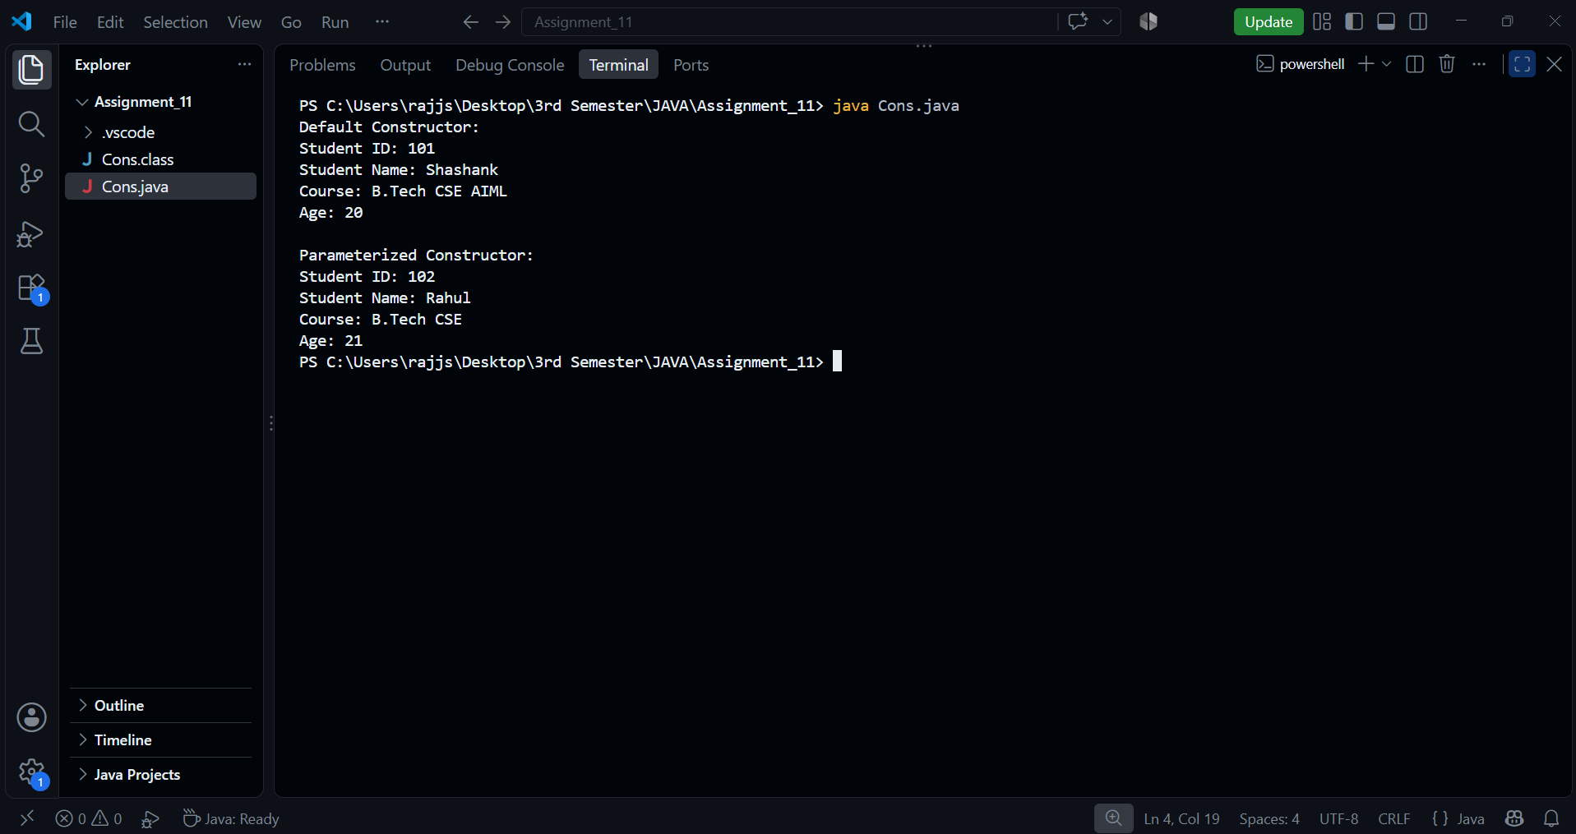

Q2) Create a class named Employee with the following requirements:
- Declare employee ID, name, designation, and salary.
- Create a default constructor.
- Create a parameterized constructor.
- Create a copy constructor that initializes an object using another Employee object.
- Display the details of all three employee objects

Answer-
class Employee {
int employeeId;
String name;
String designation;
double salary;
Employee() {
employeeId = 101;
name = "Amit";
designation = "Developer";
salary = 30000;
}
Employee(int id, String name,
String designation, double salary) {
this.employeeId = id;
this.name = name;
this.designation = designation;
this.salary = salary;
}
Employee(Employee e) {
this.employeeId = e.employeeId;
this.name = e.name;
this.designation = e.designation;
this.salary = e.salary;
}
void displayDetails() {
System.out.println("Employee ID: " + employeeId);
System.out.println("Name: " + name);
System.out.println("Designation: " + designation);
System.out.println("Salary: " + salary);
}
}
public class Cons2 {
public static void main(String[] args) {
Employee e1 = new Employee();
Employee e2 = new Employee(102, "Rahul",
"Manager", 50000);
Employee e3 = new Employee(e2);
System.out.println("Default Constructor:");
e1.displayDetails();
System.out.println("\nParameterized Constructor:");
e2.displayDetails();
System.out.println("\nCopy Constructor:");
e3.displayDetails();
}
}
OUTPUT-
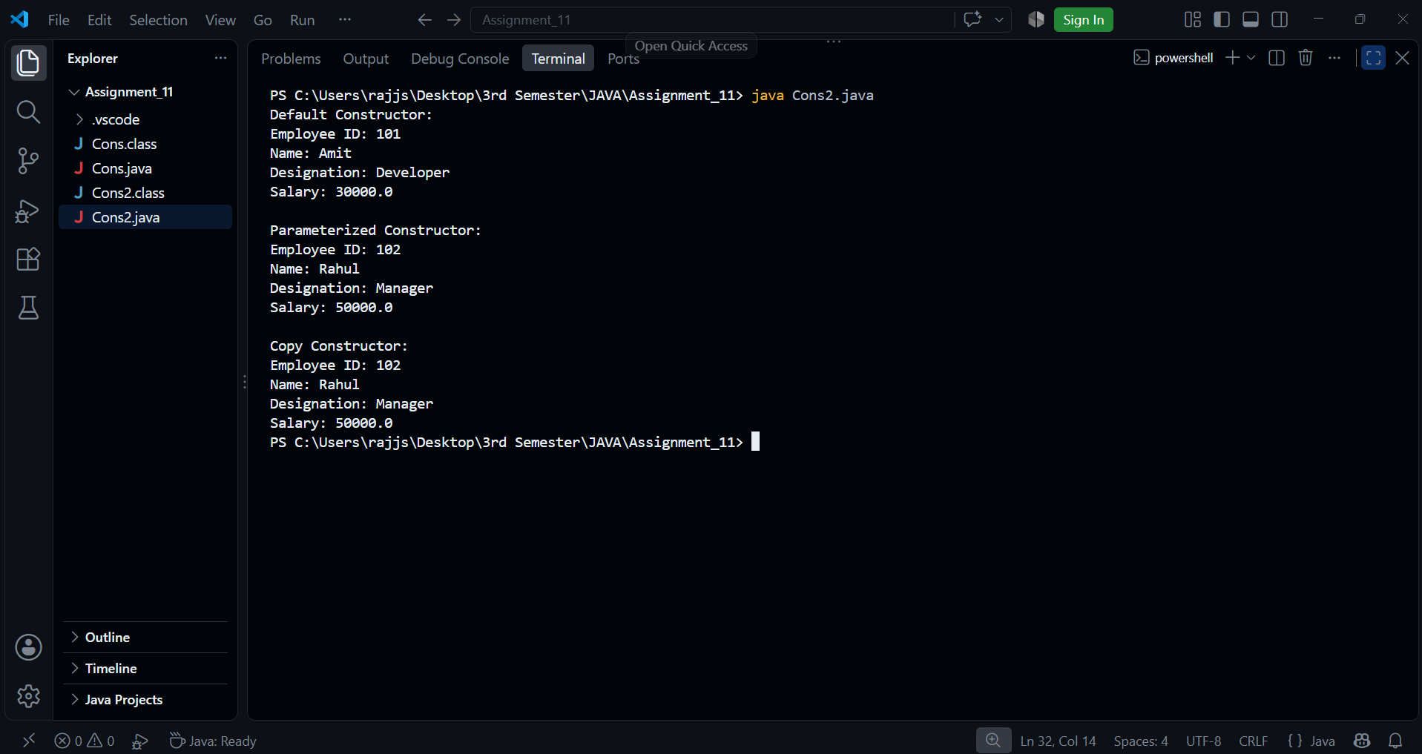

Section B – INHERITANCE
Q1) Create the following inheritance structure:
- Parent Class: Person
- Name
- Age
- Email
- Method: displayPersonDetails()
Child Class: Student
- Student ID
- Course
- Method: displayStudentDetails()
Requirements:
- Implement single inheritance.
- Use the super keyword to call the parent class constructor.
- Create a Student object.
- Display both personal and academic details.

Answer-
class Person {
String name;
int age;
String email;
Person(String name, int age, String email) {
this.name = name;
this.age = age;
this.email = email;
}
void displayPersonDetails() {
System.out.println("Name: " + name);
System.out.println("Age: " + age);
System.out.println("Email: " + email);
}
}
class Student extends Person {
int studentId;
String course;
Student(String name, int age, String email,
int studentId, String course) {
super(name, age, email);
this.studentId = studentId;
this.course = course;
}
void displayStudentDetails() {
System.out.println("Student ID: " + studentId);
System.out.println("Course: " + course);
}
}
public class Inher1 {
public static void main(String[] args) {
Student s = new Student(
"Shashank Raj",
20,
"shashank@example.com",
101,
"B.Tech CSE AIML"
);
System.out.println("Personal Details:");
s.displayPersonDetails();
System.out.println("\nAcademic Details:");
s.displayStudentDetails();
}
OUTPUT-
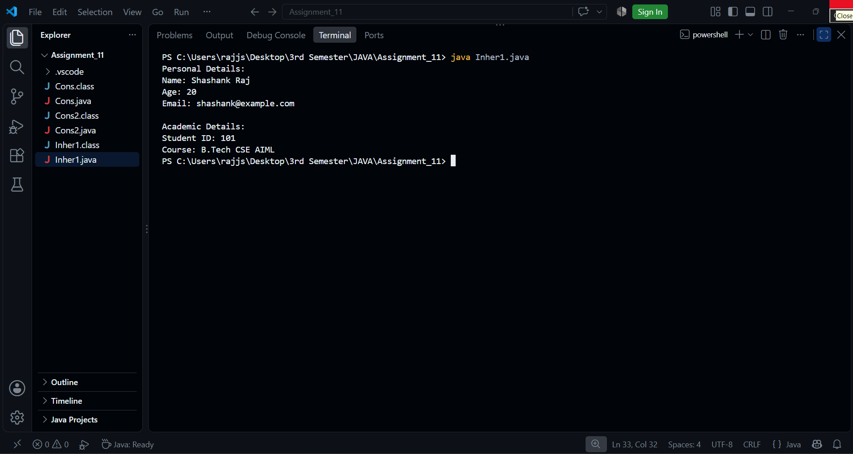
Q2) Create a Java program demonstrating multilevel inheritance.
Implement the following structure:
Employee
|
Manager
|
ProjectManager
Requirements:
- Employee ID
- Employee Name
- Basic Salary
- Department
- Team Size
- Project Name
- Project Duration
Create constructors in all three classes and use super() to invoke parent constructors.
Display complete project manager details.

Answer-
class Employee {
int employeeId;
String employeeName;
double basicSalary;
Employee(int employeeId, String employeeName,
double basicSalary) {
this.employeeId = employeeId;
this.employeeName = employeeName;
this.basicSalary = basicSalary;
}
}
class Manager extends Employee {
String department;
int teamSize;
Manager(int employeeId, String employeeName,
double basicSalary, String department,
int teamSize) {
super(employeeId, employeeName, basicSalary);
this.department = department;
this.teamSize = teamSize;
}
}
class ProjectManager extends Manager {
String projectName;
int projectDuration;
ProjectManager(int employeeId, String employeeName,
double basicSalary, String department,
int teamSize, String projectName,
int projectDuration) {

super(employeeId, employeeName, basicSalary,
department, teamSize);

this.projectName = projectName;
this.projectDuration = projectDuration;
}
void displayDetails() {
System.out.println("Employee ID: " + employeeId);
System.out.println("Employee Name: " + employeeName);
System.out.println("Basic Salary: " + basicSalary);
System.out.println("Department: " + department);
System.out.println("Team Size: " + teamSize);
System.out.println("Project Name: " + projectName);
System.out.println("Project Duration: "
+ projectDuration + " months");
}
}
public class Inher2 {
public static void main(String[] args) {
ProjectManager pm = new ProjectManager(
101,
"Shashank Raj",
75000,
"Information Technology",
10,
"AI Based Management System",
12
);
System.out.println("Project Manager Details:");
pm.displayDetails();
}
}

OUTPUT-


