Assignment – 12
Name: Shashank Raj
Roll: 25SCS1003001227
Sec: 2CSE14

Question 1
Method Overriding – Payment System (10 Marks). Create a parent class named .
Implement a method: makePayment()
Create the following child classes:
- CreditCardPayment
- UPIPayment
- CashPayment
Each child class should the makePayment() method and display an appropriate payment message. Requirements:
- Implement .
- Create objects of all child classes.
- Call the makePayment() method for each object.
- Demonstrate using a parent class reference.
Answer-
class Payment {
void makePayment() {
System.out.println("Making a payment...");
}
}
class CreditCardPayment extends Payment {
void makePayment() {
System.out.println("Payment made using Credit Card.");
}
}
class UPIPayment extends Payment {
void makePayment() {
System.out.println("Payment made using UPI.");
}
}
class CashPayment extends Payment {
void makePayment() {
System.out.println("Payment made using Cash.");
}
}
public class Main {
public static void main(String[] args) {
Payment p;
p = new CreditCardPayment();
p.makePayment();
p = new UPIPayment();
p.makePayment();
p = new CashPayment();
p.makePayment();
}
}

OUTPUT-
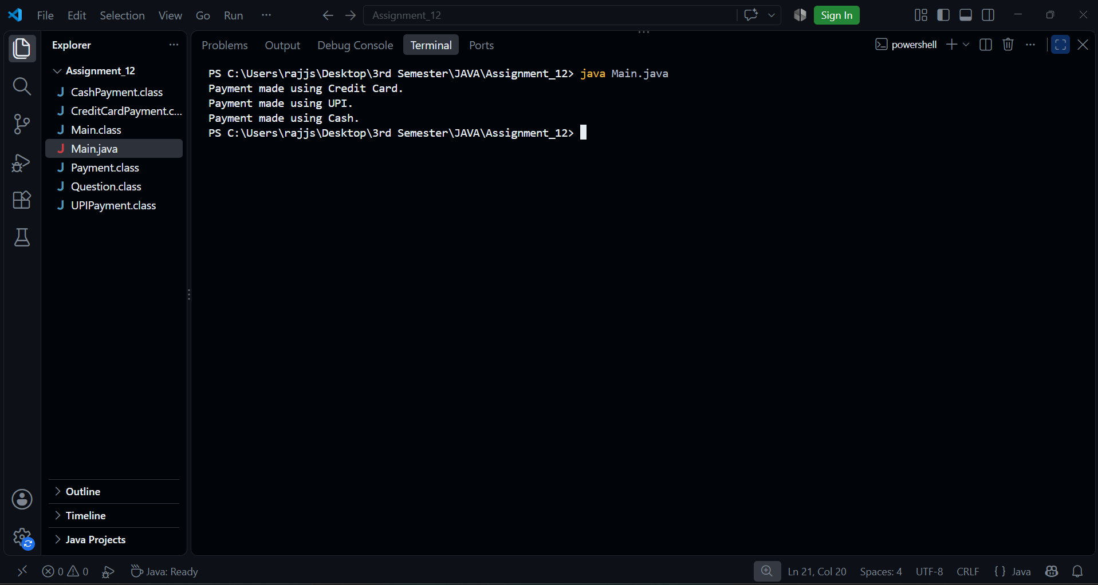

Question 2
Runtime Polymorphism – Employee Salary System (10 Marks)
Create a parent class named .
Declare:
- Employee ID
- Employee Name
Create the following child classes:
- FullTimeEmployee
- PartTimeEmployee
Implement a method: calculateSalary() Requirements:
- Calculate salary based on a fixed monthly salary.
- Calculate salary based on:
- Hours Worked
- Payment Per Hour
Demonstrate:
- Method overriding.
- Runtime polymorphism.
- Calling the calculateSalary() method using a parent class reference.

Answer-
class Employee {
int employeeId;
String employeeName;
Employee(int employeeId, String employeeName) {
this.employeeId = employeeId;
this.employeeName = employeeName;
}
void calculateSalary() {
System.out.println("Calculating employee salary...");
}
}
class FullTimeEmployee extends Employee {
double monthlySalary;
FullTimeEmployee(int employeeId, String employeeName, double monthlySalary) {
super(employeeId, employeeName);
this.monthlySalary = monthlySalary;
}
void calculateSalary() {
System.out.println("Employee ID: " + employeeId);
System.out.println("Employee Name: " + employeeName);
System.out.println("Monthly Salary: Rs. " + monthlySalary);
}
}
class PartTimeEmployee extends Employee {
int hoursWorked;
double paymentPerHour;
PartTimeEmployee(int employeeId, String employeeName,
int hoursWorked, double paymentPerHour) {
super(employeeId, employeeName);
this.hoursWorked = hoursWorked;
this.paymentPerHour = paymentPerHour;
}
void calculateSalary() {
double salary = hoursWorked * paymentPerHour;
System.out.println("Employee ID: " + employeeId);
System.out.println("Employee Name: " + employeeName);
System.out.println("Hours Worked: " + hoursWorked);
System.out.println("Payment Per Hour: Rs. " + paymentPerHour);
System.out.println("Total Salary: Rs. " + salary);
}
}
public class main2 {
public static void main(String[] args) {
Employee e;
e = new FullTimeEmployee(101, "Rahul", 30000);
System.out.println("Full-Time Employee Details:");
e.calculateSalary();
System.out.println();
e = new PartTimeEmployee(102, "Aman", 80, 200);
System.out.println("Part-Time Employee Details:");
e.calculateSalary();
}
}
OUTPUT-


