Assignment – 3
Name: Shashank Raj
Roll: 25SCS1003001227
Sec: 2CSE14

// Q1. Sum of two number

import java.util.Scanner;
public class Q_01 {
public static void main(String[] args) {
Scanner sc = new Scanner(System.in);
System.out.print("Enter First Number:");
int firstNum = sc.nextInt();
System.out.print("Enter Second Number:");
int secondNum = sc.nextInt();
int sum = firstNum + secondNum;
System.out.println("Sum: " + sum);
}
}OUTPUT-
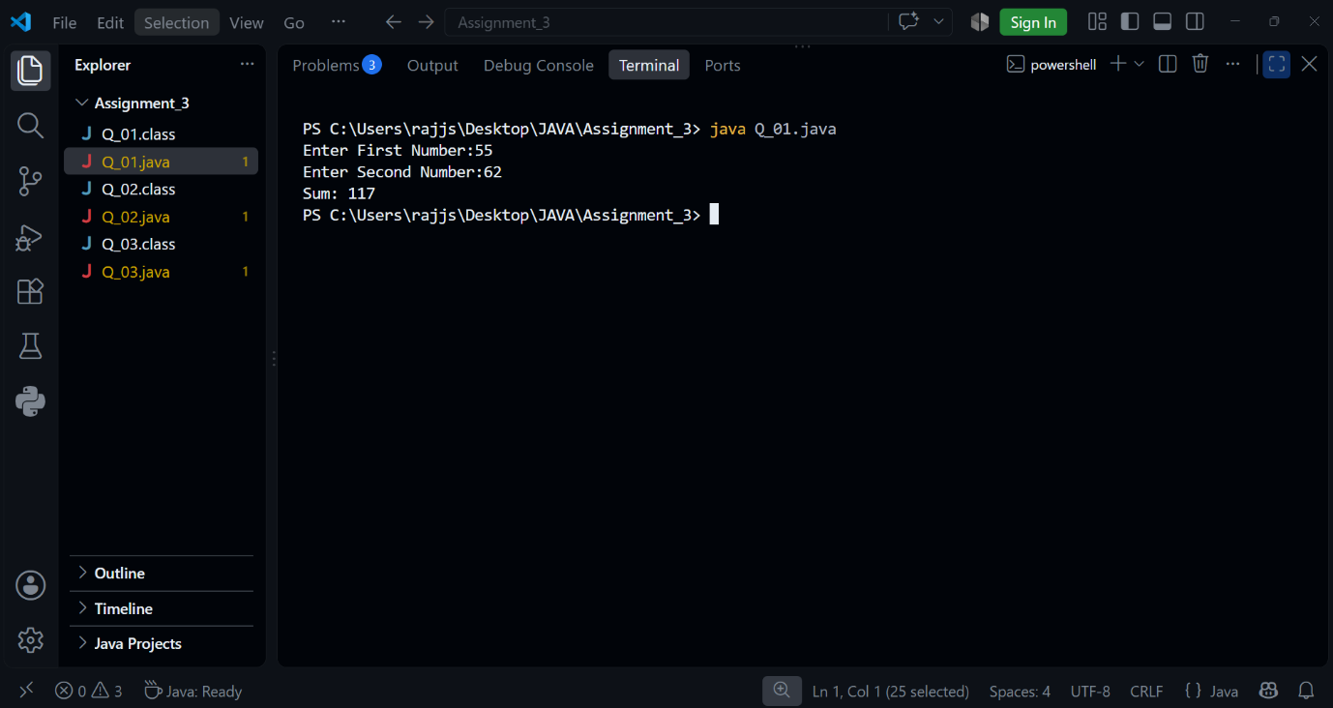

// Q2. Email Address Input

import java.util.Scanner;
public class Q_02 {
public static void main(String[] args) {
Scanner sc = new Scanner(System.in);
System.out.print("Enter Name: ");
String name = sc.nextLine();
System.out.print("Enter Email: ");
String email = sc.nextLine();
System.out.println("Student Details");
System.out.println("Name: " + name);
System.out.println("Email: " + email);
}
}

OUTPUT-
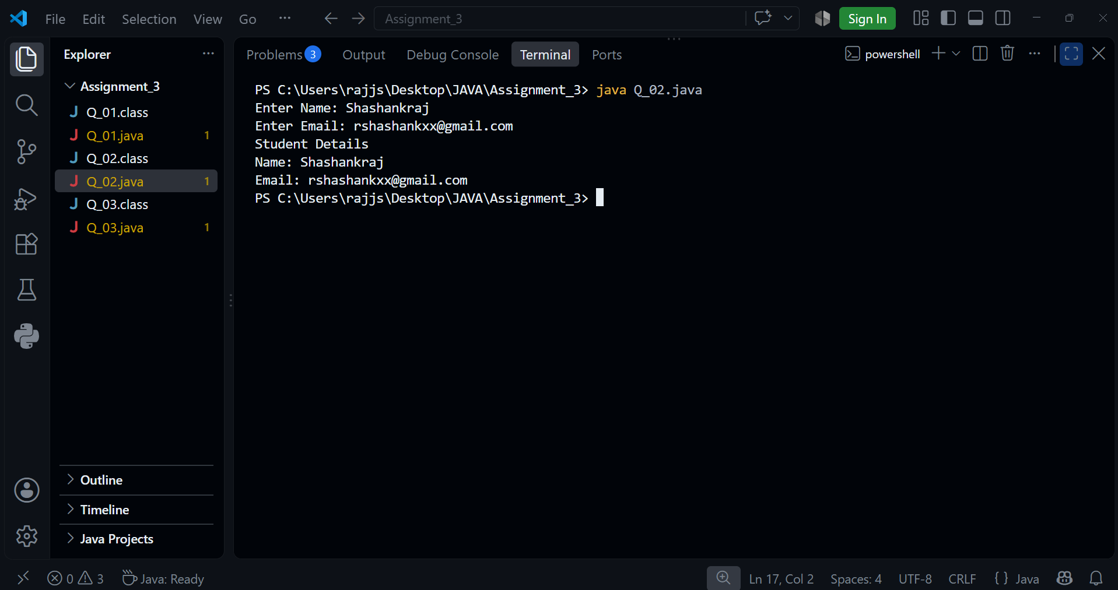

// Q3. Simple Interest Calculator
import java.util.Scanner;
public class Q_03 {
public static void main(String[] args) {
Scanner sc = new Scanner(System.in);
System.out.print("Enter Principal Amount: ");
int P = sc.nextInt();
System.out.print("Enter Rate of Interest: ");
int R = sc.nextInt();
System.out.print("Enter Time(in years): ");
int T = sc.nextInt();
int SI = (P * R * T) / 100;
System.out.println("Simple Interst: " + SI);
}
}

OUTPUT-
