Assignment – 6
Name: Shashank Raj
Roll: 25SCS1003001227
Sec: 2CSE14

// Q1. Sum of elements in an array

import java.util.Scanner;
public class Q_01 {
public static void main(String[] args) {
Scanner sc = new Scanner(System.in);
System.out.print("Enter the size of array: ");
int n = sc.nextInt();
int[] arr = new int[n];
System.out.println("Enter " + n + " elements:");
for (int i = 0; i < n; i++) {
arr[i] = sc.nextInt();
}
int sum = 0;
for (int i = 0; i < n; i++) {
sum = sum + arr[i];
}
System.out.println("Sum of array elements: " + sum);
sc.close();
}
}

OUTPUT-
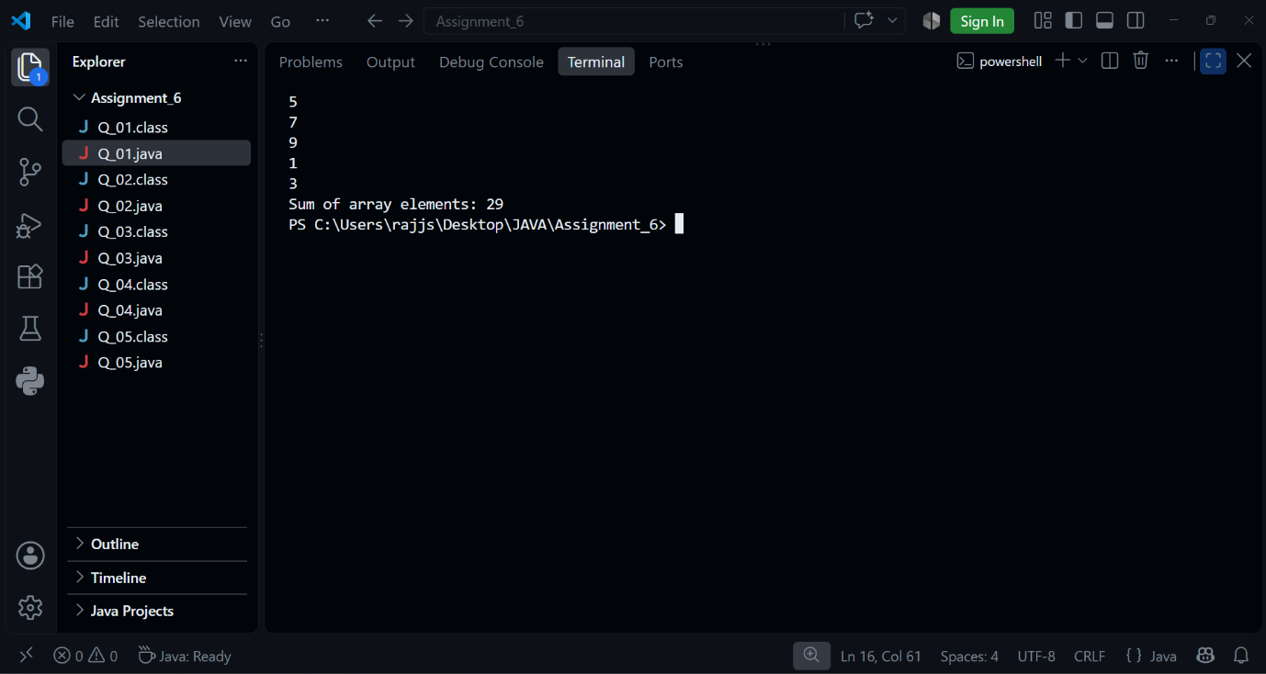

// Q2. Find Largest Element in an Array

import java.util.Scanner;
public class Q_02 {
public static void main(String[] args) {
Scanner sc = new Scanner(System.in);
System.out.print("Enter the size of array: ");
int n = sc.nextInt();
int[] arr = new int[n];
System.out.println("Enter " + n + " elements:");
for (int i = 0; i < n; i++) {
arr[i] = sc.nextInt();
}
int largest = arr[0];
for (int i = 1; i < n; i++) {
if (arr[i] > largest) {
largest = arr[i];
}
}
System.out.println("Largest element: " + largest);
sc.close();
}
}

OUTPUT-
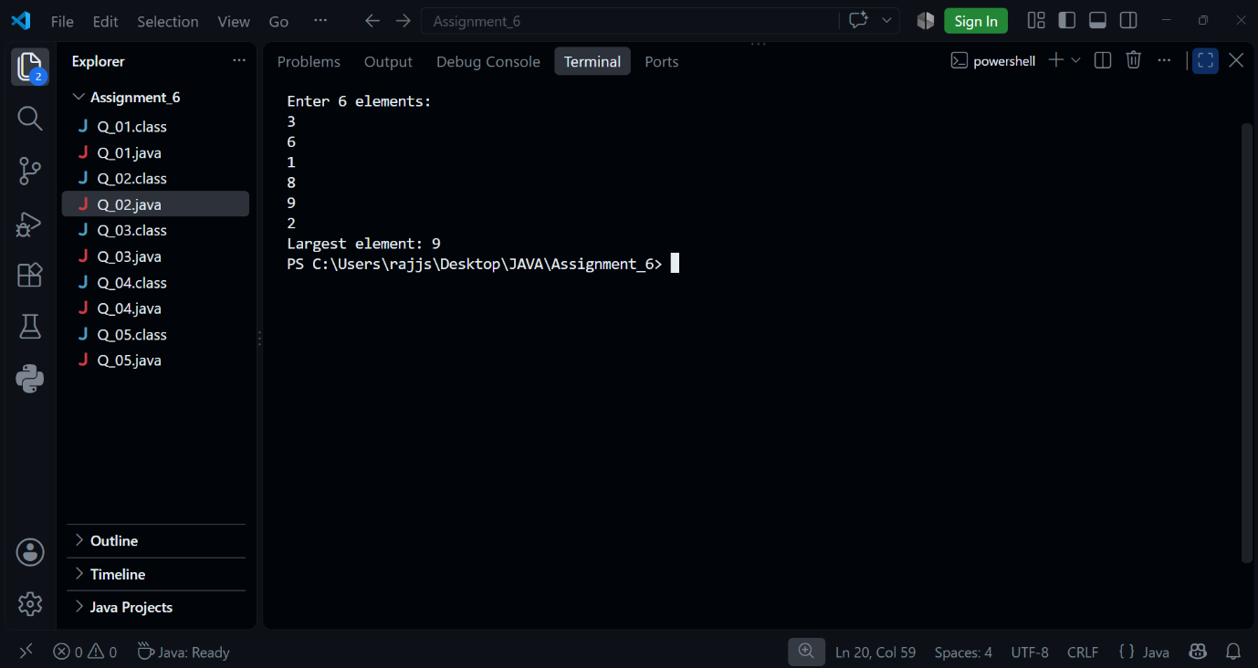

// Q3. Search an Element in an Array

import java.util.Scanner;
public class Q_03 {
public static void main(String[] args) {
Scanner sc = new Scanner(System.in);
System.out.print("Enter the size of array: ");
int n = sc.nextInt();
int[] arr = new int[n];
System.out.println("Enter " + n + " elements:");
for (int i = 0; i < n; i++) {
arr[i] = sc.nextInt();
}
System.out.print("Enter the element to search: ");
int search = sc.nextInt();
boolean found = false;
for (int i = 0; i < n; i++) {
if (arr[i] == search) {
System.out.println("Element found at index: " + i);
found = true;
break;
}
}
if (!found) {
System.out.println("Element not found");
}
sc.close();
}
}

OUTPUT-
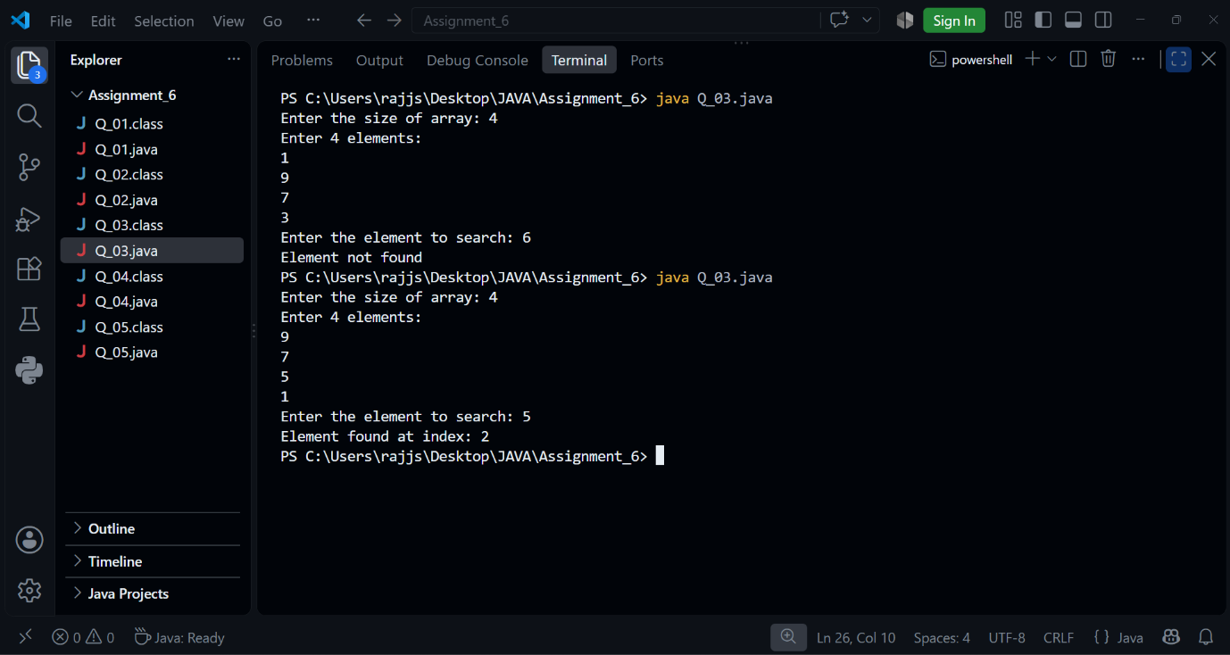

// Q4. Reverse an Array

import java.util.Scanner;
public class Q_04 {
public static void main(String[] args)
Scanner sc = new Scanner(System.in);
System.out.print("Enter the size of array: ");
int n = sc.nextInt();
int[] arr = new int[n];
System.out.println("Enter " + n + " elements:");
for (int i = 0; i < n; i++) {
arr[i] = sc.nextInt();
}
System.out.println("Reversed array:");
for (int i = n - 1; i >= 0; i--) {
System.out.print(arr[i] + " ");
}
sc.close();
}
}

OUTPUT-
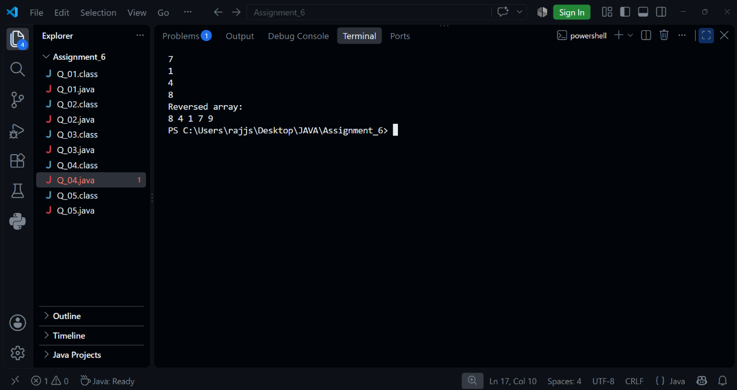

// Q5. Count Occurrence of an Element in an Array

import java.util.Scanner;
public class Q_05 {
public static void main(String[] args) {
Scanner sc = new Scanner(System.in);
System.out.print("Enter the size of array: ");
int n = sc.nextInt();
int[] arr = new int[n];
System.out.println("Enter " + n + " elements:");
for (int i = 0; i < n; i++) {
arr[i] = sc.nextInt();
}
System.out.print("Enter the element to count: ");
int search = sc.nextInt();
int count = 0;
for (int i = 0; i < n; i++) {
if (arr[i] == search) {
count++;
}
}
System.out.println(search + " occurs " + count + " time(s)");
sc.close();
}
}

OUTPUT-
