Assignment – 10
Name: Shashank Raj
Roll: 25SCS1003001227
Sec: 2CSE14

PART A – (Conceptual Questions)
Q1) What are Wrapper Classes in Java?
Explain why Java provides Wrapper Classes.
Answer-
Wrapper classes are predefined classes in Java that convert primitive data types into objects. Java has eight primitive data types, and each one has a corresponding wrapper class.
Primitive data types such as int, char, and double store values directly. However, sometimes Java programs require objects instead of primitive values. Wrapper classes solve this problem by wrapping a primitive value inside an object.
For example:
int number = 10; // Primitive data type
Integer numberObject = 10; // Wrapper class object
Here, Integer is the wrapper class for int.
Why Does Java Provide Wrapper Classes?
Java provides wrapper classes for several important reasons:
- To use primitive values as objects: Some Java features require objects instead of primitive types.
- Collections Framework: Classes such as ArrayList and HashSet store objects, so wrapper classes are required.
- Autoboxing and Unboxing: Java can automatically convert primitives into objects and objects back into primitives.
- Utility methods: Wrapper classes provide useful methods for conversion and comparison, such as Integer.parseInt().
- Support for null values: Primitive types cannot store null, but wrapper objects can.
Example Using a Wrapper Class
Integer age = 20;
System.out.println(age);
In this example, Integer stores the value 20 as an object.
In simple words: Wrapper classes act as a bridge between primitive data types and objects in Java.

Q2) Write the corresponding Wrapper Class for each primitive data type:
- byte
- short
- int
- long
- float
- double
- char
- Boolean

Answer-
Java provides a wrapper class for every primitive data type.
Primitive Data Type | Wrapper Class | Example
byte | Byte | Byte b = 10;
short | Short | Short s = 20;
int | Integer | Integer i = 100;
long | Long | Long l = 1000L;
float | Float | Float f = 10.5f;
double | Double | Double d = 25.75;
char | Character | Character c = 'A';
boolean | Boolean | Boolean flag = true;
Important Point
Most wrapper class names begin with a capital letter, but some names are different from the primitive type:
- int → Integer
- char → Character
- boolean → Boolean
These wrapper classes are part of the java.lang package, so they do not need to be imported separately.

Q3) Differentiate between:
- Primitive Data Type
- Wrapper Class
Give at least two examples.

Answer-
Primitive data types and wrapper classes both store values, but they work differently in Java.
Primitive Data Type
A primitive data type is a basic data type provided by Java that stores a simple value directly. Java has eight primitive types: byte, short, int, long, float, double, char, and boolean.
Wrapper Class
A wrapper class is a predefined Java class that stores a primitive value inside an object. It allows primitive values to be used wherever objects are required.
Difference Table
Primitive Data Type | Wrapper Class
Stores a value directly | Stores a value inside an object
It is not an object | It is an object
Generally requires less memory | Generally requires more memory
Faster for basic calculations | Slightly more overhead because it is an object
Cannot store null | Can store null
Cannot directly be used in generic collections | Can be used in collections
Does not provide object-based utility methods | Provides useful methods for conversion and manipulation
Example 1: int and Integer
int a = 10;
Integer b = 10;
System.out.println(a);
System.out.println(b);
Here, a is a primitive integer, while b is an Integer object.

Example 2: char and Character
char grade = 'A';
Character letter = 'A';
System.out.println(grade);
System.out.println(letter);
Here, grade is a primitive character, while letter is a wrapper object.

Example Using Collections
import java.util.ArrayList;
class Demo {
public static void main(String[] args) {
ArrayList<Integer> numbers = new ArrayList<>();
numbers.add(10);
numbers.add(20);
numbers.add(30);
System.out.println(numbers);
}
}
Explanation
ArrayList cannot directly store primitive int values. It stores objects, so we use Integer. Java automatically converts the primitive values into Integer objects using autoboxing.

Q4) What is Autoboxing?
Explain with a suitable example.

Answer-
Autoboxing is the automatic conversion of a primitive data type into its corresponding wrapper class object by Java.
Before autoboxing was introduced, programmers had to manually convert primitive values into objects. Modern Java performs this conversion automatically.
Example:
int num = 25;
Integer obj = num;
Here:
- num is an int primitive.
- obj is an Integer object.
- Java automatically converts int into Integer.
This automatic conversion is called autoboxing.
Another Example:
ArrayList<Integer> list = new ArrayList<>();
list.add(10);
list.add(20);
The add() method expects an Integer object, but we provide primitive integers. Java automatically converts them into Integer objects.
Manual Conversion Before Autoboxing
Earlier, programmers had to write:
Integer obj = Integer.valueOf(25);
Now Java allows:
Integer obj = 25;
In Simple Words
Autoboxing means:
Primitive → Wrapper Object
Example:
int → Integer
double → Double
char → Character

Q5) What is Unboxing?
Explain with a suitable example.

Answer-
Unboxing is the automatic conversion of a wrapper class object into its corresponding primitive data type.
It is the reverse process of autoboxing.
Example:
Integer obj = 50;
int num = obj;
Here:
- obj is an Integer object.
- num is a primitive int.
- Java automatically extracts the integer value from the object.
This process is called unboxing.
Another Example:
Integer marks = 95;
int result = marks;
System.out.println(result);
The Integer object is automatically converted into an int.
Manual Unboxing
We can also explicitly convert the object into a primitive using a method:
Integer obj = 100;
int num = obj.intValue();
However, Java usually performs this conversion automatically.
In Simple Words
Unboxing means:
Wrapper Object → Primitive
Example:
Integer → int
Double → double
Character → char
Important Note
If a wrapper object contains null, unboxing it can cause a NullPointerException.
Example:
Integer number = null;
// int value = number; // Causes NullPointerException

Q6) What is the difference between:Integer.parseInt() and Integer.valueOf()

Answer-
Both Integer.parseInt() and Integer.valueOf() are methods of the Integer wrapper class. They are used to convert a string containing a valid integer into a numeric value.
However, the main difference is what they return.
Integer.parseInt()
parseInt() converts a string into a primitive int value.
Syntax:
int result = Integer.parseInt("123");
Example:
class Demo {
public static void main(String[] args) {
String str = "250";
int num = Integer.parseInt(str);
System.out.println(num);
System.out.println(num + 50);
}
}
Explanation:
The string "250" is converted into the primitive integer 250. We can directly perform arithmetic operations on it.

Integer.valueOf()
valueOf() converts a string into an Integer wrapper object.
Syntax:
Integer result = Integer.valueOf("123");
Example:
class Demo {
public static void main(String[] args) {
String str = "250";
Integer num = Integer.valueOf(str);
System.out.println(num);
}
}
Here, the result is an Integer object rather than a primitive int.
Comparison Table
Integer.parseInt() | Integer.valueOf()
Converts String to primitive int | Converts String to Integer object
Returns int | Returns Integer
Useful for calculations using primitive values | Useful when an object is required
Example: int n = Integer.parseInt("10"); | Example: Integer n = Integer.valueOf("10");
Combined Example
class Demo {
public static void main(String[] args) {
int a = Integer.parseInt("100");
Integer b = Integer.valueOf("200");
System.out.println("Primitive int: " + a);
System.out.println("Integer object: " + b);
}
}
Important Point
Although valueOf() returns an Integer object, Java can automatically unbox it when a primitive value is needed.

PART B – (Basic Programming)

Q1) Primitive and Wrapper Variables
Create a Java program that declares variables for all 8 primitive data types and their corresponding Wrapper Classes.
Example:int → Integer
double → Double
char → Character
boolean → Boolean
Display the values of both primitive and Wrapper variables.

Answer-
public class PrimitiveWrapperDemo {
public static void main(String[] args) {
// Primitive data type variables
byte b = 10;
short s = 20;
int i = 30;
long l = 40000L;
float f = 5.5f;
double d = 10.25;
char c = 'A';
boolean bool = true;
// Wrapper class variables (Autoboxing)
Byte wb = b;
Short ws = s;
Integer wi = i;
Long wl = l;
Float wf = f;
Double wd = d;
Character wc = c;
Boolean wbool = bool;
// Display primitive values
System.out.println("Primitive Data Type Values:");
System.out.println("byte: " + b);
System.out.println("short: " + s);
System.out.println("int: " + i);
System.out.println("long: " + l);
System.out.println("float: " + f);
System.out.println("double: " + d);
System.out.println("char: " + c);
System.out.println("boolean: " + bool);
// Display wrapper class values
System.out.println("\nWrapper Class Values:");
System.out.println("Byte: " + wb);
System.out.println("Short: " + ws);
System.out.println("Integer: " + wi);
System.out.println("Long: " + wl);
System.out.println("Float: " + wf);
System.out.println("Double: " + wd);
System.out.println("Character: " + wc);
System.out.println("Boolean: " + wbool);
}
}
OUTPUT-
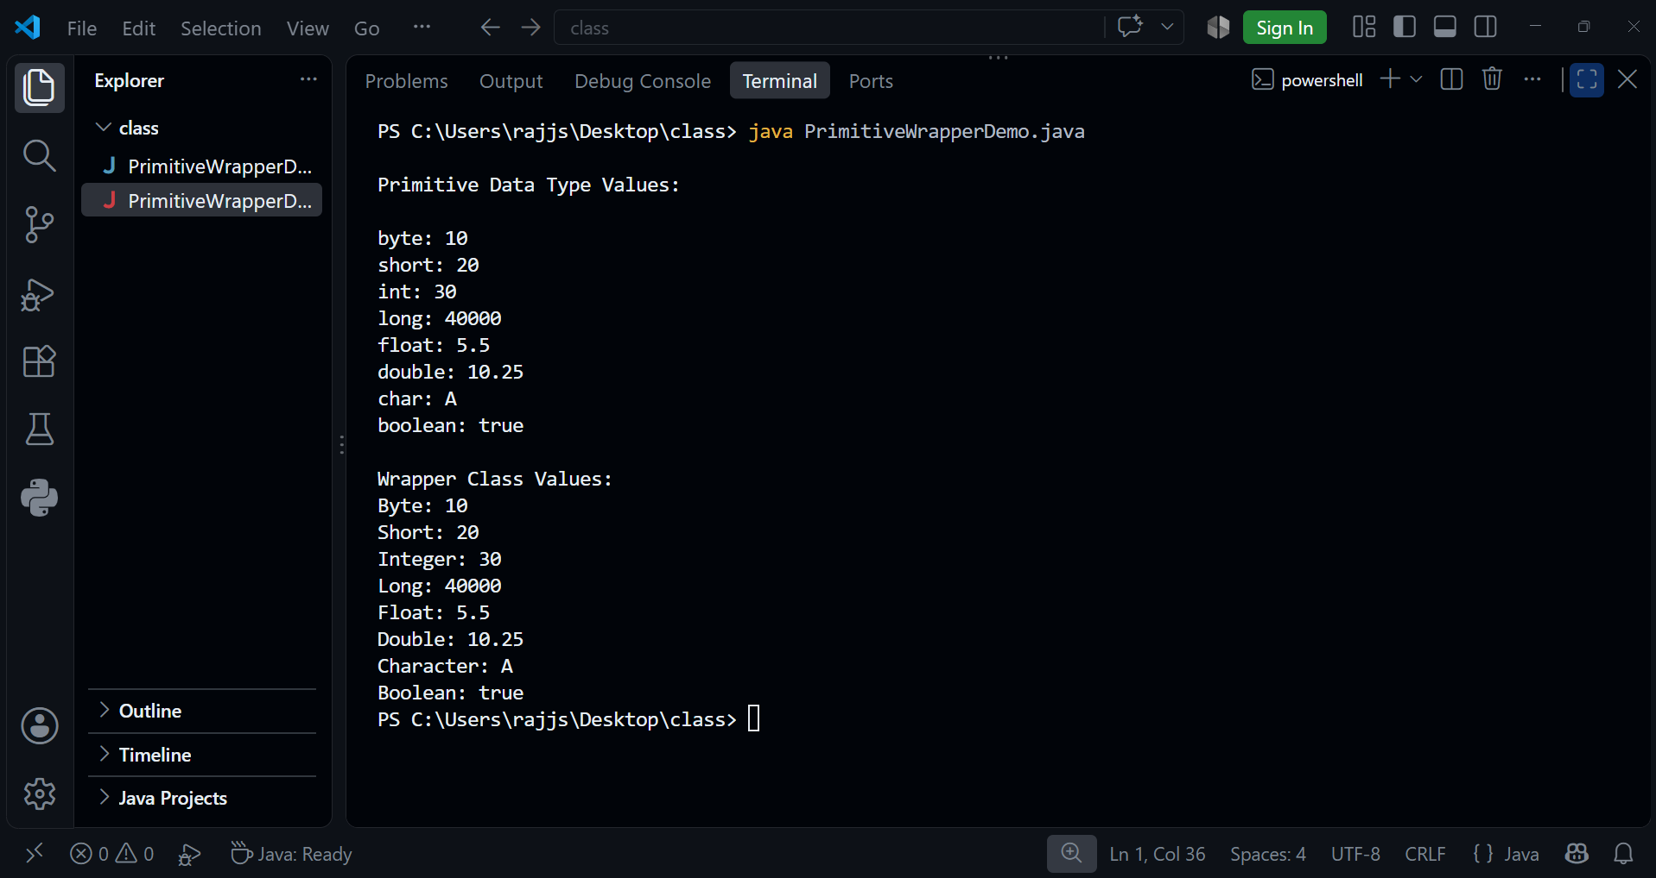

Q2) Autoboxing Demonstration
Create a program to demonstrate .
Convert the following primitive values into Wrapper objects:int
double
char
boolean
Display the values after conversion.
Example:int number = 100;
Integer obj = number;
Answer-
public class AutoboxingDemo {
public static void main(String[] args) {
// Primitive values
int number = 100;
double decimal = 25.5;
char letter = 'A';
boolean status = true;
// Autoboxing: Primitive to Wrapper objects
Integer intObj = number;
Double doubleObj = decimal;
Character charObj = letter;
Boolean boolObj = status;
// Display converted values
System.out.println("Integer object: " + intObj);
System.out.println("Double object: " + doubleObj);
System.out.println("Character object: " + charObj);
System.out.println("Boolean object: " + boolObj);
}
}

OUTPUT-
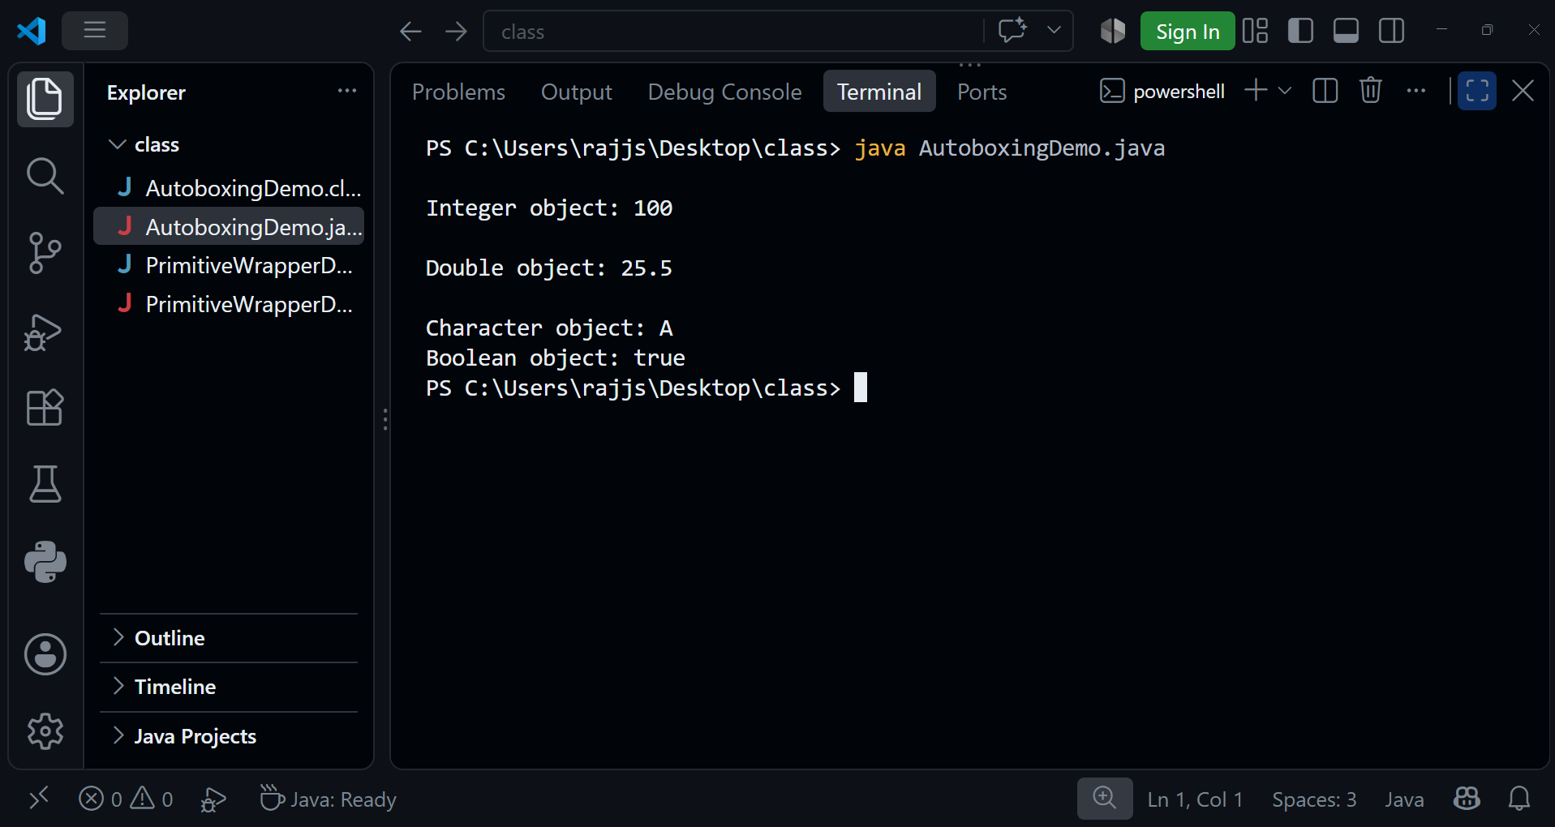

Q3) Unboxing Demonstration
Create a program to demonstrate .
Convert the following Wrapper objects into primitive values:Integer → int
Double → double
Character → char
Boolean → boolean
Display the converted values.
Answer-
public class UnboxingDemo {
public static void main(String[] args) {
// Wrapper class objects
Integer intObj = 100;
Double doubleObj = 25.5;
Character charObj = 'A';
Boolean boolObj = true;
// Unboxing: Wrapper objects to primitive values
int number = intObj;
double decimal = doubleObj;
char letter = charObj;
boolean status = boolObj;
// Display converted values
System.out.println("int value: " + number);
System.out.println("double value: " + decimal);
System.out.println("char value: " + letter);
System.out.println("boolean value: " + status);
}
}

OUTPUT-
