Assignment- 5
Name: Shashank Raj
Roll: 25SCS1003001227
Sec: 2CSE14

// Q1. Find the sum of numbers from 1 to N
import java.util.Scanner;
public class Q_01 {
public static void main(String[] args) {
Scanner sc = new Scanner(System.in);
System.out.print("Enter N: ");
int n = sc.nextInt();
int sum = 0;
for (int i = 1; i <= n; i++) {
sum = sum + i;
}
System.out.println("The sum is: " + sum);
sc.close();
}
}
OUTPUT-
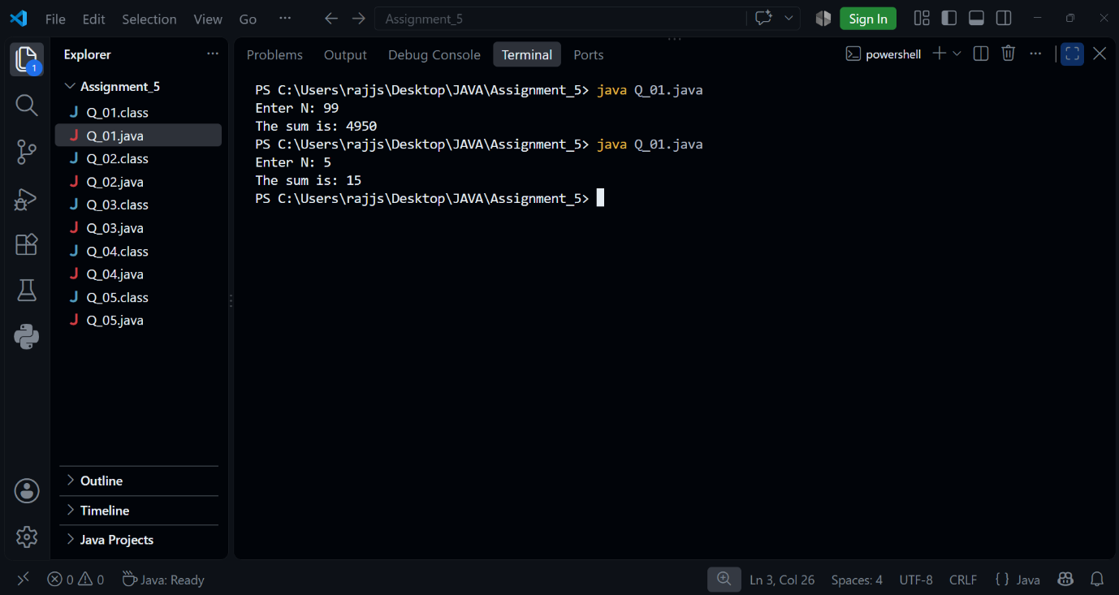
// Q2. Print multiples of 5 from 1 to 100

public class Q_02 {
public static void main(String[] args) {
for (int i = 1; i <= 100; i++) {
if (i % 5 == 0) {
System.out.println(i);
}
}
}
}

OUTPUT-
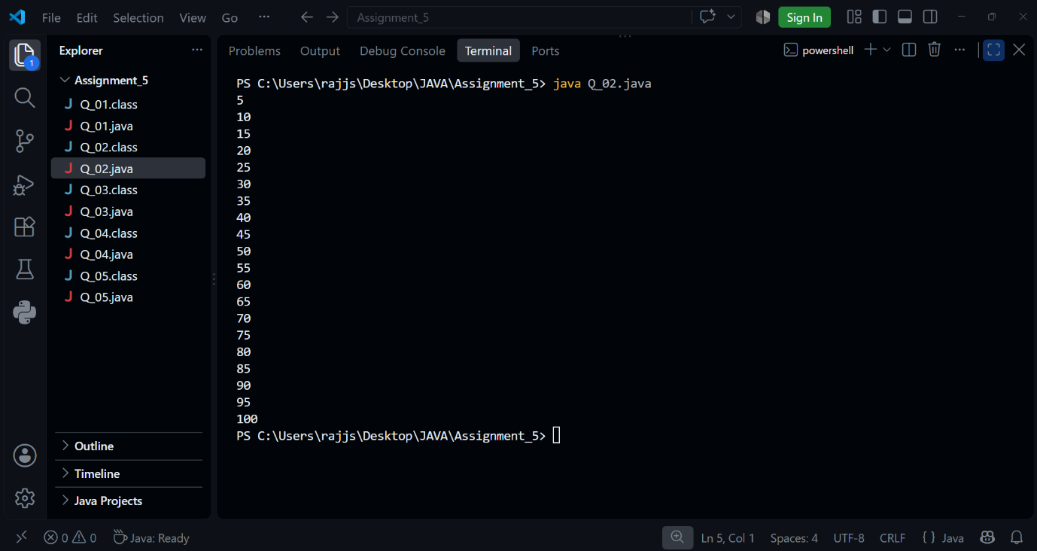

// Q3. Count how many numbers are divisible by 3 between 1 and N

import java.util.Scanner;
public class Q_03 {
public static void main(String[] args) {
Scanner sc = new Scanner(System.in);
System.out.print("Enter N: ");
int n = sc.nextInt();
int count = 0;
for (int i = 1; i <= n; i++) {
if (i % 3 == 0) {
count++;
}
}
System.out.println("Count of numbers divisible by 3: " + count);
sc.close();
}
}

OUTPUT-
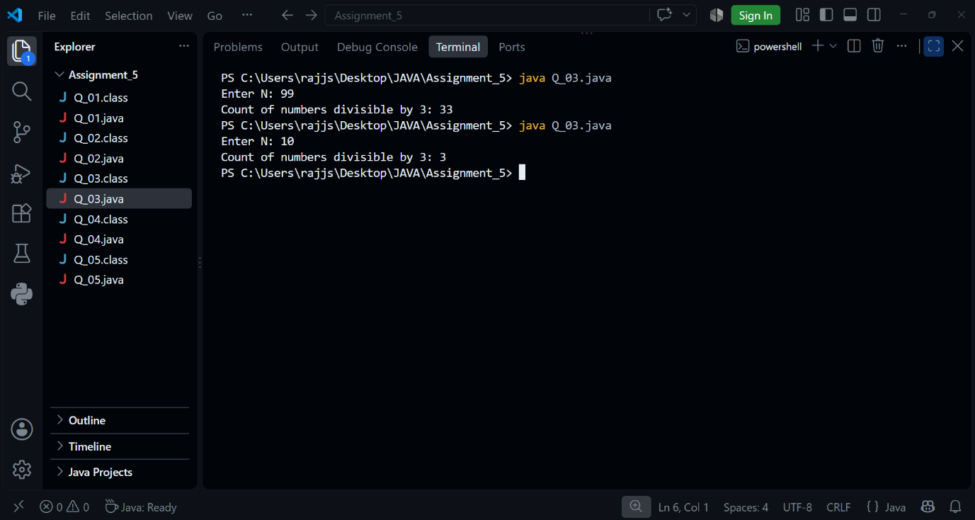

// Q4. Check whether a number is prime or Not

import java.util.Scanner;
public class Q_04 {
public static void main(String[] args) {
Scanner sc = new Scanner(System.in);
System.out.print("Enter a number: ");
int n = sc.nextInt();
boolean isPrime = true;
if (n <= 1) {
isPrime = false;
} else {
for (int i = 2; i < n; i++) {
if (n % i == 0) {
isPrime = false;
break;
}
}
}
if (isPrime) {
System.out.println(n + " is a Prime number");
} else {
System.out.println(n + " is not a Prime number");
}
sc.close();
}
}

OUTPUT-
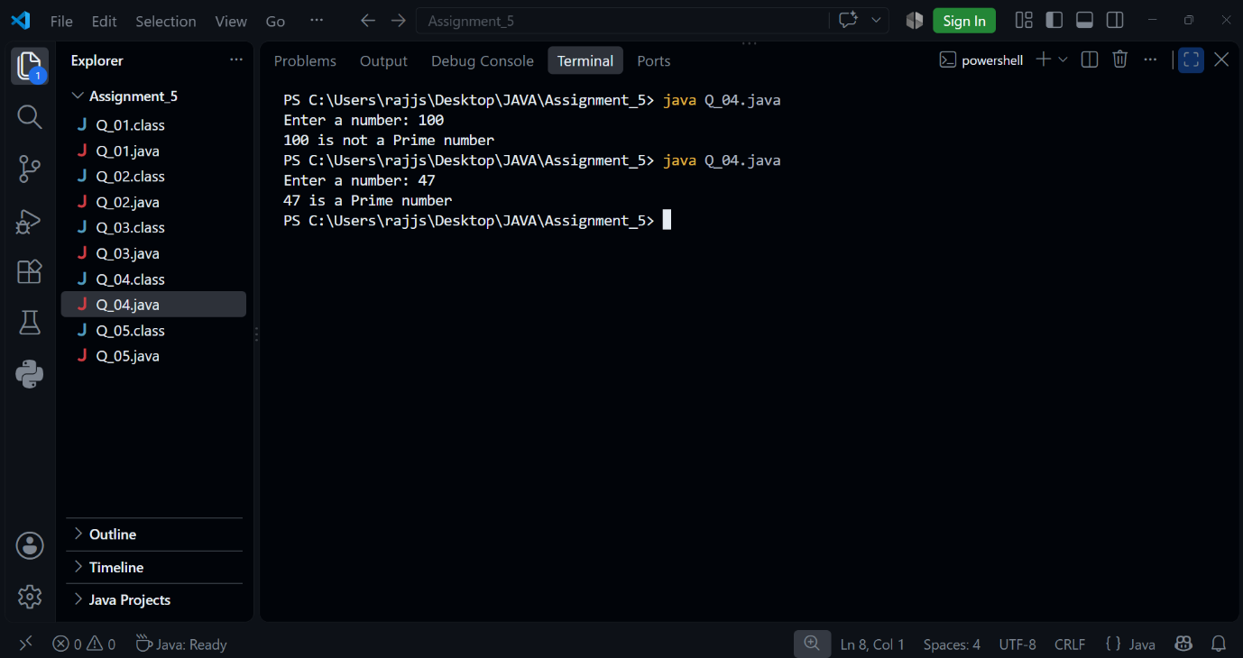

// Q5. Reverse of a Given number

import java.util.Scanner;
public class Q_05 {
public static void main(String[] args) {
Scanner sc = new Scanner(System.in);
System.out.print("Enter a number: ");
int num = sc.nextInt();
int reverse = 0;
while (num != 0) {
int digit = num % 10;
reverse = reverse * 10 + digit;
num = num / 10;
}
System.out.println("Reversed number: " + reverse);
sc.close();
}
}

OUTPUT-
