**4. To build any Java Project (with and without parameters) using Jenkins**

1.Create Freestyle project.

2.Execute windows batch command

3. WITHOUT PARAMETERS

Command:

cd C:\Users\REJITH JACOB\Desktop\bruh

javac hello.java

java hello

Code:

class hello {

  public static void main(String[] args) {

    System.out.println("Username is:");

  }

}

4. WITH PARAMETERS

Code:

class hi {

  public static void main(String[] args) {

    System.out.println("Username is:" + args[0]);

  }

}

**5. To implement windows batch command on a project in Jenkins**

**(with and without parameters)**

**Without parameters**

1.Select execute windows batch command.

2.write echo “hello world”

**With Parameters**

1.Select this project is parametrized

2.Select string fname

3.Select string lname

4.Select Choice

5.Select execute windows batch command.

6.write echo ‘%fname’

echo ‘%lname’

**6. To build any python project (python file and script) in Jenkins**

1.Execute Python Script

2.

Code:

num = 7

factorial = 1

if num < 0:

print("Sorry, factorial does not exist for negative numbers")

elif num == 0:

print("The factorial of 0 is 1")

else:

for i in range(1,num + 1):

factorial = factorial*i

print("The factorial of",num,"is",factorial)

**7. To build a Maven and Ant project in Jenkins**

**MAVEN** <https://github.com/avizway1/maven-helloworld>

1.Create maven project

2.Git and add the url.

3.Build goals type clean compile package and build

4. Clicking on the build now button will generate this war file

C:\ProgramData\Jenkins\.jenkins\workspace\maven\webapp\target\webapp.war

5. 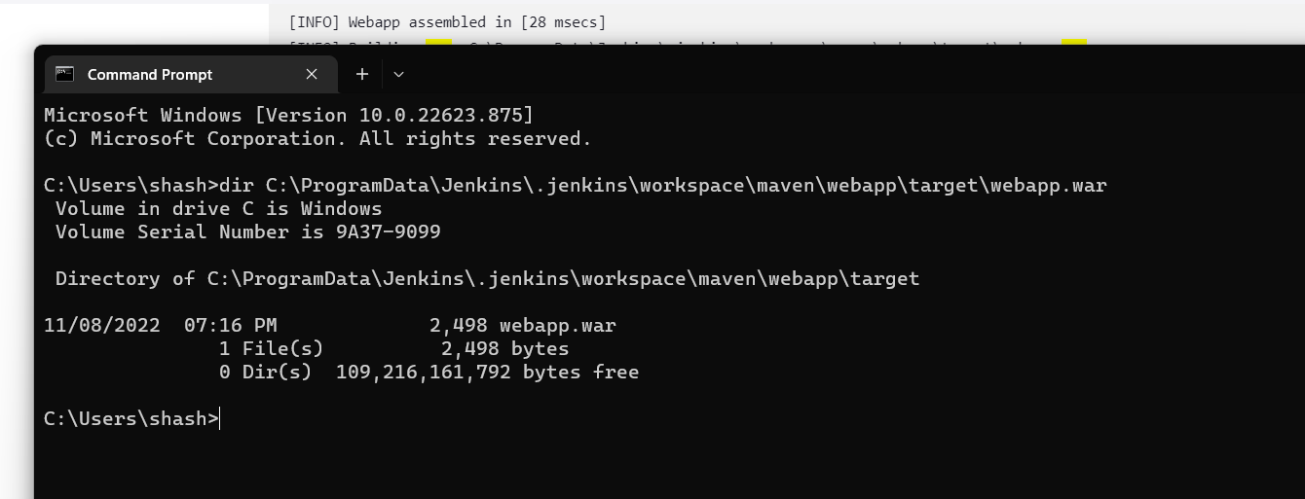

**ANT** [**https://github.com/ShashankRaiii/rps-ant**](https://github.com/ShashankRaiii/rps-ant)

1.Create a freestyle project

2.Git <URL:after> forking

3.Build steps invoke ant and add ant version as ant.

4.Targets: clean compile test package war.

5.Go to cmd and >dir path of war file.

**8. To create a pipeline script and build a pipeline of jobs in Jenkins**

**A.Use hello world script**

**B.Own script**

1.Create a pipleline script

2.Code:

pipeline {

agent any

parameters {

string(name: 'PERSON' , defaultValue: 'Rejith', description: 'say hello')

choice(name: 'CHOICE' , choices: ['1','2','3','4'], description: 'pick')

password(name: 'PASSWORD' , defaultValue: '1234', description: 'enter pass')

}

stages {

stage('name') {

steps {

echo "Hello ${params.PERSON}"

}

}

stage('choice') {

steps {

echo "Choice ${params.CHOICE}"

}

}

stage('password') {

steps {

echo "Password: ${params.PASSWORD}"

}

}

}

}

**9. To create a Jenkinsfile and build a pipeline of jobs in Jenkins**

1.Create pipeline project

2.Selcet pipeline script from SCM

3.SCM select Git

4.Repository Url: <https://github.com/christianhxc/jenkins-pipeline-tutorial>

5.Script Path: hello-world/Jenkinsfile

**10. In Jenkins, show changes in a project with the help of webhooks.**

**Also show how builds can be scheduled with cron commands**

1. First, download Ngrok. In the folder where ngrok is located, open the cmd window.

Here are the commands to type

Ngrok.exe --version

Ngrok.exe http 8080

2. Copy forwarding, up to Ngrok.io

3.Go to git repo settings add web hook and paste the ngrok.io.

4.Create a pipeline project

5. Build triggers: GitHub hook trigger for GITScm polling

6.Script Path: hello world.

7. Now using Cron Commands:

Build Triggers->Build periodically and schedule H/1 * * * *

**11. To Implement Docker Commands**

Commands:

-Docker version

-Docker login

-docker pull ubuntu

-docker pull ubuntu:jammy

-docker images -q

-docker images -a

-docker images -f “dangling=false”

-docker images -f “dangling=true”

-docker run ubuntu

-docker ps

-docker ps -a

-docker run –name student -it ubuntu bash

-docker ps

-docker pause student

-docker stop student

-docker stats student

-docker ps -a

-docker inspect ubuntu

-docker -rmi ubuntu

-docker push ubuntu

-docker history ubuntu

**12. To build an image for a web application using Dockerfile**

1. Download Dockerfile from classroom exp 10 reference material

FROM ubuntu:latest

MAINTAINER "Shree Jaswal"

RUN apt update -y

RUN apt install nginx -y

EXPOSE 80

COPY rejith.html /usr/share/nginx/html/rejith.html

COPY rejith.html /var/www/html/rejith.html

CMD ["nginx","-g","daemon off;"]

2.create a folder and move Dockerfile to this folder

3.create index.html here

<html>

<head>

<title>Welcome Rejith</title>

</head>

<body>

<h1>Welcome to my website</h1>

<h2>Main Categories:</h2>

<p>Pages (HTML)</p>

<p>Style Sheets</p>

<p>Computer Code(Javascript)</p>

<p>Live Data</p>

</body>

</html>

4.in cmd

5.go to folder

6.docker –version

7.docker login

8.docker build -t kashyap_image .

9.docker run -it -p 8888:80 kashyap_image

10.go to browser & open localhost:8888

**13. In Jenkins, create a slave node, connect it with master and build a**

**project in slave node**

1.Create a folder on Desktop

2.Go to Manage Jenkins and create a new node

3.Mention the path of the created folder in the remote root dir and custom work dir.

4.Open the slave and and download the agent.jar file and paste it in the folder.

5.Copy the full address from the slave and open the cmd from the folder and run the address then the slave gets connected.

6.Create a freestyle proj and select restrict where the proj can be run to slave .

7.execute windows batch command and type echo “Hello World”.

**14. To create and run a test case on Chrome/Firefox browser with selenium**

 search selenium IDE

add to chrome as extension

open selenium extension

create new project

set base url - <https://www.youtube.com>

start recording

stop recording

name the test

run test

**test completed successfully**