* **Raw Data**

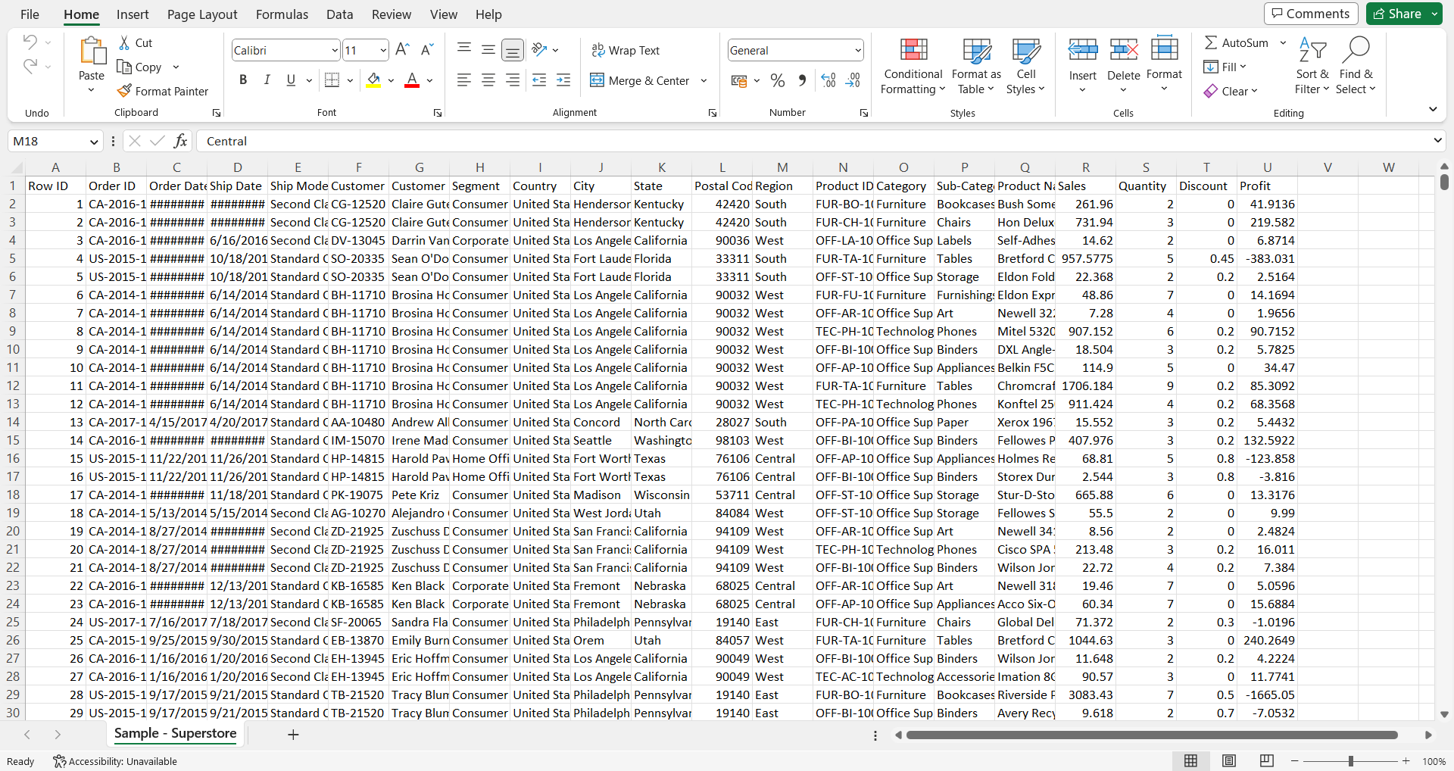

* **Formatted Data**

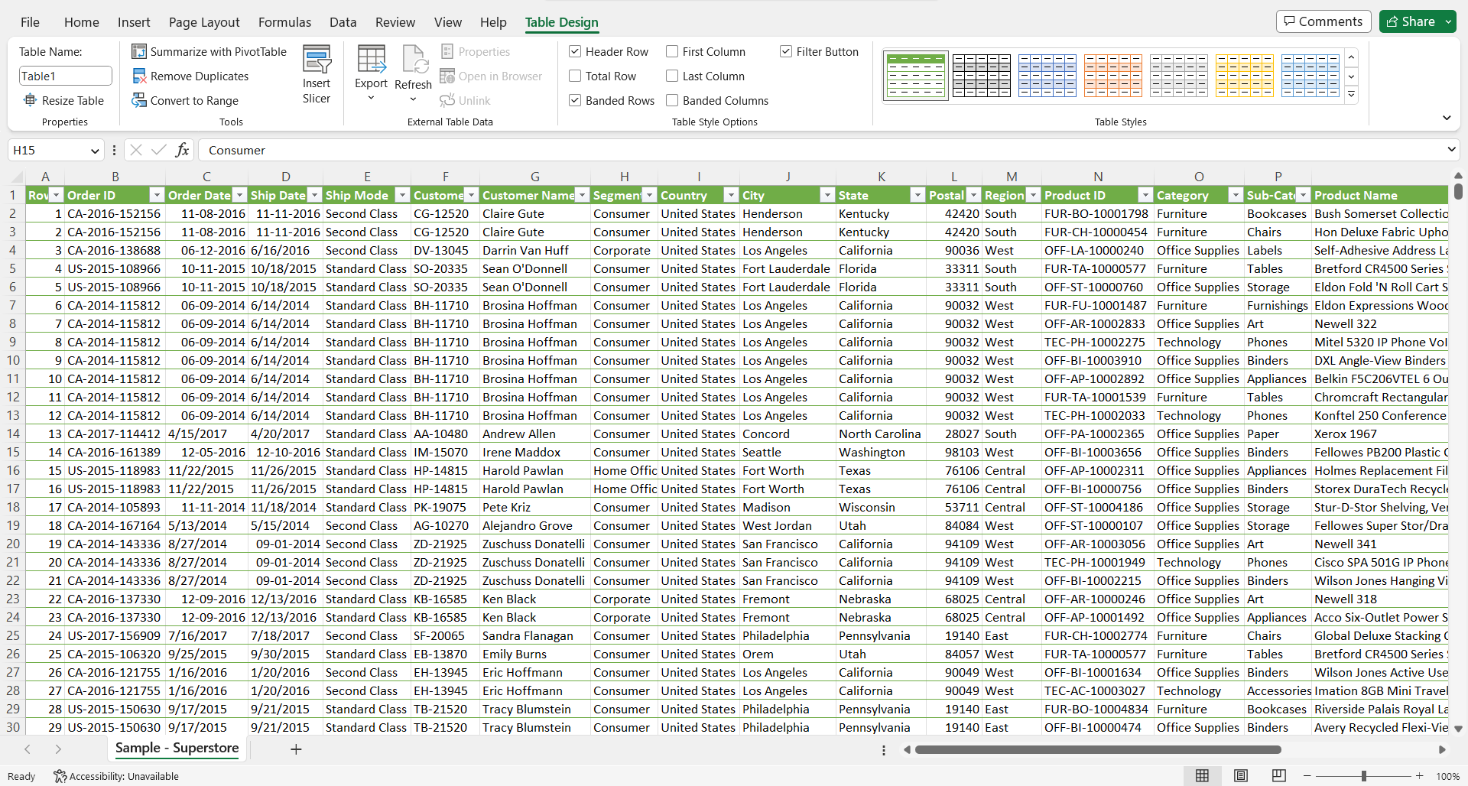

* **Functions in Excel**

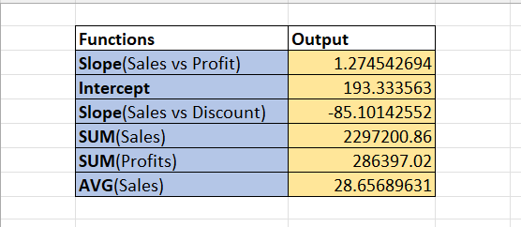

* **Statistics**

|  |  |  |  |  |
| --- | --- | --- | --- | --- |
| **Row Labels** | **Sum of Quantity** | **Sum of Sales** | **Sum of Discount** | **Sum of Profit** |
| **Furniture** | **8028** | **741999.7953** | **368.89** | **18451.2728** |
| Bookcases | 868 | 114879.9963 | 48.14 | -3472.556 |
| Chairs | 2356 | 328449.103 | 105 | 26590.1663 |
| Furnishings | 3563 | 91705.164 | 132.4 | 13059.1436 |
| Tables | 1241 | 206965.532 | 83.35 | -17725.4811 |
| **Office Supplies** | **22906** | **719047.032** | **947.8** | **122490.8008** |
| Appliances | 1729 | 107532.161 | 77.6 | 18138.0054 |
| Art | 3000 | 27118.792 | 59.6 | 6527.787 |
| Binders | 5974 | 203412.733 | 567 | 30221.7633 |
| Envelopes | 906 | 16476.402 | 20.4 | 6964.1767 |
| Fasteners | 914 | 3024.28 | 17.8 | 949.5182 |
| Labels | 1400 | 12486.312 | 25 | 5546.254 |
| Paper | 5178 | 78479.206 | 102.6 | 34053.5693 |
| Storage | 3158 | 223843.608 | 63.2 | 21278.8264 |
| Supplies | 647 | 46673.538 | 14.6 | -1189.0995 |
| **Technology** | **6939** | **836154.033** | **244.4** | **145454.9481** |
| Accessories | 2976 | 167380.318 | 60.8 | 41936.6357 |
| Copiers | 234 | 149528.03 | 11 | 55617.8249 |
| Machines | 440 | 189238.631 | 35.2 | 3384.7569 |
| Phones | 3289 | 330007.054 | 137.4 | 44515.7306 |
| **Grand Total** | **37873** | **2297200.86** | **1561.09** | **286397.0217** |

* **Power BI Dashboard -1**

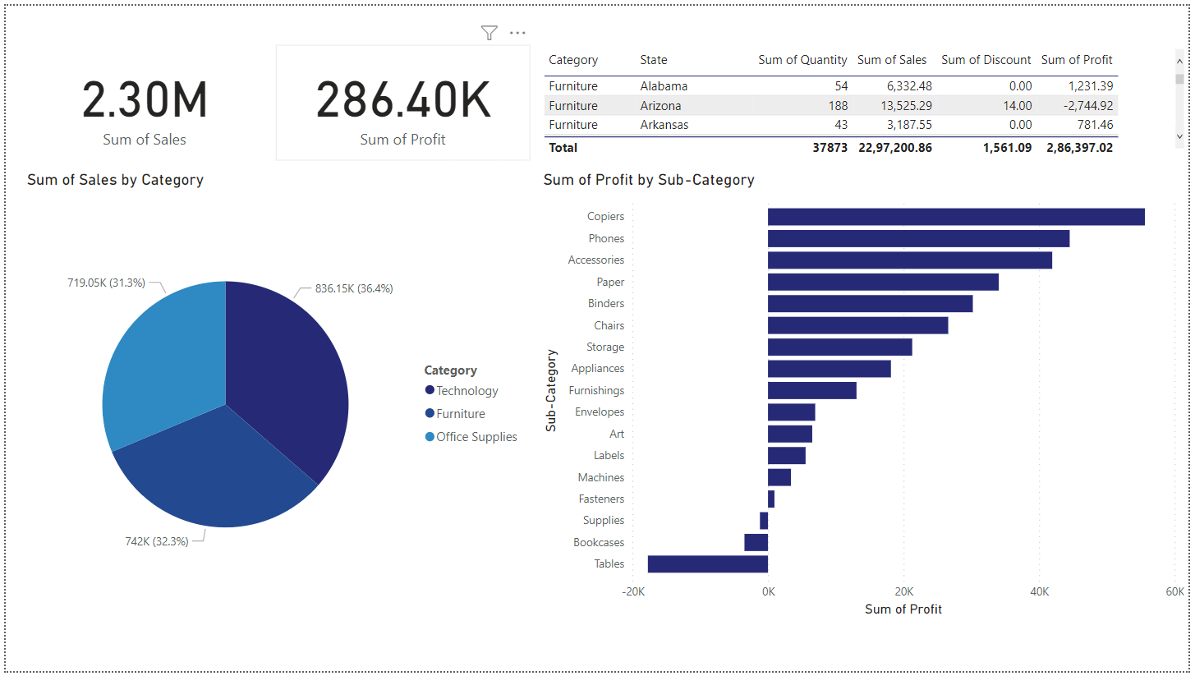

* **Power BI Dashboard -2**

