Linux Basics – Command Line Practice

Name: Shashanka
Assignment: Tutedude – Linux Basics
GitHub Repository: https://github.com/ShashankaP06/DevOps/tree/main/01_Linux_Basics_Shashanka

Objective
Practise essential Linux command-line operations – file and directory management, viewing files, searching, archiving, downloading, permissions, and environment variables.

Environment Used
All commands below were run in a Linux terminal (WSL / Ubuntu). The exact same commands are saved as ready-to-run shell scripts in the scripts/ folder of this project (see README.md for the full list), so the project can be re-run and re-verified at any time.

Task 1: Creating and Renaming Files/Directories

Explanation: mkdir creates a new, empty directory. touch creates a new, empty file (or updates its timestamp if it already exists). mv moves a file/directory to a new location – when the source and destination are in the same folder, mv effectively renames the file.

Commands used:
mkdir test_dir
touch test_dir/example.txt
mv test_dir/example.txt test_dir/renamed_example.txt
ls -l test_dir

What happens: A folder named test_dir is created. Inside it, an empty file example.txt is created, then immediately renamed to renamed_example.txt. The final ls -l confirms only renamed_example.txt exists.

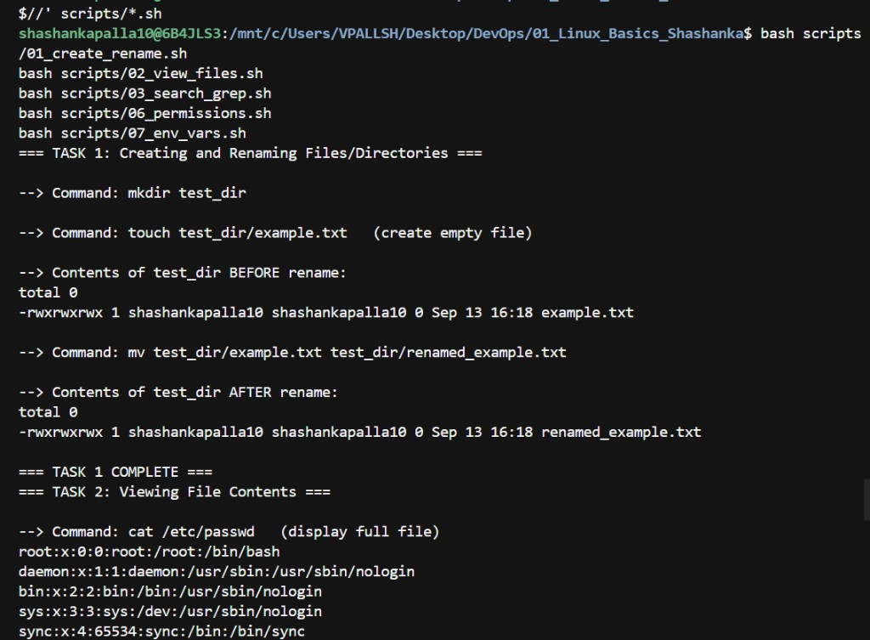
Screenshot: Task 1 - mkdir / touch / mv / ls -l (scripts/01_create_rename.sh)

Task 2: Viewing File Contents

Explanation: cat prints the entire contents of a file to the screen. head -n 5 prints only the first 5 lines. tail -n 5 prints only the last 5 lines. These are useful for quickly inspecting large files without opening a full text editor.

Command – full file:
cat /etc/passwd

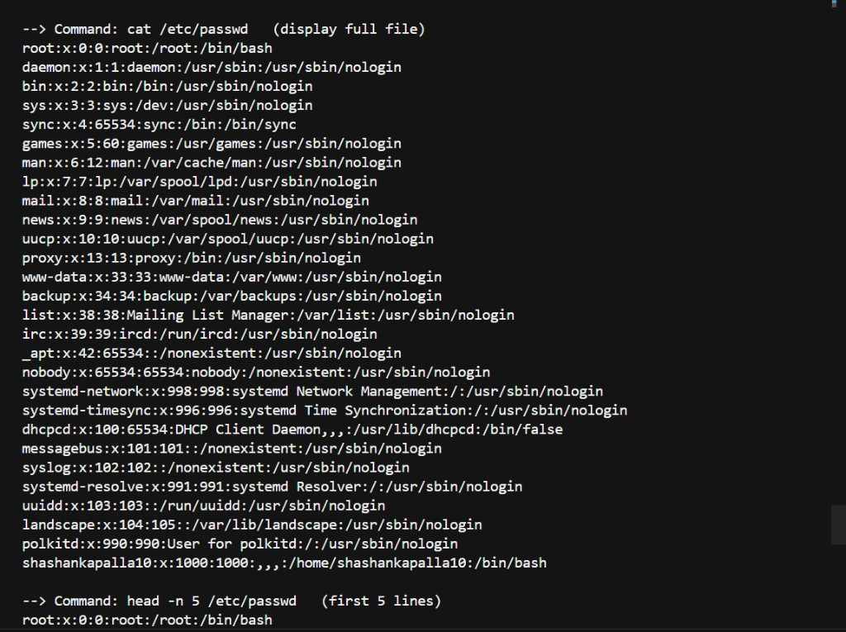
Screenshot: Task 2 - cat /etc/passwd (full output) and head -n 5

Command – first 5 lines:
head -n 5 /etc/passwd

(See the screenshot above under Task 2a – the same terminal capture also shows the head -n 5 output.)

Command – last 5 lines:
tail -n 5 /etc/passwd

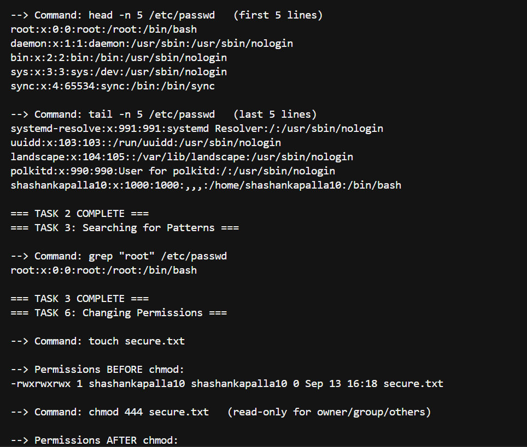
Screenshot: Task 2 - tail -n 5, plus Task 3 (grep) and start of Task 6

Task 3: Searching for Patterns

Explanation: grep searches the given file line-by-line for a pattern (here, the plain text "root") and prints every matching line. It is one of the most-used tools for finding information inside text/log files.

Command used:
grep "root" /etc/passwd

What happens: Every line in /etc/passwd that contains the word "root" is printed – typically the root user's own entry, plus any other accounts/comments that happen to include that word.

(See the screenshot above under Task 2c – the same terminal capture continues into the grep "root" output.)

Task 4: Zipping and Unzipping

Explanation: zip -r recursively compresses a directory (and everything inside it) into a single .zip archive. unzip extracts the contents of a .zip archive into a target directory using the -d flag.

Command – compress:
zip -r test_dir.zip test_dir

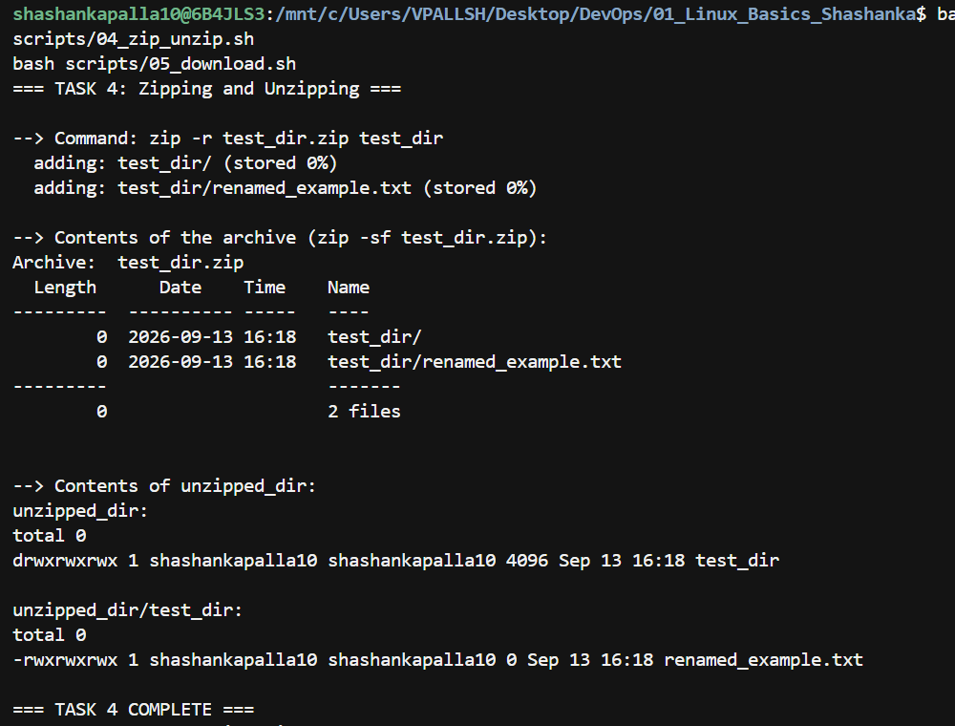
Screenshot: Task 4 - zip -r test_dir.zip test_dir, archive listing, unzip, and result

Command – extract:
unzip test_dir.zip -d unzipped_dir

What happens: test_dir.zip is created containing a compressed copy of test_dir/. It is then extracted into a brand-new folder called unzipped_dir/, recreating the original folder structure inside it.

(See the screenshot above under Task 4a – the same terminal capture also shows the unzip output and directory listing.)

Task 5: Downloading Files

Explanation: wget downloads a file from a URL over HTTP/HTTPS/FTP directly from the command line, without needing a browser. The -O flag lets you choose the saved filename.

Command used:
wget https://example.com/sample.txt -O sample.txt

Note: example.com is a placeholder/demo domain and does not actually host a file at /sample.txt, so wget may report a 404 error – this still correctly demonstrates the command's usage and syntax. A working alternative used for a guaranteed successful download is noted as a commented-out fallback URL inside scripts/05_download.sh.

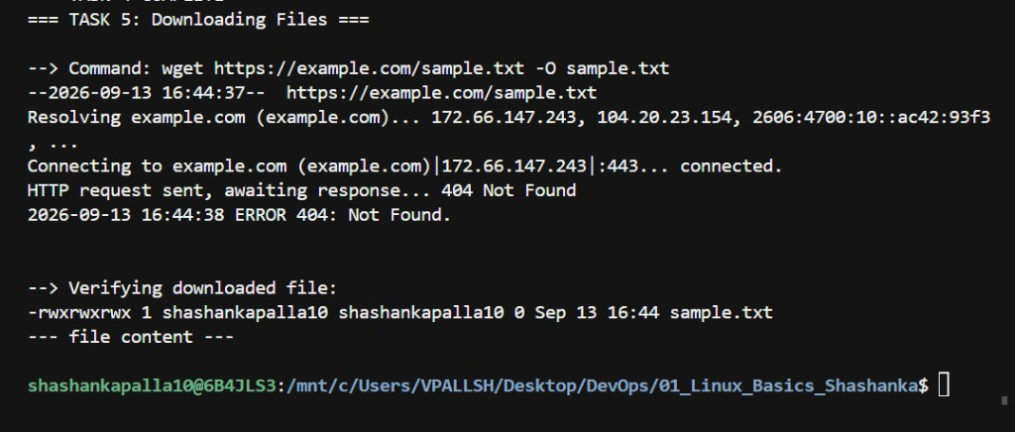
Screenshot: Task 5 - wget https://example.com/sample.txt -O sample.txt (404, as documented above)

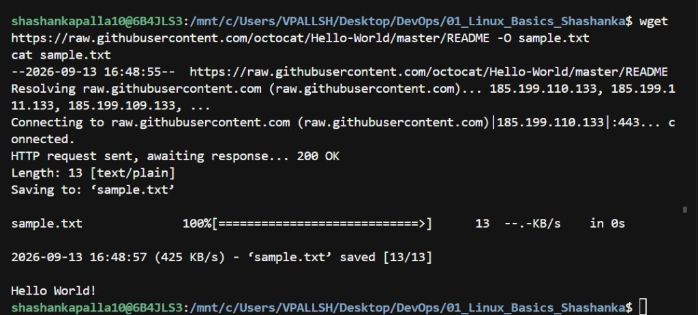
Bonus screenshot: successful wget download (200 OK) using a real file – wget https://raw.githubusercontent.com/octocat/Hello-World/master/README -O sample.txt, then cat sample.txt printing “Hello World!”

Task 6: Changing Permissions

Explanation: Every Linux file has three permission groups – owner, group, and others – each with read (r), write (w), and execute (x) permissions. chmod changes those permissions. The numeric mode 444 means read-only (r--r--r--) for owner, group, and others alike – i.e. read-only for everyone, with no write or execute permission for anyone.

Commands used:
touch secure.txt
ls -l secure.txt
chmod 444 secure.txt
ls -l secure.txt

What happens: Before chmod, a new file typically has rw-r--r-- (644) permissions. After running chmod 444, the ls -l output changes to r--r--r--, confirming write access has been removed for everyone.

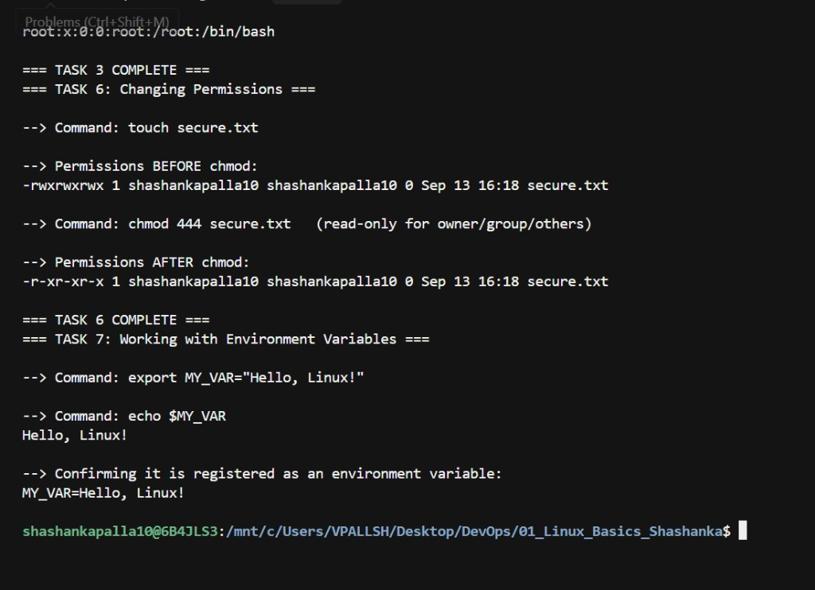
Screenshot: Task 6 - ls -l secure.txt before/after chmod 444, and Task 7 (export/echo)

Task 7: Working with Environment Variables

Explanation: Environment variables store values (like configuration settings or shell-wide data) that programs and shell sessions can read. export both creates/updates a variable and makes it available to the current shell and any child processes launched from it. echo $VARNAME prints its value.

Commands used:
export MY_VAR="Hello, Linux!"
echo $MY_VAR

Note: For an authentic screenshot, these two lines were also typed directly into the interactive terminal (in addition to running via scripts/07_env_vars.sh), since export only persists for the current shell/its children – running it purely inside a script would not keep the variable set in the parent terminal afterwards.

(See the screenshot above under Task 6 – the same terminal capture continues into the export/echo MY_VAR output.)

Appendix A: Project Structure
DevOps/
01_Linux_Basics_Shashanka/
scripts/
01_create_rename.sh
02_view_files.sh
03_search_grep.sh
04_zip_unzip.sh
05_download.sh
06_permissions.sh
07_env_vars.sh
run_all.sh
Documentation_Linux_Basics_Shashanka.rtf
README.md
HOW_TO_RUN.md
output_log.txt (generated after running run_all.sh)

Appendix B: How This Was Run
All seven tasks were executed in order using the master script:
bash scripts/run_all.sh

Full step-by-step setup instructions (including installing WSL) are in HOW_TO_RUN.md included in this project folder.

Conclusion
This project demonstrates practical, hands-on use of the core Linux command-line operations required by the assignment: creating/renaming files and directories, viewing file contents, searching text with grep, archiving with zip/unzip, downloading files with wget, managing permissions with chmod, and working with environment variables via export. All commands are reproducible using the scripts provided in this repository.

