Software Architecture & Design — Hostel Management System (HMS)

Software Architecture & Design (SAD) Specification
Hostel Management System (HMS) — IEEE 1016-2009 (design description) and ISO/IEC/IEEE 42010 (architecture description) structure Version 2.0 · 2026-11-05 · Course: Software Engineering (UE23CS341A) · Team: Shashankb30, abhijeetcyalgi
Version | Date | Change
1.0 | Oct 2026 | Architecture draft (views, layers, subsystems)
2.0 | 2026-11-05 | Added: sequence diagrams, API design, error-handling protocol, security architecture, FR-to-component traceability, deviations; corrected file references and lock-out rule to match the code

1. Introduction

1.1 Purpose
This SAD describes how HMS realises docs/SRS.md: its architectural pattern, components, security architecture, detailed design (sequence diagrams, API, error handling) and traceability to requirements.

1.2 Scope
All ten modules FR-01..FR-10 and the non-functional and security requirements NFR-01..NFR-08, SR-1..SR-7. The data model is in Documents/design/er-diagram.md and Documents/design/schema.sql.

1.3 Definitions
HMS, FR/NFR/SR as in the SRS. MVT = Django Model-View-Template. ORM = object-relational mapper. ADR = architecture decision record.

1.4 References
SRS docs/SRS.md; Test Plan docs/Test_Plan.md; ADR Documents/adr/0001-tech-stack.md; ER diagram Documents/design/er-diagram.md; docs/DEVIATIONS.md.

2. Architectural goals and constraints
Goal | Source | Architectural response
Secure login, RBAC, safe passwords and sessions | NFR-01, SR-1..7 | Django auth + role_required decorator on every view, lock-out, CSRF, no-store cache middleware (section 5)
Responses ≤ 3 s | NFR-03 | Indexed lookups, derived values via aggregate queries, pagination (25/page) on student, leave, notice and visitor lists
Backup / restore | NFR-04 | backup_database and restore_database management commands (JSON fixture or SQLite file copy)
Integrity enforced by the database | NFR-05 | Unique, check and partial-unique constraints + service-layer rules + row locking
Modularity | NFR-06 | One Django app per SRS module; cross-module calls only via services and foreign keys
Multiple hostels | NFR-07 | Hostel entity; hostel-owned records carry a hostel foreign key
Availability signal | NFR-08 | /health/ JSON endpoint (200 / 503) and maintenance page
Constraints: two developers, two one-week sprints; student laptops (SQLite); delivery via GitHub issues, PRs and Actions.

3. Architectural representation (views)
View | Question | Section
Use-case view | Which scenarios drive the design? | SRS Figure 1; section 4.1
Logical view | How is the system decomposed? | 4
Process view | How do parts cooperate at run time? | 6 (sequence diagrams)
Deployment view | Where does each part run? | 4.6
Security view | How are assets protected? | 5

4. Architecture

4.1 Architectural pattern
HMS is a layered, modular monolith that applies client–server and Django’s MVT (Model-View-Template) pattern:
Layer | Components | Responsibility | May call
Presentation | templates/, role-based menu (core/navigation.py) | Render pages, forms, menus | Application
Application | urls.py, views.py, forms.py, services.py per app | Control flow, permission checks, business rules, notifications | Domain
Domain | core/models.py (constraints, derived properties) | Entities, invariants | Data
Data | Django ORM, migrations, SQLite / PostgreSQL | Persistence | —
Why not microservices? One database, one deployment and two developers: a monolith with strict module boundaries gives the same modularity at far lower cost (ADR 0001).

4.2 Component diagram
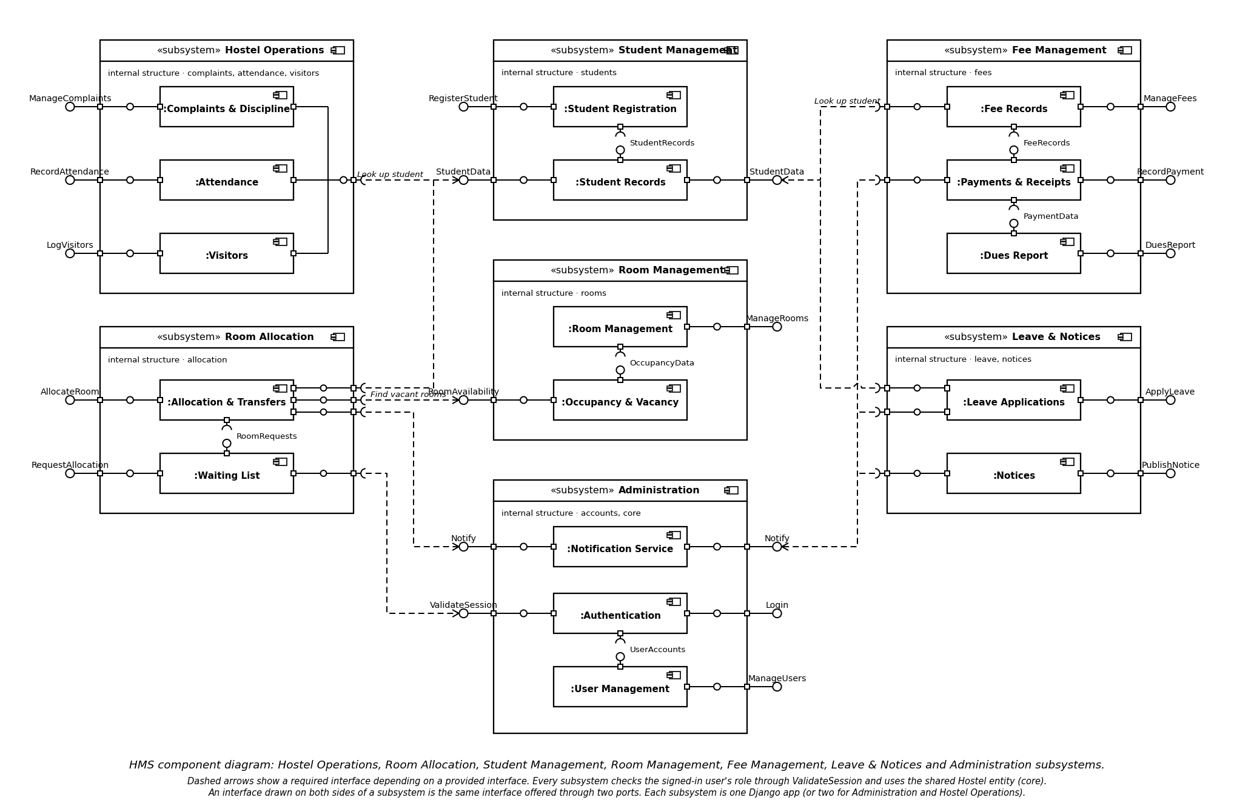
Figure 1 — HMS component diagram

4.3 Component descriptions
Component (Django app) | SRS module | Responsibility | Key files
core | shared | Models for all entities, hostel entity, notifications, role helpers, validators, error-message catalogue, dashboards, health check, seed and backup commands | core/models.py, roles.py, notifications.py, error_messages.py, views.py
accounts | FR-01 | Login view, lock-out, session middleware, password reset, user administration | accounts/services.py, lockout.py, middleware.py, user_service.py
students | FR-02 | Registration (student + login created atomically), search | students/services.py
rooms | FR-03 | Room CRUD, derived occupancy/vacancy, deactivate/delete guards | rooms/services.py, selectors.py
allocation | FR-04 | Allocate, transfer, vacate, waitlist, priority rules, report | allocation/services.py
fees | FR-05 | Fee records, payments, receipts, dues report | fees/services.py
complaints | FR-06 | Complaints, misconduct, demerit rules, status workflow, escalation | complaints/services.py
attendance | FR-07 | Check-in/out, bulk, reports | attendance/services.py
visitors | FR-08 | Visitor log, check-out, history | visitors/services.py
leave | FR-09 | Apply, review, overlap detection, records | leave/services.py
notices | FR-10 | Publish, audience, expiry, board | notices/services.py

4.4 Module dependencies (no cycles)
Module | Depends on
accounts | core
students | accounts, core
rooms | core
allocation | students, rooms, core (notify)
fees | students, core (notify)
complaints | students, core
attendance | students, allocation data (active room), core
visitors | students, core
leave | students, core (notify)
notices | core (notify)

4.5 Design principles applied
High cohesion (all rules of a module live in its services.py); loose coupling (apps share only core models and service calls); separation of concerns (views validate input and permissions, services hold rules, templates only render); abstraction (core.notifications.notify() hides how messages are stored).

4.6 Deployment view
Node | Software | Notes
User device | Browser | No installation
Application server | Python 3.12, Django 5.2, WSGI (runserver in development; gunicorn behind a TLS reverse proxy in production) | One process per worker
Database | SQLite (dev) / PostgreSQL (prod) | Same migrations
GitHub | Repo, Project board, Actions | CI runs lint, system check, schema verification, migrations, tests and coverage on every push/PR

4.7 Requirement-to-component traceability
Requirement | Component(s) | Main design element | Test cases
FR-01, SR-3, SR-4 | accounts, core | authenticate_credentials, lockout, session settings | IT_LOGIN_06, ST_LOGIN_04
FR-02 | students, core | students.services, unique constraints | UT_05_Reg, UT_06_Reg
FR-03 | rooms, core | Room unique + check constraint, selectors | UT_07_Room..UT_09_Room
FR-04 | allocation, rooms | allocate() with select_for_update (SD-2) | UT_11_Alloc, IT_10_Alloc, IT_11_Alloc
FR-05 | fees | record_payment() (SD-3) | UT_14_Fee, IT_13_Fee, ST_10_Fee
FR-06 | complaints | status workflow, DemeritRule | IT_16_Comp, IT_18_Comp
FR-07 | attendance | check-in/out rules | UT_21_Att, ST_14_Att
FR-08 | visitors | visitor log rules | UT_24_Vis, ST_16_Vis
FR-09 | leave | overlap detection | IT_27_Leave
FR-10 | notices | audience + expiry | UT_30_Notice, ST_20_Notice
NFR-01, SR-1, SR-2 | core/roles.py + every view | role_required | UT_NFR_01, UT_NFR_03, RBAC matrix
NFR-03 | all | indexes, pagination | UT_NFR_06, UT_NFR_07
NFR-04 | core commands, error handlers | backup/restore, handler4xx/5xx | UT_NFR_08, UT_NFR_09
NFR-05 | core.models, services | constraints + locking | UT_NFR_10
NFR-07 | core.models | hostel FK | UT_NFR_12
NFR-08 | core.views | health_check | UT_NFR_13

5. Security architecture
Layer | Control | Where | SRS
Authentication | Salted PBKDF2-SHA256 hashes; password validators; custom authenticate_credentials refuses inactive/locked accounts | accounts/services.py, config/settings.py | SR-3
Brute-force defence | Counter increments atomically (F() expression); at HMS_MAX_FAILED_LOGINS (default 5) is_locked = True; stays locked until an administrator unlocks it (UI or manage.py unlock_account) | accounts/lockout.py | SR-4
Session | 30-min idle timeout renewed every request, expire at browser close, HttpOnly, SameSite=Lax; no-store cache headers on authenticated pages | settings, accounts/middleware.py | SR-4, SR-7
Authorisation | role_required(*roles) on each view; a student additionally passes an ownership check on per-student URLs | core/roles.py, views | SR-1, SR-2
Request integrity | CSRF middleware; state-changing views are require_POST; X-Frame-Options: DENY; nosniff | settings | SR-5
Input / output | ORM-only queries (no raw SQL); auto-escaped templates; server-side validators in one catalogue | ORM, templates, core/validators.py | SR-6
Data integrity | DB unique/check constraints; transactions with row locks | models, services | NFR-05
Safe failure | Custom 400/403/404/500 handlers; no stack traces when DEBUG=0; transaction rollback | config/urls.py, templates/4xx.html | SR-7
Secrets | DJANGO_SECRET_KEY, DJANGO_DEBUG, DJANGO_ALLOWED_HOSTS read from environment (.env.example) | config/settings.py | SO-4
Trust boundary: browser ↔ application server (HTTP/HTTPS); application ↔ database is internal. All input from the browser is untrusted.

6. Detailed design

6.1 Data model (summary)
Entities in core/models.py: Hostel, UserAccount, Student, Room, Allocation, AllocationRequest, AllocationRule, FeeRecord, Payment, Complaint, DemeritRule, ComplaintUpdate, DemeritRecord, AttendanceRecord, VisitorLog, LeaveApplication, Notice, Notification. Key constraints: unique (hostel, room_no); capacity ≥ 1; one active allocation per student (partial unique index); payment receipts unique. Full ER diagram: Documents/design/er-diagram.md.

6.2 Sequence diagrams

SD-1 Login with lock-out (FR-01)
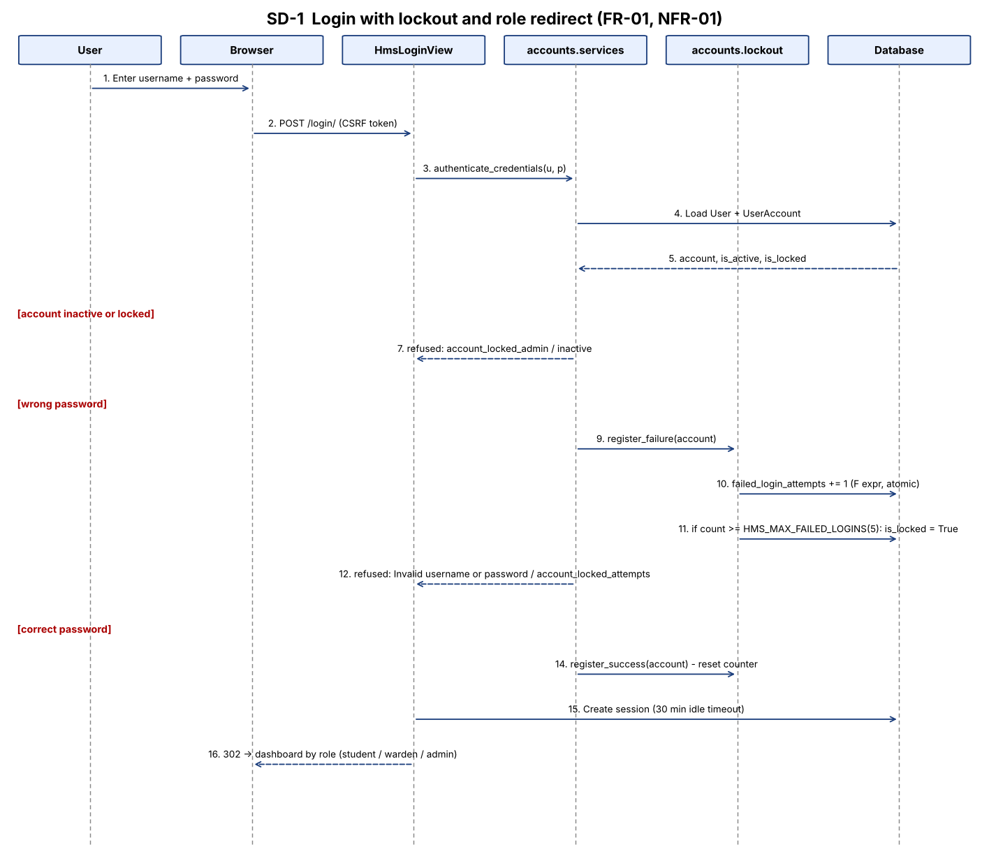
SD-1

SD-2 Allocate a room (FR-04)
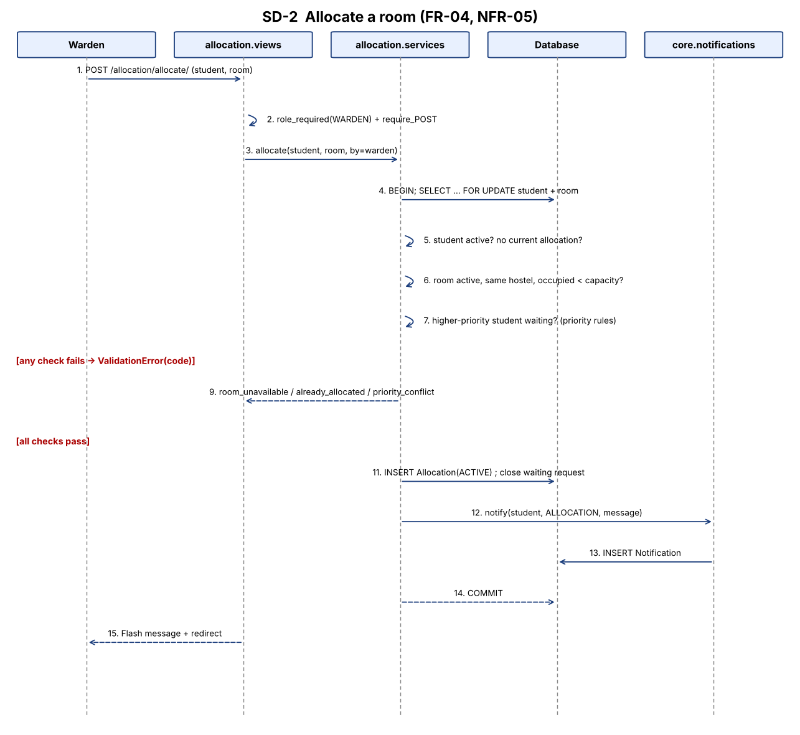
SD-2

SD-3 Record a fee payment (FR-05)
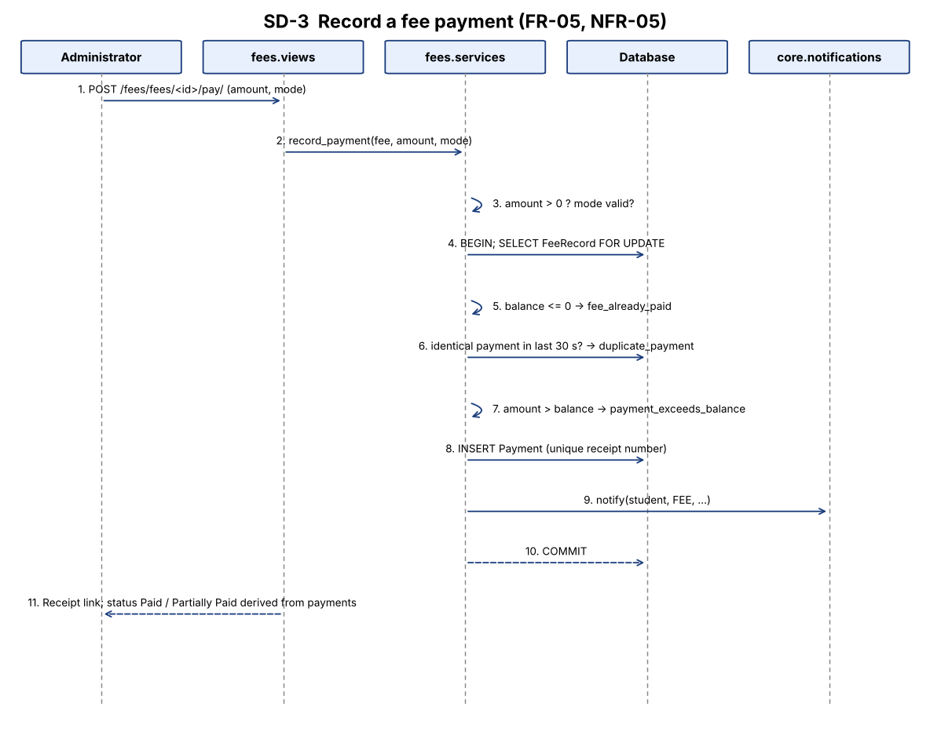
SD-3

6.3 API design
HMS is server-rendered, so its “API” is the set of HTTP routes below (Django URL conf). All state-changing routes are POST with a CSRF token. Forms re-display with field errors on HTTP 200; business-rule failures are shown as flash messages; the only JSON endpoint is /health/.
Request / response conventions
Case | Response
Success of a POST | HTTP 302 redirect to the list/detail page with a success flash message
Validation error | HTTP 200, same form with per-field error text from core/error_messages.py
Business-rule error (ValidationError code) | HTTP 200/302 with an error flash message naming the rule
Not signed in / wrong role | HTTP 403 page (403.html)
Unknown object / URL | HTTP 404 page
GET on a POST-only route | HTTP 405
Unexpected exception | HTTP 500 friendly page, transaction rolled back
Route catalogue (generated from the URL configuration, 80 routes)

FR-01 accounts
Method | Path | View | Access
GET | /accounts/users/ | user_list | Administrator
GET, POST | /accounts/users/new/ | user_create | Administrator
GET, POST | /accounts/users/<int:pk>/edit/ | user_edit | Administrator
POST | /accounts/users/<int:pk>/deactivate/ | user_deactivate | Administrator
POST | /accounts/users/<int:pk>/reactivate/ | user_reactivate | Administrator
POST | /accounts/users/<int:pk>/unlock/ | user_unlock | Administrator
GET, POST | /login/ | HmsLoginView | Public
POST | /logout/ | logout_view | Public
GET, POST | /password-reset/ | HmsPasswordResetView | Public
GET | /password-reset/done/ | PasswordResetDoneView | Public
GET, POST | /reset/<uidb64>/<token>/ | HmsPasswordResetConfirmView | Public
GET | /reset/done/ | PasswordResetCompleteView | Public

FR-02 students
Method | Path | View | Access
GET | /students/ | student_list | Administrator
GET, POST | /students/new/ | student_add | Administrator

FR-03 rooms
Method | Path | View | Access
GET | /rooms/ | room_manage | Administrator
GET, POST | /rooms/new/ | room_add | Administrator
GET, POST | /rooms/<int:pk>/edit/ | room_edit | Administrator
POST | /rooms/<int:pk>/delete/ | room_delete | Administrator
POST | /rooms/<int:pk>/deactivate/ | room_deactivate | Warden, Administrator
POST | /rooms/<int:pk>/reactivate/ | room_reactivate | Warden, Administrator
GET | /rooms/vacancy/ | room_vacancy | Warden, Administrator

FR-04 allocation
Method | Path | View | Access
GET | /allocation/ | manage | Warden
POST | /allocation/allocate/ | allocate | Warden
GET, POST | /allocation/transfer/<int:student_pk>/ | transfer | Warden
POST | /allocation/vacate/<int:allocation_pk>/ | vacate | Warden
GET | /allocation/waitlist/ | waitlist | Warden
POST | /allocation/waitlist/add/ | waitlist_add | Warden
POST | /allocation/waitlist/<int:pk>/remove/ | waitlist_remove | Warden
GET, POST | /allocation/rules/ | rules | Warden
GET | /allocation/report/ | report | Warden
GET | /allocation/my-room/ | my_room | Student

FR-05 fees
Method | Path | View | Access
GET | /fees/ | manage | Administrator
GET | /fees/student/<int:student_id>/ | student_fees | Administrator
GET, POST | /fees/student/<int:student_id>/fees/new/ | fee_create | Administrator
GET, POST | /fees/fees/<int:fee_id>/edit/ | fee_edit | Administrator
GET, POST | /fees/fees/<int:fee_id>/pay/ | payment_create | Administrator
GET | /fees/payments/<int:payment_id>/receipt/ | receipt | Administrator, Student
GET | /fees/my/ | my_fees | Student
GET | /fees/dues/ | dues_report | Administrator

FR-06 complaints
Method | Path | View | Access
GET, POST | /complaints/ | my_complaints | Student
GET | /complaints/<int:pk>/ | detail | Any signed-in role
GET, POST | /complaints/<int:pk>/edit/ | edit | Student
GET | /complaints/manage/ | manage | Warden, Administrator
GET, POST | /complaints/manage/misconduct/ | log_misconduct | Warden, Administrator
GET, POST | /complaints/manage/rules/ | rules | Warden, Administrator
GET | /complaints/manage/report/ | report | Warden, Administrator
POST | /complaints/manage/<int:pk>/status/ | update_status | Warden, Administrator
POST | /complaints/manage/<int:pk>/reopen/ | reopen | Warden, Administrator
POST | /complaints/manage/<int:pk>/escalate/ | escalate | Warden, Administrator

FR-07 attendance
Method | Path | View | Access
GET | /attendance/ | my_attendance | Student
GET | /attendance/manage/ | manage | Warden, Administrator
POST | /attendance/manage/check-in/ | check_in | Warden, Administrator
POST | /attendance/manage/check-out/ | check_out | Warden, Administrator
POST | /attendance/manage/bulk/ | bulk | Warden, Administrator
GET | /attendance/manage/report/ | report | Warden, Administrator
GET | /attendance/manage/student/<int:pk>/ | student_history | Warden, Administrator

FR-08 visitors
Method | Path | View | Access
GET | /visitors/ | visitor_log | Warden, Administrator
GET, POST | /visitors/add/ | visitor_add | Warden, Administrator
POST | /visitors/<int:pk>/checkout/ | visitor_checkout | Warden, Administrator
GET | /visitors/report/ | visitor_report | Warden, Administrator
GET | /visitors/student/<int:student_id>/ | student_visitor_history | Any signed-in role

FR-09 leave
Method | Path | View | Access
GET | /leave/my-leaves/ | my_leaves | Student
GET, POST | /leave/apply/ | apply_leave | Student
GET, POST | /leave/<int:pk>/resubmit/ | resubmit_leave | Student
POST | /leave/<int:pk>/cancel/ | cancel_leave | Student
GET | /leave/review/ | review_list | Warden, Administrator
GET, POST | /leave/review/<int:pk>/ | review_detail | Warden, Administrator
GET | /leave/records/ | consolidated_records | Warden, Administrator

FR-10 notices
Method | Path | View | Access
GET | /notices/board/ | board | Any signed-in role
GET | /notices/manage/ | manage_notices | Warden, Administrator
GET, POST | /notices/add/ | notice_add | Warden, Administrator
GET, POST | /notices/<int:pk>/edit/ | notice_edit | Warden, Administrator
POST | /notices/<int:pk>/delete/ | notice_delete | Warden, Administrator
POST | /notices/<int:pk>/expire/ | notice_expire | Warden, Administrator

core
Method | Path | View | Access
GET | / | home | Signed-in
GET (JSON) | /health/ | health_check | Public
GET | /maintenance/ | maintenance_view | Public
GET | /dashboard/student/ | dashboard_student | Student
GET | /dashboard/warden/ | dashboard_warden | Warden
GET | /dashboard/admin/ | dashboard_admin | Administrator
GET /health/ response: {"status": "healthy", "database": "connected", "service": "...", "version": "1.0.0", "timestamp": "..."} → HTTP 200; HTTP 503 with status: unhealthy when the database is unreachable.

6.4 Error-handling protocol
- Validate at the edge. Forms and core/validators.py check type, length, range and format. Messages come from one catalogue so the same mistake always gives the same text (e.g. “Room number already exists”).
- Enforce rules in services. Services raise ValidationError(msg, code=...) with a stable code (room_unavailable, already_allocated, payment_exceeds_balance, duplicate_payment, no_active_checkin, …). Views catch it and show the message; they never swallow other exceptions.
- Make multi-step changes atomic. Allocation, transfer, payment, registration and misconduct logging run in transaction.atomic(); any exception rolls everything back (UT_NFR_09).
- Back up rules with the database. Unique / check / partial-unique constraints reject what a bug lets through; IntegrityError is caught and converted to the same user message in attendance, fees and rooms (and by form uniqueness checks elsewhere).
- Fail safely. Unhandled errors render the friendly 400/403/404/500 templates; DEBUG is off in production so no stack trace or settings are shown.
- Login messages. A wrong username or wrong password gives the same text, “Invalid username or password”. For inactive or locked accounts the system names the reason (required by Test Plan IT_03_Login); this is a deliberate usability trade-off that reveals the account exists.
- Monitor. /health/ returns 503 when the database is unreachable.
Failure | Detection | Handling | User sees
Invalid field | Form / validator | Form re-displayed | Field error
Rule violated | Service ValidationError(code) | Flash message, no write | Rule message
Concurrent conflict | Row lock + constraint | Second request refused | “Room unavailable” etc.
Forbidden access | role_required | HTTP 403 | Access-denied page
Missing record | get_object_or_404 | HTTP 404 | Not-found page
Crash | handler500 | Transaction rollback (no application logging is configured; see DEVIATIONS D-07) | Friendly error page
DB down | /health/ | HTTP 503 | JSON status

7. Quality attributes
Attribute | Tactics | Verified by
Security | Section 5 | Test Plan 5.1 (SEC-01..10)
Performance (NFR-03) | Indexes (e.g. room hostel+active, attendance hostel+day), aggregate queries, pagination | scripts/benchmark_performance.py, UT_NFR_06
Integrity | Constraints + locking | UT_NFR_10, allocation and fee concurrency tests
Modifiability | One app per module, services, no cycles | Lint in CI, review against 4.4
Testability | Service layer separate from views; seed command; 681 automated tests, 94.9 % statement / 84.2 % branch coverage | docs/reports/
Recoverability | Backup/restore commands | UT_NFR_08

8. Deviations from the initial SRS / SAD
Deviations are listed, with reasons, in docs/DEVIATIONS.md and are to be explained in the demo. Summary: lock-out is administrator-unlock (not 15-minute timed); notice audiences are all/students/wardens; seniority is the only priority rule; audit logging is not implemented; extra features (password reset, waitlist, bulk attendance, leave resubmission).

