Use Case Diagram
Hostel Management System
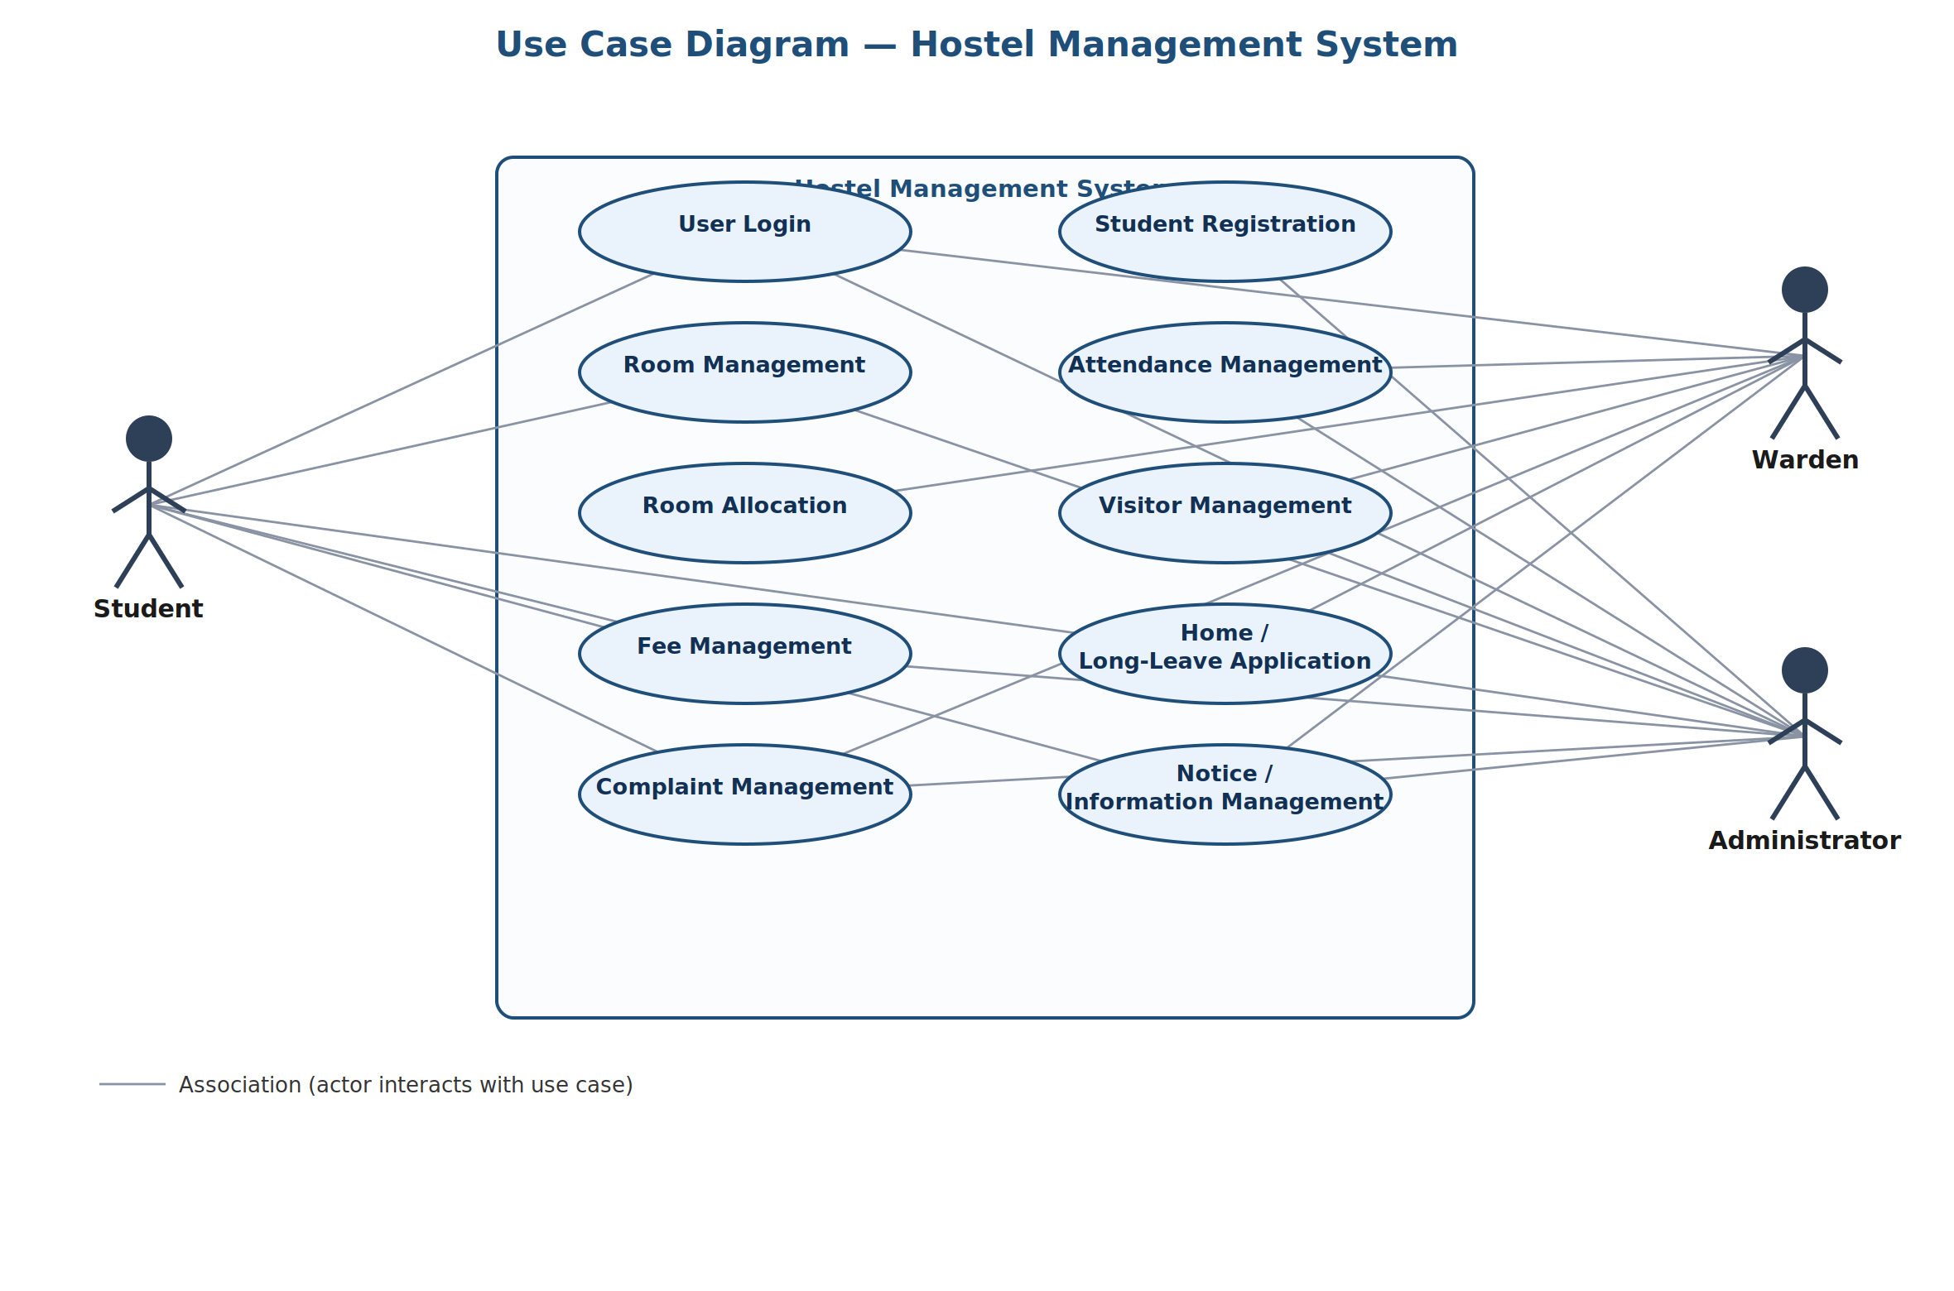
The diagram shows three actors — Student, Warden, and Administrator — and their associations with the ten functional use cases of the Hostel Management System, grouped within the system boundary.

