**BMS Institute of Technology and Management**

(An Autonomous Institution, Affiliated to VTU, Belagavi)

Avalahalli, Doddaballapura Main Road, Bengaluru – 560064

**DEPARTMENT OF CHEMISTRY**



**2024-2025/ ODD SEM**

**REPORT**

*on*

**”Contribution of Polymers to Electronic Memory Devices and Applications ”**

{**GROUP RESEARCH, As a part of Comprehensive Continuous Assessment**}

Submitted by,

**Shrish Patil**

**Shashank S B**

**Sinchana Hebbar K M**

**Sameeksha   
Samith Reddy S**

(CSE/4/Batch-10)

Submitted to,

**Dr. SWETHA G A**

Assistant Professor, Department of Chemistry

**CONTENTS**

1. **Title of the report**
2. **Abstract**
3. **Key words**
4. **Introduction**
5. **Objectives**
6. **Detailed explanation**
7. **Conclusion**
8. **Acknowledgement**

**Title of the report: *Contribution of Polymers to Electronic***

***Memory Devices and Application***

**Abstract :**

Recent advances in electronic memory devices are being achieved by incorporation of new materials, which include polymers, into emerging types of memory devices: memristors, charge trap memory, and floating-gate memory. Polymers possess several benefits, such as simplicity of fabrication, mechanical flexibility, and suitability for neuromorphic applications. This review comments on the role of polymers in developing these advanced memory technologies, pointing specifically to their advantages. Besides, it discusses promising opportunities and challenges for a polymer-based memory device about how improvements in device performance, stability, and issues relevant to practical applications would develop.

**Key Words :**

* Polymers
* Memory Devices
* Organic Memory
* Floating Gate
* Electret
* Ferroelectric
* Memristor
* Resistive Memory
* Optoelectric
* Neuromorphic
* Flexible
* Biodegradable

**Introduction :**

**Polymer-Based Electronics:** Such attention has been drawn on polymers as electronic devices materials due to solution processability, mechanical durability and ease of fabrication on large areas. These features will be very suitable for applications such as flexible and wearable electronics, thin-film transistors (TFTs), disposable sensors and other emerging applications of the electronics industry.

**Memory Devices:** All the most important elements inside modern electronics are memory devices which include flash memory, DRAM, and SRAM. During the last 15 years, polymer-based memory devices have been developed in a very fast-pasted manner wherein polymers have been used to advance all types of memory technologies.

Types of Polymer-Based Memory Devices:

1. **Floating-Gate Memory :** This device relies on the charge storage potential of polymers to achieve non-volatile memory **.**
2. **Polymer Electret Memory :** This is one of the types of memory devices, where polymer electrets are utilized as charge storage elements. The polymer electrets are dielectric materials that store electric charges quasi-permanently; they have applications in field-effect transistor memory and artificial synaptic devices.
3. **Ferroelectric Memory**: Ferroelectric polymers can be applied to design highly sensitive memory devices that respond to an electric field and may provide novel memory functionalities.

**Types of Ferroelectric Memory :**

* Two-Terminal Ferroelectric Memory
* Three-Terminal Ferroelectric Memory

1. **Filament-Induced Memristors and Charge-Trapping Memory**: These are polymer-based memory devices that are highly efficient and reliable and can even store data when the power is lost.

**New Memory Functions**:

**•** Optoelectrical Switching: Light-sensitive polymer-based devices, which can switch states based on light, thus providing new functionalities.

• Synapse-like functionality: Polymers exist within memory devices that can provide the synaptic functionality that may be necessary for any computation model with some brain-like tendencies, particularly in neuromorphic computing.

• Flexible and Bio-degradable Memory: With polymers, one has the flexibility of making memory that is integrated into wearable, biodegradable electronics that could have eco-friendly application.

**Objectives:**

* To explore and focus on the contribution of polymers in developing electric memory devices.
* This paper reviews recent breakthroughs in polymer memory devices and discusses their potential for next-generation applications in memory, particularly flexible, stretchable, and biodegradable electronics.
* Research on their applications in advanced memory technologies.
* This review focuses on the overview of role and place of polymers within the devices that work as memory storages with special emphasis given to the exciting prospects offered by future development in the field and with special consideration given to practical, sustainable, and flexible memory solutions.

**1.Polymer-Based Memory Devices :**

**1.1.Floating-Gate Memory**

Floating gate memory is a memory technology based on the non-volatile kind, mostly used in modern electronics such as USB drives, solid-state drives (SSDs), or even embedded systems. It retains all the data during the time of removing the source of power and is important for applications requiring data after a long duration of its storage time. Floating-gate memory defines that memory in which a special layer, called the 'floating gate', stores charges that contain the data, usually arranging them in logical states of "0-1." Charges can be injected into the gate from an electrical voltage and removed to change its state and store data. Floating-gate memory devices based on polymers are categorized by material as well as operating mechanisms. Some of them are as follows: Metal-floating gates, nanoparticle polymer floating gates, blended polymers, and nanocrystal floating gates.

* Metal-Floating Gates: Liu et al. demonstrated that poly(4-vinylphenol) (PVP) was used as the tunneling barrier with on/off current ratio 1500. Baeg et al. enhanced the mobility and switching performance by using gold floating gates and optimized the layers of F8T2.
* Floating Gates of Nanoparticle: Zhang et al. used Ag-Pt bimetallic nanoparticles, which enhanced the performance due to effective electron and hole trapping with on/off ratios greater than 10⁵.
* Graphene-Based Gates: Kim et al. demonstrate graphene-based flexible devices employing inkjet-printed PEDOT:PSS electrodes. It is shown that flexible graphene-based devices can show a device on/off ratio of 10⁴. Moreover, the devices with these graphene-based gates also exhibit voltage control via tunneling and detrapping based mechanisms.

Even so, the challenge that presents itself is that these transistors operate at high voltages. For better performance efficiency, thinner, more conformal polymer dielectric layers are needed.

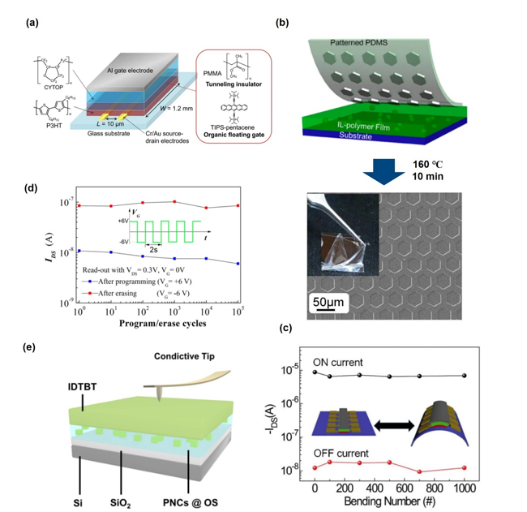

**Figure 1:** Illustrates the design, fabrication, and performance of a floating gate organic memory device and shows its promising potential for flexible and rugged applications. The memory consists of layers supported on a glass substrate and has P3HT as the semiconducting channel, CYTOP as the insulating layer, and TIPS-pentacene as an organic floating gate that traps and retains charge. PMMA is the tunneling insulator in the case of tunneling, and thus electron transfer occurs during programming and erasing. The operation of the device is controlled by an aluminium gate electrode. The process includes integrating an ionic liquid polymer (IL-polymer) film with a patterned PDMS layer, followed by thermal curing at 160°C for 10 minutes, to make the device flexible and robust for wearable or foldable electronics.

More advance quantum-dot-and-nanoparticle-based floating-gate devices continue to push forward further to improve the performance aspect as more emphasis is laid down for photo-assisted operation mechanisms and advanced charge-trapping mechanisms.

* Floating Quantum Dot Gates:

CdSe material quantum dots; Kim et al. uses with FBC3SH insulator to attain steady-on states with the onset of hole accumulation by induced-dipole moment.

Li et al. hybridized a memory that composed of PS, PCBM, and CsPbBr3 quantum dots, wherein this memory was found to possess ambipolar charge trapping with high-speed erasing and low voltage.

* Nanoparticle Floating Gates:

Sun et al. optimized Au nanoparticles using PMMA for an ambipolar characteristic where on/off ratio of 10⁴ was attained using a memory window of 20 V.

Zhang et al. have synthesized the PS combined with Ag and Pt nanoparticles by bimetallic charge trapping for larger memory windows and higher on/off ratios.

* Blended Polymers and Photoactive Materials:

Wu et al. have blended TIPS-pentacene and PS for large memory windows (25 V) and stable performance up to 500 cycles.Chen et al. applied the PFO and PS blends for electron trapping with on/off ratios of high stability that was beyond 10,000 s. Yang et al. applied the blend of CH₃NH₃PbBr₃/poly(2-vinylpyridine) in photowriting and photobleaching photoconductivity that showed stability after the bending cycle of 1,000.

These developments show quantum dot and polymer breakthroughs in bendable, photo-assisted, and high-performance memory devices that could be the next generation of imaging and memory technologies.

They have optical memory devices that use light to erase and read data to be recorded in the devices. Advances allow multilevel storage for effective data handling.

* Photoerasable Devices:  
  Li et al. prepared a floating-gate memory containing PCBM and PMMA, thus recording two bits that can also erase mass data efficiently.  
  Jeong et al. Surface-modified ligand CdSe QD memory with stable ON-typetransistor performance up to fast erasing ratios over 10⁵.
* Mechanisms of Multilevel Storage:

F8BT, as well as polystyrene polymer floating gates, for three-level information storage combining electronic, neutral, and hole storage states according to Xu et al.  
Jin et al. demonstrated a four-layer non-volatile memory made from Cs₂Pb(SCN)₂Br₂/polymer floating gates that can store and retain data through selectively tuned wavelengths over 20 cycles.  
Zhou et al. fabricated an ambipolar memory device based on PDPP-TBT with metal nanoparticles as a floating gate, showing five-level multibit flash memory with a broadened memory window.These developments reveal the ability of light-assisted and multibit memory technologies to store and maintain data.

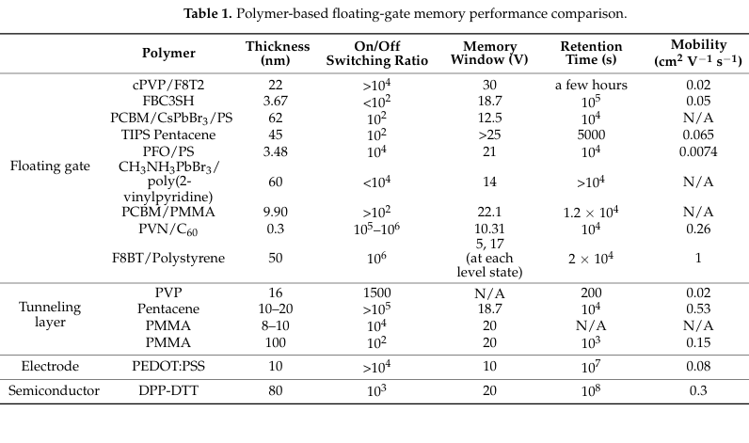

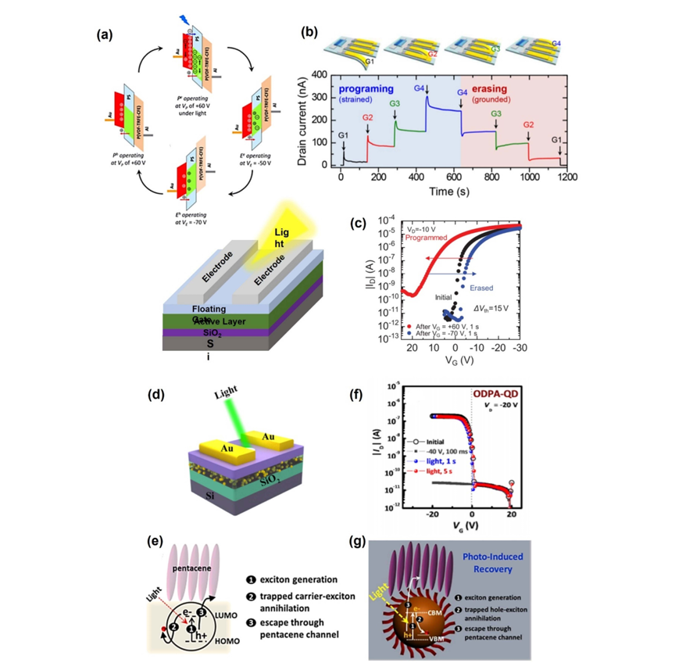

**Figure 2:** Mechanisms and principles of polymer floating-gate memory devices. Multilevel storage and photo-assisted operations are improved. Polymer floating-gate memory can store multilevel information, as shown in (a) by enabling three-level storage using distinct electronic, neutral, and hole storage states, and in (b) by achieving four-level storage using advanced materials that allow precise programming and erasing cycles. Demonstrated photosupported memory operations include memory level programming and erasing by light irradiation, schematic diagram of the photo-writing process, and a description of the photo-writing principle in terms of energy transfer mechanisms. Photoerasable memory is also looked into, and (f) is a graph showing retention and switching stability of the photoerasable memory device, while (g) demonstrates how the energy bandgap principle can be the basis for photo-erasing functionality. These arepotential that polymer-based floating-gate devices hold for efficient, multilevel, and light-driven memory applications.

1.2. Polymer Electret Memory

Similar to floating-gate memory, polymer electret memory employs dielectric materials storing quasi-permanent electrical charges. This is widely utilized in sensors, memories, and gas filters. From the memory properties of such polymers, it could be concluded that nonpolar polymers like polystyrene (PS), poly(-methyl styrene) (PaMS), and poly(2-vinyl naphthalene) (PVN) have better properties than hydrophilic polymers. Charge storage in polymer electrets is provided by permanent dipole orientation (in polar materials) and charge trapping by structural defects or boundaries. Organic field-effect transistor (OFET) devices with hydrophobic polymers, showed by studies such as that by Kim et al. charge effectively in the polymer electrets. In contrast, polar and hydrophilic polymer electrets like PVP, PVA, and PVPyr stored charges less effectively due to high rates of electron emission resulting from dipoles, atmospheric moisture, and ions in the hydrophilic layer.

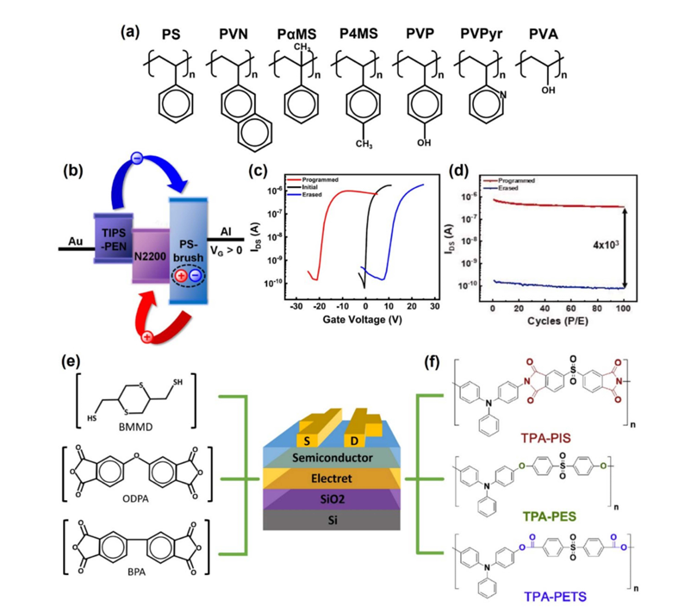

**Figure 3** : Figure Demonstrates the use of styrene-based polymer electret materials in memory devices. Panel (a) shows some examples such as PS, PVN, PaMS, P4MS, PVP, PVPy, and PVA, which demonstrate the applicability of charge storage. Panels (b), (c), and (d) demonstrate the charge storage mechanism, current–voltage behavior, and retention properties of polystyrene-brush (PS-brush) electret memory, respectively. Panel (e) schematically illustrates an OFET memory device with electret layers, like chemical structures of PITE (BMI-BMMD), PI(APS-BPA), and PI(APS-ODPA), that can provide efficient memory performance. Panel (f) shows TPA-based electrets, such as TPA-PIS, TPA-PES, and TPA-PET, from which novel styrene-based polymers would be designed to achieve future memory applications. Overall, all these elements demonstrate the prominent position of styrene-based polymers in organic memory device innovations.

Ambipolar memory devices, which store both electrons and holes, have recently gained quite a bit of momentum. For example, He et al. have developed an ambipolar memory device using poly(α-methylstyrene) (PαMS), where carriers are stored under gate bias in the trap states in the polymer. This device showed a memory window of 24 V and displayed a high on/off current ratio of 10⁵, and retention time up to 3 hours. The capability of such a device to store both types of charge carriers (electrons and holes) is a major development since it can lead to more versatile and efficient memory systems.

In another paper, Kim et al. showed the memory device fabrication by combining n-type N2200 and p-type TIPS-Pentacene with polystyrene-brush (PS-brush) electrets. The devices had a remarkable memory window of 30 V with over 100 cycles of highly reproducible performance. Additionally, the devices exhibited an unusually long retention time of 10⁸ seconds with an on/off current ratio of 10⁴. Both n-type and p-type materials contained in the devices facilitate better performance of these devices at a broader range of operation conditions, thus increasing the robustness and hardness of these devices.

As mentioned by Yu et al., PI layers also represent one of the key aspects in the electret memory device. For example, it has been shown that non-volatile flash memory is present in electret memory devices with PI(APS-ODPA) and PI(APS-BPA) layers. This shows that such devices can store data even when there is no power supply, which makes them suitable for applications requiring the retention of data. The potential of using such PI-based materials in WORM memory systems further enhances the secure data storage and retrieval capabilities.

Cheng et al. prepared TPA-based polymer electrets, TPA-PIS, TPA-PES, and TPA-PET, which showed both ambipolar and unipolar charge trapping behavior. The performance was remarkable with memory windows up to 32.4 V, and switching current ratios were reported in the range of 10³ to 10⁶. However, one of the major challenges with these devices is their high-voltage programming and erasing requirement because the polymer layers are quite thick. This limits their efficiency, especially in low-voltage applications. Future research will probably focus on making thinner polymer films to reduce the operating voltage while maintaining the performance characteristics, thus making these devices more suitable for practical, low-power applications.

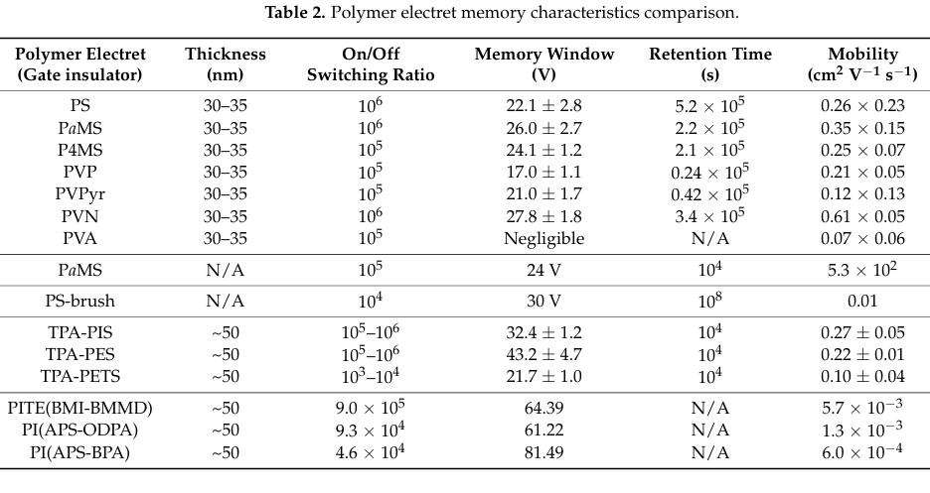

**1.3. Ferroelectric Memory**

**1.3.1.Two-Terminal Ferroelectric Memory**

This topic discuses the role of ferroelectric materials in non-volatile memory, particularly in the Internet of Things. Such a material can be aligned by applying an electric field to make dipoles and forming electric polarization. It may be used for storing data as "0" and "1". The data stored in this will not be lost even after power switch-off, hence this is called a non-volatile memory.

One of the most extensively researched ferroelectric polymers is Polyvinylidene Fluoride, which exists in four crystalline phases: α, β, γ, and δ. The β-phase having a highest polarization of 13 C/cm² is reported to be the favorable phase for ferroelectricity but PVDF primarily crystallizes into non-ferroelectric phases due to their high thermal stability.

This P(VDF-TrFE), a copolymer of PVDF and trifluoroethylene, is heavily applied in ferroelectric memory due to strong polarization. The material is readily fabricated through elementary processes like spin coating or roll-to-roll inkjet printing with no high temperature processing required.

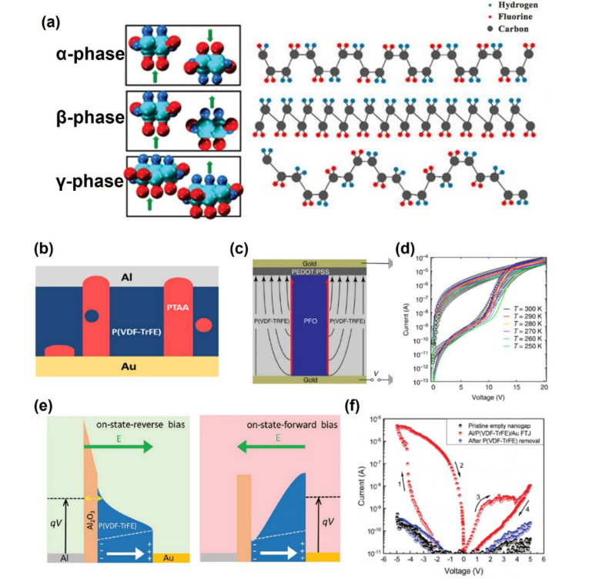

**Figure 4:** Illustrates some of the characteristics of ferroelectric memory and its characteristics. (a)Shows the crystalline phases of PVDF, which illustrate their various structural arrangements, as obtained from sources like MDPI and the American Chemical Society. (b–d) Illustrate diode-type ferroelectric memory devices and their working characteristics, as obtained from Nature and the American Institute of Physics.(e, f)Schematic diagram of the mechanism and transfer curve of such a memory ferroelectric tunnel junction thus demonstrating work mechanism and performance adapted from John Wiley and Sons. Pictures here focus on ferroelectric type of memories together with the operating mechanism on the principle of operations between phase behavior crystalline and characteristics concerning the device.

Kim et al. synthesized an organic ferroelectric resistive random-access switching memory using ZnO nanoparticles (NP) and P(VDF-TrFE), which displays ferroelectric polarization. The ZnO nanocomposite aligned with the dipole field of the ferroelectric, forming a filament as the applied voltage increased. Devices fabricated with an optimal ratio of 20 wt. % ZnO nanoparticles showed a stable resistive switching characteristic with an on/off ratio of 2 ×10⁷ and holding time of 10⁴ seconds at a low operating voltage (±4 V). Furthermore, space charge effects in the ferroelectric film have been controlled for the implementation of resistive switching memory.

Diode-type devices were developed in place of tunneling current-based systems since the formation of filaments with thick ferroelectric layers is a challenge. In these devices, the carriers are transported by ferroelectric polarization in the semiconductor. Lenz et al. demonstrated a ferroelectric diode using poly(9,9-dioctylfluorene) (PFO) as the semiconductor and P(VDF-TrFE) as the ferroelectric polymer, using a soft lithography method. As a result of further increased positive bias, the device entered efficient charge injection by way of ferroelectric polarization and demonstrated on-state with the on-current density larger than 10³ A/m² maintained up to 10⁴ s and showed the on/off switching ratio 10³.

Ferroelectric tunnel junctions are considered to be outstanding candidates for low-power, non-volatile memory and memristic devices. FTJs tune the TER at the interface between the ferroelectric and the electrode by changing ferroelectric polarization, hence current flow. Majumdar et al. reported improved switching characteristics by altering annealing conditions of ultrathin films of P(VDF-TrFE) in FTJ structures. Higher crystallinity resulted in better switching behavior, and a high TER ratio was obtained by biasing, with switching times comparable to those of ceramic ferroelectrics (1 ps to 1 ns). Kumar et al. used adhesion lithography to prepare FTJs based on P(VDF-TrFE) and reported large, stable TERs. Ferroelectric polarization is modulating the tunneling current. The change was 106% in the barrier of the Al/P(VDF-TrFE) interface in planar FTJs.

**1.3.2.Three-Terminal Ferroelectric Memory (FeFET)**

Unlike two-terminal ferroelectric memory, three-terminal ferroelectric memory uses the FeFET structure. Although the mechanism of operation for FeFETs is precisely the same as for the general FET, ferroelectric polarization affects the former. The way it operates is as follows for a standard FeFET memory using an n-type semiconductor and gate insulator: (1) Positive gate bias puts the ferroelectric material in a biased state that aligns the polarization in the direction of the semiconductor, thereby allowing accumulation of electrons at the semiconductor-ferroelectric interface, forming a conductive channel. (2) Because of polarization existing there even at a 0-V gate bias, current can flow without hesitation, whereas in the usual FET, it wouldn't since the channel would be off. (3) Applying a negative voltage inverts the direction of the polarization; thus, when current does not flow because of this blocking, the system will produce two definite states (0 and 1) through the existence of hysteresis. This non-volatile memory function enables FeFETs to maintain the on or off state without any additional biasing and, therefore, is particularly suitable for data loss-free memory applications.

In this way, a ferroelectric film plays the most significant role in an FeFET. However, in a FeFET, inappropriate bonding at the ferroelectric layer-semiconductor interface or ferroelectric layer-electrode interface would cause inappropriate polarization and may have a side effect on increased leakage currents and a greater operating voltage. Studies concerning improvements at the ferroelectric film-semiconductor interface are related to utilizing buffer layers and maximizing surface roughness.

For example, Nguyen et al. have fabricated non-volatile FeFET memory using pentacene as the semiconductor and P(VDF-TrFE) as the gate insulator. By annealing the P(VDF-TrFE) film at 140°C to enhance its crystallinity, they were able to achieve an on/off switching current ratio of 10⁴ for 5000 seconds. To prevent leakage current, Xu et al. suggested a ferroelectric polymer layer between two ultrathin AlOX buffer layers, which resulted in the achievement of a memory with high mobility (1.7-3.3 cm²/V·s), reliable switching endurance (over 2700 cycles), and stable data retention (more than 8×10⁴ seconds). Xu et al. further enhanced the P(VDF-TrFE-CTFE) films by introducing a protective TTC layer to enhance the crystalline quality of the pentacene film and prevent interfacial traps. Consequently, FeOFETs with 15 V operating voltage, mobility of 0.5 cm²/V·s, and stable program/erase cycles over 1000 cycles with storage retention of 6000 seconds were obtained.

Song et al. prepared FeFETs with C8-BTBT as the semiconductor and PMMA as the buffer layer. The concentration of PMMA was varied, which decreased the RMS roughness of the PMMA/P(VDF-TrFE) surface, and they achieved the mobility of 5.6 cm²/V·s and the on/off ratio of 10⁶. These devices, having switching times of ca. 3.0 ms, demonstrate that the organic materials are also attractive for FeFET-based non-volatile memory applications.

The conductivity and ambipolarity of the 2D semiconductor layers have greatly contributed to improved performance for FeFETs. Indeed, using a graphene as the semiconductor layer in Amiri et al., authors made FeFET, with an ambipolarity characteristic that allowed transferring hysteretic properties with two distinguishable bistable levels for conductivity at zero gate voltage bias. They got a 2.4 ratio on/off, 50 Ω of contact resistance and a mobility of 400 cm²/V·s.

Lee et al. have used BP for non-volatile memory FETs with P(VDF-TrFE) as the gate insulator. Due to its high mobility, allotropic property, and direct narrow bandgap, BP can show a memory window of 15V with a mobility of 1159 cm²/V·s along with an on/off current ratio of 10³ at room temperature. It could maintain its program/erase ratio for over 1000 seconds without degradation.

Tian et al. fabricated FeFETs using ultra-thin zinc oxide nanosheets (ZnONS) and P(VDF-TrFE) as a protective film. The ZnONS layer showed excellent residual polarization and high single-crystal quality, resulting in a memory window of 16.9V, an on/off current ratio exceeding 10⁷, and a program/erase retention time of over 3000 seconds.

Moreover, Kim et al. fabricated FeFETs with a P(VDF-TrFE)/PMMA blended buffer layer, which exhibited superior electrical performance. The BL-FeFETs showed more than 25 times higher on-current (3.40 A) than single-layer FeFETs (130 nA), improved memory retention (103 s), and a higher on/off switching current ratio compared to conventional single-layer FeFETs.

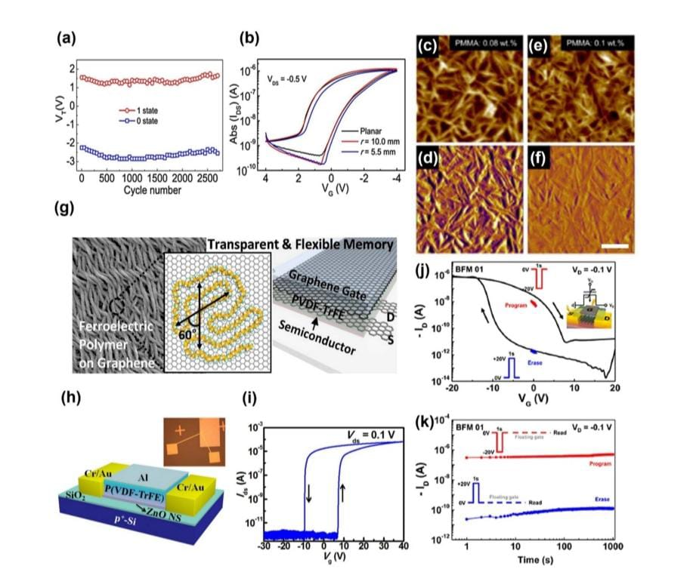

**Figure 5:** (a,b) Stable data storage retention over 8 104 seconds with a memory 102 of on-off in P(VDF-TrFE-CTFE) ferroelectric FETs (adapted from with permission from Nature). (c--f) RMS roughness of the PMMA/P(VDF-TrFE) surface with varying PMMA concentration from 0.08 wt. % to 0.1 wt. % (adapted from with permission from the American Chemical Society). (g) Ferroelectric FETs based on 2D materials: graphene (adapted from with permission from the American Chemical Society) and (j,k) black phosphorus (BP) (adapted from with permission from the American Chemical Society). (h,i) Structural and I–V characteristic curve of ferroelectric FETs using metal oxide (ZnO) (adapted from [89] with permission from AIP Publishing).

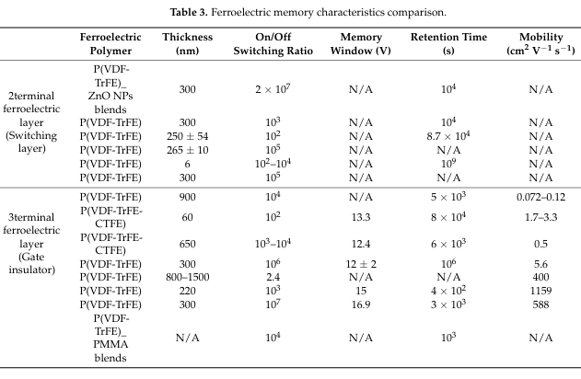

**1.4.Memristor**

A memristor is an electric circuit element that exhibits the phenomenon of resistance switching by integrating the magnetic flux and electric charge. It is generally constructed in two major structural configurations, which are vertical and horizontal. In the former case, two electrodes are sandwiched between an insulating material. In the horizontal structure, the electrodes are kept horizontal, and the carrier moves through the semiconductor material at the bottom. The operation in both types of devices is based on the movement of negative ions, which causes a resistance switching effect with the presence of hysteresis through the formation of filaments within the polymer layer.

Through chemical reaction of poly(ethylene-alt-maleate) and oxybenzyl alcohol, Ree et al. were able to synthesize the novel oxygen-based polymers used as the switching layer containing a different poly (ethylene-alt-di(3,4,5-trimethoxybenzylmaleate) - denoted as PEM-BzOMe3 - at the Al electrode. Here, the memristor operated with p-type unipolarity, with low set voltage values of 9.97 V, on/off switching current ratio of 10⁸, and high reliability for 40,000 seconds. With the off-state conduction showing Schottky emission and trap space charge-limited and the on-state conduction showing hopping,.

Furthermore, a few organic 2D material-based memristor devices with ordered structures, high surface area, stability, and tunable functions have been reported. For example, Lv et al. have shown a memristor composed of conventional diode of van der Waalsheterostructures (vdWHs) of [6,6]-phenyl-C61-butyric acid methyl ester (PCBM) and molybdenum disulfide (MoS2) nanocomposites.

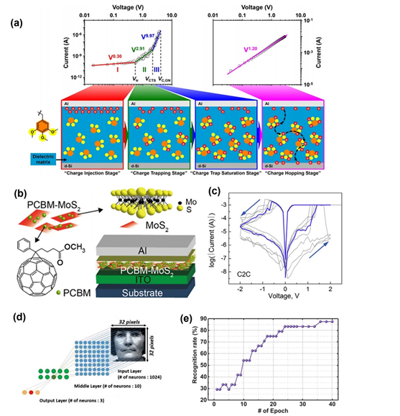

**Figure 6 :** Classifies polymers on the basis of their characteristics in memory devices. It begins with (a), showing the working mechanism of oxygen-based polymers in memristor devices. (b)deals with 2D material polymers and its application in future memory devices. (c) shows how conductive metal bridges filaments are utilized in memristors resistance switching mechanism.(d)describes the preparation of a memristor device using PVP, and (e) presents the memory application recognition rate of the same. The figures collectively depict the different kinds of polymers used in memristor devices along with their specific functionalities.

Recent research has been carried out, which presents many innovative membrane devices based on polymers and 2D materials. As an example, a memristor based on PCBM doped with MoS2 nanosheets showed tunable electric properties and nonvolatile operations with low switching voltages of ~2 V and high on/off ratios (~3 × 10²) and excellent bistability. Minnekhanov et al. have published a sandwich memristor that utilizes Cu, Parylene dimer, and ITO. In the present work, conductive filaments were broken and formed under positive and negative bias, respectively, for resistive switching. Chen et al. fabricated a flexible memristor by bonding parylene to nanopore graphene. A significantreduction in resetcurrent and programming power consumption was observed. In addition, Jang et al. demonstrated the successful fabrication of a memristor with poly(1,3,5-trivinyl-1,3,5-trimethyl cyclotrisiloxane) as an interlayer, showing synaptic switching behavior and flexibility, but still presents a challenge for endurance enhancement in practical applications for the polymer-based memristor.

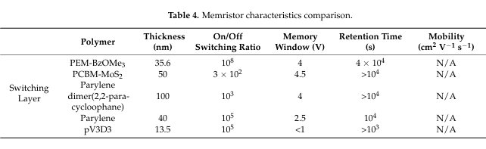

**2.New Applications**

**2.1. Optoelectrical Memory :**

This allows the irradiation of light to be regarded as a controllable variable which can improve the performance of devices without causing any damage. Photogenerated carriers generate an additional electric field while interacting with photoreactive materials. Such principles are applied in memory types: field-effect transistor memory, resistive random-access memory, multilevel memory, and phase-change memory.

Researchers have designed optically variable memories based on different kinds of photoreactive materials. For instance, Leydecker et al. developed a multistage nonvolatile optical memory thin-film transistor using a blend of poly(3-hexylthiophene) (P3HT) and photochromic diarylethenes (DAE). DAEs are found to be very thermally stable and exhibit efficient photoisomerization; hence, they have been applied in phototunable memory devices. Electrical behavior of the device varies when benzene ring bond changes of DAE molecules are altered with specific light wavelengths.

The above device obtained 256 levels of current (8-bit storage) with 3 ns laser pulses, exceeding more than 70 write/erase cycles, and has a data retention time of 10⁷ seconds. These devices can be tailored for all photochemical properties like absorption, refractive index, fluorescence, etc. along with all physical parameters such as HOMO, LUMO, trap states, charge mobility, etc.

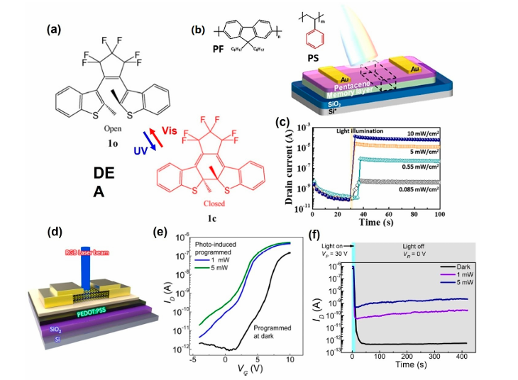

**Figure 7:** A few photonic transistor memory devices which have been developed are exemplified here. Panel (a) depicts the chemical structures of the diarylethene (DAE) used in its open and closed forms, whereas the structure of the memory devices has been adapted from Elsevier. Panels (b) and (c) depict a multilevel photonic transistor memory that utilizes conjugated/insulated polymer blend electrets, adapted from the American Chemical Society. Panels (d) to (f) show a schematic diagram of MoS₂ flash memory with a PEDOT:PSS floating gate under light illumination, and its transfer and retention curves based on different programming operations, adapted with permission from *Nature*. These developments have shown a wide range of materials and configurations that will enable advanced photonic memory applications.

The Ambipolar organic field-effect transistor (OFET) memory devices are designed and constructed by Yi et al., where the pentacene/poly(N-vinylcarbazole) (PVK)-based active layer shows exciton induction in the pentacene layer after the operation of light irradiation. Memory operation results through the accumulation of charges at the pentacene-PVK interface. These devices operated based solely on illumination in "programming/erasing" states with retention times greater than 10⁴ seconds and on/off current ratios of 10³–10⁴. That is where the memory window was doubled, relative to unipolar OFET memory devices to 70 V.

Shih et al. enhanced photonic memory through the use of a mixture of the conjugated polymer poly(9,9-di-n-octylfluorenyl-2,7-diyl) (PF) and the insulating polymer polystyrene(PS) as an electret layer. The devices enabled light-writing and voltage-erasing within one second, offered a "Photo-On"/"Electrical-OFF" on/off ratio greater than 10⁶, and presented a retention time of three months. Multilevel memory behavior could be trapped using light sources of different wavelengths (405, 450, and 520 nm).

In addition, Ercan et al. synthesized optical memory devices using CH₃NH₃PbBr₃ perovskite NPs and PMAA polymer electrets. As the photoresponse of perovskite NPs-based optical memory devices was higher than that of device without perovskites, it also shows excellent on/off switching current ratio of 10⁵ along with optical memory operation.

Hong et al. demonstrated the first multifunctional optoelectronic memory by using MoS₂ semiconductor and PEDOT:PSS floating gates. These devices exhibit enhanced performance under illumination with 1000× read current, a switching ratio of 2.3 × 10⁷, a memory window of 62 V, and retention up to 1000 cycles. Photo-memory exhibits programmable states based on light illumination that combine photodiode and memory functions for versatile applications.

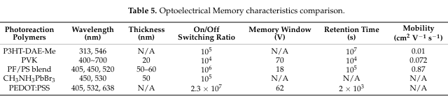

**2.2.Neuromorphic Devices:**

Neuromorphic devices that mimics neural networks provide low power data processing capabilities. It is hence very relevant to the tasks of big-data handling complex tasks. Recently, discovery of new devices includes a memory-based ion-gel neurotransmitter device. Melianas et al have formulated an organic electrochemical random-access memory (ECRAMs) that work at a low voltage ranging from ~1 V of vacuum conditions using EIM:TFSI-based electrolytes. These devices were observed to display linear resistive switching, ultra-fast switching as low as 20 ns and larger dynamic range ~4× through the fast ionic movement due to the proton movement in hydrogen bonded networks by Grotthuss mechanism, EIM:TFSI also exhibiting superior temperature stability compared with PEDOT:PSS.

Kong et al. successfully implemented artificial synaptic field-effect transistors with amorphous indium-zinc-oxide thin films, along with a P(VDF-HPF) ion-gel dielectric layer. Using the superior capacitance of ion-gel dielectrics, Park et al. could show synaptic functionalities with artificial synaptic devices: EPSC, spike-time-dependent plasticity, PPF, and dynamic synaptic behaviors. These innovative inventions detail the potential of developing such ion-gel-based neuromorphic devices in electronics applications.

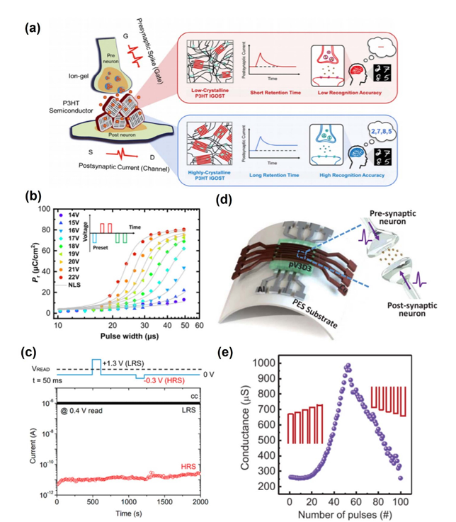

**Figure 8:** Neuromorphic devices presentation. (a) Represents neuromorphic behavior using ions. (b) Shows ferroelectric polymer material with the voltage dependent behaviour in this panel. Panel c: ambipolar neuromorphic device. Panels d and e: Flexible device made from PV3d3 whose conductance response towards pulses is also represented here. From these examples one can point to the potential diversity of the materials and mechanisms implemented in the neuromorphic functions.

The new breakthroughs in neuromorphic devices focus on novel material innovation and functionality. Wang et al. synthesized devices made of P(VDF-TrFE) and P(VP-EDMA-ESAES)as a synaptic gate dielectric so that it can switch into an electrochemical and/or ferroelectric mode that exhibits STP and LTP. Organic neuromorphic devices also respond to light and change synaptic signal frequencies, intensities, and wavelengths. Kim et al. showed the optimal contact metals in FeFET synapses, achieving the performance that, in simulation, reaches a recognition rate of 74.7% on MNIST.

Yu et al. synthesized synaptic devices based on the p-type polymer PDBT-co-TT to increase both charge retention and interchain interaction for enhanced memory properties. Consistently, Jang et al. developed flexible memristors with pV3D3 as the active material and Cu electrodes, which could even realize NOR gate operations under bending conditions and therefore represent a soft neuromorphic device.

Choi et al. demonstrate a curved neuromorphic image sensor using a MoS₂/pV3D3 heterostructure that mimics human vision systems. The sensor neither needed redundant data storage nor complex optics to deal with noisy optical inputs and kept a photocurrent on/off ratio of 11.03. These results point toward the possibility of novel materials and designs in neuromorphic and integrated sensor systems.

**2.3.Flexible Devices:**

With the advent of flexible displays and wearable devices, flexible memory has garnered significant attention. Research, therefore, is focused on the applications of versatile polymer and organic materials to produce innovative structures. Different categories of flexible memory would then include rollable, foldable, stretchable, fabric-type, and memory systems compatible with wearable devices.

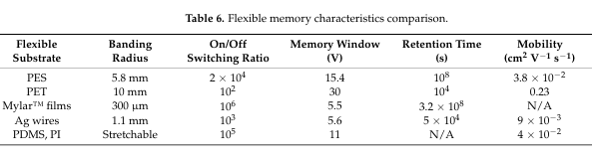

Wang et al. demonstrated flexible non-volatile memory based on a PES substrate using layers of polymers, including the semiconductor P(NDI2OD-T2), the tunneling insulator PS, the floating charge trapping layer PVA, and the blocking insulators PMMA and P(VDF-TrFE-CFE). The memory current ratio of the on/off was 2 times 104 and the memory window is 15.4 V over 100 read/write cycles with data retention as 108 seconds. Performance was stable after 1,000 bending tests with a 5.8 mm bend radius.

Li et al have fabricated non-volatile OFET heterostructure memory devices on a poly(ethylene terephthalate) substrate, utilizing a pentacene P13 pentacene trilayer. The memory devices have more than 30 V window, over 102 on/off current ratio and are mechanically stable, retaining performance in bending with 10,000 cycles of bending at radius of curvature of 10 mm.

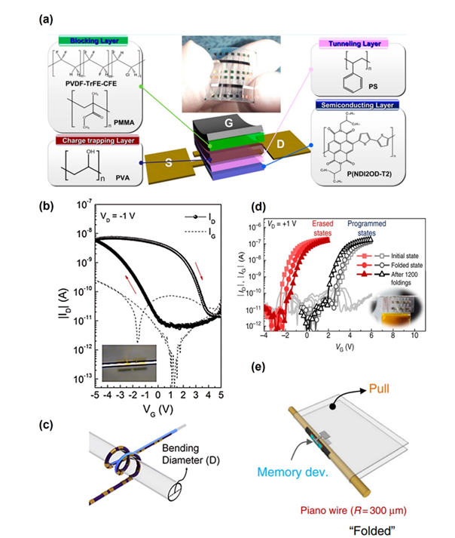

**Figure 9 :** Flexible Memory Advancement Prototypes. Panel (a) Schematic of top-gate organic FET non-volatile memory with polymer layers showing their chemical

structures.Panels (b and c) Fibriform memory coiled on a capillary tube with a 1.1 mm diameter during measurement. Panels (d and e) Memory performance after 1,200 folding cycles with a 300 µm radius for the device showing durability against mechanical stress.

Lee et al. have developed a flexible flash memory using thin polymer insulators grown by iCVD, incorporating C60-based organic TFTs with pV3D3 and pEGDMA films as tunneling and blocking insulators, respectively. The fabricated device on ultra-thin Mylar™ films showed a memory window of 5.5 V, with an on/off ratio of 10^6 that showed functionality after 1,200 folding cycles under a 300 µm bending radius. Kang et al. showed the application of P(VDF-TrFE) on flexible Ag wires for fibriform organic transistor memory with a memory window of 5.6 V and an on/off ratio of 103. This memory was stable even under significant bending, including being integrated into stretchable polypropylene fabric. Jung et al fabricated stretchable organic FeFETs on PDMS substrates by localizing the strain with rigid polyimide (PI) dies. The memory window persisted at 11 V mobility of 4×10-2 cm2 V-1 S-1 along with an on/off ratio of 105 Welch that displayed stability towards the strain values of up to 50%. These enhancements are capable of making memory persistible in wearables and flexible electronics.

**2.4.Biodegradable Memory Devices:**

With the increasing concern for environmental sustainability, biodegradable polymer-based memory devices are acquiring value. The devices rely upon techniques like copolymerization, blending, cross-linking, and polymer nanocomposites. Though organic materials enhance biodegradability, it always compromises performance and endurance, so metal-semiconductor compatibility remains important to maintain balance in these trade-offs.

Wu et al fabricated a WORM memory based on gold nanoparticle-embedded alkali lignin on a polylactide substrate. It had an on/off ratio > 104 with a long data retention over > 103 s and an operation at 4.7 V. The device was biodegradable in enzyme solutions, therefore it broke down into little pieces within five days. Analogously, Huang et al. synthesized a flexible Al/gelatin/Ag RRAM on bio-cellulose (BC) that presented a high on/off ratio (~104), low operating voltage (<3 V), and full soil decomposition in five days. It maintained its performance when attached to simulated human skin conditions.

Ji et al. reported W/silk fibroin/Mg ambipolar resistive switching memory utilizing the isotropy and quick decomposition of silk fibroin. The device was totally biodegradable in both water and PBS solutions for 24 h without leaving any residue and showed an on/off ratio of 104, retention of 100 cycles, and a memory window of 5.4 V. These breakthroughs find promising applications in wearable, biomedical, and implantable devices.

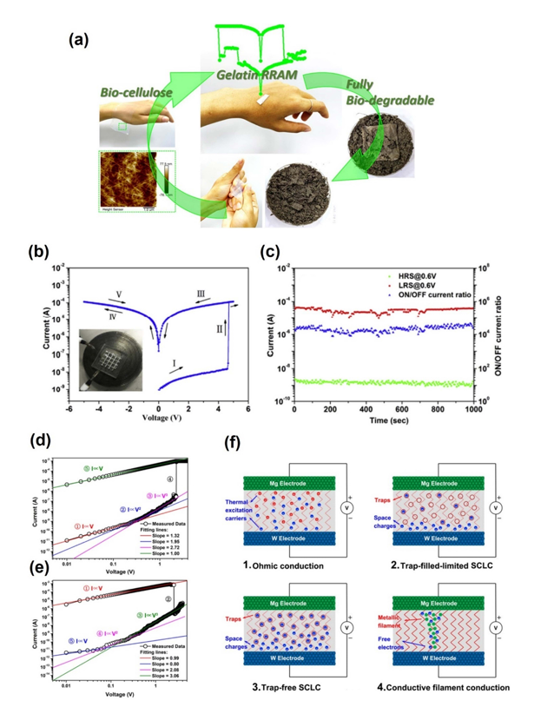

**Figure 10**: Biodegradable memory devices. Panel (a) is a cellulose-based device degrading in five days. Panels (b) and (c) show the I–V curve and retention performance. Panels (d) and (e) demonstrate the set/reset processes of a resistive switching model, and panel (f) demonstrates carrier distribution under different voltage biases.

**Conclusion:**

These memory devices have a distinct advantage over traditional silicon or inorganic memory technologies: extremely low process temperatures, below 200°C. This greatly reduces the manufacturing cost and energy, since it would not require high thermal budgets found with silicon-based devices. Further, since polymers are solution processed, they circumvent high-vacuum deposition steps and minimize the expense and complexity of production. These properties make polymer-based devices suitable for various applications, like optoelectric systems, neuromorphic computing, and mechanically flexible memory that are essential elements in next-generation technologies-wearable electronics and flexible displays.High-performance memory operations provided by floating-gate, polymer-electret, ferroelectric, or filament-induced memory devices are well demonstrated to have their great promise. New functions in this kind of development open up more ways of being integrated with mechanically flexible or lightweight structures to perform or with unique behavior during memory operations.It remains for these challenges: The reliability of the functioning for broad-scope usage requires a sufficiently high robustness of their operational features at changing conditions. This calls for efforts toward reducing the surface traps, which frequently represent the source of instability. Another challenge is that polymer devices should be scalable and compatible with the miniaturization and high-density integration of contemporary memory technologies. Development of lithography-compatible polymer materials might serve as a bridge to solve this problem. The long-term air stability of organic materials also needs to be improved so that these devices can remain functional and durable over years of use and exposure to environmental factors.

Although these challenges pose difficulties, inherent advantages and continuous

advancement of polymer-based memory technologies strongly suggest a promising future. Further research and development on polymers can create them as the driving forces for the next generation of memory devices, bringing forward new solutions to technological needs in the future.

**Acknowledgment :**

We would like to express our heartfelt gratitude to our chemistry teacher, Dr.SWETHA G A, for her invaluable guidance, support, and encouragement throughout the preparation of this report. Her expertise and constructive feedback were essential in helping us explore this topic, we also extend our sincere thanks to our group members, for their teamwork, dedication, and collaboration. This project was a collective effort, and it would not have been possible without their contributions and commitment.