**A PROJECT REPORT**

***ON***

## RECIPE FINDER

***Submitted by***

## 

## Shashank Kumar Singh

## Arya Siddarath Rao

## Sandeep Bhardwaj

***in partial fulfillment for the award of the degree of***

**Bachelor Of Technology**

**IN**

COMPUTER SCIENCE AND ENGINEERING

**GLA University , Mathura**

NOVEMBER 2023

**DECLARATION OF STUDENT**

I hereby declare that the work, which is being presented in the Project Report, entitled “ **RECIPE FINDER** " in partial fulfilment for the award of Degree of Bachelor of Technology'' in Deptt. Of Computer Science and Engineering and

submitted to the Department of Computer Science and Engineering , GLA

University, is a record of my own investigations carried under the Guidance of

**Mr. Ankit Arora** ,the Department of Training and Development,

GLA University.

I have not submitted the matter presented in this Project Report anywhere for

the award of any other Degree.

(Name and Signature of Candidates)

**Shashank Kumar Singh-(C-2115000938)**

**Arya Siddarath Rao- (G-2115000210)**

**Sandeep Bhardwaj-(E-21150000907)**

Counter Signed By

**ACKNOWLEDGEMEN**T

It is my pleasure to be indebted to various people, who directly or indirectly contributed in the

development of this work and who influenced our thinking, behaviour and acts during the course of

study.

We express our sincere gratitude to **Mr. Ankit Arora**, for providing us an opportunity to

undergo this Project as the part of the curriculum.

We are thankful to **Mr. Ankit Arora** for his support, cooperation, suggestion and motivation

provided to us during the training for constant inspiration, presence and blessings.

We also extend our sincere appreciation to **Mr. Ankit Arora** who provided his valuable

suggestions and precious time in accomplishing our Project report.

Lastly, we would like to thank the almighty and our parents for their moral support and friends with

whom we shared our day-to-day experience and received lots of suggestions that improved our

quality of work.

**Shashank Kumar Singh.**

**Arya Siddarath Rao**.

**Sandeep Bhardwaj.**

**ABSTRACT**

Food is one of the main human needs. Through food is the source of energy obtained.

In its development food today is not only as a filler of energy needs, but more than that food has become an art and has added value. A wide variety of innovative creations in food have been developed and spread widely. Many of them use only the minimal amount of material to create an original recipe .A recipe consist of a set of instructions that tells us how to prepare and cook food, which include a list of what food is needed for . Cooking recipe consists of several aspects including: name, step, tools and materials, time and amount of dish.

The proposed system is to build an interface that has a feature to search for recipes based on material owned by the user. The system suggests recipes according to the vegetables and fruits available to the user. User scans the available ingredients and android application displays a list of possible recipes online. The application is personalised, which means the recipes displayed are filtered according to the user’s preferences and health conditions.

In conclusion, the Recipe Finder System is a strategic asset for individuals aiming to optimise cooking operations, searching recipes, and provide superior services.

Its integration of technology and automation aligns with the demands of modern foods and recipe , making it an indispensable tool .

Table of Contents

1. Introduction

1.1 Background

1.2 Purpose of the Recipe Finder System

1.3 Timeline

2. Key Components

2.1 Recipe Managing

2.2 Reporting and Analytics

3. Functionalities

3.1 Recipe Find

3.2 Integration & Capabilities

4. Benefits

4.1 Cost Reduction

4.2 Improved Accuracy

4.3 Enhanced Customer Satisfaction

4.4 Health Management

5. Design Flow/Process

6. Result Analysis and Validation

7.Technology

a) HTML

b) CSS

c) Java script

8. Conclusion

9. References

**Introduction**

**1.1 Background**

A recipe finder is a tool or platform designed to help individuals discover and explore a wide variety of recipes based on their preferences, dietary restrictions, and available ingredients. Whether you're an experienced chef looking for new culinary adventures or a novice cook seeking simple and delicious meal ideas, a recipe finder can be a valuable resource.

Overall, a recipe finder is a versatile tool that caters to a wide audience, providing inspiration and guidance for both seasoned cooks and beginners in their culinary endeavours.

**1.2 Purpose of the Recipe Finder System**

The purpose of a recipe finder system is to assist individuals in discovering, selecting, and preparing recipes based on their specific preferences, dietary needs, and available ingredients. This type of system serves several purposes:

**Culinary Exploration:**

Recipe finders encourage users to explore a diverse range of cuisines, cooking techniques, and flavour profiles. This promotes culinary creativity and helps individuals discover new and exciting dishes.

**Time Efficiency:**

By offering quick and efficient search options, recipe finders save users time by providing instant access to a wide variety of recipes. This is particularly beneficial for those with busy schedules who want to prepare delicious meals without spending excessive time searching for recipes.

**Dietary Guidance:**

Recipe finders often include filters and tags for dietary preferences and restrictions, such as vegetarian, vegan, gluten-free, or low-carb. This allows users to find recipes that align with their specific dietary needs and health goals.

**Ingredient Utilisation:**

Users can input the ingredients they have on hand, and the recipe finder suggests recipes that can be prepared with those ingredients. This helps reduce food waste and encourages efficient use of available resources.

**Meal Planning:**

Some recipe finders incorporate meal planning features, allowing users to organise recipes into weekly meal plans. This facilitates efficient grocery shopping and streamlines the cooking process for busy individuals or families.

**Nutritional Information**:

Many recipe finders provide nutritional information for each recipe, enabling users to make informed choices about their meals. This is especially valuable for those who are conscious of their calorie intake or have specific nutritional goals.

In summary, a recipe finder system serves as a valuable tool for individuals seeking culinary inspiration, efficient meal planning, and personalised cooking experiences tailored to their preferences and dietary requirements.

**1.3 Timeline**

Certainly! Here's a breakdown of your project timeline aligned with your specified tasks for each week:

**Week 1: Working on Git Setup and Structuring (HTML)**

- Days 1-2: Git Setup

- Establish version control using Git.

- Create a repository for the project.

- Days 3-5: HTML Structuring

- Develop the basic HTML structure of the project.

- Define essential components and layout.

**Week 2: Making it Dynamic and Studying Colour Wheel**

- Days 1-3: Dynamic Elements

- Integrate dynamic elements using HTML and CSS.

- Incorporate placeholders for future dynamic content.

- Days 4-5: Colour Wheel Study

- Research and understand colour theory.

- Implement a colour scheme in the project.

**Week 3: Making the Site Responsive and Adding JavaScript**

- Days 1-3: Responsive Design

- Implement responsive design principles using CSS.

- Ensure optimal user experience across devices.

- Days 4-5: JavaScript for Validation and Link.

- Integrate JavaScript for form validation.

- Add interactive features and ensure seamless navigation.

**Week 4: Adding and Understanding API**

- Days 1-3: Understanding API And its Integration.

- Embedding API into the project.

- Customise API according to project requirements.

- Days 4-5: - Customise API according to project requirements.

- Plan the integration of API data into the project.

A recipe finder typically consists of several key components that work together to provide users with a comprehensive and user-friendly cooking experience. These components may vary slightly depending on the platform or application, but the following are common elements found in recipe finder systems:

**Search Bar:**

The central feature allowing users to input keywords, ingredients, cuisine types, or dietary preferences to find relevant recipes. Filtering Options :Tools for users to refine search results based on criteria such as cooking time, difficulty level, dietary restrictions, and more.

**Recipe Database:**

A robust collection of diverse recipes, ranging from appetisers and main courses to desserts and beverages.

**Nutritional Information:**

Display of nutritional details for each recipe, including calorie count, macronutrient breakdown, and other relevant information. User

**Meal Planning:**

Tools for users to organise recipes into weekly meal plans, facilitating efficient planning and preparation.

**Photographs and Visuals:**

High-quality images of each recipe to give users a visual preview of the finished dish.

**Video Tutorials:**

Integration of video content, such as cooking tutorials or step-by-step demonstrations, to enhance the user's understanding of the cooking process.

**API Integration:**

Connectivity with external APIs (Application Programming Interfaces) to source additional recipe data, nutritional information, or other relevant details.

**Functionalities**

The recipe app provides direct access to the items to a larger audience. There are multiple features that are put in the app, such as personalised recipe recommendations, social sharing, cooking guide videos, and many more that help the user to get the best results and be a part of a loyal customer list.

**Recipe Find:**

In this module, user can add and remove ingredients as of his/her needs and then the available ingredients are added to find the recipe. There are different options for selecting the ingredients for the recipes. One among them is the direct selection of the required ingredient in the page. Second option is taking the picture of the unknown vegetable or fruit. Then, that image is scanned and processed and then it is identified using Machine Learning approach. After the selection of all the ingredients, corresponding recipes are displayed . The recipes are filtered before displaying based on user’s health preferences.

**Benefits**

Users can simply browse through the website and find a recipe that fits their requirements instead of searching through cookbooks or the internet. Additionally, these sites provide step-by-step instructions for cooking the recipe, which makes it easier for even novice cooks to prepare the dish.

The proposed system is to build an application interface that has a feature to search for recipes based on material owned by the user. The system suggests recipes according to the vegetables and fruits available to the user. User scans the available ingredients and android application displays a list of possible recipes online. The application is personalised, which means the recipes displayed are filtered according to the user’s preferences and health conditions.

**Design Flow/Process**

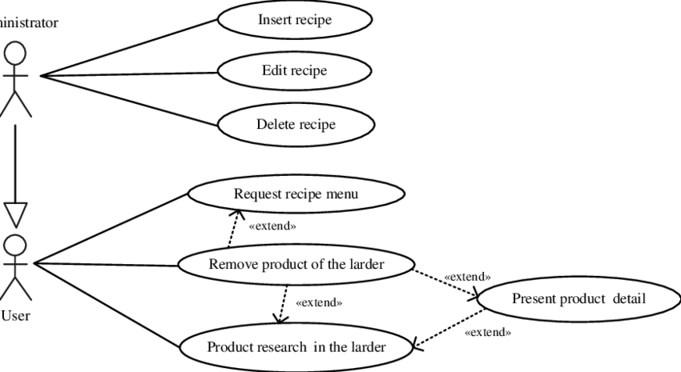

**Result Analysis and Validation**

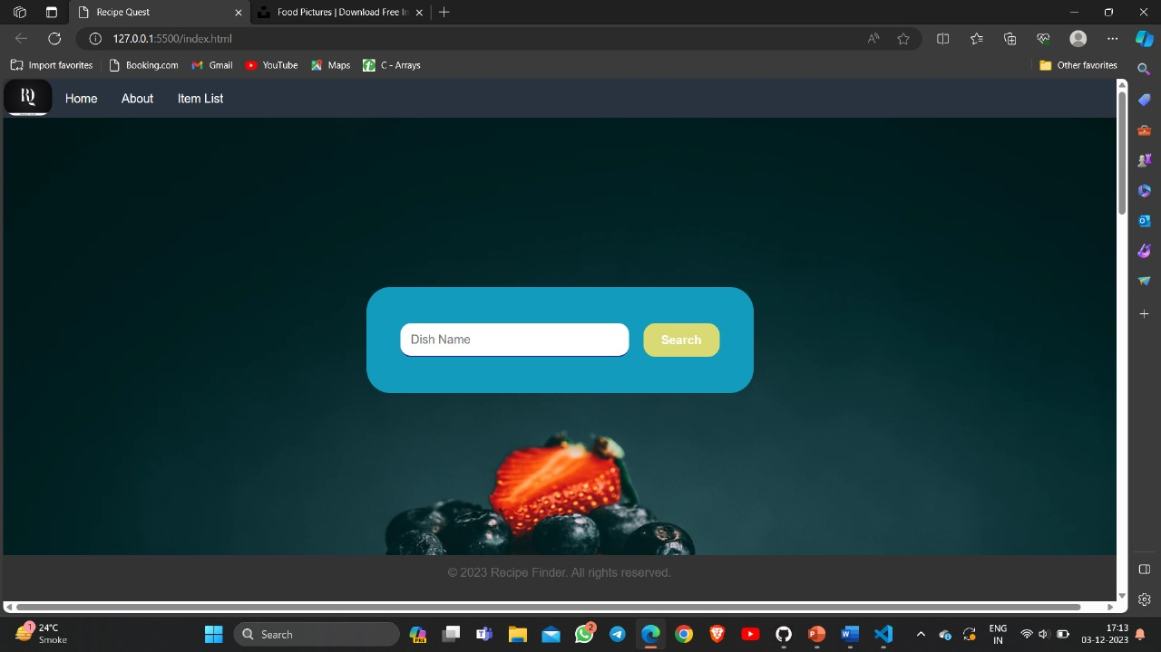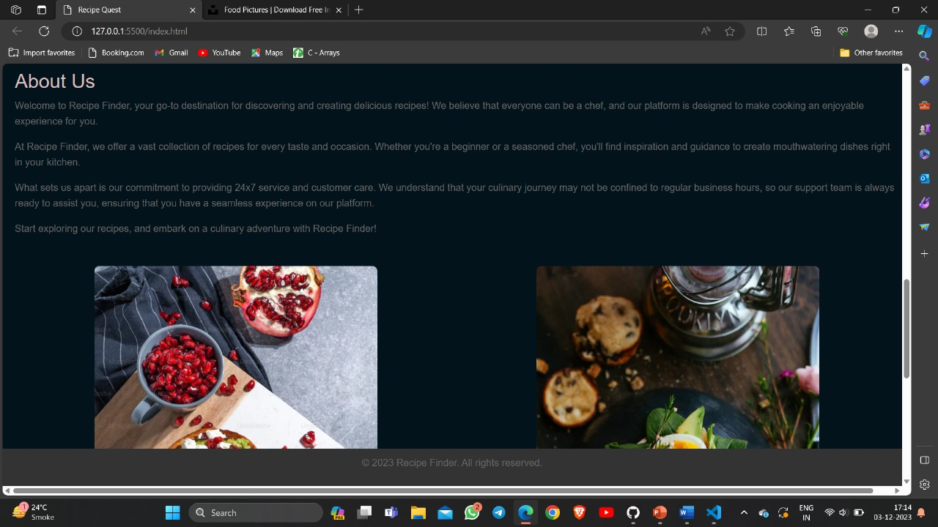

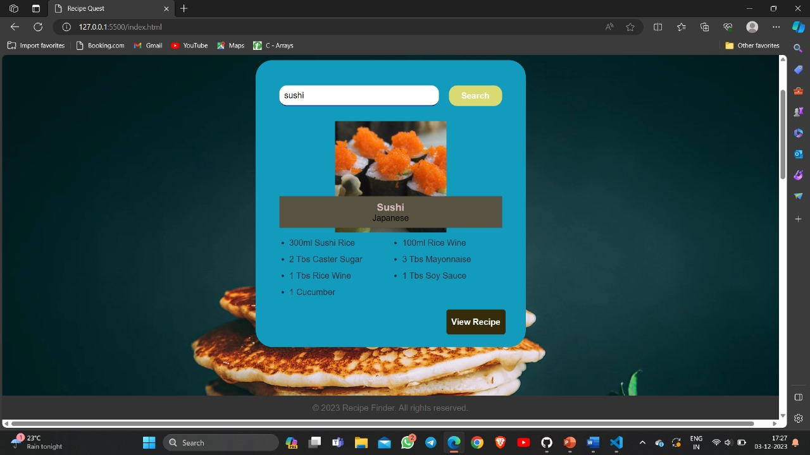

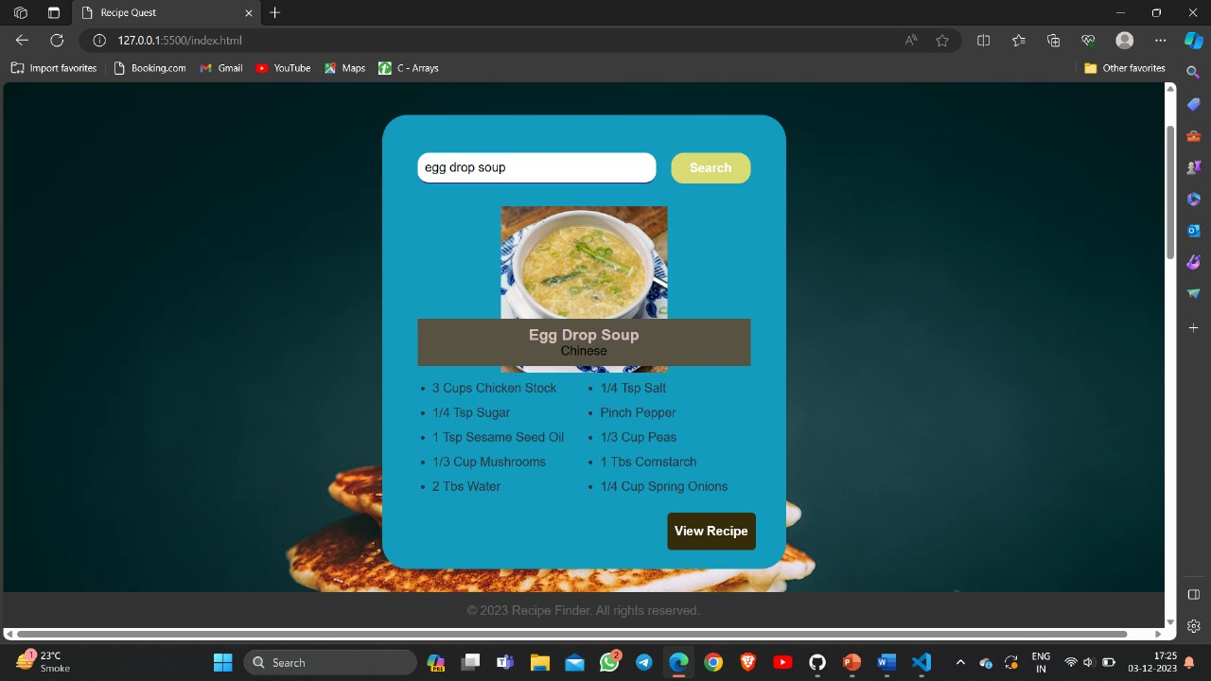

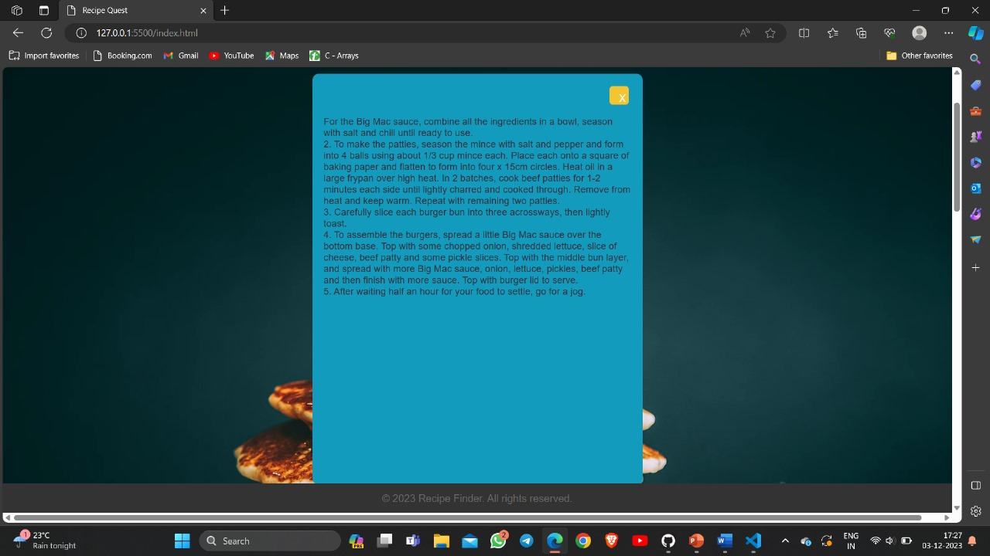

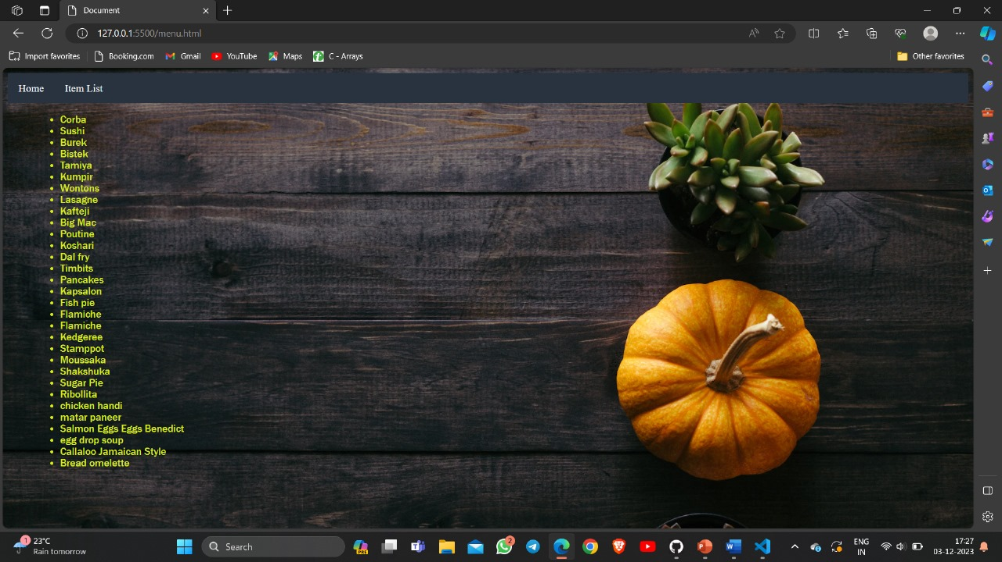

**Technology**

**What is HTML ?**

HTML, which stands for HyperText Markup Language, is the standard markup language used to create and design the structure of web pages and web applications. It is an essential component of the World Wide Web and is used in conjunction with other

technologies like Cascading Style Sheets (CSS) and JavaScript to build dynamic and interactive websites.

HTML uses a system of markup tags to annotate the content of a web page. These tags

define the structure of the document, such as headings, paragraphs, lists, links, images, forms, and other elements. Each HTML tag consists of an opening tag, content, and a closing tag, and they are enclosed within angle brackets (**<** and **>**).

**<!DOCTYPE html>** declares the document type and version of HTML being used (HTML5

in this case).

**<html>** is the root element of the HTML document.

**<head>** contains meta-information about the HTML document, such as the title that

appears in the browser tab.

**<body>** contains the content of the HTML document, including headings, paragraphs,

lists, and images.

**<h1>** defines a top-level heading.

**<p>** defines a paragraph.

**<ul>** and **<li>** define an unordered list and list items, respectively.

**<img>** embeds an image with a specified source (**src**) and alternative text (**alt**).

HTML provides the basic structure and semantics of a web page, while CSS is used for styling and layout, and JavaScript is used for adding interactivity and dynamic behaviour to the web page. Together, these technologies form the foundation of modern web development.

**What is CSS ?**

CSS, or Cascading Style Sheets, is a style sheet language used for describing the

presentation and layout of documents written in HTML and XML. In simpler terms, CSS

allows web developers to control the appearance of web pages, defining how elements

should be displayed on a screen, printed, or even spoken.

CSS allows the separation of document content (HTML) from document presentation

(CSS). This separation makes it easier to maintain and update the visual style of a website

without altering its content.

CSS uses selectors to target HTML elements and declarations to define the style

of those elements.

**What is Javascript ?**

JavaScript is a high-level, versatile, and interpreted programming language primarily

known for its role in building dynamic and interactive web pages. It is a core technology

for front-end web development and is widely used to enhance user experience by

enabling client-side interactivity within web browsers.

**Conclusion**

Recipe application has a function to find recipes with ingredients that match what is owned by the user . This is a personalised app which is useful to those who don’t know cooking. Users can find recipes either by selecting ingredients from the application or by using image processing method to scan the list of available ingredients to get the recipes accordingly. Based on users health preferences ,the recipes are filtered.

**References**

**. Google**

**. YouTube**

**. StackOverflow**

**.Github**