Problem Statement

Design an Employee Performance and Salary Analysis System using Python and Pandas. The system should analyze employee data to support salary decisions, promotions, and workforce management.

Enter the following dataset manually.
Employee Table:
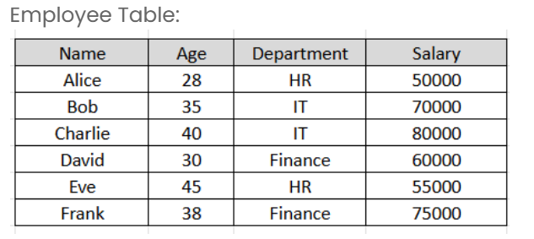

The system should:
- Store employee details such as Name, Age, Department and Salary
- Add employee experience data
- Experience column is generated using NumPy with np.random.seed(1) and np.random.randint(1, 10, size=6)
- Calculate average salary of each department
- Find highest paid employee with more than 5 years experience
- Identify department with youngest average age
- Calculate bonus and total salary
- Display employees earning above department average salary

Implement the following:
- Use pandas.DataFrame for storing and manipulating employee data
- Use groupby() with mean() for department-level aggregations
- Use np.random.seed(1) and np.random.randint(1, 10) for reproducible experience data
- Use idxmax() and idxmin() for finding top/bottom performers
- Use map() with department averages to filter employees above department average
- Apply integer arithmetic for bonus: Salary * 10 // 100

Bonus = Salary x 10 / 100
Total Salary = Salary + Bonus
Input format :
No user input required. The program uses a fixed dataset of 6 employees with NumPy random seed 1 for experience data.
Output format :
The first line of output prints Average Salary by Department: followed by the department-wise average salary.
The second line of output prints Highest Paid Employee: followed by the name of the highest paid employee with more than 5 years experience.
The third line of output prints Department with Youngest Average Age: followed by the department name.
The fourth line of output prints Employees Above Department Average Salary: followed by the names of qualifying employees.
Refer to the sample output for formatting specifications.
Code constraints :
Fixed dataset of exactly 6 employees
Three departments: HR, IT, Finance
Fixed random seed = 1 for experience generation
Experience values are integers in range [1, 10)
Bonus rate = 10%
Only employees with Experience > 5 are considered for highest paid
Sample test cases :
Input 1 :
Output 1 :
Average Salary by Department:
Department
Finance 67500.0
HR 52500.0
IT 75000.0
Name: Salary, dtype: float64

Highest Paid Employee:
Charlie

Department with Youngest Average Age: Finance

Employees Above Department Average Salary:
2 Charlie
4 Eve
5 Frank
Name: Name, dtype: object
Note :
The program will be evaluated only after the “Submit Code” is clicked.
Extra spaces and new line characters in the program output will result in the failure of the test case.

