Single File Programming Question
Problem Statement

Design a Student Course Enrollment Analysis System using Python and Pandas. The system should combine student and course datasets and perform group-based analysis.

Enter the following dataset manually.

Students Table:
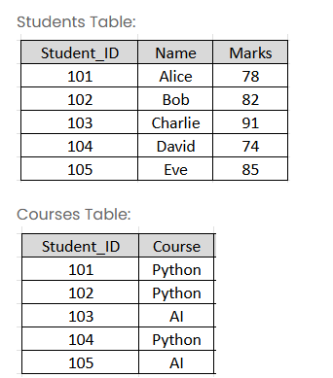

The system should:
- Store student details and course enrollment in separate DataFrames
- Merge both datasets using Student ID
- Calculate average marks by course
- Find highest scoring student
- Count students enrolled in each course
- Display students scoring above course average
- Identify course with highest average marks

Implement the following:
- Use pandas.merge() to combine the two DataFrames on Student_ID
- Use groupby() with aggregation (mean(), size()) for course-level analytics
- Use idxmax() to identify top performers
- Use filtering with map() to compare individual marks against course averages
Input format :
No user input required. The program uses fixed datasets of 5 students and their course enrollments.
Output format :
The first line of output prints Merged Data: followed by the combined DataFrame.
The second line of output prints Course Average: followed by the average marks per course.
The third line of output prints Highest Scoring Student: followed by the student name.
The fourth line of output prints Students Per Course: followed by the count per course.
The fifth line of output prints Students Above Course Average: followed by the names of qualifying students.
The sixth line of output prints Best Course: followed by the course with the highest average marks.
Refer to the sample output for formatting specifications.
Code constraints :
Fixed dataset of 5 students.
Fixed course enrollment for 5 students.
Sample test cases :
Input 1 :
Output 1 :
Merged Data:
Student_ID Name Marks Course
0 101 Alice 78 Python
1 102 Bob 82 Python
2 103 Charlie 91 AI
3 104 David 74 Python
4 105 Eve 85 AI

Course Average:
Course
AI 88.0
Python 78.0
Name: Marks, dtype: float64

Highest Scoring Student: Charlie

Students Per Course:
Course
AI 2
Python 3
dtype: int64

Students Above Course Average:
1 Bob
2 Charlie
Name: Name, dtype: object

Best Course: AI
Note :
The program will be evaluated only after the “Submit Code” is clicked.
Extra spaces and new line characters in the program output will result in the failure of the test case.

