**Crypto- Lab 5**

**1. Write a Python Program to perform brute force attack on the cipher text “dvvkzecfssprkkve"**

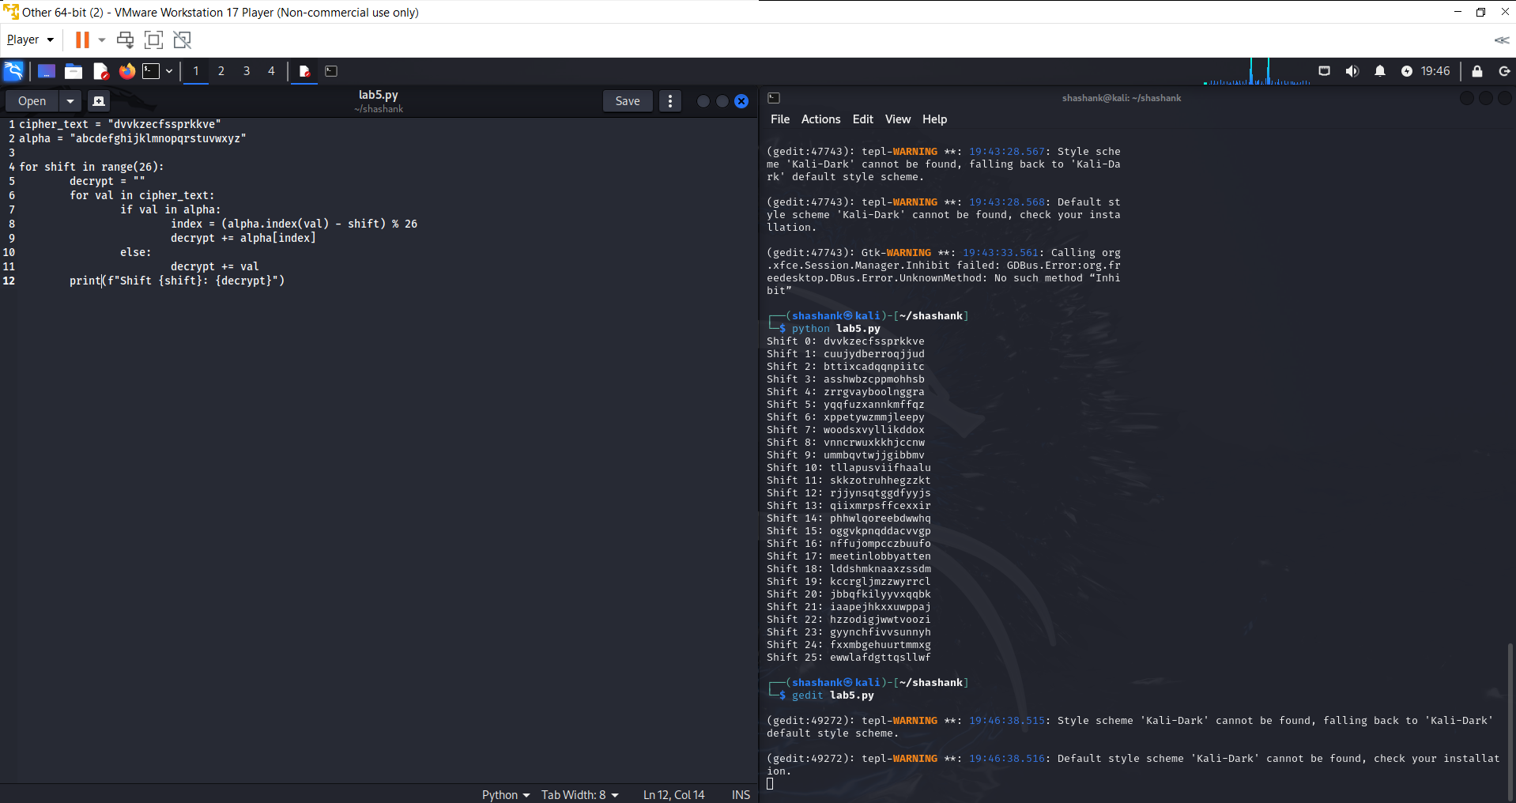

**2. Write a Python program to use brute force attack to decipher the message.**

**Assume Affine cipher was used and "ab" is encrypted as "GL". Find the value of keys.**

**XPALASXYFGFUKPXUSOGEUTKCDGFXANMGNVS**

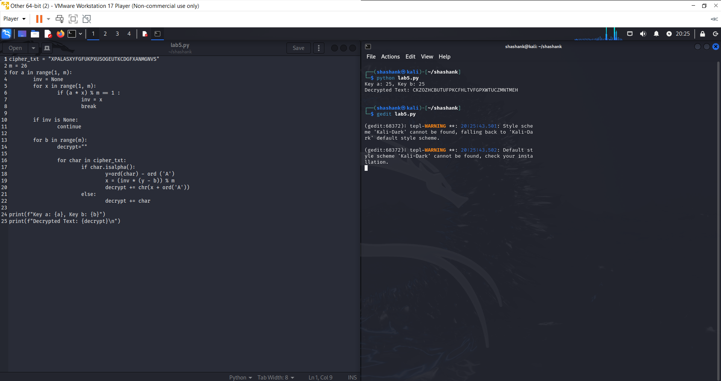

**3. Encrypt the plain text using Rail Fence cipher.**

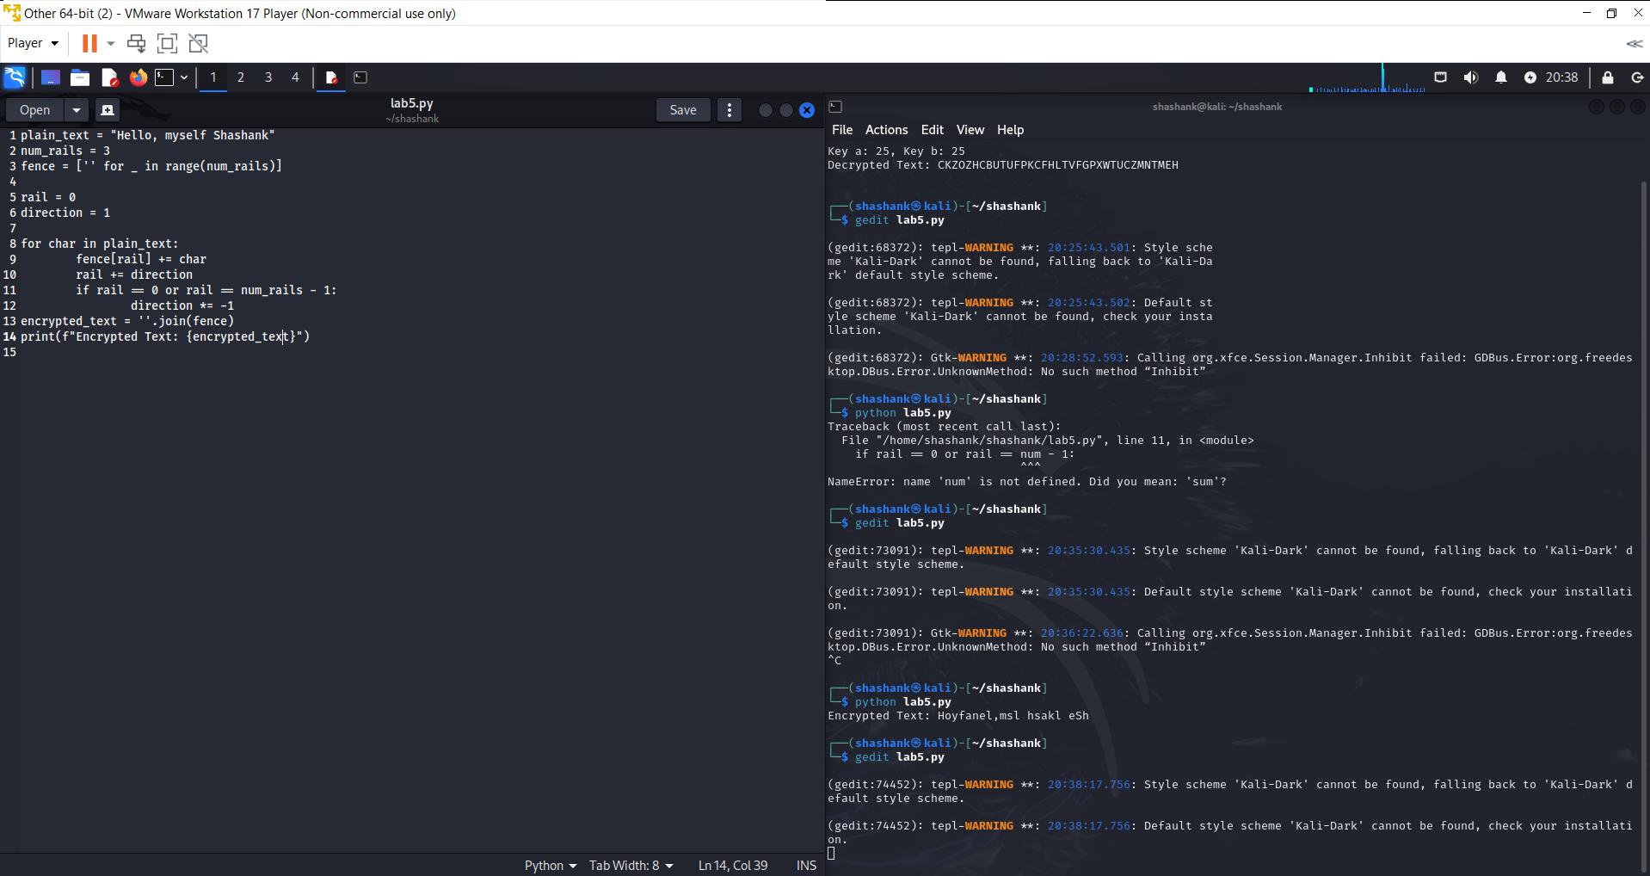

**Decrypt the cipher using Rail Fence**

**AAIUJ SIHBE KTEAO TEADE SNUTF EAEMR TAHSA**

**RHROA YHNFO AITTE EHCBO FVCAT RNMNS NUTFE**

**RASHL WFHLN HIUJS IHTKS OEHNI FISAE FNTIG**

**RMRSO LSTIS OKIEH PEOE**