1. Write a python script to encrypt the string using Caesar cipher.

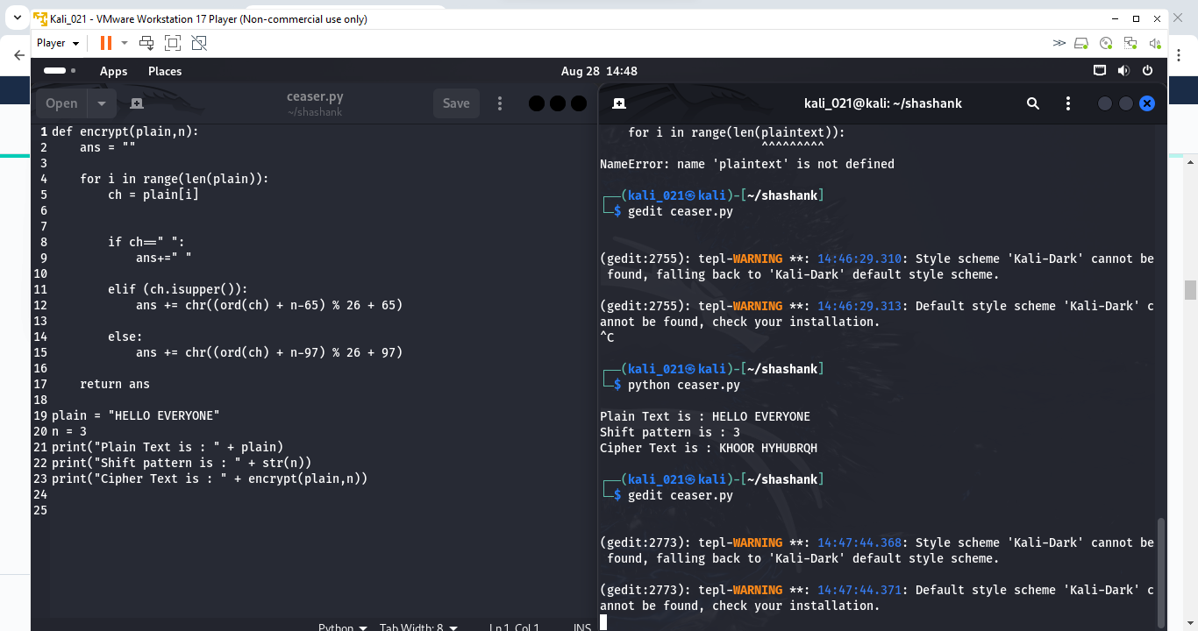

1. Write a Python script to Modify the above script to shift cipher based on user choice.

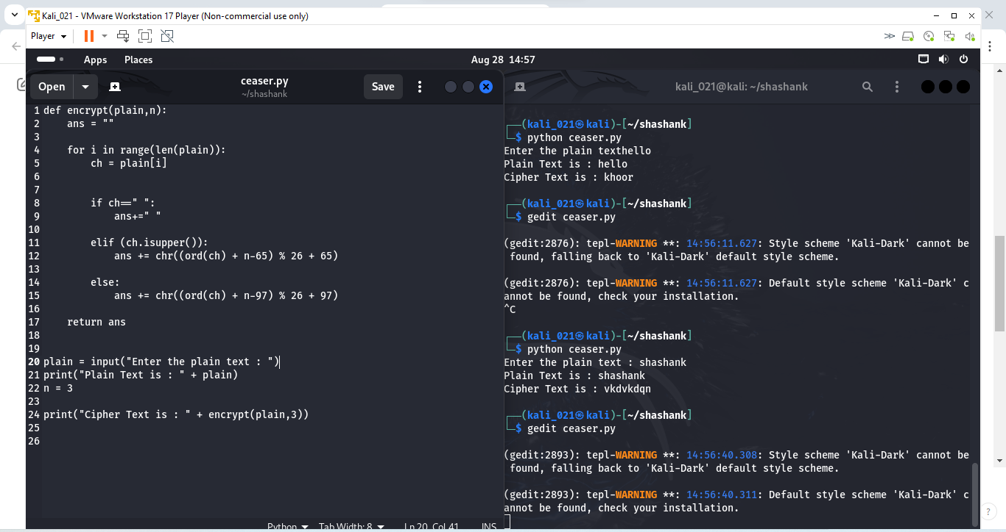

1. Write a Python script to convert cipher text into uppercase characters and split the cipher into group of 5 of characters.

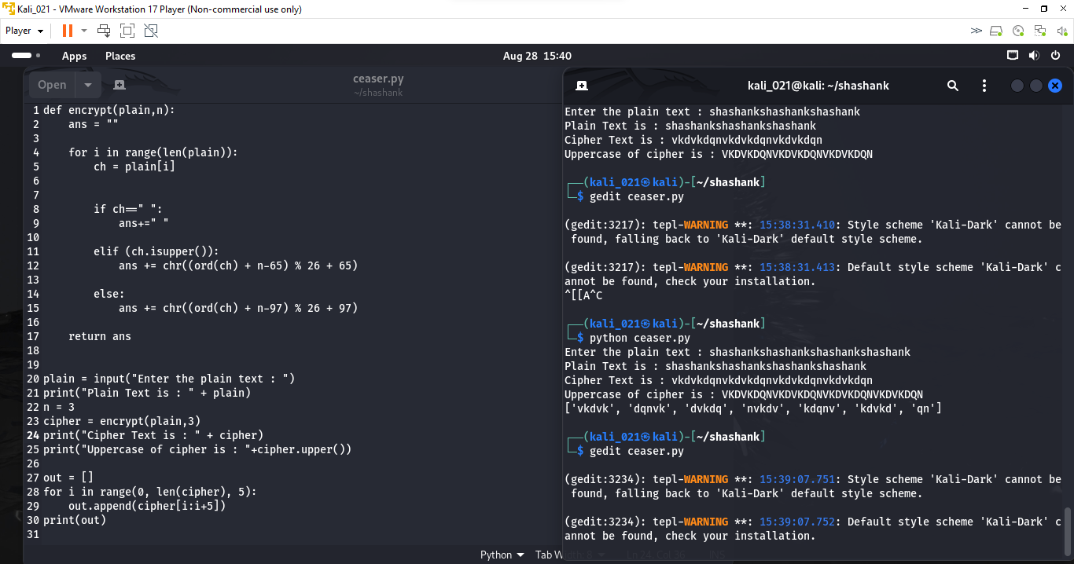

1. Write a Python program to Find the histogram for each characters.

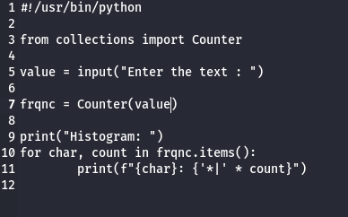

1. Write a Python script to read the contents from the file.

6. Write a Python script to encrypt the contents from the file.

7. Do validation to the python program (2)

- not to accept special characters

- not to accept numeric values

- not to accept empty value

- accept only string

- string should be lowercase if not convert the case

8. Write a Python program to checks if two given strings are anagrams of each other.

example: mug, gum

cork, rock

note, tone

9. Write a Python program to check the given string is palindrome or not

Do not use built in functions

Example: MADAM

RACECAR

LEVEL

CIVIC

10. Write a Python program to check if a substring is present in a given string.

Example: Understand -- stand

11. Explore string module

import the string module in your python script.

print all the lowercase characters

print all the uppercase characters

print all the lowercase and uppercase characters

print all the digits

print all the punctuation symbols

count the total number of punctuation symbols

Programming is a skill best acquired by practice and example rather than from books -- unknown

The only way to do great work is to love what you do --Steve Jobs