**Task 2:**

**<meta>**: Defines metadata about the HTML document

The **<meta http-equiv="content-type" content="text/html; charset=UTF-8">** tag in HTML specifies the character encoding for the web page. Here's a breakdown:

* **http-equiv="content-type"**: Informs the browser that the type of content is specified.
* **content="text/html; charset=UTF-8"**: Indicates the document is HTML and uses the UTF-8 character encoding.

**<meta name="viewport" content="width=device-width, initial-scale=1, maximum-scale=1, user-scalable=0"/>**

Purpose: Ensures responsive design by controlling how the website appears on different devices.

* width=device-width: Sets the width of the viewport to the device's screen width.
* initial-scale=1: Sets the initial zoom level to 100%.
* maximum-scale=1: Prevents the user from zooming in.
* user-scalable=0: Disables user zooming altogether.

**<meta http-equiv="X-UA-Compatible" content="ie=edge"/>**

* **Purpose**: Ensures compatibility with Internet Explorer (IE).
* **ie=edge**: Tells IE to use the latest rendering engine available instead of older, backward-compatible modes.

**<meta name="format-detection" content="telephone=no"/>**

• **Purpose**: Prevents the browser (primarily on mobile devices) from auto-detecting and formatting phone numbers into clickable links.

• **content="telephone=no"**: Disables phone number detection.

**<meta name="keywords" content="Institution, Engineering, MIT Manipal, Manipal Institute Of Technology, Manipal Academy of Higher Education, BTech &amp; MTech Courses , MTech Courses, Application Form - MIT, mit, Manipal Institute of Technology, Faculty of Technology &amp; Science , Engineering, Manipal, Automobile Engineering"/>**

* **Purpose**: Defines keywords related to the content for search engines.
* **content**: A comma-separated list of relevant keywords to improve SEO. These keywords help describe the page's content, but modern search engines like Google rely less on them.

**<meta name="description" content="MIT college is one of the Top Ranked Engineering Colleges in India. Find Complete Information of MIT Manipal Engineering course details, Eligibility, Fees &amp; Admission form at MAHE."/>**

• **Purpose**: Provides a summary of the page's content for search engines and users. Appears in search engine results.

• **content**: A concise, keyword-rich description that improves SEO and user click-through rates.

**Heading <h1> <h2> <h3> tags :**

• <h1> is the top-level heading.

• <h2> is a subsection under <h1>.

• <h3> is a subsection under <h2>, and so on.

Semantic Elements <header>, <footer>, <section>

<header> : Represents the introductory content or a container for navigational links for a webpage or a specific section.

<footer> : Represents the footer content of a webpage or a section.

<section> : Used for logical grouping of content.

**Multimedia**: It is the integration of multiple forms of media in digital or physical formats to deliver content. It combines text, audio, video, images, animations, and interactivity to create engaging and informative experiences.

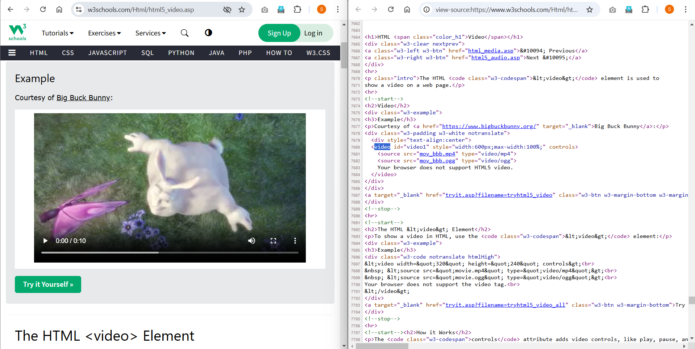

Found iframe sandbox in the w3schools.

The sandbox attribute on the <iframe> element restricts the behaviour of embedded content, limiting what it can do on the parent webpage. 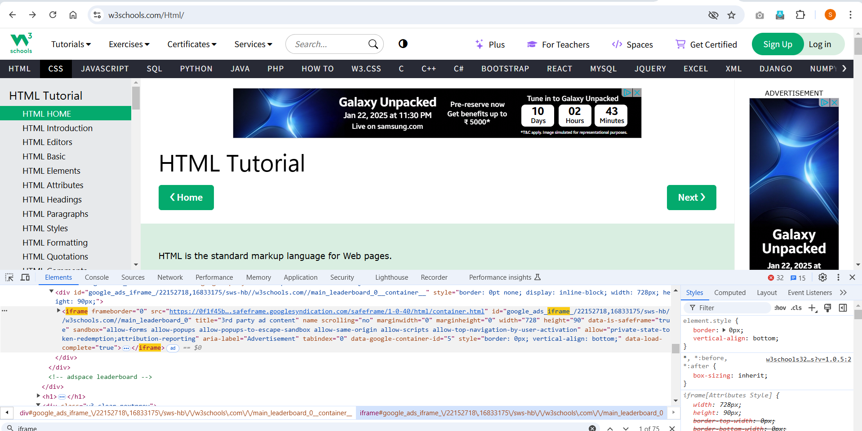

CORS (Cross-Origin Resource Sharing):

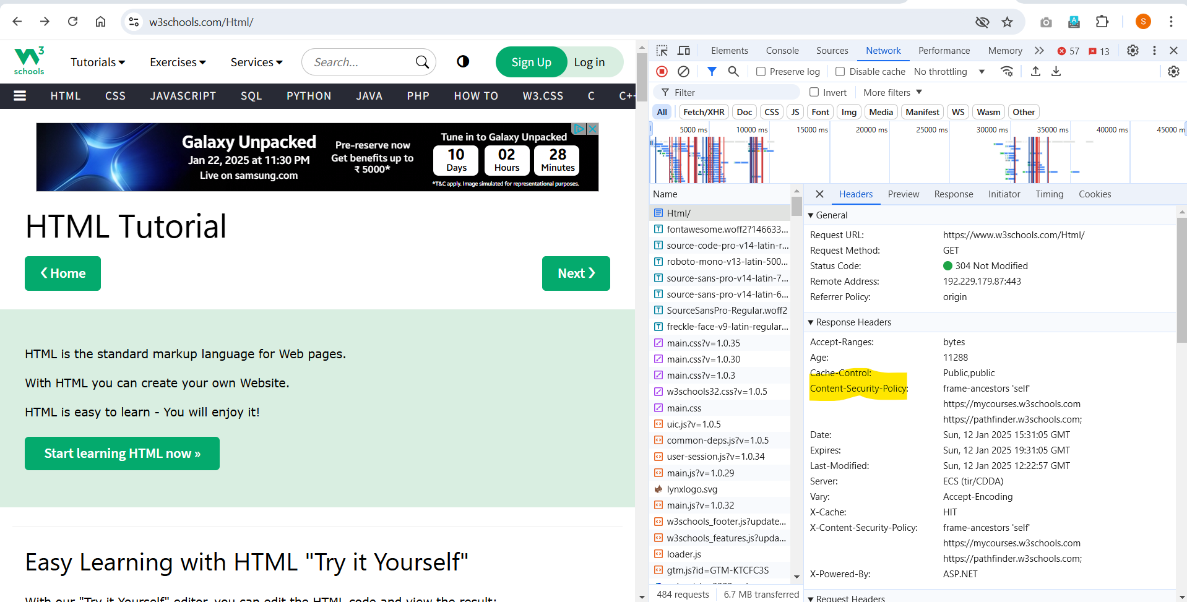

SRI (Subresource Integrity):

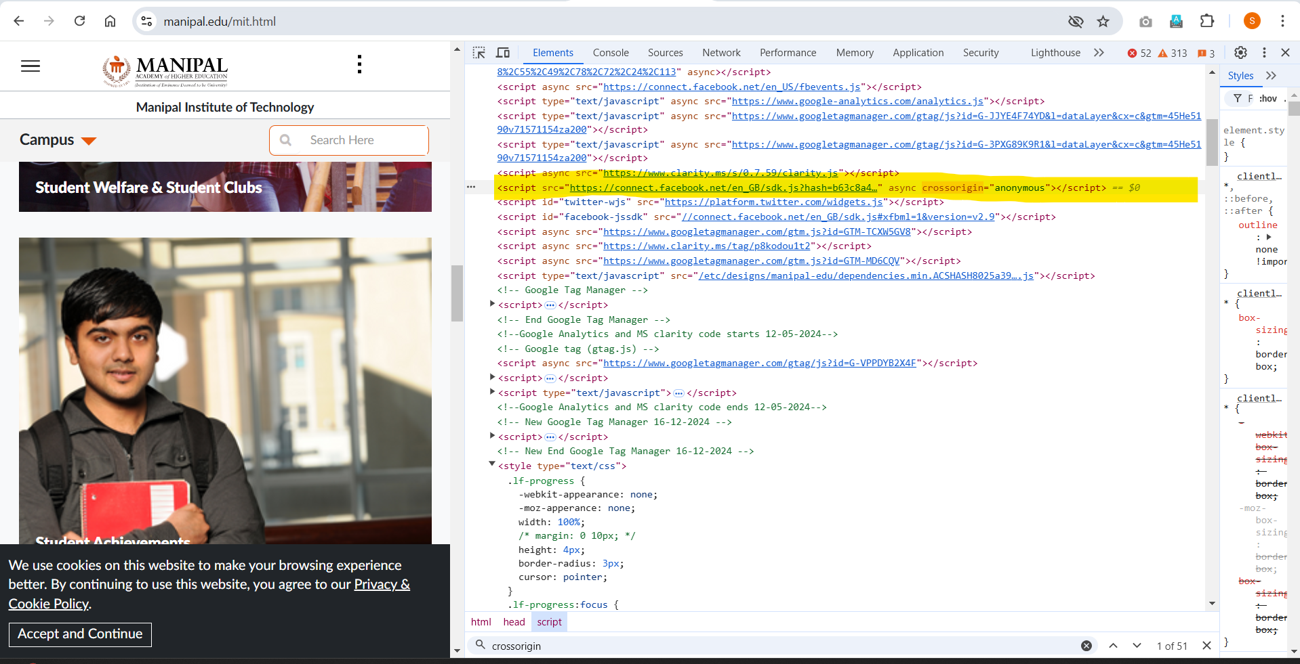

Task 3: Inspect the Source Code of Your Page

Inspect the page you created in Task 1 using your browser’s developer tools. Analyze the structure and content of the page and make sure the HTML elements are correctly implemented.

Task 4: Apply Styles Using CSS

In a separate external CSS file, apply the following styles to the webpage you created in Task 1:

Change the font color of the <h1> heading.

Set the background color of the page.

Set the font size of the paragraph <p> to 16px (or as desired).

Style the list (<ul> or <ol>) by adding bullets and setting the list items to have a margin of 10px.

Add a border and padding to a <div> container element.

You may also apply additional styles of your choice to enhance the page.

* + Refer styles.css and lab1_1.html