Who is the domain registrar of www.manipal.edu?

What is the domain creation date?

What is the expiration date of the domain?

Identify the name servers associated with the domain.

Is there any contact email provided for administrative or technical support?

What country is the domain registered in?

Run a WHOIS query for example.com and check if the registrant’s details (name, address, email) are visible.

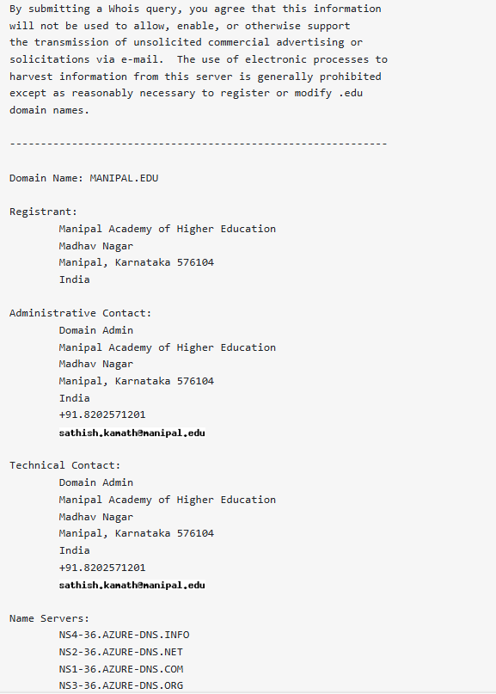

If privacy protection is enabled, what information is displayed instead of actual owner details?

* Address, technical person and his contact details

What are the security implications of exposing or hiding data?

* Exposing the data will lead to phishing attacks, brute force attacks and social engineering attacks++ Hiding the data we make full stop for all of these by, we cannot verify the legitimacy of the website.

Look for Name Server (NS) records and associated domains.

what are the different methods to find the subdomain using both passive and active methods.

* For passive method we can use google dorking where for active method we can use gobuster, ffuf etc

Identify CMS (WordPress, Joomla, etc.) and frameworks used.

compare whatweb and wappalyzer

* whatweb is a command line tool where are wapplyzer is a browser extension.

Fetch the HTTP Header ( Many methods are available). Identify the tools used to find HTTP Header details

* the tool use here is curl -I manipal.eduA computer screen shot of a computer

  AI-generated content may be incorrect.

Check whether domain have firewall installed or not

do they have load balancer

Search for exposed environment configuration files

Look for log files that may contain sensitive information

Find database backup files

Find live camera feeds

Search for open IoT device