**JMeter**

1. Perform 2 rounds of load testing with minimum 20 users, on OrangeHrm application using JMETER
2. Open the Jmeter
3. Give the name to the test plan

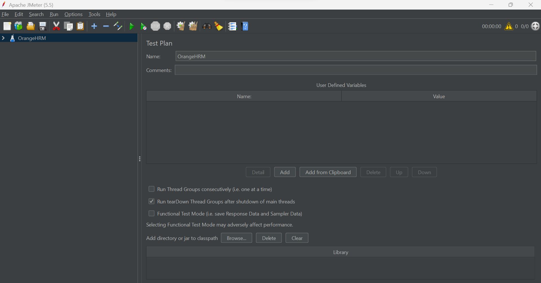

1. In the Thread Group, give a name to the thread group, add 20 user (Number of threads), with ramp-up period of 2 and the loop count of 2.

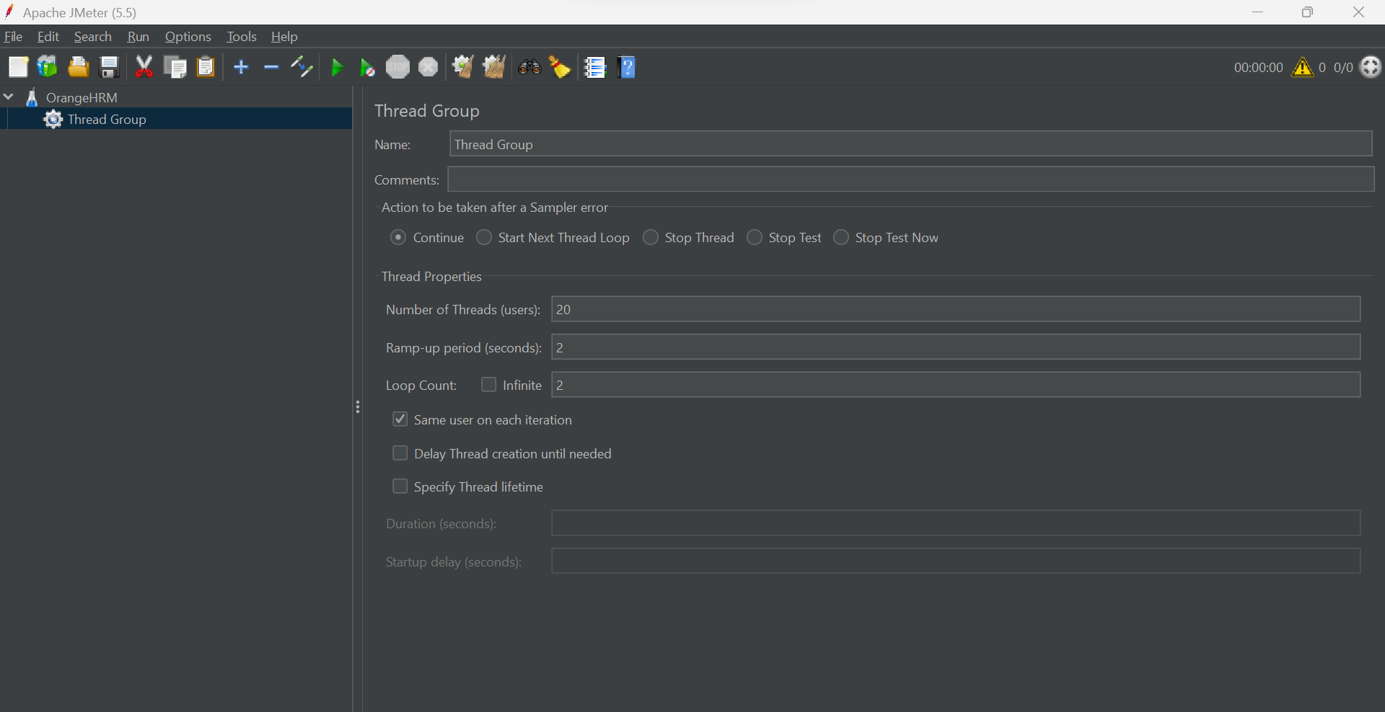

4.Create two HTTP request for login and admin page of OrangeHRM, give the source name and the path.

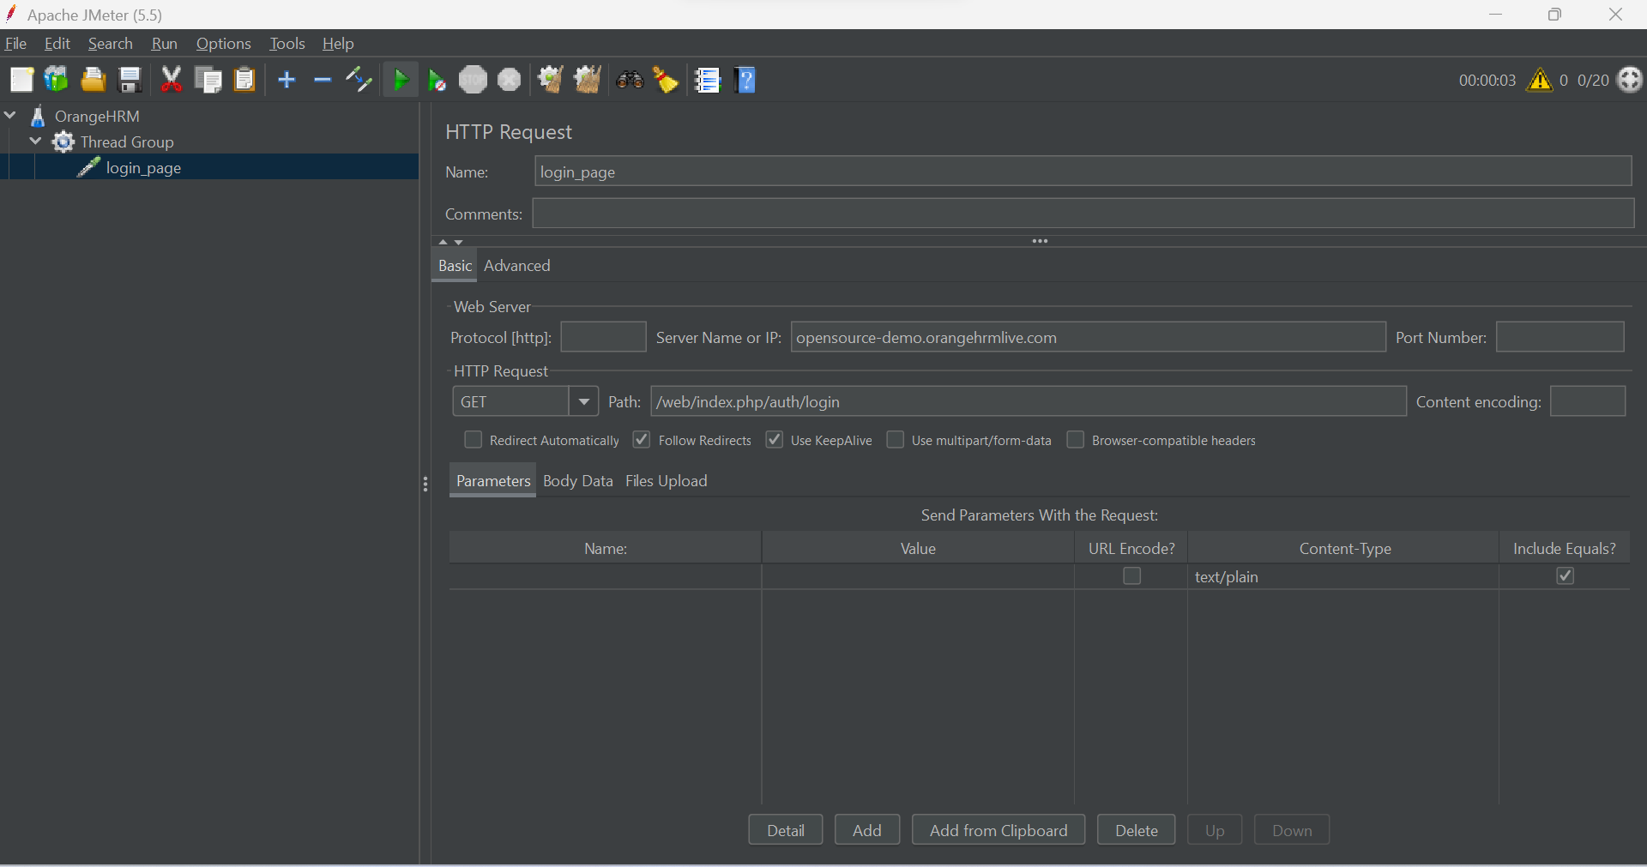

1. Create a loop controller with loop count of 2.

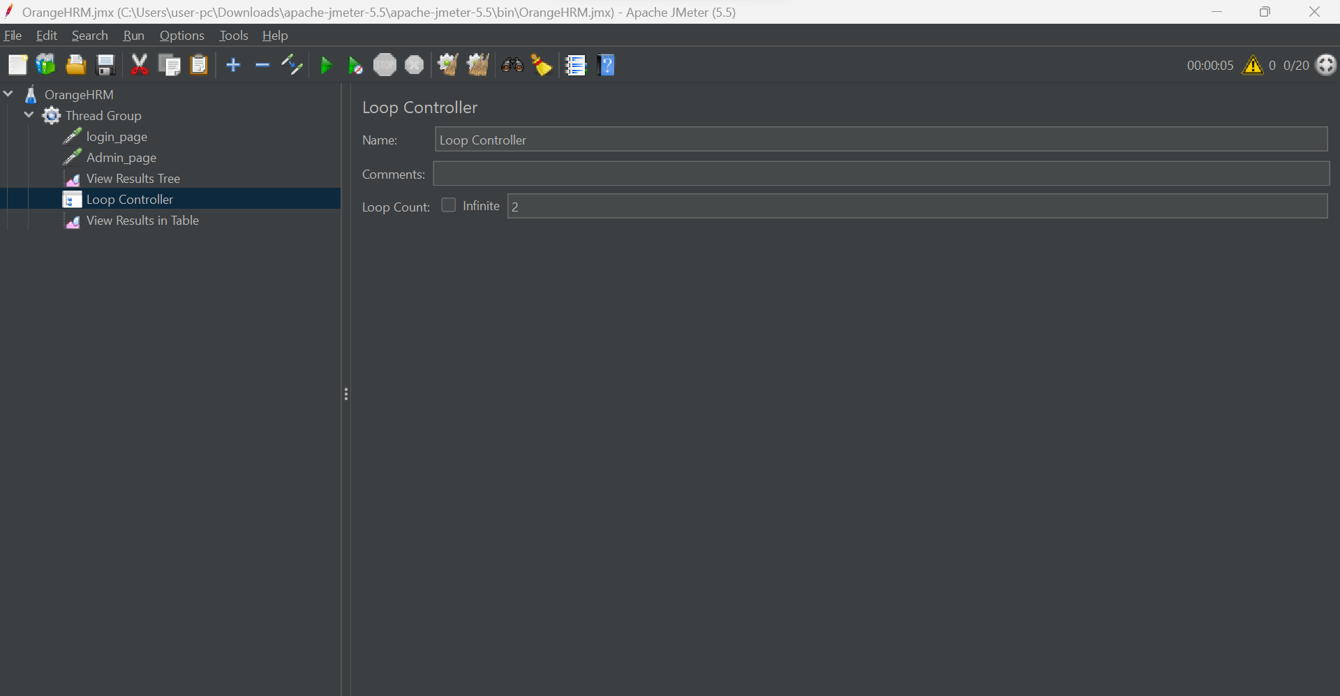

6.To view the results use View Results in Table and View Results Tree.

