MINOR PROJECT REPORT
INCOME CLASSIFICATION SYSTEM
A Machine Learning Based Web Application

Submitted By
Name: Shashant Sahu
Semester: 5th Sem
DERP - 6606190
B.Tech – Computer Science and Engineering

Declaration
I hereby declare that this report titled “Income Classification System” describes my Minor Project work, including its web interface, machine-learning models, evaluation results, and screenshots.
Name : Shashant Sahu

Acknowledgement
I would like to thank my faculty members and institution for the opportunity to work on this project. I also acknowledge the open-source Python and machine-learning tools used to develop the application.

Abstract
The Income Classification System is a machine-learning-based web application that predicts whether a person's income belongs to the <=50K or >50K category. It includes a dashboard, a prediction form, and a model-performance page. Logistic Regression and Decision Tree classifiers are evaluated using accuracy, precision, recall, F1 score, and confusion matrices. In the displayed results, Decision Tree achieves 85.5% accuracy and a 67.1% F1 score, while Logistic Regression achieves 84.7% accuracy and a 65.8% F1 score.

Table of Contents
1. Introduction
2. Problem Statement and Objectives
3. Dataset and Features
4. Methodology
5. System Design and Technology
6. Implementation
7. Results and Evaluation
8. Website Screenshots
9. Testing
10. Limitations and Future Scope
11. Conclusion
12. References
Appendix: Running the Project

1. Introduction
Income classification is a binary classification task that estimates an income category from personal and employment-related attributes. This project combines supervised machine-learning models with a web interface so users can enter feature values, view a prediction, and compare model evaluation results.

2. Problem Statement and Objectives
The problem is to build a web-based system that classifies a person into the <=50K or >50K income category using selected attributes, and presents model performance in an understandable format.
- Create a dashboard summarizing the dataset and models.
- Use Logistic Regression and Decision Tree classifiers.
- Display accuracy, precision, recall, F1 score, and confusion matrices.
- Provide a form for entering personal and employment details.
- Show the predicted income category for the selected model.

3. Dataset and Features
The interface identifies the source as the UCI Adult dataset. The dashboard reports 30,139 dataset records, with 75.1% in the <=50K category and 24.9% in the >50K category. The exact preprocessing and data split should be confirmed from the source code.
Features shown in the prediction form: Age, Education, Work Class, Occupation / Job, Marital Status, Sex, Hours per Week, Capital Gain, and Capital Loss. The target categories are <=50K and >50K.
Dataset source: UCI Machine Learning Repository, Adult dataset: https://uci-ics-mlr-prod.aws.uci.edu/dataset/2/adult

4. Methodology

4.1 Preprocessing
The project dashboard describes a pipeline of input data, preprocessing, machine-learning model, and prediction. Categorical values must be encoded and the input prepared in the same format used for training. Refer to train_model.py for the exact implementation.

4.2 Logistic Regression
Logistic Regression is a supervised classification algorithm that estimates the probability of a binary outcome. It is one of the models available in this application.

4.3 Decision Tree
A Decision Tree classifier applies a sequence of feature-based splits to assign a class. It achieves the highest displayed accuracy in this project's evaluation.

4.4 Evaluation metrics
- Accuracy: proportion of all evaluated cases classified correctly.
- Precision: proportion of predicted positive cases that are truly positive.
- Recall: proportion of actual positive cases identified.
- F1 score: harmonic mean of precision and recall.
- Confusion matrix: summarizes correct and incorrect predictions for each class.

5. System Design and Technology
Application flow: the user enters personal/employment details and selects a model; the application processes the values and displays an income category and the estimated probability for the >50K class. The performance page presents model metrics and confusion matrices.
- Python — application and machine-learning logic.
- Pandas — tabular data processing.
- Scikit-learn — classification and evaluation.
- Joblib — saved model artifacts, as indicated by the project structure.
- Flask — web application framework.
- HTML and CSS — interface and styling.
- Git/GitHub — source control; Render — deployment.
Main files: app.py (Flask app), train_model.py (training/evaluation), model/ (saved models and metrics), templates/ (HTML pages), static/style.css (styling), requirements.txt (dependencies), and Procfile (deployment configuration).

6. Implementation :
The application provides Dashboard, Predict, and Model Performance views. The dashboard summarizes dataset distribution and compares models. The prediction page collects feature values and a model selection. The evaluation page shows model metrics and confusion matrices.
The provided prediction screenshot shows an example with age 27, education Some-college, work class Self-emp-inc, occupation Tech-support, marital status Never-married, sex Male, 40 hours per week, and capital gain/loss set to zero. With Logistic Regression selected, the displayed result is <=50K and the displayed probability of >50K is 4.2%. This is an example output, not an overall performance metric.

7. Results and Evaluation :
The following values are transcribed from the provided Model Performance screenshot.
Model | Accuracy | Precision | Recall | F1 Score
Logistic Regression | 84.7% | 73.8% | 59.4% | 65.8%
Decision Tree | 85.5% | 77.3% | 59.2% | 67.1%
Decision Tree has the highest displayed accuracy (85.5%), precision (77.3%), and F1 score (67.1%). Logistic Regression has a slightly higher displayed recall (59.4% versus 59.2%). Based on accuracy and F1 score, Decision Tree is the stronger overall model in the displayed results.

7.1 Confusion matrices
Model | Actual <=50K / Pred <=50K | Actual <=50K / Pred >50K | Actual >50K / Pred <=50K | Actual >50K / Pred >50K
Logistic Regression | 4211 | 316 | 609 | 892
Decision Tree | 4266 | 261 | 612 | 889
The confusion-matrix counts are reproduced from the screenshot. They appear to represent an evaluation subset rather than all 30,139 records reported by the dashboard.

8. Website Screenshots :

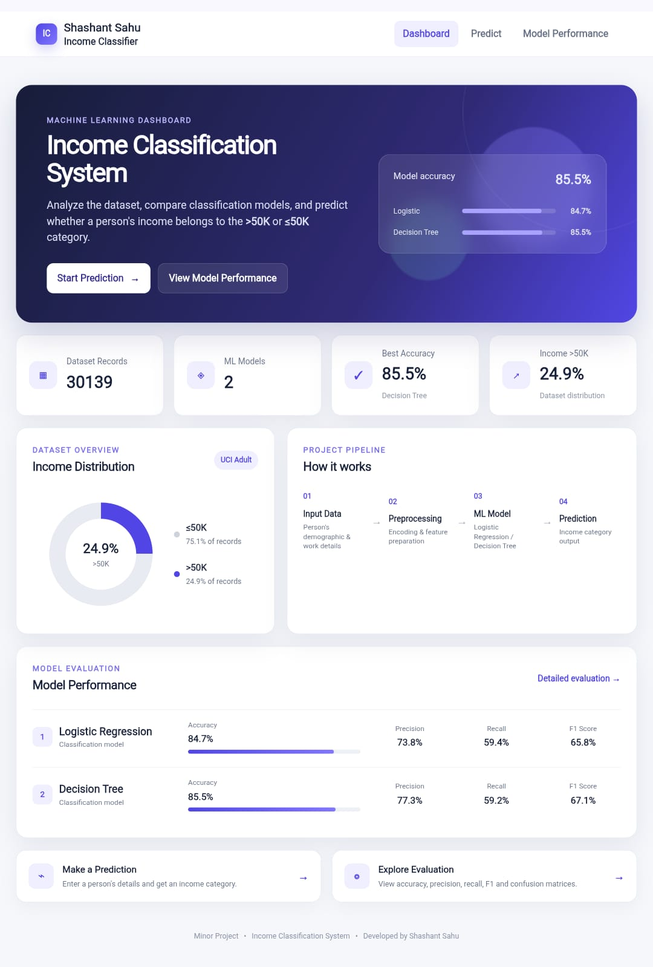
Figure 2. Prediction form and example result

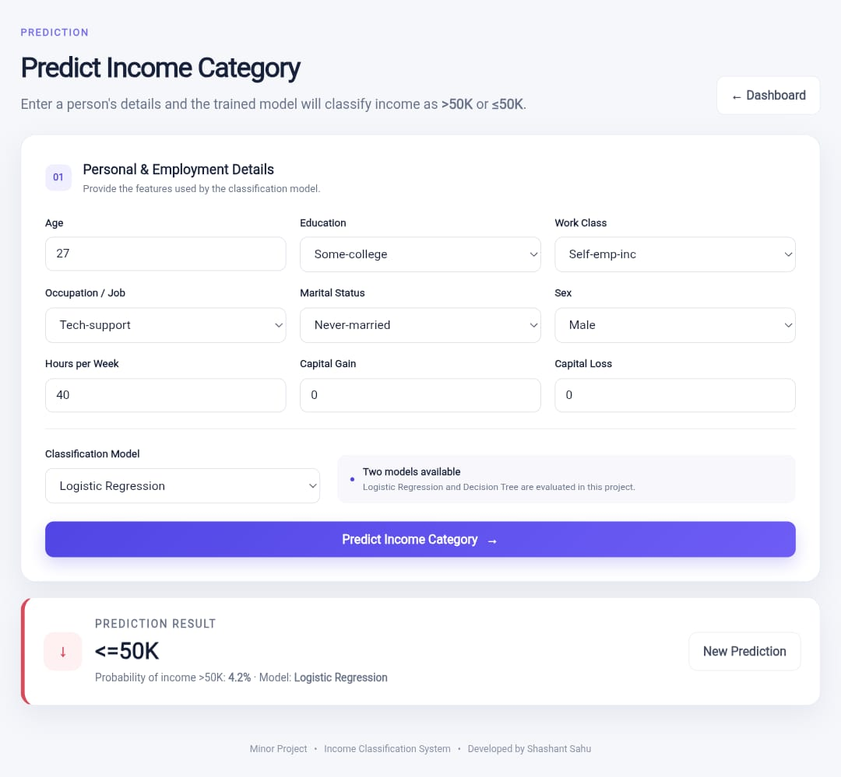
Figure 2: Prediction form and example Logistic Regression output: <=50K, with displayed probability of >50K of 4.2%.

Figure 3. Model performance and confusion matrices
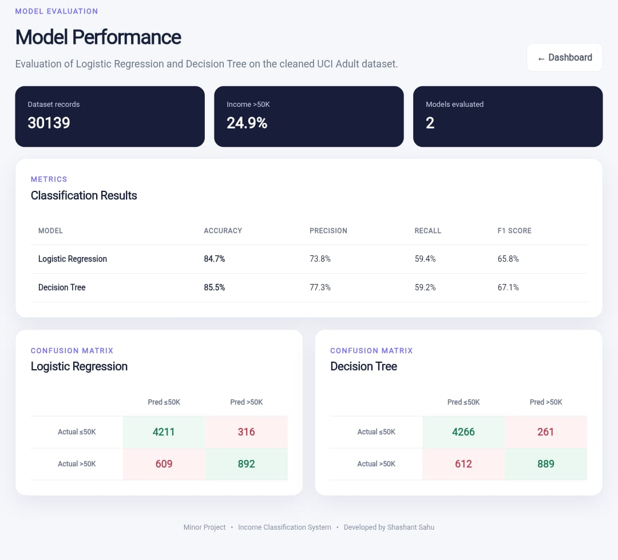
Figure 3: Evaluation metrics and confusion matrices for Logistic Regression and Decision Tree

9. Testing :
Test case | Expected behavior | Evidence in screenshots
Dashboard | Show summary and model comparison | Dashboard shows records, class distribution, and metrics.
Prediction form | Accept feature values and model selection | Input fields and model selector are visible.
Prediction output | Display an income category | Example output displays <=50K.
Model evaluation | Display metrics and confusion matrices | Both models' metrics and matrices are visible.

10. Limitations and Future Scope :
- Predictions depend on the training data, preprocessing, and model configuration.
- The source data may contain biases; predictions should not be the sole basis for real-world financial or employment decisions.
- A model's probability estimate does not guarantee a person's actual income.
- Future improvements may include cross-validation, explainability, more robust validation, input validation, and fuller documentation of preprocessing and model settings.

11. Conclusion :
The Income Classification System demonstrates an end-to-end machine-learning web application for binary income classification. It includes a dashboard, prediction form, and model evaluation page. Decision Tree achieves 85.5% accuracy and a 67.1% F1 score in the displayed results, while Logistic Regression achieves 84.7% accuracy and a 65.8% F1 score. The project illustrates how supervised classification models can be presented through an accessible web interface.

12. References :
- UCI Machine Learning Repository, Adult dataset: https://uci-ics-mlr-prod.aws.uci.edu/dataset/2/adult
- Scikit-learn documentation: https://scikit-learn.org/stable/
- Pandas documentation: https://pandas.pydata.org/docs/
- Flask documentation: https://flask.palletsprojects.com/

13. Appendix: Running the Project :
pip install -r requirements.txt
python train_model.py # if models need retraining
python app.py
Use the exact commands and deployment configuration in the current repository if they differ. Before submission, replace the cover-page placeholders with your roll number, faculty/guide name, college/university name, and academic year. Verify preprocessing and training/test split details against train_model.py.

