VELLORE INSTITUTE OF TECHNOLOGY
School of Computer Science and Engineering
BCSE406L – NoSQL Databases
Fall Semester 2026-27 | Faculty: Dr. S. Geetha
Digital Assignment 1 – Review 1: Project Proposal & NoSQL Design
ThreatGraph: A Neo4j-Powered Cyber Intelligence Engine
A GraphRAG system correlating structured vulnerability data with unstructured threat intelligence using Neo4j
Team Members
Name | Registration No. | Primary Responsibility
Yuvraj Singh Hajari | 23BCE1995 | Graph data modelling and Neo4j database implementation
Shashwat Singh | 23BCE1517 | GraphRAG retrieval pipeline (vector search, multi-hop traversal, LLM synthesis)
Samarth Mishra | 23BCE1881 | Application interface, query design and dataset curation

1. Problem Statement
Security teams today track vulnerabilities (CVEs), the threat actors who exploit them, and the software those vulnerabilities affect as three separate, loosely connected sources: CVE databases, actor profiles from threat intel vendors, and free-text advisory reports. Answering a practical question such as “which threat actors target our database systems, and how do we mitigate that” currently means manually cross-referencing all three. A relational join can connect the structured records, but it cannot reason over the unstructured mitigation text inside advisory reports, and a plain keyword or vector search over the reports cannot recover the structured actor-to-CVE-to-software relationships. This project builds a single connected graph that holds both, and a retrieval pipeline that queries across both at once, so this kind of question can be answered directly instead of being pieced together by hand.

2. Objectives
- Model threat actors, vulnerabilities, affected software, and threat intelligence reports as a single connected property graph in Neo4j.
- Store vector embeddings of unstructured report and CVE-description text as node properties, and expose them through Neo4j's native vector index.
- Build a hybrid retrieval pipeline that combines vector similarity search with multi-hop Cypher traversal, rather than relying on vector search alone.
- Use an LLM to synthesise a natural-language answer grounded only in the graph context that was actually retrieved.
- Provide a Streamlit interface where a user can ask a question and see the answer, the Cypher that ran, and the graph nodes that were retrieved.

3. Existing System / Current Approach
At present, this kind of correlation is done manually or with siloed tools. CVE details are looked up in the National Vulnerability Database or vendor advisories. Threat actor attribution comes from separate vendor reports (Mandiant, CrowdStrike, and similar). Internal asset-to-software mappings, where they exist at all, live in spreadsheets or a relational CMDB. None of these systems store the relationships between actors, CVEs, and software as first-class, traversable links, so answering a multi-hop question means an analyst opening several sources and connecting the dots by hand. Where organisations have attempted this with a relational database, the actor-to-CVE and CVE-to-software relationships end up as junction tables, and any question that needs an unknown or variable number of hops (for example, “what else does this actor target”) turns into a recursive SQL query that is awkward to write and slow to run as the data grows.

4. Proposed System
ThreatGraph stores threat actors, vulnerabilities, software, and reports as nodes in Neo4j, connected by EXPLOITS, AFFECTS, and DESCRIBES relationships. Unstructured report text and CVE descriptions are embedded and stored directly as vector properties on their nodes, and indexed using Neo4j's native vector index. A query goes through three stages: a vector search finds the most semantically relevant report or CVE nodes for the question, a Cypher traversal expands one to two hops out from those seed nodes to pull in every connected actor, CVE, and software node, and an LLM is given that combined structured-and-unstructured context to produce the final answer. A Streamlit front end lets a user type a question and see the answer alongside the exact Cypher that ran and the nodes it touched, so the reasoning is inspectable rather than a black box.

5. Why NoSQL?
The core data here is relationships, not records: an actor's relevance to a question depends on which CVEs it exploits, which software those affect, and which reports describe those nodes, and the number of hops needed is not fixed in advance. Neo4j stores each relationship as a directly-traversable pointer, so walking from an actor to its CVEs to their software is a constant-time hop rather than a join whose cost grows with table size. A relational schema would need junction tables for EXPLOITS and AFFECTS, and any “find everything connected within N hops” query would need a recursive CTE that gets slower and harder to write as N grows. The schema is also expected to evolve, for example adding a TARGETS relationship to sectors, which a graph model absorbs without a migration, whereas a relational schema would need a new table and new foreign keys.

6. Selection of NoSQL Database
Database chosen: Neo4j (Community Edition, run locally via Docker; AuraDB is a drop-in alternative for cloud deployment).

Justification
- The problem is dominated by relationship-heavy, variable-depth queries (actor → CVE → software, and back), which is Neo4j's core strength over document or column-family stores.
- Neo4j 5.x has a native vector index (db.index.vector.queryNodes), so the same database can serve both the structured graph traversal and the vector similarity search, without needing a separate vector database bolted on.
- Cypher's pattern-matching syntax (MATCH (a)-[:EXPLOITS]->(v)-[:AFFECTS]->(s)) reads close to the question being asked, which keeps the query layer maintainable as the schema grows.
- A document database (e.g. MongoDB) was considered, but it would force choosing between duplicating actor/CVE data inside every report document (embedding) or manually resolving reference IDs in application code for every multi-hop question (referencing), and Neo4j avoids that trade-off because relationships are native, not simulated.

7. NoSQL Data Model
ThreatGraph uses a property graph model: labelled nodes with key-value properties, connected by typed, directed relationships that can themselves carry properties if needed.
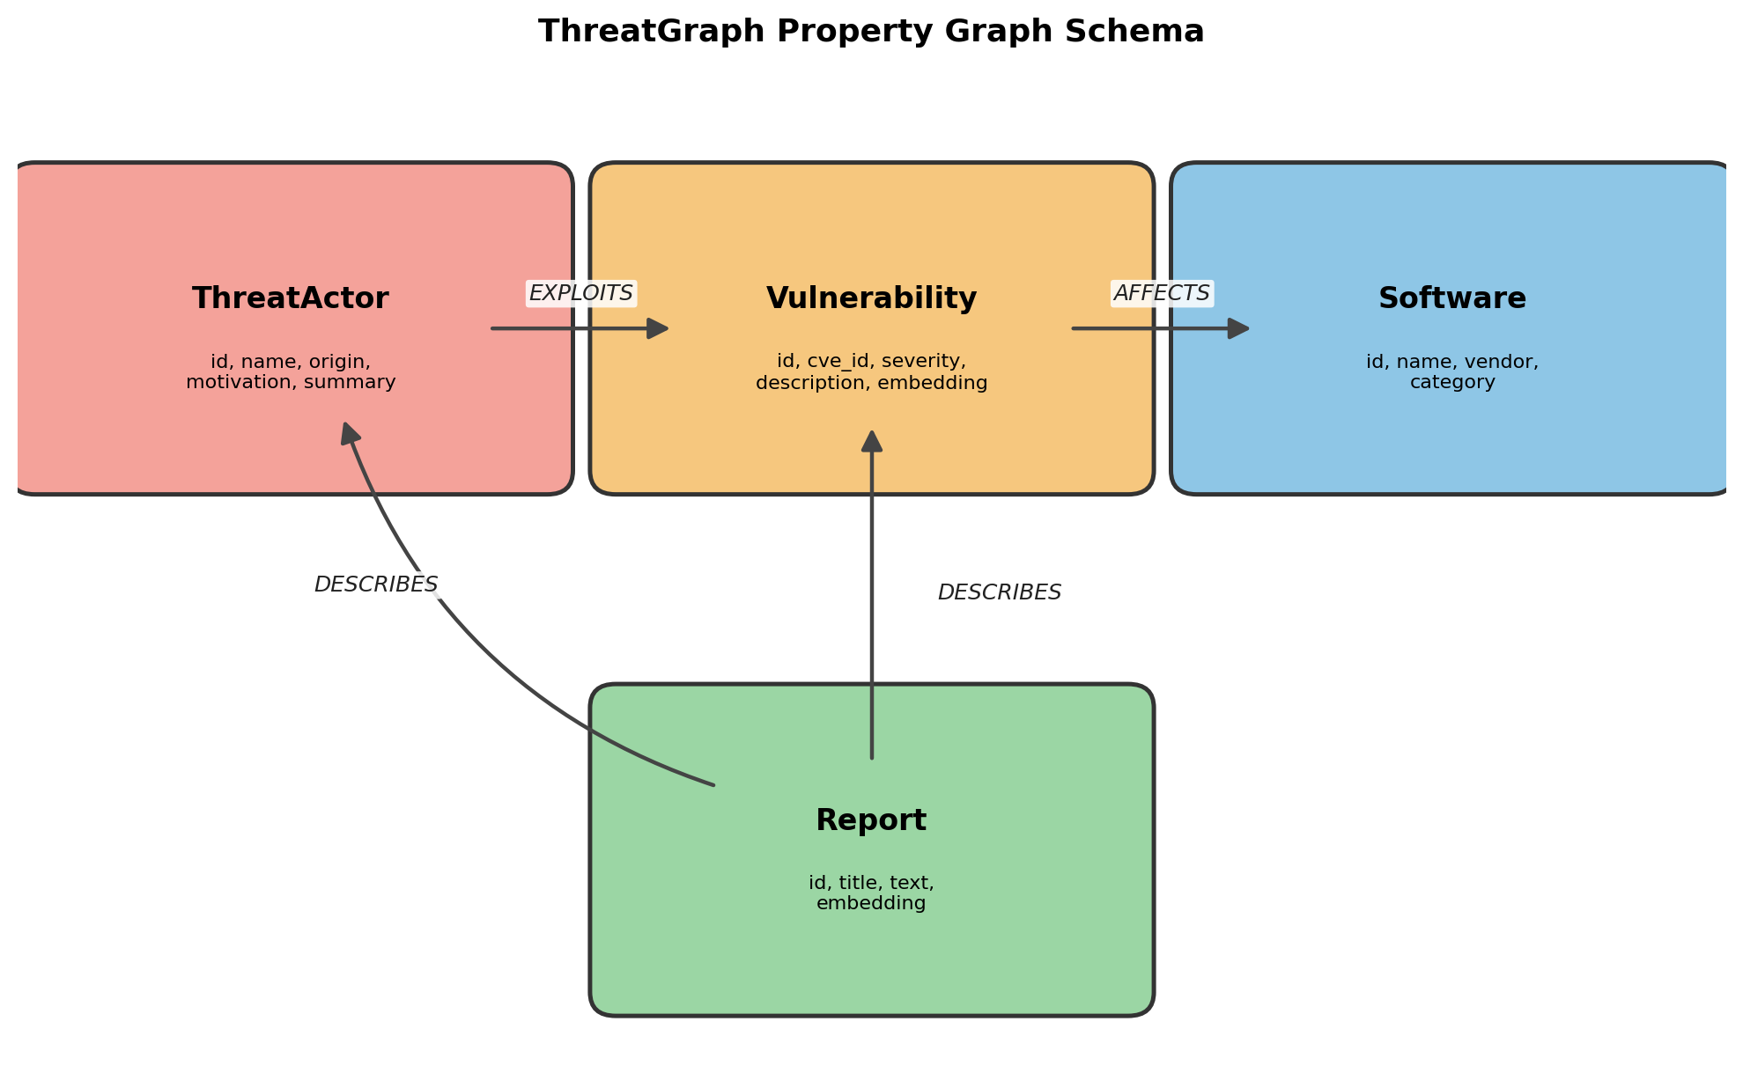

8. Initial Database Design

8.1 Conceptual (ER-like) view
Conceptually: a ThreatActor exploits one or more Vulnerabilities; each Vulnerability affects one or more Software products; each Report describes one Vulnerability and/or one ThreatActor. This is a many-to-many structure at every step: one CVE can be exploited by several actors, and one actor typically exploits several CVEs, which is exactly the shape that motivates a graph over a rigid relational schema.

8.2 NoSQL schema
(:ThreatActor {id, name, origin, motivation, summary})
(:Vulnerability:CVE {id, cve_id, severity, description, embedding})
(:Software {id, name, vendor, category})
(:Report {id, title, text, embedding})
(ThreatActor)-[:EXPLOITS]->(Vulnerability)
(Vulnerability)-[:AFFECTS]->(Software)
(Report)-[:DESCRIBES]->(Vulnerability)
(Report)-[:DESCRIBES]->(ThreatActor)

8.3 Sample records
Five representative nodes as they are actually stored in Neo4j (property maps), one per label plus one extra Vulnerability to show variation:
ThreatActor node
{
id: "actor-apt29",
name: "APT29 (Cozy Bear)",
origin: "Russia",
motivation: "Espionage",
summary: "State-sponsored group known for stealthy, long-dwell
intrusions against government and diplomatic targets."
}
Vulnerability node
{
id: "cve-2021-44228",
cve_id: "CVE-2021-44228",
severity: "Critical",
description: "Log4Shell: a remote code execution vulnerability in
the Apache Log4j logging library triggered via
unsanitized JNDI lookups.",
embedding: [0.0123, -0.0871, 0.0456, ... ] // 1536-dim vector
}
Software node
{
id: "sw-oracledb",
name: "Oracle Database",
vendor: "Oracle",
category: "Database System"
}
Report node
{
id: "report-5",
title: "FIN7 Pivots Toward Database-Layer Attacks",
text: "FIN7 has shifted from point-of-sale malware toward directly
targeting backend database systems, exploiting
authentication and privilege-escalation flaws in MySQL and
Oracle Database to reach payment card data at the source.",
embedding: [-0.0345, 0.0678, ... ] // 1536-dim vector
}
Second Vulnerability node (shows schema consistency across records)
{
id: "cve-2012-2122",
cve_id: "CVE-2012-2122",
severity: "High",
description: "An authentication bypass in MySQL and MariaDB caused
by an incorrect memcmp() return-value check.",
embedding: [0.0091, -0.0212, ... ]
}

9. System Architecture Diagram
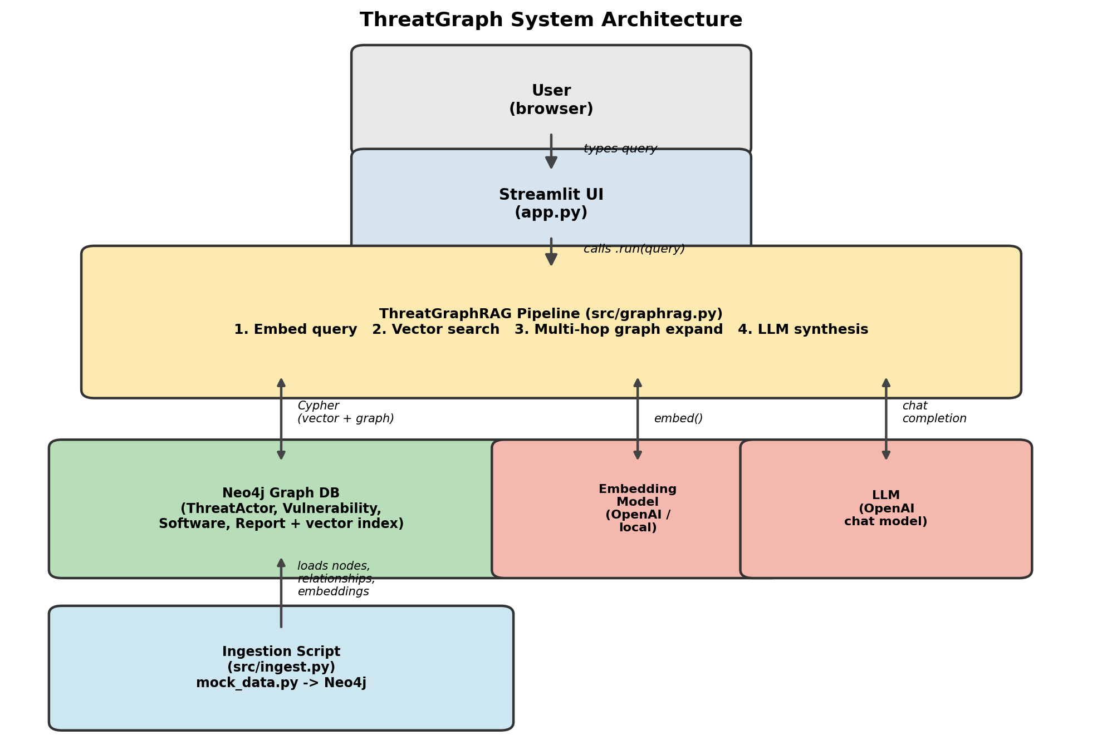

10. Expected Queries / Operations
The pipeline runs three Cypher stages per user question (vector search, graph expansion, relationship extraction, all shown to the user in the UI), on top of which the following eight operations cover ingestion, retrieval, and maintenance. Queries 1–5 are the project-specific retrieval queries; 6–8 cover create/update/delete so the required CRUD coverage is demonstrated end to end.
Query 1: Vector search for reports/CVEs relevant to a query embedding
CALL db.index.vector.queryNodes('report_embedding_index', 3, $query_vector)
YIELD node, score
RETURN node.id, node.title, score
Query 2: Multi-hop expansion from a seed node (the core graph-native query)
MATCH (seed) WHERE seed.id = $seed_id
MATCH path = (seed)-[*1..2]-(connected)
RETURN DISTINCT connected, labels(connected)
Query 3: Which threat actors exploit vulnerabilities affecting database software
MATCH (a:ThreatActor)-[:EXPLOITS]->(v:Vulnerability)-[:AFFECTS]->(s:Software)
WHERE s.category = 'Database System'
RETURN DISTINCT a.name, v.cve_id, s.name
Query 4: All reports describing a given actor's vulnerabilities (bridging structured + unstructured)
MATCH (a:ThreatActor {name: 'FIN7'})-[:EXPLOITS]->(v:Vulnerability)
MATCH (r:Report)-[:DESCRIBES]->(v)
RETURN v.cve_id, r.title, r.text
Query 5: Rank software by number of distinct threat actors targeting it (aggregation)
MATCH (a:ThreatActor)-[:EXPLOITS]->(:Vulnerability)-[:AFFECTS]->(s:Software)
RETURN s.name, count(DISTINCT a) AS actor_count
ORDER BY actor_count DESC
Query 6: Create: add a newly disclosed CVE and link it to affected software
MERGE (v:Vulnerability:CVE {id: $id})
SET v.cve_id = $cve_id, v.severity = $severity, v.description = $description
WITH v
MATCH (s:Software {id: $software_id})
MERGE (v)-[:AFFECTS]->(s)
Query 7: Update: revise a vulnerability's severity after re-assessment
MATCH (v:Vulnerability {cve_id: $cve_id})
SET v.severity = $new_severity
Query 8: Delete: remove a retracted report and its relationships
MATCH (r:Report {id: $report_id})
DETACH DELETE r

Embedded vs. referenced: a concrete example
Neo4j does not have MongoDB-style document embedding, but the same underlying design choice, whether to store data with the entity or as a separate connected entity, still applies to properties. The Report node stores its embedding vector and full text directly as properties on the node itself (equivalent to embedding): there is no separate “ReportBody” node, because that text is only ever read together with the report it belongs to, so splitting it out would just add a join with no benefit. By contrast, a Report's link to the Vulnerability or ThreatActor it discusses is modelled as a DESCRIBES relationship to a separate node (equivalent to referencing): the same CVE is described by multiple independent reports, and the same actor profile is reused across many reports, so duplicating that data into every Report node would mean updating every copy whenever an actor's profile changes. The rule applied throughout the schema: data is embedded as a property when it is only ever accessed together with its owner and never shared, and modelled as a separate node with a relationship when it is reused, updated independently, or queried on its own.

11. Individual Contribution Plan
Work is split across the three pipeline stages described in Section 9, so each member owns a vertical slice they can independently build, test, and explain at the review.
Yuvraj Singh Hajari (23BCE1995): Graph data & database layer
- Design and finalise the property graph schema (node labels, properties, relationship types).
- Build the ingestion script: constraints, MERGE statements for all four node types, and the EXPLOITS/AFFECTS/DESCRIBES relationships.
- Create and tune the Neo4j native vector indexes over Report and Vulnerability embeddings.
Shashwat Singh (23BCE1517): Retrieval pipeline
- Implement the vector search stage (query embedding + db.index.vector.queryNodes calls).
- Implement the multi-hop graph expansion Cypher and the relationship-extraction query.
- Wire up LLM context assembly and answer synthesis, and tune prompts so answers stay grounded in retrieved context.
Samarth Mishra (23BCE1881): Application, queries & data
- Build the Streamlit interface: query input, answer display, and the Cypher/retrieved-nodes inspection panels.
- Curate and validate the mock dataset (threat actors, CVEs, software, reports) for realism and consistency.
- Design and test the eight project queries in Section 10, and run end-to-end verification once the database is populated.

12. Final Implementation Notes
The proposed design above was built and verified end-to-end against a running Neo4j instance. Four points in the executed system deviate from, or add precision to, the proposal as originally written, plus one on the final demo dataset.

12.1 Deployment
Deployed as proposed: Neo4j 5.24 Community Edition, run locally via Docker Compose (the AuraDB alternative was not needed for the demo). The container’s JVM heap and page cache were explicitly capped (256 MB heap, 128 MB page cache) so it runs comfortably alongside the team’s other local services — sized for this dataset, not for production load.

12.2 Embeddings and LLM synthesis
- Embeddings: generated locally with sentence-transformers (all-MiniLM-L6-v2, 384 dimensions) rather than an OpenAI embedding model, so the pipeline needs no external API key or per-call cost for this stage. The Vulnerability and Report embedding properties, and both Neo4j vector indexes, are configured for 384 dimensions accordingly — the 1536-dimension figure in the Section 8.3 sample records reflects the original OpenAI-sized design and was superseded by this choice.
- LLM synthesis: performed via the Groq API (model: openai/gpt-oss-120b) in place of the OpenAI chat model shown in the Section 9 architecture diagram, for faster inference during live demos. The synthesis prompt still enforces the same rule described in Objective 4: answer only from the graph context actually retrieved, and say so explicitly when that context is insufficient.

12.3 Query 2 bounded for execution
The multi-hop expansion query in Section 10 (MATCH (seed)-[*1..2]-(connected)) is unbounded as written. The executed version adds LIMIT 50 so a single UI click cannot return an unbounded fan-out on a denser part of the graph; the unmodified Cypher above remains the canonical statement of the traversal pattern being demonstrated.

12.4 Final demo dataset and verification
The mock dataset actually loaded for the review: 8 ThreatActor, 15 Vulnerability, 12 Software, and 20 Report nodes, connected by 27 EXPLOITS relationships (plus the full set of AFFECTS and DESCRIBES edges implied by the schema). All eight queries in Section 10 were run against this data and returned non-empty, meaningful results — including the full create/update/delete cycle in Queries 6–8 — and the Streamlit interface was confirmed end-to-end with live questions answered from retrieved graph context.

Individual Understanding Declaration
I confirm that I understand the database design proposed in this document and can explain the design decisions made by our team. I have contributed to the preparation of this submission.

