CMF project workflow
How one project moves from process plan to a completed part. Admin and the manufacturing coordinator plan the work. The project coordinator owns the project and the process plan. The supervisor prepares the floor and reviews logs. The operator runs the job card.
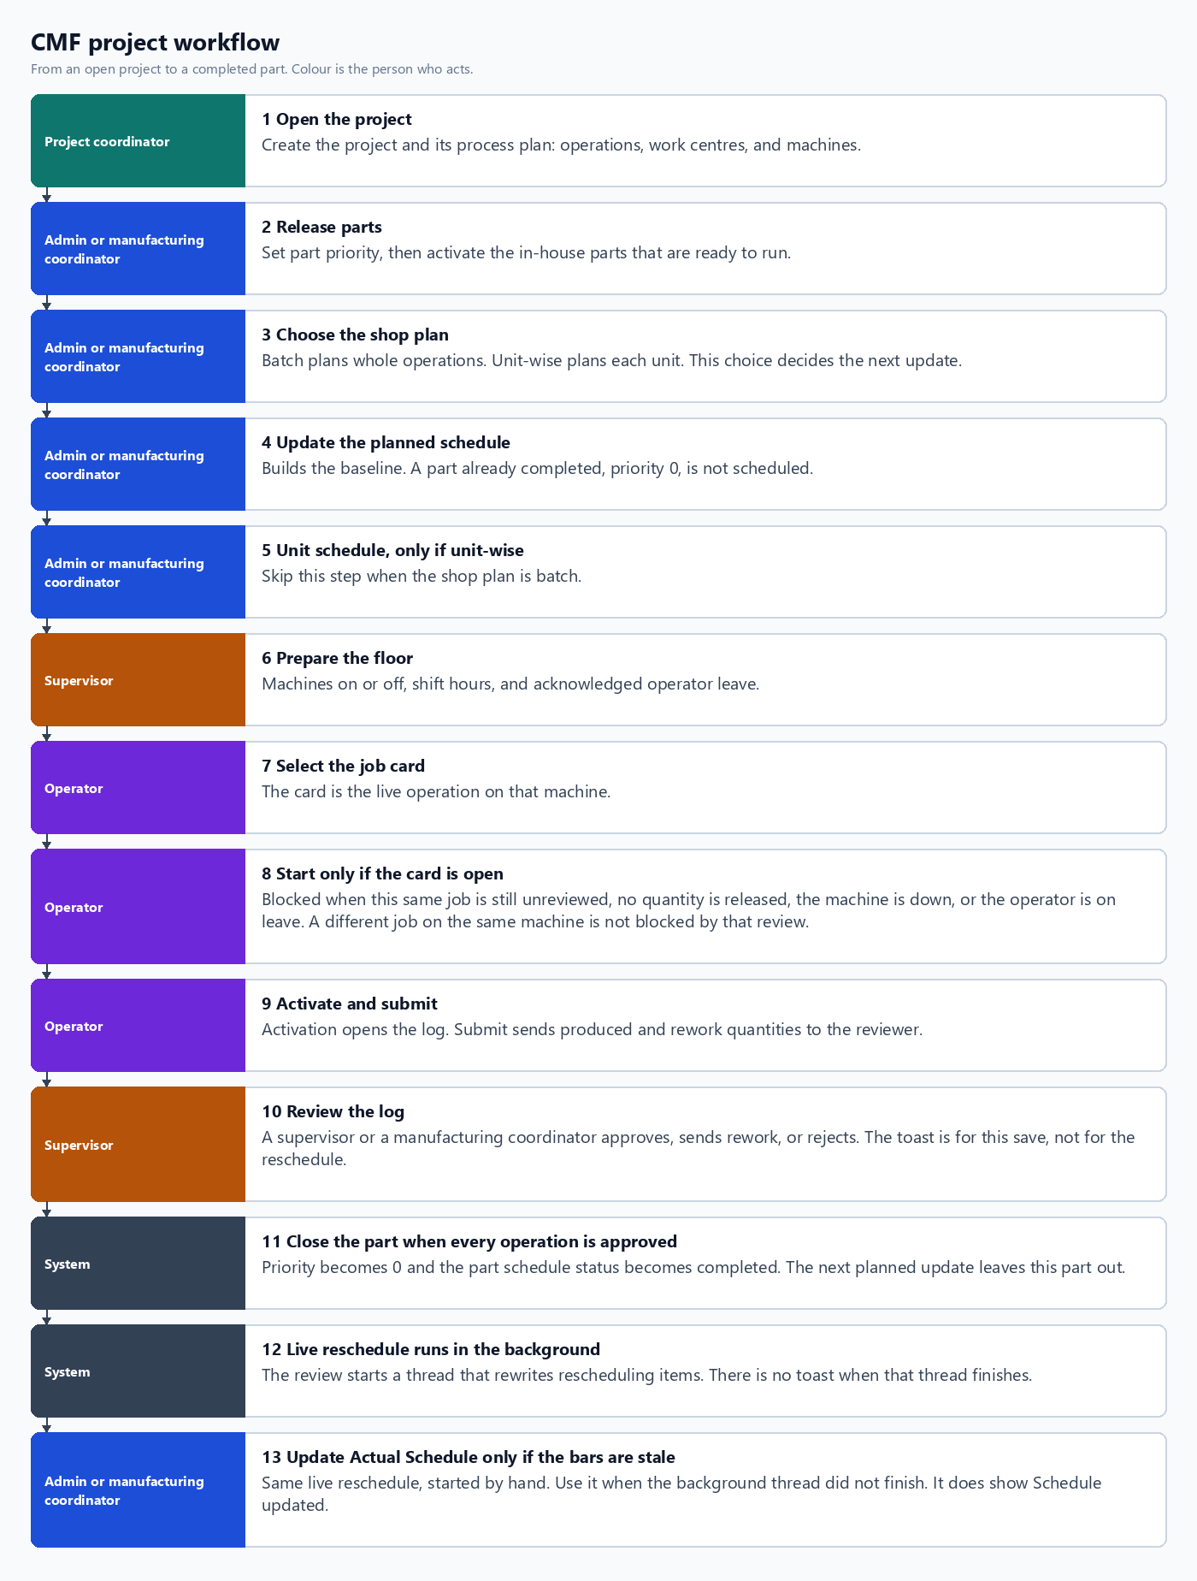
Figure 1. Project workflow by role.

Who does what
Role | In this workflow
Project coordinator | Opens the project and maintains the process plan. Does not run schedule updates.
Admin or manufacturing coordinator | Sets priority, activates parts, chooses batch or unit-wise, and updates the planned schedule. Updates the actual schedule only when the live bars are stale.
Supervisor | Sets machine availability, shifts, and leave. Reviews production logs. A manufacturing coordinator can review logs too.
Operator | Selects the job card, activates it when the checks pass, and submits the log.
System | Closes a fully approved part and starts the live reschedule after a review. That thread does not show a toast.

How a review updates the live plan
- Saving a review as completed, in progress, rework, or rejected returns at once. The toast is Quantities updated successfully, or Review saved — part order is complete when nothing is left to approve.
- That same save starts a background thread. The thread rewrites rescheduling items. It does not toast when it finishes.
- Press Update Actual Schedule only when those live bars are still the old ones. That button runs the same reschedule and toasts Schedule updated when the request finishes.
- Update on the planned schedule is a different run. It builds a new baseline. A part with priority 0 and status completed is not put back on that baseline.

When a job card can start
- This same job still has a log in progress, or a submitted log the reviewer has not updated.
- The previous schedulable operation has not released at least one approved unit.
- The machine is down.
- The operator has acknowledged leave today.
- The operation is already fully approved.
An unreviewed log blocks only that job. Another operation on the same machine can still be activated.

