CMF Production Planning & Scheduling
Role-based user manual
Operator · Manufacturing coordinator · Supervisor
This guide walks you through the application in plain English. Use the matching Mermaid diagrams in backend/mermaids/user-manual/ when you want an interactive flowchart (open the .mmd in Mermaid Live or view-role-user-manuals.html).

1. Words you will see
Read this once. The diagrams use the same words.
Sale order / Project. The customer order (for example GSP2405105). Manufacturing coordinators only see orders assigned to them.
Part. One item on the sale order, with a quantity (how many units to make).
Unit. One piece of that part. Unit-wise planning schedules each piece; batch planning schedules the whole quantity together.
Activate part. Release an in-house part so it can be scheduled. Needs process plan and readiness checks. This comes first.
Priority. Run order of active parts. Assigned when the part is activated (earlier activation gets the next number). 1 runs before 2. Priority 0 means completed and stays out of new plans. Coordinators can later swap priorities if needed.
Shop floor plan. Factory-wide switch: Batch or Unit-wise. Only admin or manufacturing coordinator can change it. Switching does not build a schedule by itself.
Batch. Live job cards come from the live (actual) schedule. Use Planned Update for the baseline and Actual Update for live cards.
Unit-wise. Live job cards come from the unit schedule. Use Unit Scheduling Update after the shop plan is Unit-wise.
Planned schedule. Baseline Gantt for batch planning. Completed parts are not put back here.
Actual / live schedule. What operators use on batch. Refreshes after reviews (background) or when someone presses Update Actual Schedule.
Unit schedule. What operators use on unit-wise. Built only when Unit Scheduling Update runs while the shop plan is Unit-wise.
Job card. The operator’s work ticket on a machine. You see either batch cards or unit-wise cards — never both at once.
Activate job card. Start work on that card. Opens a production log. Blocked for the same job if a log still waits for review, if quantity is not released yet, if the machine is down, or if the operator is on leave.
Production log. What the operator submitted (produced / rework). A supervisor or manufacturing coordinator must review it.
Review. Approve, rework, or reject the log. The save confirmation toast is for the review only — not for the background reschedule.
Released quantity. Approved quantity from the previous operation that unlocks the next operation.
Shift hours. Working windows for a day (GENERAL, and NEXT for overtime).
Machine–operator assignment. On overtime days, pin which operator covers which machine. That operator is notified.

2. Big picture — from active part to completed part
Everyone should understand this loop. Details for each role come in the next sections. Mermaid file: 01-consolidated-pps-workflow.mmd
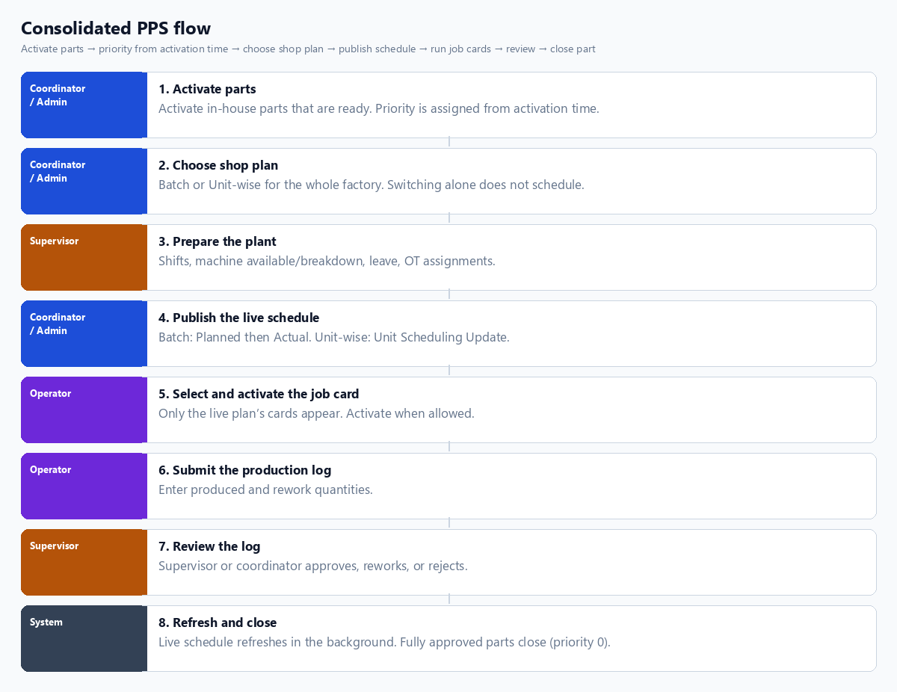
- Operators never see batch and unit-wise cards together.
- If the Gantt looks stale after a review, the coordinator presses Update Actual Schedule.
- A completed part (priority 0) does not return on the next planned update.

3. Manufacturing coordinator — fill your shoes
Mermaid file: 02-manufacturing-coordinator-workflow.mmd
You own release and the live shop plan for the factory. You only manage your assigned sale orders (for example Bharath does not see Vignesh’s orders on Unit Scheduling).
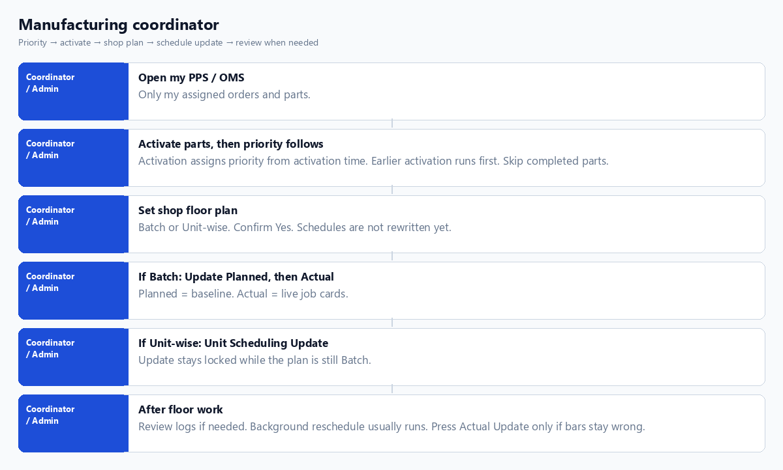

Success checklist
- Parts I want on the floor are activated; priority follows activation time (swap later only if needed).
- Shop plan matches how I want operators to work today.
- I pressed the matching Update after switching the plan.
- Operators report seeing cards for that plan only.
- If Actual Gantt is wrong after reviews, I press Update Actual Schedule once — I do not delete rows by hand.

Common confusion
- Switching to Unit-wise without Unit Update → empty or old unit cards.
- Saving assignment modes while still on Batch → rejected; switch plan first.
- Two coordinators can both change the shop plan; last successful save wins for the whole factory.

4. Supervisor — fill your shoes
Mermaid file: 03-supervisor-workflow.mmd
You keep the plant runnable and you review what operators submitted. You do not switch the shop plan and you do not run Planned / Unit schedule Update.
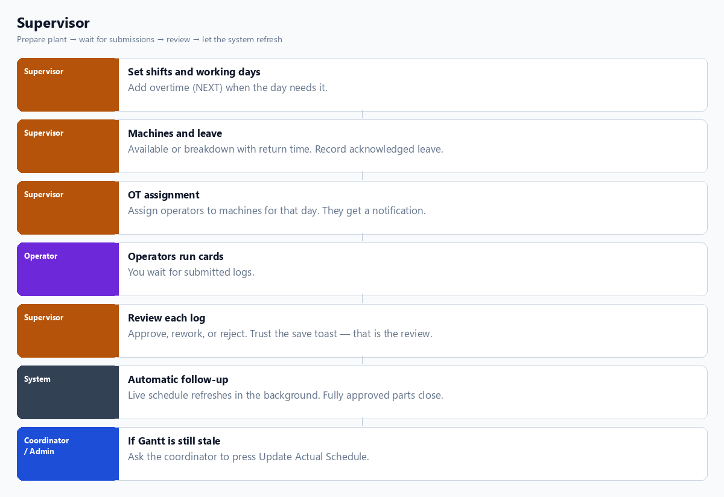

Success checklist
- Today’s calendar and shift hours are saved before the shift starts.
- Broken machines are marked with a return window.
- OT operators were assigned and notified.
- Every submitted log is reviewed promptly so the next job can unlock.

5. Operator — fill your shoes
Mermaid file: 04-operator-workflow.mmd
You pick your machine, open the job cards for the live shop plan, activate when allowed, do the work, and submit the log. You do not choose Batch vs Unit-wise — the shop plan decides that.
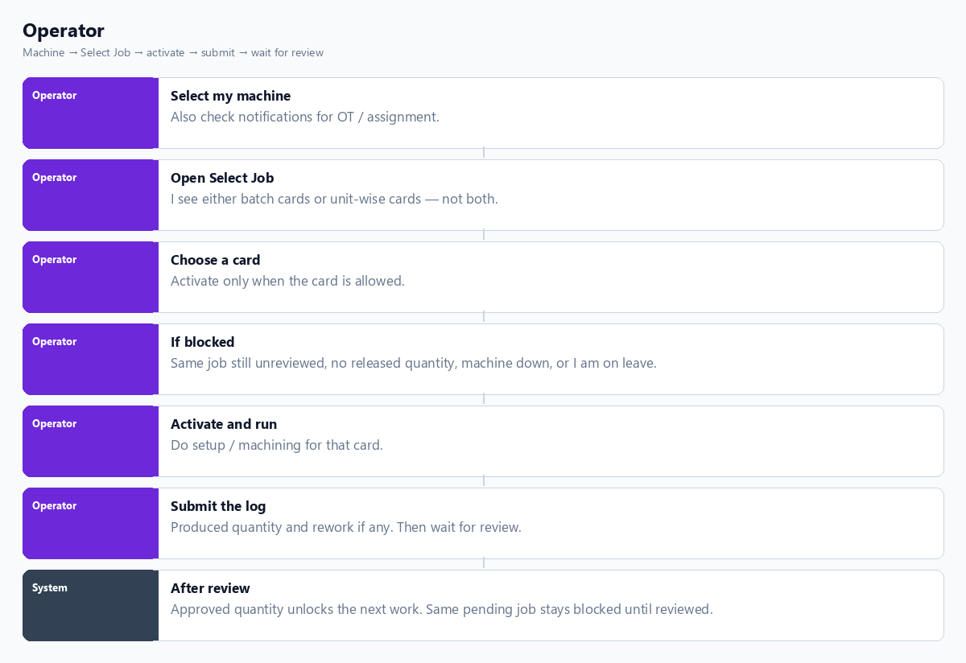

Success checklist
- Correct machine selected before Select Job.
- I am working the card that matches today’s shop plan.
- I activate only when the card is green / allowed.
- I submit honest quantities and wait for review before re-activating the same job.
- A different job on the same machine is not stuck behind another job’s pending review.

6. When the plan switches
- All work still pending, Batch → Unit-wise + Unit Update → operators get unit-wise cards only. Batch cards lock.
- Unit-wise → Batch + Actual/planned path → operators get batch cards only. Unit cards lock.
- Open in-progress work can block switching until that engine’s open card is cleared.
- Old rows may still exist in the database; operators only see the live engine’s list.

7. Where the diagram files live
D:\Harshith\CMF Digitalization\backend\mermaids\user-manual
- 01-consolidated-pps-workflow.mmd
- 02-manufacturing-coordinator-workflow.mmd
- 03-supervisor-workflow.mmd
- 04-operator-workflow.mmd
- README.md — how to open and read the diagrams
- view-role-user-manuals.html — browser preview

8. One-page “who does what”
Role | Main actions in PPS
Manufacturing coordinator / Admin | Priority, activate parts, shop plan, Planned / Actual / Unit Update, optional log review
Supervisor | Shifts, machines, leave, OT assignment, production-log review
Operator | Select machine, select job card, activate, submit log
System | Background live reschedule after review; auto-close fully approved parts

