**Practical 5**

**Aim**: Create 2 tables : Employee(Empid, Name , Dept) and Accounts(Empid, Salary)

1. Define Empid as the Primary Key in both the tables , also define Empid in accounts as foreign key in Employee table , name as NOT NULL and check salary >0.
2. Display the names of all employees having salaries greater than 10,000.

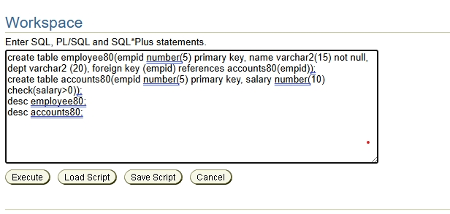Answers :-

1 )

