**Practical 8**

**Aim: Introduction to grouping clauses by GROUP BY , ORDER BY and HAVING**

**Q**) Create table cusomer185 with attributes cust_ID,name and country and perform the following queries :

a) SELECT COUNT(CUST_ID),COUNTRY FROM CUSOMER185 GROUP BY COUNTRY;

b) SELECT COUNT(CUST_ID), COUNTRY FROM CUSOMER185 GROUP BY COUNTRY HAVING COUNT(CUST_ID)>2;

c) SELECT COUNT(CUST_ID), COUNTRY FROM CUSOMER185 GROUP BY COUNTRY HAVING COUNT(CUST_ID)>2 ORDER BY COUNT(CUST_ID) ASC , COUNTRY DESC;

d) SELECT COUNT(CUST_ID), COUNTRY FROM CUSOMER185 GROUP BY COUNTRY HAVING COUNT(CUST_ID)>2 ORDER BY COUNT(CUST_ID) ASC , COUNTRY DESC;

e) CREATE VIEW CUSTVIEW AS SELECT * FROM CUSOMER185;

f) DROP VIEW CUSTVIEW;

**Answers :**

**Step1: Create the table cusomer185 and enter 10 entries**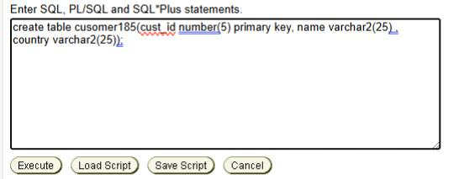

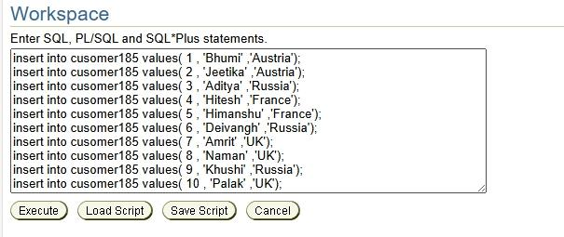

**Step 2: Perform the following queries :**

1. SELECT COUNT(CUST_ID),COUNTRY FROM Cusomer185 GROUP BY COUNTRY;

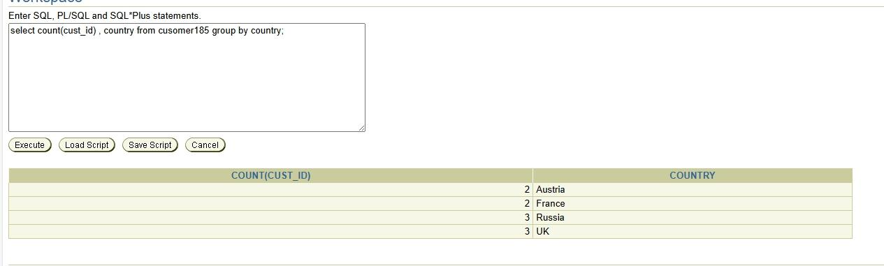

1. SELECT COUNT(CUST_ID), COUNTRY FROM CUSOMER185 GROUP BY COUNTRY HAVING COUNT(CUST_ID)>2;

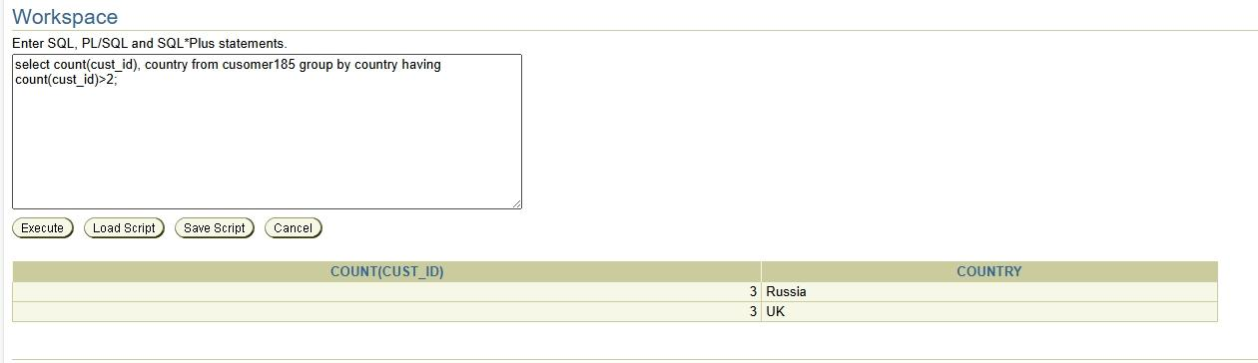

1. SELECT COUNT(CUST_ID), COUNTRY FROM CUSOMER185 GROUP BY COUNTRY HAVING COUNT(CUST_ID)>2 ORDER BY COUNT(CUST_ID) ASC , COUNTRY DESC;

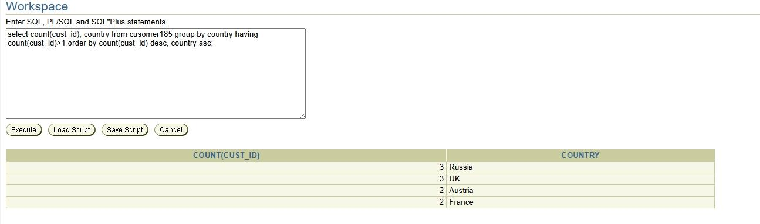

1. CREATE VIEW CUSTVIEW AS SELECT * FROM CUSOMER185;

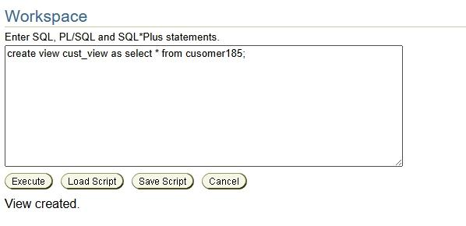

1. DROP VIEW CUSTVIEW;

