Made for Harshitha, on Mac or Windows
Harshitha's Career Hub
Hi Harshitha! This is your own app for the job hunt. It finds marketing jobs that match your resume, signs you in, fills applications and uploads your resume, one job or many in a row. It reads your job Gmail and moves every application along as companies reply. You check everything before anything is sent.
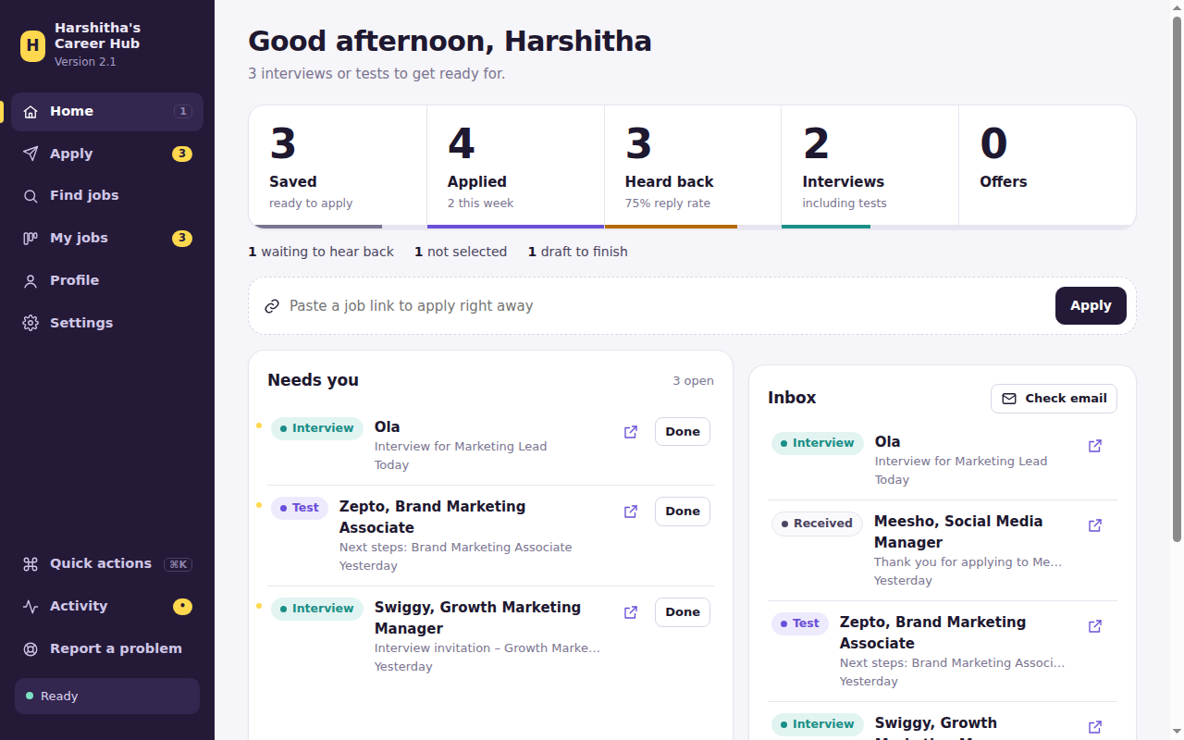
Home: your job hunt at a glance

What you need
 | Details
A Mac or Windows laptop with Google Chrome | Chrome is free from google.com/chrome.
The Career Hub folder | From the zip file.
Your resume as a PDF | You add it inside the app.
15 minutes, once | For setup. After that, one double-click.

A quick tour
In the sidebar | What it's for
Home | Your funnel (saved, applied, heard back, interviews, offers), what needs you, and your inbox. Paste a link at the top to apply straight away.
Apply | Paste one link or many. Save links for later and apply to all of them in one go.
Find jobs | Reads your resume and finds new jobs that fit, with a match score for each. Also shows jobs from your LinkedIn, Indeed and Naukri alert emails.
My jobs | A board of every application. Drag a card to change its stage; click it for emails and notes.
Profile | Your details, your files (resume, cover letter) and the answers the app remembers.
Settings | Appearance (light or dark), job email, logins, job search, daily limit, AI helper, help, updates and what's new.
Quick actions | Press Ctrl+K (⌘K on Mac) and type what you want, like "dark" or "email".
Activity | Everything the app is doing, step by step. Useful if something looks stuck.
Report a problem | Sends the activity log and screenshots to your helper in one click.

Shortcuts: press 1 to 6 to jump between pages, Ctrl+K (⌘K on Mac) for quick actions, Esc to close a panel. Quick actions, Activity and Report a problem are under More in the sidebar. When the app asks a question with options, press the option's number.
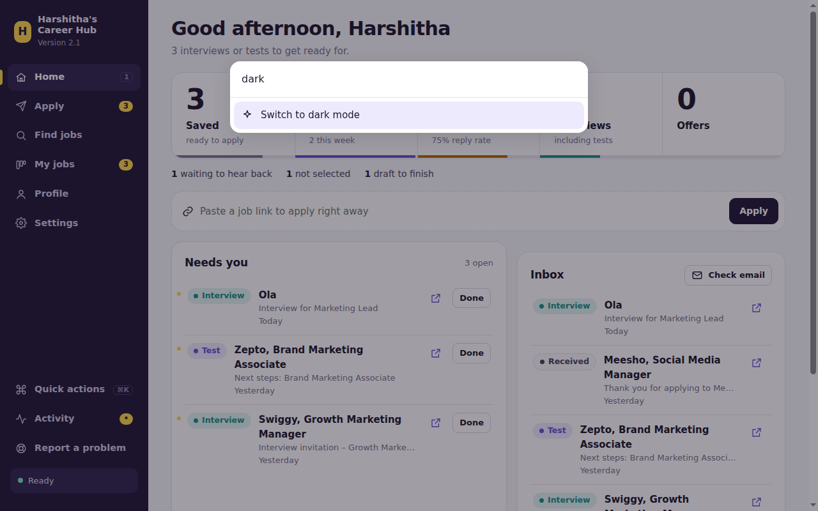
Quick actions

What's in the folder
File or folder | What it's for | You…
Setup (Mac) / Setup (Windows) | Installs what the app needs. | Double-click once.
Open Career Hub (Mac) / (Windows) | Opens the app. | Double-click every time.
career_hub.py, careerhub, ui | The app itself. | Leave alone.
Harshitha's Data | Everything personal: your data, files, summaries, logs and backups. | Leave alone. Never delete it.

Part A: one-time setup
About 15 minutes.

STEP 1 Put the folder on your Desktop
- Double-click career_hub.zip in Downloads. A Career Hub folder appears.
- Drag it onto your Desktop.

STEP 2 Double-click "Setup (Mac)"
A Terminal window installs everything (2 to 10 minutes). Wait for ALL SET, HARSHITHA!
Mac says the file "can't be opened" or "could not verify" it?
Normal for downloaded files. Click Done.
Newer Macs: open System Settings, then Privacy & Security, scroll down, click Open Anyway next to the Setup file, enter your Mac password, click Open.
Older Macs: right-click the Setup file, choose Open, then Open again.
Only needed once.

If you see | Do this
A request to install command line developer tools | Click Install, then Agree. When it finishes, double-click Setup again.
"Terminal would like to access files…" | Click Allow.

STEP 3 Open the app and fill in your profile
Double-click Open Career Hub (Mac). A small Terminal window opens too and tucks itself into the Dock: that runs the app, so don't close it. The app opens on Profile.
- Fill in your details. Anything you leave empty, the app asks about when a site needs it.
- A yellow bar appears when you change something: click Save changes.
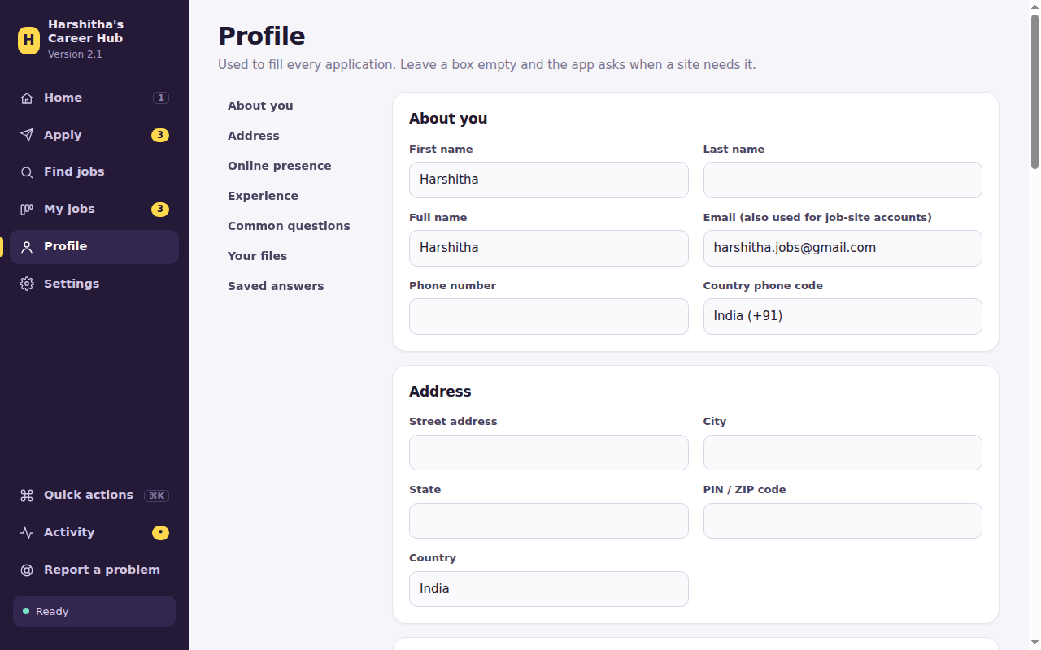

Add your resume
Scroll to Your files and drop your resume PDF onto the box (or click it to choose). It's picked as your resume automatically; click Save changes. Add a cover letter the same way if you have one.
Work and education: in Profile, open Work and education and press Read from my resume. Check each job and degree, fix anything wrong, then press Save. Sites like Workday ask for these one by one, and the app adds them for you.
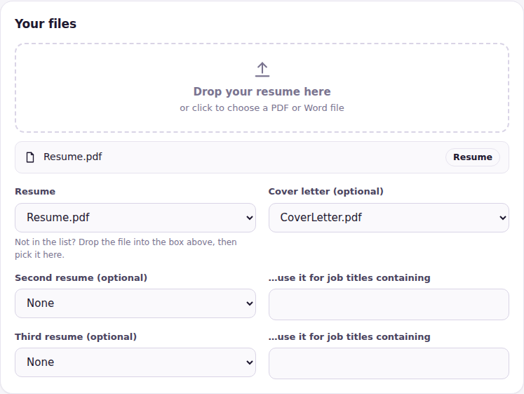

STEP 4 Connect your job Gmail (in Settings, 5 minutes)
This lets the app find replies from companies and job links from your job alert emails. It only reads: it never sends from, deletes or changes your emails. Gmail needs a special app password:
- Sign in to your job Gmail, then open myaccount.google.com.
- Click Security and turn on 2-Step Verification if it's off.
- Open myaccount.google.com/apppasswords, type Career Hub, click Create, and copy the 16-letter password.
- In the app: Settings, then Job email. Fill in the address, paste the app password, Save changes, then Test connection.
- Optional: a second or third job Gmail can be added in the same place (each needs its own app password). The app reads all of them.
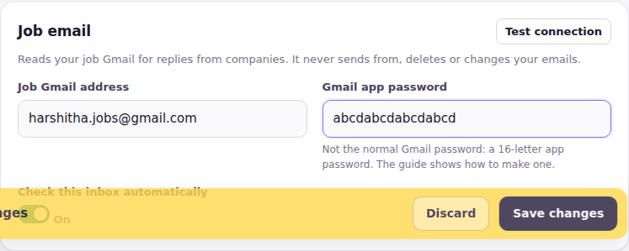
While you're in Settings: under Help, add your helper's email so problem reports reach them, and under Job-site logins, choose the password the app uses when it creates new job-site accounts.

Part B: applying
Every time you want to apply.

STEP 5 Paste links and press Apply
How | What to do
One job, fast | Paste the link into the box at the top of Home and press Apply.
A few jobs | On Apply, paste several links. Each becomes a chip showing the site. Press Apply to N jobs.
Save for later | Collect links during the week with Save for later, then Apply to all saved jobs.
Let me check each page | On: you see each page before it moves on. Off: it goes straight to Submit. Keep it on for your first few jobs.
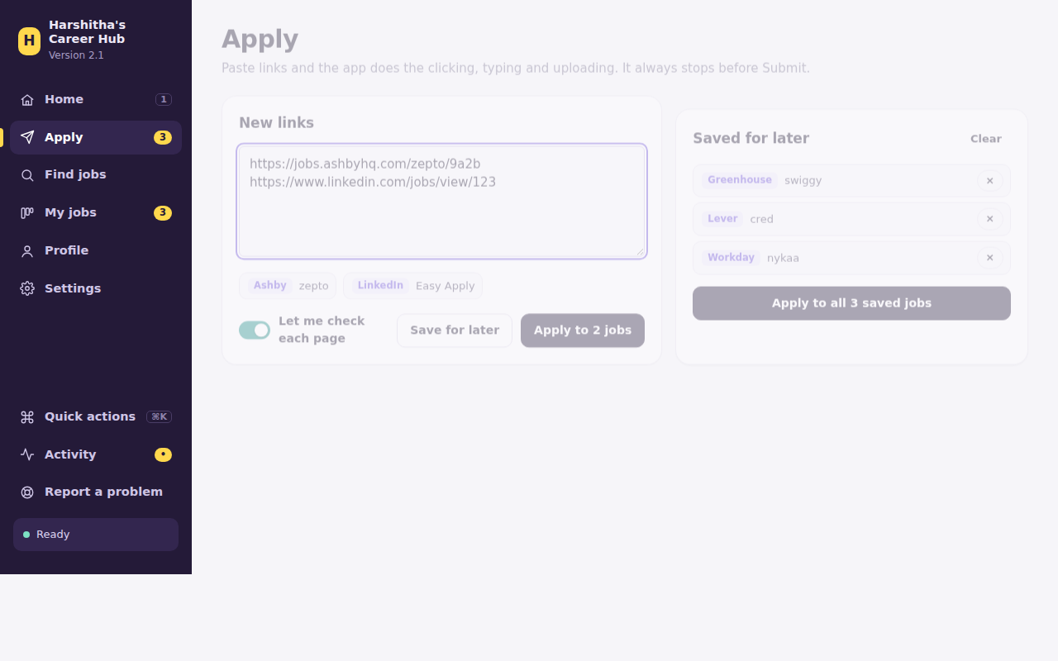

STEP 6 Watch it work
A separate Chrome window opens with the job (it has a small purple label at the bottom-left). The app clicks Apply, signs in or creates your account, and fills page after page. A bar at the top shows which job it's on; Stop ends the run any time without sending anything.
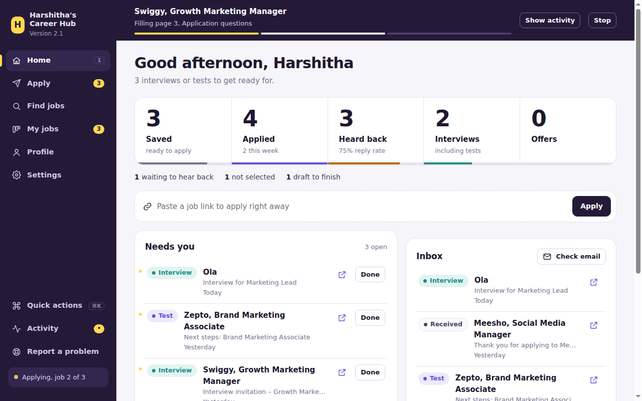
Things you do yourself | What to do
"Check your email" | Open your inbox, click the verification link, then continue in the app.
LinkedIn, Google, Indeed or Naukri logins | Log in once in the app's Chrome window. It stays logged in.
"I'm not a robot" or a code by SMS | Complete it in Chrome.
"I need your help in Chrome" | Do the step in Chrome, then click the first button.

STEP 7 Answer new questions, once each
When a site asks something new, a card pops up. Click an answer (or press its number), or type one.
- Skip this time leaves it empty now. Never ask this again always leaves it empty.
- For uploads, your files are listed. Add new ones in Profile, then Refresh list.
- With the AI helper on, written questions get a Draft with AI button. Read the draft, fix anything that isn't true, then save.
- If an old answer mentions another company, the app shows it to you to edit instead of reusing it.
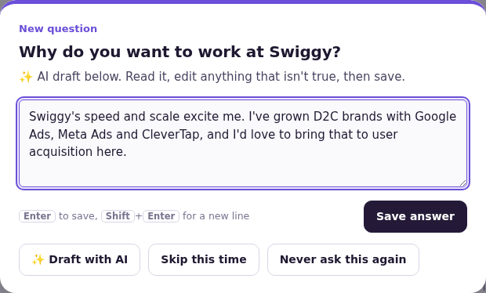
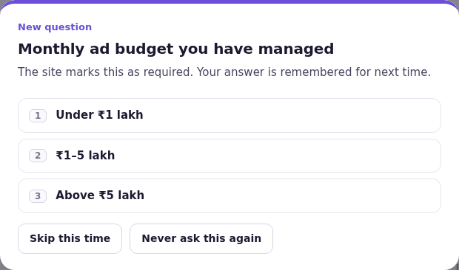

STEP 8 Check each page
Rows in orange are best guesses (for example your "No" matched to "No, I don't need sponsorship"). Check them in Chrome. Required boxes that are still empty are listed too.
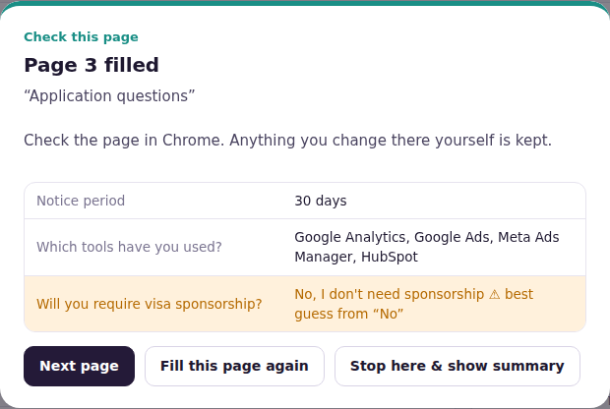

STEP 9 Decide: send or not
Button | What happens
Submit it for me | The app clicks Submit and looks for a "thank you" message. If it can't see one, it asks you.
I submitted it myself | You clicked Submit in Chrome.
Don't submit | Nothing is sent; finish it later on the website. It shows as a draft.
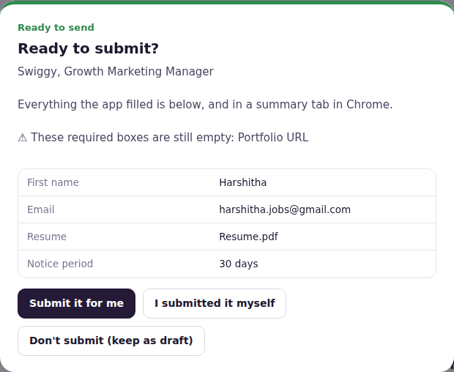
A small celebration plays when an application is sent. With several links, the next job starts by itself.

LinkedIn, Indeed and Naukri: safe use
New in version 2.3. These sites don't like automatic tools, so the app goes slowly on purpose.
You can paste LinkedIn, Indeed and Naukri job links into Apply like any other link. To keep your accounts safe, the app follows these rules by itself:
Rule | What it means for you
Daily limit | At most 10 applications a day on each of these sites. Links over the limit stay in your Apply list for tomorrow. Change the number in Settings, Applying, but lower is safer.
Slow and steady | The app waits 25 to 70 seconds between two jobs on the same site, like a person would. You'll see "Waiting…" in Activity. Stop works during the wait.
If a site checks you're human | A card asks you to solve the check in Chrome. If it asks again, or you choose Stop for today, the app rests from that site until tomorrow.
You log in | Log in once in the app's Chrome window. The app never types your password on these sites.
You press the last button | The app always stops before the final Submit, as everywhere else.

Tips
Keep Let me check each page on for these sites.
Don't run the app on LinkedIn for hours. A few jobs a day is plenty.
If a site shows a warning or restricts your account, stop using it for a few days and tell your helper.

Part C: finding jobs and following up
New jobs that fit you, and every reply in one place.

STEP 10 Find jobs
- The top shows what the app read in your resume. Add or remove job titles (type and press Enter).
- Keep Companies that are hiring on: the app checks the job boards of many companies for you. Under it you can add your own companies (type a name, or paste a careers-page link). Repeat this search daily runs it again each day when you open the app.
- Each result has a match ring: how well it fits your resume. Untick what you don't want, then Apply now or Save for later.
- Too many results? Use the filter box, the date and match lists, and the sort list above the results. Select all only picks what is showing. The Apply list has a filter box too.
Cities, words to skip, minimum match and job age are in Settings, Finding jobs.
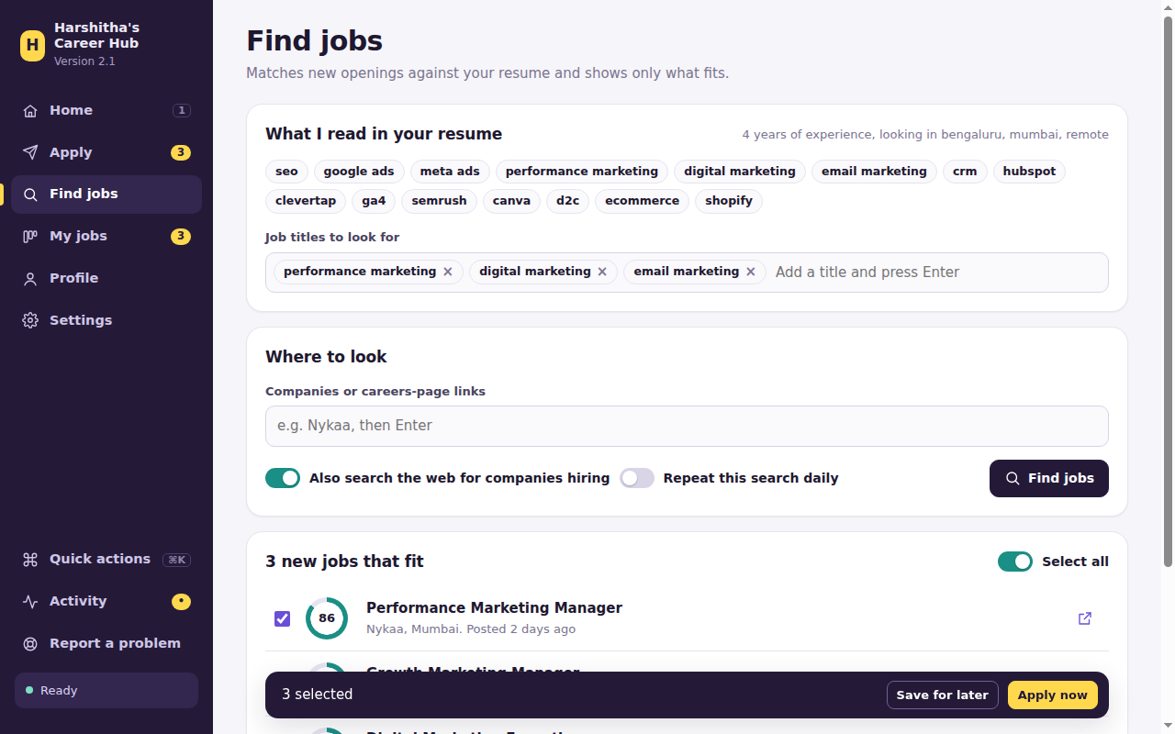

Jobs from LinkedIn, Indeed and Naukri alerts
These sites can't be searched by the app, but their job alert emails work well:
- On each site, create a job alert for your kind of job and send it to your job Gmail.
- The app reads the alert emails when it checks your inbox and adds the job links to Find jobs. Look for "LinkedIn alert", "Indeed alert" or "Naukri alert" in the company column.
- Tick the ones you like and press Apply now or Save for later.
These jobs have no match percentage, because the app has only seen the email, not the full job.

STEP 11 Home: what needs you
Home shows your funnel: saved, applied, heard back, interviews and offers. Click a stage to see those jobs. Needs you lists interview invites, tests and offers from your inbox: open the email, then click Done. The inbox checks itself every few hours; Check email checks now.
The app reads your job Gmail by itself when it opens and then every hour. Press Check email to do it right now: a spinning circle shows while it works. Home shows the latest 8 emails; See all opens the full list, 25 at a time.
Calendar: when an interview email gives a date, it appears on the calendar by itself (marked "from your email"). Add one yourself with + Add interview, or press the small calendar button on an interview in Needs you. Click a day to see what is on it.
To-do: type a reminder and press Enter. Tick it when done, and Clear done removes the ticked ones.
After more than 6 rejection emails, the app shows a kind note. Every no is part of a job search, so keep going.

STEP 12 My jobs board
- Each column is a stage. Cards move by themselves when emails arrive.
- Drag a card to another column to change it yourself (for example after a phone call).
- Waiting for reply: an interview card moves here by itself once the interview date has passed, so you can see who still owes you an answer.
- No response: a job you applied to 30 or more days ago, with no reply at all, moves here by itself. Drag it back if you still want to follow it up.
- Click a card for its details: stage, links to the job and the latest email, your notes (saved as you type) and every email about that job.
- Use the search box and the stage list above the board to narrow it down. Search also works on Emails, Accounts and Found.
- The tabs at the top switch to a List, all Emails, your job-site Accounts (passwords hidden until you click Show) and Found jobs. Open in Excel exports the list.
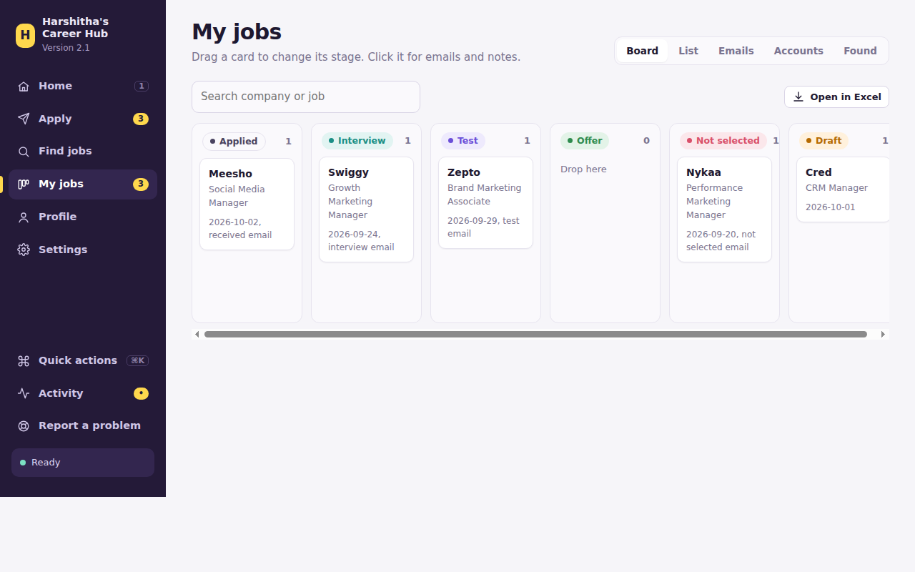
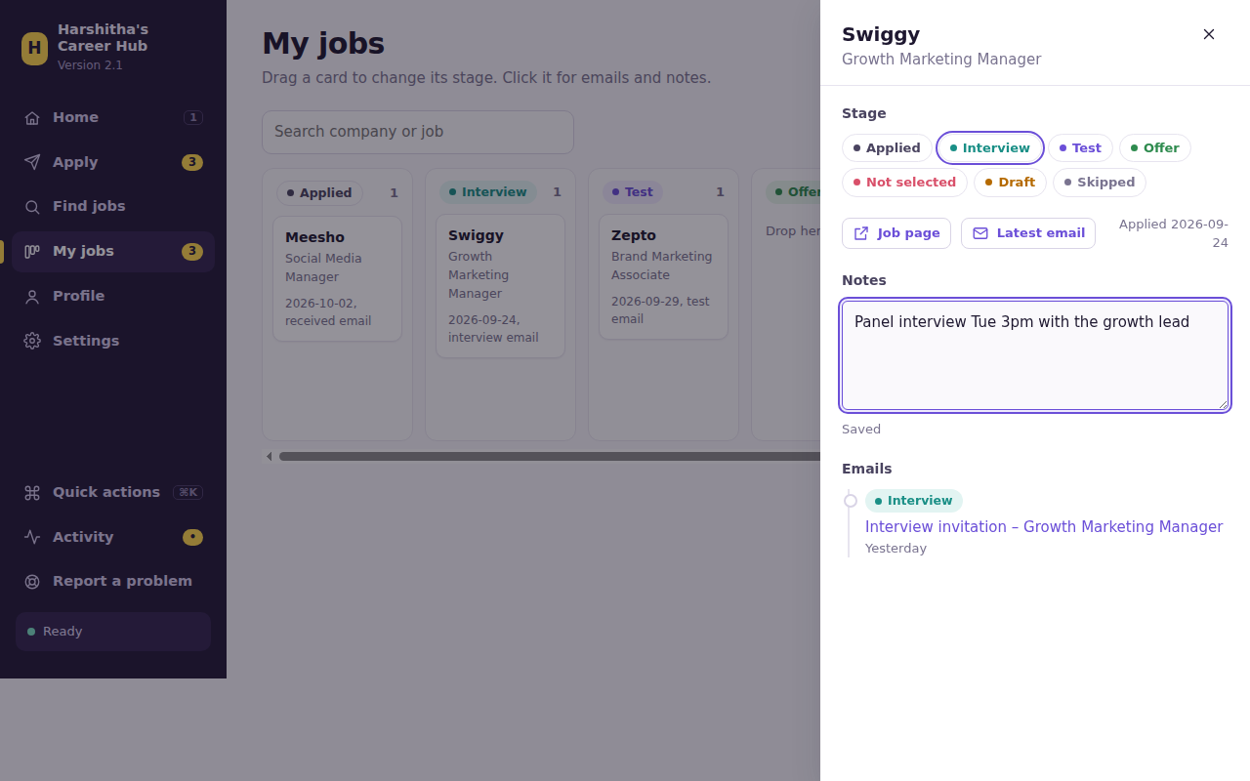

STEP 13 Saved answers
At the bottom of Profile: every answer you've given. Edit one, switch Ask me on to be asked again, or delete it. Changes save straight away.

Part D: settings, help and updates
Make it yours, and keep it running smoothly.

STEP 14 Appearance
Settings, Appearance: choose a colour theme. Clean white (white pages with a charcoal side panel) is the default; Sand, Emerald, Slate and Mint are the others. Or press Ctrl+K (⌘K on Mac) and type "theme".
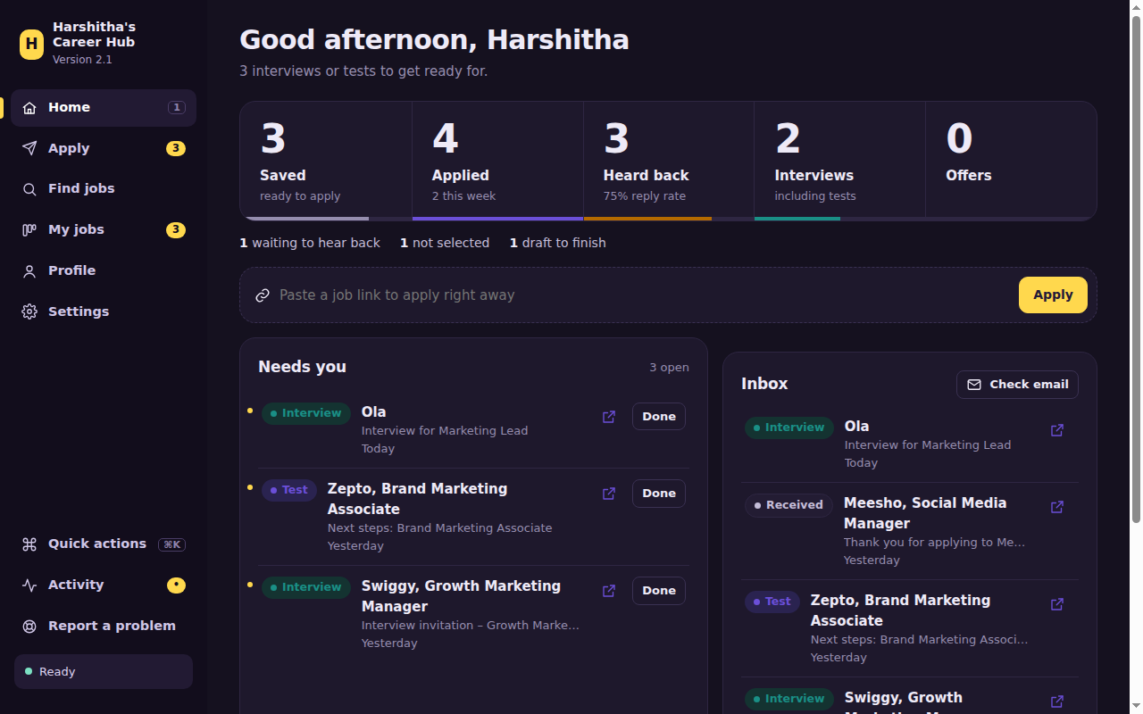

STEP 15 AI helper (optional)
- Create an account at console.anthropic.com, add a little credit under Billing (pay as you go), then API keys, Create key, and copy it.
- Paste it in Settings, AI helper and save. Written questions now get Draft with AI.
- Switch on tailored cover letter to get one written for each job: you edit it, and it's saved as a PDF and uploaded.
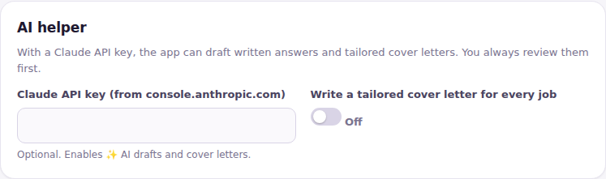
Always read AI text first
It only uses your resume and the job posting, but fix anything that isn't true or doesn't sound like you. Treat the key like a password.

STEP 16 Something went wrong? Report a problem
- Open More at the bottom of the sidebar, click Report a problem, write a short note, and send. Your helper gets an email with the activity log and screenshots. Passwords and keys are never included.
- If a run hits errors, the app offers to send a report by itself.
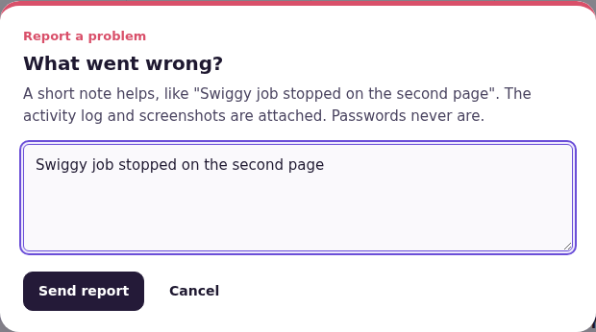

STEP 17 Updates and what's new
- Updates install themselves. The app checks when it starts and every hour. When there is a new version, a card shows what's new: click Update now. The app restarts by itself.
- If a new version ever fails to start, the app puts the previous version back automatically.
- Your data is never touched by updates. A backup is saved before every update, and every day.
- Every version is listed in Settings, What's new. No internet at that moment? Press Updates at the bottom of the left menu (or Check for updates in Settings) to try again. A small "new" tag appears there when an update is waiting.

Your weekly routine
- Open Career Hub. Look at Needs you on Home and reply to interview invites.
- Find jobs: your favourite companies plus a web search, and the new alert-email jobs. Apply to the good ones.
- On LinkedIn, Indeed and Naukri, keep to a handful of jobs a day.
- Answer the few new questions, check, send.
- Glance at the My jobs board and add notes after any calls.

Tips for more interviews in marketing
- Your portfolio link works hardest. Put 3 to 5 best pieces in one place: a campaign with results, social posts, a content sample, a dashboard.
- Answer with numbers the first time a question appears ("Grew Instagram from 8k to 30k in 6 months"). It's reused everywhere.
- Bulk-apply the long list, hand-craft the short list. Use the time you save to tailor your resume for your top companies and ask for referrals.
- Watch your funnel. Many applications and few replies usually means the resume or portfolio needs work, not more volume.

If something goes wrong
Problem | Fix
Mac won't open a file | See the yellow box in Step 2.
"Not set up yet" in Terminal | Double-click Setup and let it finish.
The app window closed | Double-click Open Career Hub again. (Closing the Terminal window closes the app too.)
"Couldn't read your resume" | Add it in Profile, Your files, and make sure it's a real PDF (not a scan).
A box was filled wrongly | Fix it in Chrome, then correct the answer in Profile, Saved answers.
"Gmail refused the login" | Use the 16-letter app password from Step 4, not your normal password.
An email was sorted wrongly | Drag the card to the right column in My jobs. Your choice always wins.
A site says the password is wrong | The app asks for that site's password. Type it, or choose to log in yourself.
A dropdown inside a dropdown (Workday) | Pick it yourself in Chrome, then Fill this page again.
"Daily limit reached" for LinkedIn, Indeed or Naukri | That's the safety rule. The job stays in your list: try again tomorrow.
"Resting from this site until tomorrow" | The site asked you to prove you're human. Wait until tomorrow, and use fewer jobs a day.
The app seems stuck | Open Activity to see what it's doing, or look for a card waiting for you. It may just be waiting a little between two jobs. Otherwise press Stop.
Find jobs shows few results | Lower the minimum match in Settings, add cities or titles, or add more companies.
Anything else | Report a problem.

Good to know
- Always review before sending. Every site is different; the app can occasionally miss a box.
- Your data stays on your laptop, in Harshitha's Data. Passwords are saved there as plain text, so use a password that's only for job sites, and don't share the folder.
- LinkedIn, Indeed and Naukri don't allow automated tools. The daily limit and the waiting are there to protect you. Don't try to get around them.
- You always do: CAPTCHAs, codes by SMS, assessments and video interviews.

Using a Windows laptop
Same app, slightly different setup.
- Install Google Chrome if you don't have it.
- Unzip career_hub.zip (right-click, Extract All) and move the folder to your Desktop.
- Double-click Setup (Windows). If Python isn't installed, a page opens: download Python and, in the installer, tick "Add python.exe to PATH" before Install Now. Then double-click Setup again.
- If Windows shows "Windows protected your PC": click More info, then Run anyway.
- Every time: double-click Open Career Hub (Windows). A small black window starts minimised: leave it open. Use Ctrl+K for quick actions.

For the helper
The person who set this up and fixes problems.
Topic | What to know
Reports | Arrive from her job Gmail, subject Career Hub problem report, with a zip: activity log, info.txt (version, computer, masked settings, last 5 jobs), screenshots, last summary.
Releasing | Update the docs first (MAP.md, CLAUDE.md, and this guide). Then bump APP_VERSION in careerhub/config.py, add an entry at the top of CHANGELOG in careerhub/changelog.py, run tools/make_release.py, and push to GitHub. Her app installs it from the Update now card.
This guide | Edit docs/Career_Hub_Guide.docx (the source), then run python tools/make_guide.py to make Career_Hub_Guide.pdf for her. Keep the version in the page header in step with APP_VERSION.
Data | Everything personal is Harshitha's Data/career_data.json plus Files/, Summaries/, Logs/, Backups/. New data goes into that file through Store.upgrade(); never rename or remove existing sections.
Restoring | Close the app, copy career_data.json back from Backups/<date>, reopen. Backups/before-update_… also holds the previous app files.
Job-site limits | careerhub/jobsites.py holds the LinkedIn / Indeed / Naukri rules: daily limit (setting jobsite_daily_limit), pacing, robot-check rest, alert-email links.
Old version | Data from the old Job Autofill layout is moved in automatically on first start (same folder or a job_autofill folder next to it). Originals are kept in Backups/old-files-before-2.0.

