**Software Development Life Cycle**

The **Systems Development Life Cycle (SDLC)**, or Software Development Life Cycle in systems engineering, information systems and software engineering, is the process of creating or altering systems, and the models and methodologies use to develop these systems.

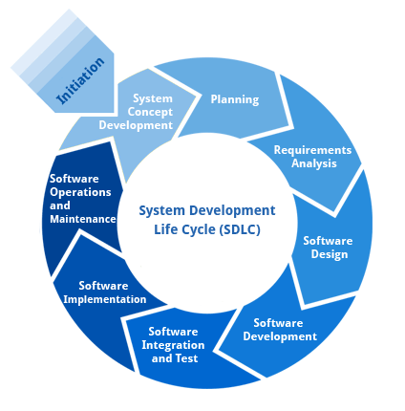

**Requirement Analysis and Design**

Analysis gathers the requirements for the system. This stage includes a detailed study of the business needs of the organization. Options for changing the business process may be considered. Design focuses on high level design like, what programs are needed and how are they going to interact, low-level design (how the individual programs are going to work), interface design (what are the interfaces going to look like) and data design (what data will be required). During these phases, the software's overall structure is defined. Analysis and Design are very crucial in the whole development cycle. Any glitch in the design phase could be very expensive to solve in the later stage of the software development. Much care is taken during this phase. The logical system of the product is developed in this phase.

**Implementation**

In this phase the designs are translated into code. Computer programs are written using a conventional programming language or an application generator. Programming tools like Compilers, Interpreters, and Debuggers are used to generate the code. Different high level programming languages like C, C++, Pascal, Java, .Net are used for coding. With respect to the type of application, the right programming language is chosen.

**Testing**

In this phase the system is tested. Normally programs are written as a series of individual modules, this subject to separate and detailed test. The system is then tested as a whole. The separate modules are brought together and tested as a complete system. The system is tested to ensure that interfaces between modules work (integration testing), the system works on the intended platform and with the expected volume of data (volume testing) and that the system does what the user requires (acceptance/beta testing).

**Maintenance**

Inevitably the system will need maintenance. Software will definitely undergo change once it is delivered to the customer. There are many reasons for the change. Change could happen because of some unexpected input values into the system. In addition, the changes in the system could directly affect the software operations. The software should be developed to accommodate changes that could happen during the post implementation period.

**SDLC METHDOLOGIES**

This document play a vital role in the development of life cycle (SDLC) as it describes the complete requirement of the system. It means for use by developers and will be the basic during testing phase. Any changes made to the requirements in the future will have to go through formal change approval process.

**SPIRAL MODEL** was defined by Barry Boehm in his 1988 article, “A spiral Model of Software Development and Enhancement. This model was not the first model to discuss iterative development, but it was the first model to explain why the iteration models.

As originally envisioned, the iterations were typically 6 months to 2 years long. Each phase starts with a design goal and ends with a client reviewing the progress thus far. Analysis and engineering efforts are applied at each phase of the project, with an eye toward the end goal of the project.

**The following diagram shows how a spiral model acts like:**

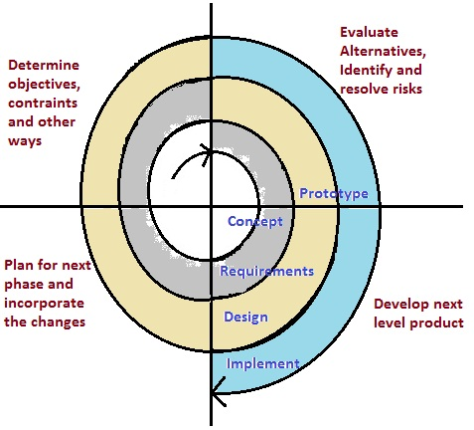

The steps for Spiral Model can be generalized as follows:

* The new system requirements are defined in as much details as possible. This usually involves interviewing a number of users representing all the external or internal users and other aspects of the existing system.
* A preliminary design is created for the new system.
* A first prototype of the new system is constructed from the preliminary design. This is usually a scaled-down system, and represents an approximation of the characteristics of the final product.
* A second prototype is evolved by a fourfold procedure:

1. Evaluating the first prototype in terms of its strengths, weakness, and risks.
2. Defining the requirements of the second prototype.
3. Planning an designing the second prototype.
4. Constructing and testing the second prototype.

* At the customer option, the entire project can be aborted if the risk is deemed too great. Risk factors might involved development cost overruns, operating-cost miscalculation, or any other factor that could, in the customer’s judgment, result in a less-than-satisfactory final product.
* The existing prototype is evaluated in the same manner as was the previous prototype, and if necessary, another prototype is developed from it according to the fourfold procedure outlined above.
* The preceding steps are iterated until the customer is satisfied that the refined prototype represents the final product desired.
* The final system is constructed, based on the refined prototype.
* The final system is thoroughly evaluated and tested. Routine maintenance is carried on a continuing basis to prevent large scale failures and to minimize down time.