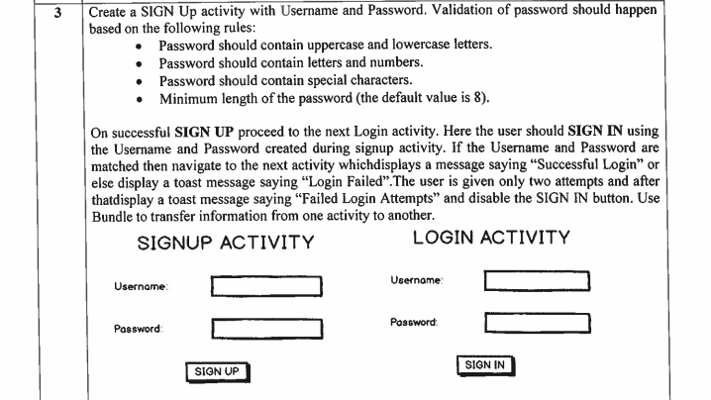

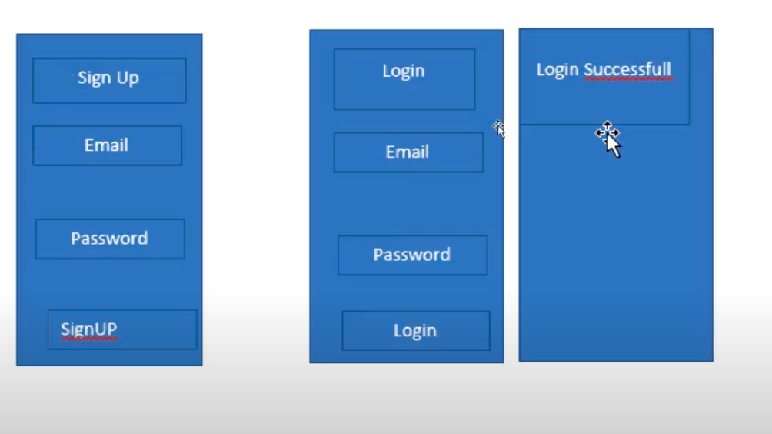

Package com.example.signup;
import androidx.appcompat.app.AppCompatActivity;
import android.content.Intent;
import android.os.Bundle;
import android.view.View;
import android.widget.Button;
import android.widget.EditText;
import android.widget.Toast;
import java.util.regex.Pattern;
public class MainActivity extends AppCompatActivity {
EditText emailEditText, passwordEditText;
Button signUpBtn;
@Override
protected void onCreate(Bundle savedInstanceState) {
super.onCreate(savedInstanceState);
setContentView(R.layout.activity_main);
emailEditText = findViewById(R.id.emailEditText);
passwordEditText = findViewById(R.id.passwordEditText);
signUpBtn = findViewById(R.id.signUpBtn);
signUpBtn.setOnClickListener(new View.OnClickListener() {
@Override
public void onClick(View view) {
String email = emailEditText.getText().toString();
String password = passwordEditText.getText().toString();
if (!isValidPassword(password)) {
Toast.makeText(MainActivity.this, "password doesnt match the rules", Toast.LENGTH_LONG).show();
return;
}
Intent intent = new Intent(MainActivity.this, LoginActivity.class);
intent.putExtra("email", email);
intent.putExtra("password", password);
startActivity(intent);
}
});
}
Pattern lowercase = Pattern.compile("^.*[a-z].*$");
Pattern uppercase = Pattern.compile("^.*[A-Z].*$");
Pattern number = Pattern.compile("^.*[0-9].*$");
Pattern specialCharacter = Pattern.compile("^.*[^a-zA-Z0-9].*$");
private Boolean isValidPassword(String password) {
if (password.length() < 8) {
return false;
}
if (!lowercase.matcher(password).matches()) {
return false;
}
if (!uppercase.matcher(password).matches()) {
return false;
}
if (!number.matcher(password).matches()) {
return false;
}
if (!specialCharacter.matcher(password).matches()) {
return false;
}
return true;
}
}

