Loral Quadras

Q1. Explain the following: i)SMP ii)Shared-nothing architecture

i)SMP:
-SMP stands for Symmetric Multiprocessing.
-SMP is a multiprocessor system in which two or more identical processors share a single main memory.
-All processors have equal access to the shared memory and I/O devices.
-All processors are controlled by a single operating system (OS).
-Each processor can execute programs independently and work on different tasks at the same time.
-SMP is a tightly coupled multiprocessing system.
-A cache is usually associated with each processor to improve performance.
-A bus or interconnection network connects the processors, memory, and I/O devices.
-SMP is also called a shared-memory system.

Advantages of SMP:
- Faster processing – Multiple processors can execute tasks simultaneously.
- Resource sharing – Processors share the same memory and I/O resources.
- Reliability – If one processor fails, other processors may continue working.
- Better performance – Work can be divided among multiple processors.
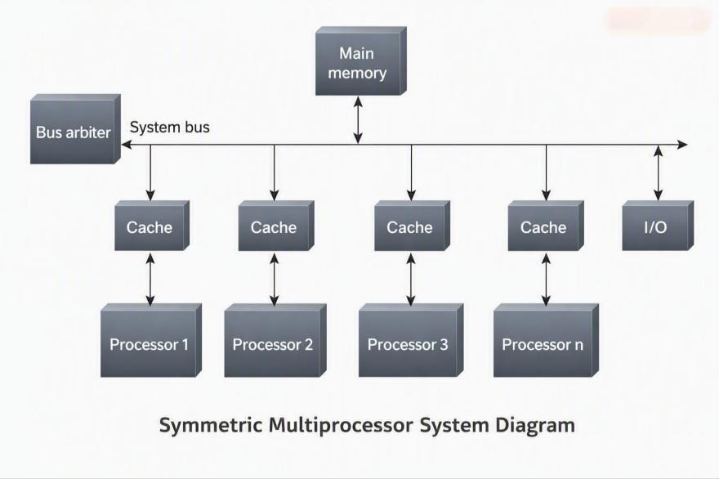

ii)Shared-nothing architecture
There are three most common types of architecture for multiprocessor high-transaction-rate systems:
1. Shared Memory (SM)
A common central memory is shared by multiple processors.
All processors can access the shared memory.
Example: SMP (Symmetric Multiprocessing).

- Shared Disk (SD)
Multiple processors have their own private memory.
They share a common collection of disks.
Each processor can access the shared disk/storage.
- Shared Nothing (SN)
Each processor/node has its own private memory and storage.
There are no shared resources between the nodes.
Nodes communicate with each other through a network.
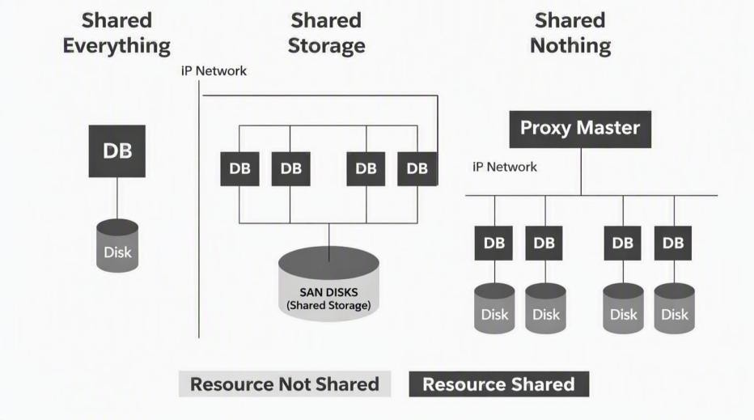
Shared-Nothing Architecture:
Shared-Nothing Architecture was proposed by Michael Stonebraker in 1986.
Shared-Nothing Architecture is a distributed computing architecture in which each node works independently with its own CPU, memory, and storage.

Features
- Independent Resources
Each node has its own CPU, memory, and storage.
- No Shared Resources
Nodes do not share memory or storage with other nodes.
- Network Communication
Nodes communicate with each other through a network.
- Independent Operation
Each node can operate and process tasks independently.
- Horizontal Scaling
New nodes can be added easily to increase the capacity and performance of the system.
- Fault Tolerance
If one node fails, other nodes can continue working, improving system availability.
- Cost Effectiveness
The system can be built using multiple smaller and less expensive machines, making it cost-effective.

Advantages
-Eliminates Single Point of Failure (SPOF)
-Supports non-disruptive upgrades
-Allows easy expansion
-Provides high availability
-Supports self-healing capabilities
Disadvantages
-Hard to program
-Adding new nodes may require reorganization
-Managing communication between nodes can be complex

Example
A large e-commerce platform can distribute transactions among multiple servers. If one server fails, other servers can continue processing transactions.

GopalKrishna

Q2: Compare Parallel and Distributed Systems and Discuss the Importance of NoSQL Parallel Systems
A parallel system is a system in which multiple processors or processing units work simultaneously on different parts of the same problem. The main aim is to reduce processing time and improve performance by dividing a large task into smaller tasks that can be executed at the same time.

Distributed Systems
A distributed system consists of multiple independent computers or servers connected through a network. These computers cooperate with each other and appear to the user as a single system. In a
distributed system, several servers are networked together, which provides greater processing capability but also introduces challenges such as hardware failure.

Comparison between Parallel and Distributed Systems
Feature Parallel System Distributed System
Multiple processors work Multiple independent computers
Basic concept together on a single task. work together over a network.
Usually within the same
Location of Processors/computers may
processors be computer or tightly connected physically separated.
environment.
Usually through shared
Communication memory or very fast Mainly through network
interconnections. communication.
Increase speed and reduce Share resources, improve
Main objective execution time. scalability and availability.
Often shared or closely Each machine generally has its
Memory coordinated. own local memory and storage.
Failure of a major shared Individual nodes can fail
Failure component can affect the independently and the system must whole computation. handle such failures.
Multi-core processor
Hadoop cluster consisting of

Example performing several calculations simultaneously. multiple networked nodes.

Importance of NoSQL
NoSQL (Not Only SQL) databases are important in Big Data because traditional relational databases are not always suitable for very large volumes of structured, semistructured, and unstructured data.
The major importance of NoSQL is:
- Handles large volumes of data: NoSQL databases are designed to manage huge amounts of data efficiently.
- Scalability: They can scale horizontally by adding more machines or nodes to the system.
- Supports different data formats: NoSQL is suitable for flexible and varied data such as
JSON, XML, text, and other semi-structured or unstructured formats. The book similarly highlights the need for systems that can handle structured and unstructured data and formats such as XML and JSON in Big Data processing.
- High performance: NoSQL databases can provide fast read and write operations for large-scale applications.
- Flexible data model: Unlike relational databases, NoSQL does not require a rigid table structure, making it easier to handle changing data.
- Suitable for distributed environments: NoSQL databases are commonly used across multiple nodes, making them useful for large distributed applications.
- Cost-effective: Big Data systems can use multiple relatively low-cost machines instead of depending on expensive high-end hardware. The source contrasts this with RDBMS, which may require expensive hardware for huge data volumes.

Conclusion
Parallel systems mainly focus on speeding up computation by performing tasks simultaneously, whereas distributed systems focus on coordinating multiple independent computers connected through a network. NoSQL is important because it provides scalability, flexibility, and efficient handling of large and varied datasets, making it highly useful for Big Data and distributed applications.

M Pratham
Q3:List and explain key terminologies used in big data environments Key Terminologies in Big Data
- Big Data
Big Data refers to very large and complex datasets that are difficult to store, process, and analyze using traditional database systems.
- Volume
Volume refers to the huge amount of data generated and stored. Big Data can grow from terabytes (TB) to petabytes (PB) and beyond.
- Velocity
Velocity refers to the speed at which data is generated, collected, and processed. For example, social media and sensor data can be generated continuously.
- Variety
Variety refers to the different types and formats of data. Hadoop can handle structured as well as unstructured data, including XML, JSON, and text files.
- RDBMS (Relational Database Management System)
RDBMS is a traditional database system that stores data in tables with relationships between them. It is mainly suitable for structured data where consistent relationships are required.
- Hadoop
Hadoop is a framework used for Big Data processing and storage. It supports structured and unstructured data and works using a node-based architecture.
- Hadoop Cluster
  - Hadoop cluster is a group of connected computers/nodes that work together to store and process large amounts of data.
- Node
  - node is an individual computer/server in a distributed system or Hadoop cluster. A Hadoop node can use a processor, network card, and a few hard drives.
- Distributed Computing
Distributed computing means dividing data and processing tasks among multiple networked computers instead of depending on a single computer. The PDF discusses hardware failure as an important challenge in distributed systems.
- Structured Data
Structured data is data organized in a fixed format, such as rows and columns in a relational database.
- Unstructured Data
Unstructured data does not follow a fixed table-like format. Examples include text files, documents, images, and other forms of data.
- Hardware Failure
Hardware failure occurs when one or more servers in a distributed system stop working. Since distributed systems contain several networked servers, failure is an important challenge Prajnana
Q4. Explain a Typical Data Warehouse Environment and its Key Components
Answer: A Data Warehouse (DW) environment is a system in which operational or day-to-day business data is collected from different sources, processed using ETL, and stored in a data warehouse or data marts for analysis and decision-making.

Data Sources
Business data is gathered from different operational and transactional systems such as ERP
(Enterprise Resource Planning), CRM (Customer Relationship Management), Legacy systems and Third-party applications. Data may come from the same or different geographical locations.

Different Data Formats
The data from these sources may be in different formats. It may be stored in RDBMS such as Oracle, MS SQL Server, DB2, MySQL and Teradata, or in spreadsheets such as .xls and .xlsx, as well as .csv and .txt files.

ETL Process
The collected data is integrated, cleaned, transformed and standardized through ETL (Extraction, Transformation and Loading).
- Extraction: Data is collected from different source systems.
- Transformation: Data is cleaned, integrated, transformed and standardized.
- Loading: The transformed data is loaded into the data warehouse or data marts.

Enterprise Data Warehouse
The transformed data is loaded into the enterprise data warehouse, which is available at the enterprise level and acts as a central source for analysis.

Data Marts
The transformed data can also be loaded into data marts, which are available at the business-unit, functional-unit or business-process level.

Business Intelligence and Analytics Tools
Business intelligence and analytics tools use the warehouse data to support decision-making. Examples include ad-hoc querying, SQL, enterprise dashboards, data mining, OLAP and modeling.

Prajna
Q5:Explain CAP theorem and its significance in distributed systems Ans:
The CAP theorem is also called the Brewer's Theorem. It states that in a distributed computing environment (a collection of interconnected nodes that share data), it is impossible to provide the following guarantees. Refer Figure 3.14. At best you can have two of the following three - one must be sacrificed.

- Consistency

- Availability

- Partition tolerance

3.12.7.1 CAP Theorem

Let us spend some time understanding the earlier mentioned terms.

  - Consistency implies that every read fetches the last write.

  - Availability implies that reads and writes always succeed. In other words, each non-failing node will return a response in a reasonable amount of time.

  - Partition tolerance implies that the system will continue to function when network partition occurs.

Let us try to understand this using a real-life situation.

You work for a training institute, "XYZ." The institute has 50 instructors including you. All of you report to a training coordinator. At the end of the month, all the instructors together with the training coordinator peruse through the training requests received from the various corporate houses and prepare a training schedule for each instructor. These training schedules (one for each instructor) are shared with "Amey," the office administrator. Each morning, you either call the office helpdesk (essentially Amey's desk) or check in-person with Agey for your schedule for the day. In case a training request has been cancelled or updated (updates can be in the form of change in course, change in duration, change of the training timings, etc.), Amey is informed of the updates and the schedules are subsequently updated by him.

Things were good until now. Few corporate houses were your clients and the schedules of each instructor could be smoothly managed without any major hiccups. But your training institute has been implement ing promotion campaigns to expand the business. As a result of advertising in the media and word of mouth publicity by your existing clients, you suddenly see an upsurge in training requests from existing and new clients. In consequence of that, more instructors have been recruited. Few trainers/consultants have also been roped in from other training institutes to help tackle the load. Now when you go to Amey to check your schedule or call in at the helpdesk, you are prepared for a wait in the queue. Looking at the current state of affairs, the training coordinator decides to recruit an additional office administrator "Joey." The helpdesk number will remain the same and will be shared by both the office administrators.

This arrangement works well for a couple of days. Then one day...

You: Hey Amey!

Amey: Hi! How can I help?

You: I think I am scheduled to anchor a training at 3:00 pm today. Can I please have the details?

Amey: Sure! Just a minute.

Amey browses through the file where he maintains the schedules. He does not see a training scheduled against your name at 3:00 pm today and responds back, "You do not have any training to conduct at 3:00 pm."

You: How is that possible? The training coordinator called up yesterday evening to inform of the same and said he has updated the office administrators of the same.

Amey. Oh! Did he say which office administrator? It could have been Joey. Please check with Joey.

Amey. Hey Joey! Please check the schedule for Paul here... Do you see something scheduled at 3:00 pm today?

Jory: Sure enough! He is anchoring the training for client "Z" today at 3:00 pm.

A clear case of inconsistent system!!! The updates in the schedule were shared by the training coordinator with Joey and you were checking for your schedule with Amey.

You share thincident with the training coordinator and that gets him thinking. The issue has to be addressed immediately otherwise it will be difficult to avoid a chaotic situation. He comes up with a plan and shares it with both the office administrators the following day.

Training Coordinator. Folks, each time that either an instructor or me calls any one of you to update a schedule, make sure that both of you update it in your respective files. This way the instructor will always get the most recent and consistent information irrespective of whom amongst the two of you he/she speaks to.

Jory. But that could mean a delay in answering either a phone call or sharing the schedule with the instructor waiting in queue.

Training Coordinator. Yes, I understand. But there is no way that we can give incorrect information.

Amey. There is this other problem as well. Suppose one of us is on leave on a particular day. That would mean that we cannot take any update related calls as we will not be able to simultaneously update both the files (my file and Joey's).

Training Coordinator. Well, good point! That's the availability problem!!! But I have thought about that as well. Here is the plan:

- If one of you receives the update call (any updates to any schedule), ensure that you inform the other person if he is available.

- In case the other person is not available, ensure that you inform him of all the updates to all schedules via email. It is a must!!! Wow!!! That is sure a Consistent and Available system!!!

Looks like everything is in control. Wait a minute! There is a tiff that has taken place between the office administrators. The two are pretty much available but are not talking to each other which, in other words, means that the updates are not flowing from one to the other. We have to be partition tolerant!!! As a train-ing coordinator, you instruct them saying that none of you are taking any calls requesting for schedules or updates to schedules till you patch up. This implies that the system is partition tolerant but not available at that time.

In summary, one can at most decide to go with two of the three.

- Consistent: The instructors or the training coordinator, once they have updated information with you, will always get the most updated information when they call subsequently.

- Availability: The instructors or the training coordinators will always get the schedule if any or both of the office administrators have reported to work.

- Partition Tolerance: Work will go on as usual even if there is communication loss between the office administrators owing to a spat or a tiff!

When to choose consistency over availability and vice-versa...

- Choose availability over consistency when your business requirements allow some flexibility around when the data in the system synchronizes.

- Choose consistency over availability when your business requirements demand atomic reads and writes.

Examples of databases that follow one of the possible three combinations:

  - Availability and Partition Tolerance (AP)

  - Consistency and Partition Tolerance (CP)

  - Consistency and Availability (CA)
