Assignment 7
1. Find the optimal hyperplane for SVM use the following data set
positive class:(3,1),(3,-1),(6,1),(6,-1)
Negative Class:(1,0),(0,1),(0,-1),(-1,0)
2. Apply Naive Bayesian Classifier on
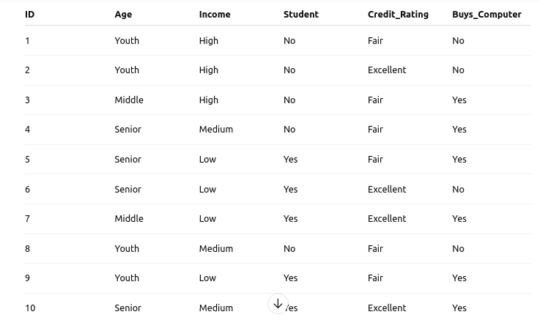

3. Apply PCA to reduce the dimensionality to 1 component, and visualise the result in a 2D scatter plot.

ID | Feature1 | Feature2
1 | 5.702 | 4.386
2 | 9.884 | 1.02
3 | 2.089 | 1.613
4 | 6.531 | 2.533
5 | 4.663 | 2.444
6 | 1.59 | 1.104
7 | 6.563 | 1.382
8 | 1.966 | 3.687
9 | 8.21 | 0.971
10 | 8.379 | 0.961

