1. Apply KNN and predict the class for customer John.Find the error with changed value of k.
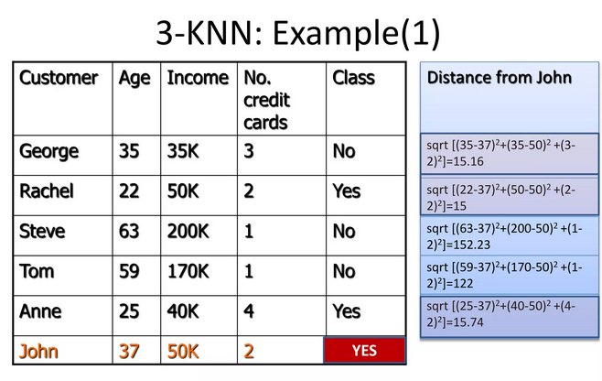

2.Apply decision tree for the following dataset
