What is Machine Learning?
- Machine learning is a growing technology which enables computers to learn automatically from past data.
- Machine learning uses various algorithms for building mathematical models and making predictions using historical data or information.
- Currently, it is being used for various tasks such as image recognition, speech recognition, email filtering, Facebook auto-tagging, recommender system, and many more.
- Machine Learning is said as a subset of artificial intelligence that is mainly concerned with the development of algorithms which allow a computer to learn from the data and past experiences on their own.
- The term machine learning was first introduced by Arthur Samuel in 1959. We can define it in a summarized way as:
- Machine learning enables a machine to automatically learn from data, improve performance from experiences, and predict things without being explicitly programmed.
- With the help of sample historical data, which is known as training data, machine learning algorithms build a mathematical model that helps in making predictions or decisions without being explicitly programmed.
- Machine learning brings computer science and statistics together for creating predictive models.
- Machine learning constructs or uses the algorithms that learn from historical data.
- The more we will provide the information, the higher will be the performance.

Machine Learning vs. Traditional Programming
- Traditional programming differs significantly from machine learning.
- In traditional programming, a programmer code all the rules in consultation with an expert in the industry for which software is being developed.
- Each rule is based on a logical foundation; the machine will execute an output following the logical statement.
- When the system grows complex, more rules need to be written. It can quickly become unsustainable to maintain.
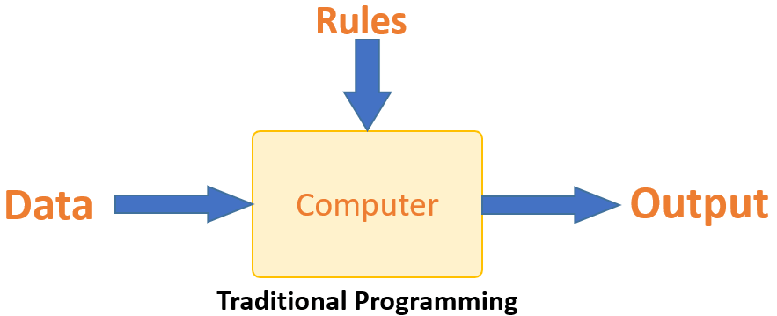

- Machine learning is supposed to overcome this issue.
- The machine learns how the input and output data are correlated and it writes a rule.
- The programmers do not need to write new rules each time there is new data.
- The algorithms adapt in response to new data and experiences to improve efficacy over time.
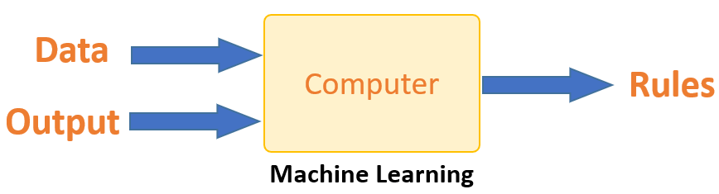

How does Machine Learning Work?
- Machine learning is the brain where all the learning takes place.
- The way the machine learns is similar to the human being.
- Humans learn from experience.
- The more we know, the more easily we can predict.
- When we face an unknown situation, the likelihood of success is lower than the known situation.
- Machines are trained the same way.
- To make an accurate prediction, the machine sees an example.
- When we give the machine a similar example, it can figure out the outcome.
- However, like a human, if it is fed a previously unseen example, the machine has difficulties to predict.
- That is, a Machine Learning system learns from historical data, builds the prediction models, and whenever it receives new data, predicts the output for it.
- The accuracy of predicted output depends upon the amount of data, as the huge amount of data helps to build a better model which predicts the output more accurately.
- Suppose we have a complex problem, where we need to perform some predictions, instead of writing a code for it, we just need to feed the data to generic algorithms, and with the help of these algorithms, machine builds the logic as per the data and predict the output.
- Machine learning has changed our way of thinking about the problem. The below block diagram explains the working of Machine Learning algorithm:
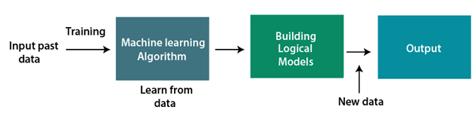
Learning, Inference and Data:
- The core objective of machine learning is the learning and inference.
- First of all, the machine learns through the discovery of patterns.
- This discovery is made by using the data.
- One crucial part of the data scientist is to choose carefully which data to provide to the machine.
- The list of attributes used to solve a problem is called a feature vector.
- You can think of a feature vector as a subset of data that is used to tackle a problem.

Model:
The machine uses some algorithms to simplify the reality and transform this discovery into a model.
Therefore, the learning stage is used to describe the data and summarize it into a model.
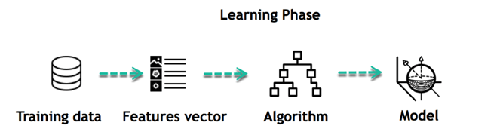
- For example, the machine is trying to understand the relationship between the wage of an individual and the likelihood to go to a fancy restaurant.
- The machine finds a positive relationship between wage and going to a high-end restaurant: This is the model

Inferring
- When the model is built, it is possible to test how powerful it is on never-seen-before data.
- The new data are transformed into a features vector, go through the model and give a prediction.
- There is no need to update the rules or train again the model.
- You can use the model previously trained to make inference on new data.

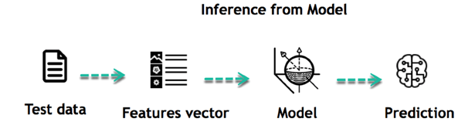

Steps in Machine Learning:
- The life of Machine Learning programs is straightforward and can be summarized in the following points:
- Define a question
- Collect data
- Visualize data
- Train algorithm
- Test the Algorithm
- Collect feedback
- Refine the algorithm
- Loop 4-7 until the results are satisfying
- Use the model to make a prediction
- Once the algorithm gets good at drawing the right conclusions, it applies that knowledge to new sets of data.

Features of Machine Learning:
- Machine learning uses data to detect various patterns in a given dataset.
- It can learn from past data and improve automatically.
- It is a data-driven technology.
- Machine learning is much similar to data mining as it also deals with the huge amount of the data.

Need for Machine Learning
- The need for machine learning is increasing day by day. The reason behind the need for machine learning is that it is capable of doing tasks that are too complex for a person to implement directly.
- As a human, we have some limitations as we cannot access the huge amount of data manually, so for this, we need some computer systems and here comes the machine learning to make things easy for us.
- We can train machine learning algorithms by providing them the huge amount of data and let them explore the data, construct the models, and predict the required output automatically.
- The performance of the machine learning algorithm depends on the amount of data, and it can be determined by the cost function.
- With the help of machine learning, we can save both time and money.
- The importance of machine learning can be easily understood by its uses cases,
- Currently, machine learning is used in self-driving cars, cyber fraud detection, face recognition, and friend suggestion by Facebook, etc.
- Various top companies such as Netflix and Amazon have built machine learning models that are using a vast amount of data to analyze the user interest and recommend product accordingly.

Following are some key points which show the importance of Machine Learning:
- Rapid increment in the production of data
- Solving complex problems, which are difficult for a human
- Decision making in various sector including finance
- Finding hidden patterns and extracting useful information from data.

Challenges in Machine Learning
- We are living in a situation with numerous cutting edge applications developed using machine learning.There are certain challenges an ML practitioner might face while developing an application from the initial stage to bringing them to production.

1. Data Collection
- Data plays a key role in any use case. 60% of the work of a data scientist lies in collecting the data. For beginners to experiment with machine learning, they can easily find data from Kaggle, UCI ML Repository, etc.

- To implement real case scenarios, you need to collect the data through web-scraping or (through APIs like twitter) or for solving business problems you need to attain data from clients (here ML engineers need to coordinate with domain experts to collect the data).Another Example: Linkdin problem.

- Once the data is collected, we need to structure the data and store it in the database. This requires knowledge of Big data (or data engineer) which plays a major role here.

2. Less Amount of Training Data
- Once the data is collected you need to validate if the quantity is sufficient for the use case (if it is a time-series data, we need a minimum of 3–5 years of data).
- The two important things we do while doing a machine learning project are selecting a learning algorithm and training the model using some of the acquired data.
- So as humans, we naturally tend to make mistakes and as a result, things may go wrong. Here, the mistakes could be opting for the wrong model or selecting data which is bad.
- Imagine your machine learning model is a baby, and you plan on teaching the baby to distinguish between a cat and a dog. So we begin with pointing at a cat and saying ‘ it’s a CAT’ and do the same thing with a DOG (possibly repeating this procedure many times). Now the child will able to distinguish between dog and cat, by identifying shapes, colors, or any other features. And just like that, the baby becomes an expert in distinguishing objects.
- Similarly, we train the model with a lot of data. A child may distinguish the animal with less number of samples, but a machine learning model requires thousands of examples for even simple problems. For complex problems like Image Classification and Speech Recognition, it may require data in a count of millions.
- Therefore, we need to train a model with sufficient DATA.

3. Non-representative Training Data
- The training data should be representative of the new cases to generalize well i.e., the data we use for training should cover all the cases that occurred and that is going to occur. By using a non-representative training set, the trained model is not likely to make accurate predictions.
- Systems which are developed to make predictions for generalized cases in business problem view are said to be good machine learning models. It will help the model to perform well even for the data which the data model has never seen.
- If the number of training samples is low, we have sampling noise which is unrepresentative data, again countless training tests bring sampling bias if the strategy utilized for training is defective.
- A popular case of examining sampling bias occurred during the US Presidental election in 1936 (Landon against Roosevelt), a very large poll was conducted by the Literary Digest by sending mail to around ten million people out of which 2.4 million answered, and predicted that Landon is going to get 57% of votes with high confidence. But, Roosevelt won with 62% of the votes.
- The problem here is in the sampling method, to get the addresses for conducting the poll, Literary Digest used magazine subscribes, club membership lists, and the likes, which are utilized by wealthier individuals who are bound to cast a ballot Republican, (hence Landon). Also, non-response bias comes into the picture as only 25% of people answered the poll.
- To make accurate predictions without any drifts, the training datasets must be representative.

4. Poor Quality of Data
- In reality, we don’t directly start training the model.
- Analyzing data is the most important step. But the data we collected might not be ready for training, some samples are abnormal from others having outliers or missing values for instance. (300 kg man/woman or 9 feet height)
- In these cases, we can remove the outliers, or fill the missing features/values using median or mean (to fill height) or simply remove the attributes/instances with missing values, or train the model with and without these instances.
- We don’t want our system to make false predictions. So the quality of data is very important to get accurate results. Data preprocessing needs to be done by filtering missing values, extract & rearrange what the model needs.

5. Irrelevant/Unwanted Features

- If the training data contains a large number of irrelevant features and enough relevant features, the machine learning system will not give the results as expected. One of the important aspects required for the success of a machine learning project is the selection of good features to train the model also known as Feature Selection.
- For example if we need to predict the number of hours a person needs to exercise based on the input features that we collected — age, gender, weight, height, and location (i.e., where he/she lives).
- Among these 5 features, location value might not impact our output function. This is an irrelevant feature, we know that we can have better results without this feature.
- Also, we can combine two features to produce a more useful one i.e., Feature Extraction. In our example, we can produce a feature called BMI by eliminating weight and height. We can apply transformations on the dataset too.
- Creating new features by gathering more data also helps.

6. Overfitting the Training Data

- For example you visited a restaurant in a new city. You looked at the menu to order something and found that the cost or bill is too high. You may say that ‘all the restaurants in the city are too costly and not affordable’. Overgeneralizing is something that is done frequently,
- The frameworks can do the same and in AI, we call it overfitting.
- It means the model is performing well, making likely predictions on the training dataset, but it is not generalized well.
- Another example is suppose you are attempting to implement an Image Classification model to classify apple, peach, oranges, bananas with training samples of — 3000, 500, 500, 500 respectively. If we train the model with these samples the system is more likely to classify oranges as apples as the number of training samples for apples is too high. This can be referred to as Oversampling.
- At the point when the model is excessively unpredictable when compared to the noisiness of the training dataset, overfitting occurs. We can avoid it by:
- Gathering more training data.
- Selecting a model with fewer features, a higher degree polynomial model is not preferred compared to the linear model.
- Fix data errors, remove the outliers, and reduce the number of instances in the training set.

7. Underfitting the Training data
- Underfitting which is opposite to overfitting generally occurs when the model is too simple to understand the base structure of the data.
- It generally happens when we have less information to construct an exact model. Example: Human behavior.
- Main options to reduce underfitting are:
- Feature Engineering — feeding better features to the learning algorithm.
- Removing noise from the data.
- Increasing parameters and selecting a powerful model.

8. Offline Learning & Deployment of the model
- Machine Learning engineering follows these steps while building an application
1) Data collection
2) Data cleaning
3) Feature engineering
4) Analyzing patterns
5) Training the model and Optimization
6) Deployment.
- A lot of machine learning practitioners can perform all steps but can lack the skills for deployment.
- Bringing their applications into production has become one of the biggest challenges due to lack of practice and dependencies issues, low understanding of underlying models with business, understanding of business problems, unstable models.
- Generally, many of the developers collect data from websites like Kaggle and start training the model. But in reality, we need to make a source for data collection, that varies dynamically. (like stock ticker data, or continuous data)
- Offline learning or Batch learning may not be used for this type of variable data. The system is trained and then it is launched into production, runs without learning anymore. Here the data might drift as it changes dynamically.
- It is always preferred to build a pipeline to collect, analyze, build/train, test & validate the dataset for any machine learning project and train the model in batches.

A system doesn’t perform well if the training set is too small, or if the data is not generalized, noisy, and corrupted with irrelevant features.

Classification of Machine Learning

- At a broad level, machine learning can be classified into three types:

- Supervised learning
- Unsupervised learning
- Reinforcement learning

1) Supervised Learning
- In supervised learning we provide data to the machine learning system that are already labelled for training.
Example
Width | Height | Label
0.9 | 1 | paddy
0.7 | 1.2 | Paddy
12 | 30 | Arecanut
15 | 20 | Arecanut
1 | 1.6 | Paddy
20 | 40 | Arecanut

- This labelled data is used for training the model and predicting the output.
- Supervised learning can be grouped further in two categories of algorithms:
- Classification
- Regression

2) Unsupervised Learning

- In unsupervised learning the data is not labelled.

Width | Height
0.9 | 1
0.7 | 1.2
12 | 30
15 | 20
1 | 1.6
20 | 40

- The unlabelled data is provided to the machine learning algorithm.
- The algorithm itself will discover patterns in the data and use it for classification or prediction.
- Hence there is no supervision.
- Unsupervised learning can be classified into two types.

- Clustering (football players)
- Association (bread jam)

3) Reinforcement Learning

- Reinforcement learning is, training the system based on feedback.
- The agent is rewarded for right action taken and penalised for wrong action taken.
- The agent learns automatically from these feedbacks and improves its performance.
- The goal of an agent is to get the most reward points, and hence, it improves its performance.
- The robotic dog, which automatically learns the movement of his arms, is an example of Reinforcement learning.

