Key differences between Artificial Intelligence (AI) and Machine learning (ML):
Artificial Intelligence | Machine learning
Artificial intelligence is a technology which enables a machine to simulate human behavior. | Machine learning is a subset of AI which allows a machine to automatically learn from past data without programming explicitly.
The goal of AI is to make a smart computer system like humans to solve complex problems. | The goal of ML is to allow machines to learn from data so that they can give accurate output.
In AI, we make intelligent systems to perform any task like a human. | In ML, we teach machines with data to perform a particular task and give an accurate result.
Machine learning and deep learning are the two main subsets of AI. | Deep learning is a main subset of machine learning.
AI has a very wide range of scope. | Machine learning has a limited scope.
AI is working to create an intelligent system which can perform various complex tasks. | Machine learning is working to create machines that can perform only those specific tasks for which they are trained.
AI system is concerned about maximizing the chances of success. | Machine learning is mainly concerned about accuracy and patterns.
The main applications of AI are Siri, customer support using chatbots, Expert System, Online game playing, intelligent humanoid robot, etc. | The main applications of machine learning are Online recommender system, Google search algorithms, Facebook auto friend tagging suggestions, etc.
AI can be divided into three types, which are, Weak AI, General AI, and Strong AI. | Machine learning can also be divided into mainly three types that are Supervised learning, Unsupervised learning, and Reinforcement learning.
AI includes learning, reasoning, and self-correction. | ML includes learning and self-correction when introduced with new data.
AI completely deals with Structured, semi-structured, and unstructured data. | Machine learning deals with Structured and semi-structured data.

Datasets for Machine Learning
- In the field of machine learning or for a data scientist it is important to practice with different types of datasets.
- But finding suitable datasets for different types of machine learning projects is a difficult task.
- The sources of various datasets are provided below.

What is a dataset?
- A dataset is a collection of data organized and stored in a well ordered and well formatted manner.
- An example for a dataset is given below.
Country | Age | Salary | Purchased
India | 38 | 48000 | No
France | 43 | 45000 | Yes
Germany | 30 | 54000 | No
France | 48 | 65000 | No
Germany | 40 |  | Yes
India | 35 | 58000 | Yes

- A dataset can contain a collection of rows.
- Each row represents an observation or an instance.
- Each column in a row represents a feature or an attribute or a parameter.
- A dataset can contain data in a array or a csv file or a database table., excel file
- A dataset is most commonly stored in a "Comma Separated File," or CSV file.
- To store a "tree-like data," we can use a JSON file.

Types of data in datasets
- Numerical data:Numerical data represents numbers such as integers, real numbers. For example house price, temperature, etc.,
- Categorical data:Categorical data represents categories or groups. For example 0/1, Yes/No, Graduate/Not graduate, etc.,
- Ordinal data:Ordinal data are similar to categorical data. But they are comparative information or that represent a range.
For example
economic status as “low income”, “middle income”, “high income”,
education level as “high school”, “Bachelors”, “Masters”, “PhD”
income as “less than 50K”, “50-100K”, “over 100K”
quality as “poor”, “good”, “very good”, “excellent”.

A real world dataset will be huge in size and difficult to manage and requires powerful resources.

You can use dummy datasets or datasets that are readily available for practice.

Need for Well Prepared Dataset
- Collecting and preparing a dataset is the most important step in a Machine Learning or AI project.
- If the data is not well prepared or not pre-processed, them the machine learning technology applied will not provide efficient or accurate results.
- During the development stage of a machine learning project, the developers completely rely on the dataset.
- In a machine learning project, the data is divided into two parts
- Training dataset:
- Test Dataset

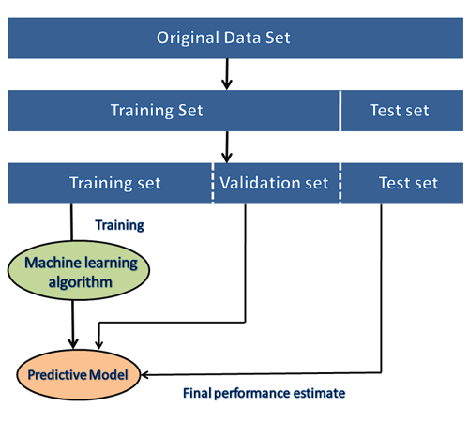

Ready made datasets available for Machine Learning:
Below is the list of datasets which are freely available for the public to work on it:

1. Kaggle Datasets
- Kaggle is a commonly and considered to be one of the best source for readymade datasets.
- It provides high quality datasets in different formats.
- A user can search, download and publish his/her own datasets.
- A developer can collaborate with other data scientists to work on machine learning projects.
- The link for the Kaggle dataset is https://www.kaggle.com/datasets.
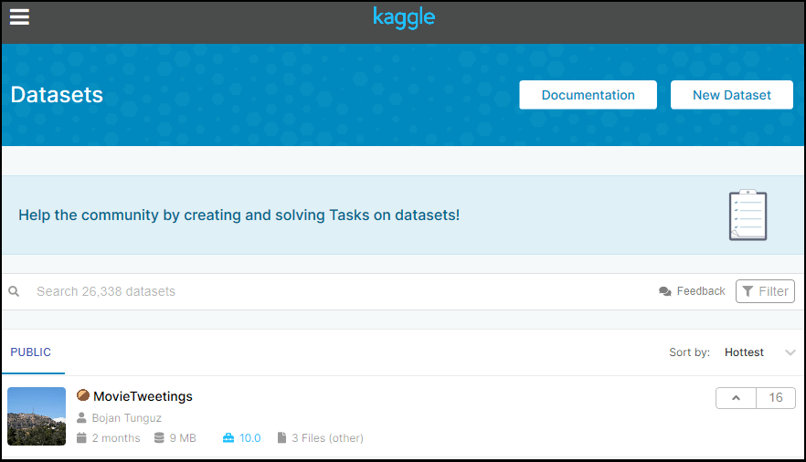

2. UCI Machine Learning Repository
- UCI Machine learning repository is one of the great sources for ML datasets.
- It contains databases, domain theories and data generators that are widely used by developers of ML projects.
- Since the year 1987, it has been widely used by students, professors, researchers.
- It has datasets classified based on the types of tasks for which they are required like, Regression, Classification, Clustering, etc.
- It also contains some of the popular datasets such as the Iris dataset, Car Evaluation dataset, Poker Hand dataset, etc.
- The link for the UCI machine learning repository is https://archive.ics.uci.edu/ml/index.php.
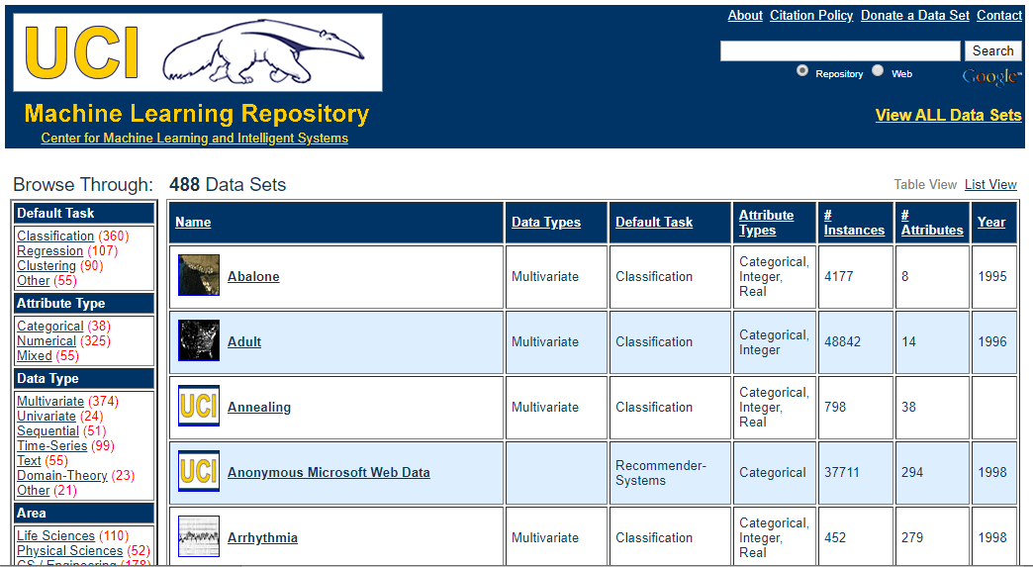

3. Datasets via AWS
- AWS allows us to search download, access and share publicly available datasets using its resources.
- The datasets are provided and maintained by government organizations, researches, businesses or individuals.
- We can search, download, access, and share the datasets that are publicly available via AWS resources. These datasets can be accessed through AWS resources but provided and maintained by different government organizations, researchers, businesses, or individuals.
- The datasets are available on the cloud. Anybody can use them.
- The link for the resource is https://registry.opendata.aws/.
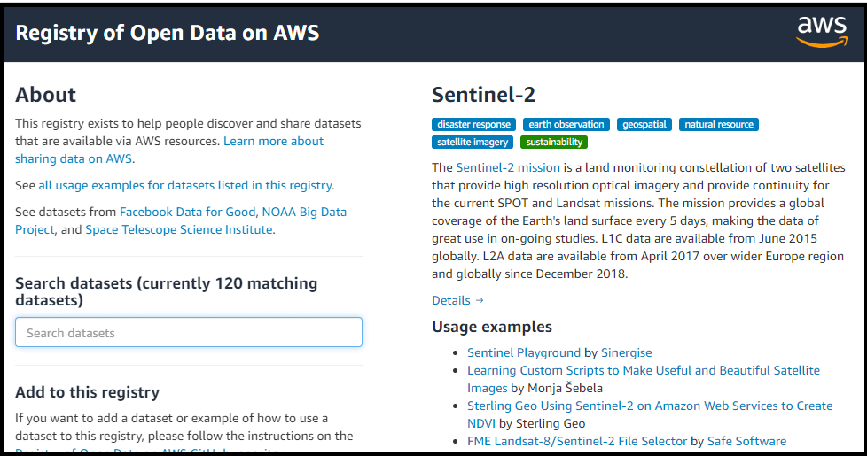

4. Google's Dataset Search Engine

- Google dataset search engine is a search engine launched by Google on September 5, 2018.
- It helps users or researches get datasets online for free.
- The link for the Google dataset search engine is https://toolbox.google.com/datasetsearch.
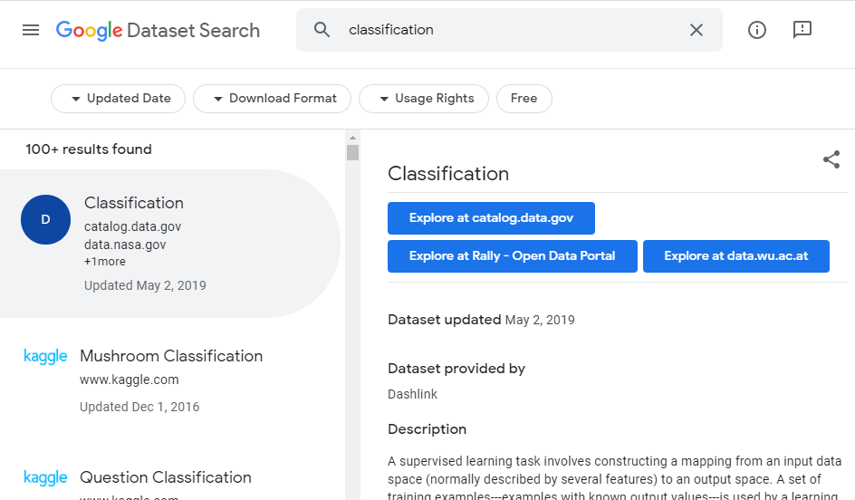

5. Microsoft Datasets
- The Microsoft has launched the "Microsoft Research Open data" repository.
- It provides datasets for free in areas like natural language processing, computer vision, and domain-specific sciences.
- Users can either download and use the datasets or directly use them on the cloud.
- The link to download or use the dataset from this resource is https://msropendata.com/.
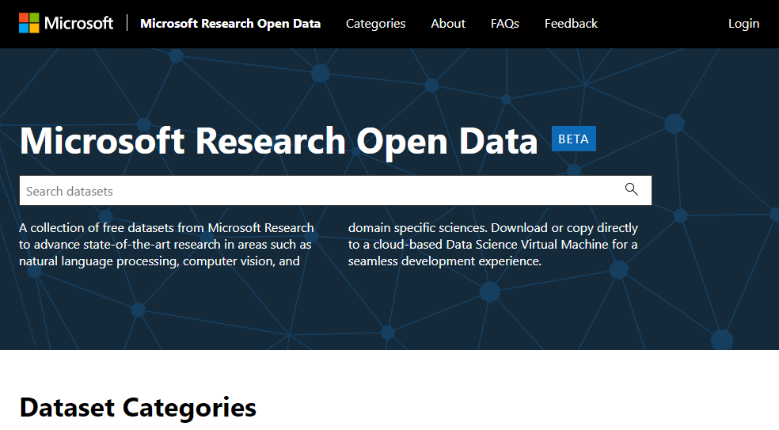

6. Awesome Public Dataset Collection
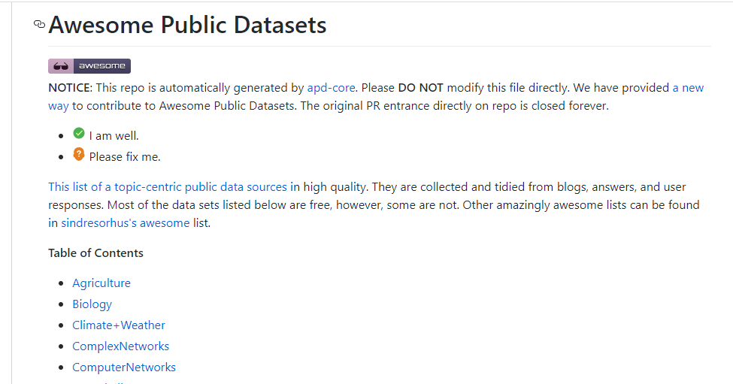
- Awesome public dataset collection provides high-quality datasets that are arranged in a well-organized manner according to various topics such as Agriculture, Biology, Climate, Complex networks, etc.
- Most of the datasets are available free, but some are for payment.
- The link to download the dataset from Awesome public dataset collection is https://github.com/awesomedata/awesome-public-datasets.

7. Government Datasets
- There are different sources that provide government datasets belonging to various departments of various countries.
- Below are some links of government datasets:
- Indian Government dataset
- US Government Dataset
- Northern Ireland Public Sector Datasets
- European Union Open Data Portal

8. Computer Vision Datasets
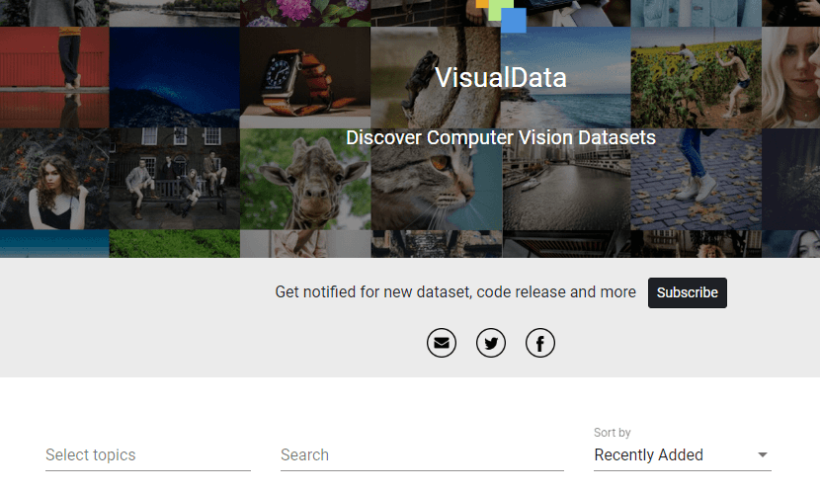
- Visual data provides many datasets that are related to computer visions such as Image Classification, Video classification, Image Segmentation, etc.
- For Image processing projects and deep learning projects you can use the datasets available here.
- The link for downloading the dataset from this source is https://www.visualdata.io/.

9. Scikit-learn dataset

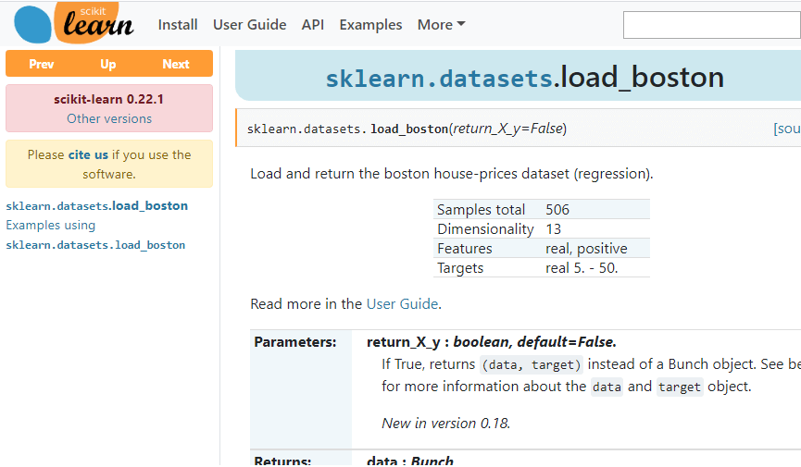
- Scikit-learn is a very good source for machine learning datasets.
- It provides both dummy as well as real-world datasets.
- These datasets can be accessed using sklearn.datasets package and using the Scikit-learn API.
- The link to download datasets from this source is https://scikit-learn.org/stable/datasets/index.html.

Data Preprocessing in Machine learning
- Data maybe of three types:
  - Structured (database/ Excel)
  - Semi structured (XML/HTML)
  - Unstructured (Text)
- The raw data that is collected may not be suitable for applying machine learning models.
- Raw data may have missing values or noise or outliers or may not be in the format that is required for processing.
- So the raw data needs to be converted to a form that can be used by the machine learning algorithms efficiently.
- That is the data needs to be cleaned.
- To do this the missing values needs to be filled with either median values or may need to be deleted.
- Categorical data may need to be converted to numeric form.
- Unstructured or Text data may have to be converted into numerical data.
- Outliers may have to be deleted.
- Multiple attributes may have to be clubbed to form a single attribute.
- Therefore data preprocessing is the process of preparing the raw data to be suitable for machine learning task.
- Data preprocessing is the first step in a machine learning project.
- If the data is not prepared, it may lead to failure of the system or lower accuracy.
- Well prepared data will lead to higher accuracy and higher efficiency of the machine learning model.
- Data pre-processing involves the following steps.

- Getting the dataset
- Importing libraries
- Importing datasets
- Finding Missing Data
- Encoding Categorical Data
- Splitting dataset into training and test set
- Feature scaling (reduce distance between the data)

1) Get the Dataset
- This is the first step in a machine learning process.
- You can use dummy dataset or dataset available in repositories like kaggle.
- Twitter datasets, speeches, image datasets, movie reviews, etc., are available. Eg: nltk library
- Electronic health records are difficult to obtain.
- Images of leaves, paddy plant, arecanut can be captured.
- Bacteria can be cultured and high resolution images taken.
- Web page contents can be scraped using customized search engines.
- Readymade scraping tools can be used.
- Readymade APIs also can be used to get the dataset. Eg: nltk library

2) Importing Libraries
- Python has inbuilt libraries for various jobs.
- In Python the 3 important libraries used for data preprocessing are:
  - Numpy: Numpy is a Python library to manipulate arrays and matrices, mathematical operations and scientific calculations.
import numpy as nm
  - Matplotlib is a library which is useful for data visualization. It helps in plotting 2D charts. It will be imported as below:
import matplotlib.pyplot as mpt
  - Pandas: Pandas is one of the most popular of the Python libraries. It is used for managing, manipulating and analyzing datasets. It is open source.
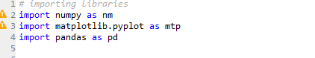

3) Importing the Datasets
To read and load the dataset which is in csv file, in Python we use the following statement from the Pandas library..
read_csv() function:
data_set= pd.read_csv('Dataset.csv')

