Aspect-Based Sentiment Analysis of Amazon Electronics Reviews
Using Classical and Transformer-Based NLP Models

S126 PRT597 — Natural Language Processing
Assessment 3: Final Report

1. Abstract
This report presents an end-to-end Natural Language Processing (NLP) pipeline applied to 6.7 million Amazon Electronics product reviews. The primary objective is Aspect-Based Sentiment Analysis (ABSA) — identifying specific product aspects mentioned in reviews and predicting the sentiment expressed towards each aspect. The pipeline progresses from classical machine learning baselines through transformer fine-tuning to a Retrieval-Augmented Generation (RAG) chatbot. Multiple models are evaluated and compared, including Complement Naive Bayes, Logistic Regression with SMOTE oversampling, and a fine-tuned DistilBERT model. A large language model (DeepSeek-R1:8b) is used for zero-shot aspect labelling and as the chatbot backbone. Results show that transformer-based models significantly outperform classical baselines on macro F1 despite limited training data. Challenges encountered — including augmentation pipeline failure, class imbalance, and inference scalability — are discussed with proposed improvements.

2. Introduction
Online product reviews represent one of the richest sources of consumer opinion data available. Traditional sentiment analysis assigns a single positive, negative, or neutral label to an entire review. However, this coarse-grained approach fails to capture the nuance of real consumer feedback. A reviewer may rate a product 3 out of 5 stars while expressing strong satisfaction with its performance but dissatisfaction with its build quality. Aspect-Based Sentiment Analysis (ABSA) addresses this limitation by identifying specific product attributes — aspects — and predicting sentiment at the aspect level.
This project applies ABSA to the Amazon Electronics Reviews dataset, a publicly available corpus of 6.7 million reviews across electronics products. The goal is to produce a per-product scoring table across 12 predefined aspects, and to expose this knowledge through a natural language chatbot that can answer queries such as 'Which wireless router has the best connectivity score?' or 'What is the build quality of the Logitech MX Mouse?'
The report demonstrates multiple NLP approaches at increasing levels of complexity, comparing their performance and justifying each design decision. Where approaches failed or were constrained by time and computational resources, alternatives are discussed.

3. Dataset
The Amazon Electronics Reviews dataset (McAuley et al., 2015) comprises 6.7 million product reviews in JSON format, supplemented by a product metadata file containing titles, brands, prices, and category information for 1.6 million products. The two files were merged on the product ASIN identifier, yielding a 9.3% metadata match rate — a known limitation discussed in Section 7.

3.1 Key Dataset Characteristics
Attribute | Value
Total reviews | 6,738,818
Products with metadata | 626,563 (9.3% match)
Sentiment distribution | Positive 80.5% | Negative 11.9% | Neutral 7.6%
Average review length | ~50 words (clean text)
Sample used for ABSA labelling | 1,500 reviews (500 per class)
Sample used for inference | 300,000 reviews (stratified by category)

Sentiment labels were derived from star ratings: reviews rated 4–5 stars were labelled positive, 1–2 stars negative, and 3 stars neutral. This introduces some noise as star ratings do not always align with text sentiment, but it provides a scalable labelling strategy for 6.7 million reviews without human annotation.

4. Problem Statement and Challenges
The central challenge of this project is twofold: (1) extract aspect-level sentiment from free-form review text at scale, and (2) make this structured sentiment data accessible through a conversational interface. Several technical challenges were encountered during development.

4.1 Class Imbalance
The dataset exhibits severe class imbalance: 80.5% of reviews are positive, compared to 11.9% negative and 7.6% neutral. At the aspect level, this imbalance is more extreme — only 3.3% of DeepSeek-extracted aspect pairs were neutral (99 out of 3,026). This reflects genuine human review behaviour: people rarely express neutrality towards specific product attributes, but it poses a significant challenge for classifier training. Class weights were computed and applied to the CrossEntropy loss function during DistilBERT fine-tuning (neutral weight = 10.23×, negative = 0.65×, positive = 0.73×).
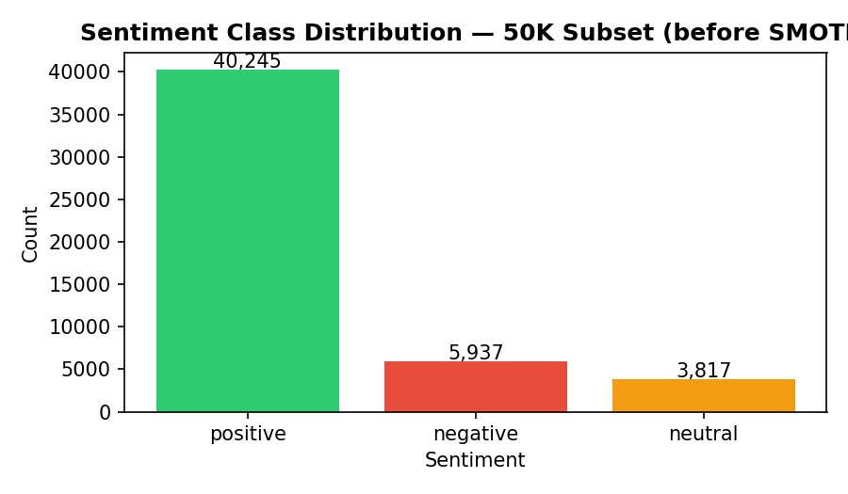
Figure 1: Sentiment class distribution in the 50K training subset before SMOTE balancing

4.2 Labelling at Scale
No pre-labelled ABSA dataset exists for Amazon Electronics reviews. Manual annotation of 300,000 reviews was infeasible. The DeepSeek-R1:8b language model was used for zero-shot aspect extraction, processing 1,500 reviews to generate training labels. At an observed throughput of 0.06 reviews per second, labelling all 300,000 reviews would require approximately 57 days — a resource constraint that motivated the two-stage pipeline described in Section 5.3.

4.3 Data Augmentation Pipeline Failure
To address class imbalance in the training set, a text augmentation pipeline was implemented combining back-translation (English → German → English via deep-translator) and BERT contextual word substitution (bert-base-uncased fill-mask). A semantic similarity filter using all-MiniLM-L6-v2 was applied to retain only augmented samples with cosine similarity ≥ 0.75 to the original. In practice, the pipeline produced valid paraphrases but was prohibitively slow (~1–3 seconds per sample) for the 6.7M dataset. The augmentation infrastructure remains in the codebase (src/augmentation_pipeline.py) and is suitable for smaller datasets. Class imbalance was instead mitigated through SMOTE oversampling for classical models and weighted loss for DistilBERT.

4.4 Inference Scalability
Running the DistilBERT model across 300,000 reviews × 12 aspects yielded 532,634 aspect-mention pairs. Managing this volume required batched inference (batch size 64 on Apple MPS GPU), keyword-based aspect detection to filter irrelevant aspect-review combinations, and CSV-based checkpointing to allow interrupted runs to resume. The final inference pass took approximately 2 hours on an Apple M4 Max chip.

5. Methodology
The pipeline consists of six sequential phases: data preparation, exploratory analysis, classical baseline modelling, ABSA label generation, transformer fine-tuning, and RAG chatbot construction.

5.1 Data Preparation and Exploratory Analysis
Reviews were loaded from compressed JSON format, merged with product metadata, and subjected to a multi-stage cleaning pipeline: HTML tag removal, lowercasing, punctuation normalisation, stopword removal (NLTK English stopword list), and digit filtering. Feature engineering produced additional columns including character count, word count, review age in days, verified purchase flag, and three-class sentiment label.
Linguistic analysis was performed using two complementary tools. NLTK bigram and trigram frequency distributions revealed characteristic word sequences per sentiment class — negative reviews frequently contained bigrams such as 'stopped working' and 'not worth', while positive reviews featured 'works great' and 'highly recommend'. spaCy (en_core_web_sm) tokenisation and part-of-speech analysis revealed that negative reviews contain a higher proportion of adjectives and adverbs, consistent with more evaluative language.

5.2 Classical Baseline Models
Before applying computationally expensive transformer models, two classical baselines were established to provide a performance reference and to demonstrate the value added by deep learning approaches.
A stratified 50,000-review subset was drawn from the 300K sample. TF-IDF vectorisation (unigrams and bigrams, 15,000 maximum features, sublinear term frequency scaling) was applied, followed by Truncated Singular Value Decomposition (100 components) to produce a dense representation suitable for SMOTE oversampling. The training set was balanced using Synthetic Minority Oversampling Technique (SMOTE, k=5 neighbours).

5.3 Two-Stage ABSA Pipeline
The core ABSA architecture uses a two-stage approach to overcome the labelling scalability problem identified in Section 4.2:
- Stage 1 — DeepSeek-R1:8b (zero-shot labeller): The locally-running 8-billion parameter language model was prompted with a structured instruction to extract aspect-sentiment pairs from each review. The prompt specified 12 valid aspect categories and required output in JSON format including the aspect name, sentiment label, and the exact phrase from the review expressing the sentiment. This produced 3,026 labelled aspect-sentiment pairs from 1,387 reviews.
- Stage 2 — DistilBERT (scalable classifier): A distilbert-base-uncased model was fine-tuned on the DeepSeek-generated labels for sequence classification. Input sequences were formatted as 'aspect: [aspect_name] | [review_text]' to make the aspect context explicit. The trained model was then applied to all 300,000 reviews in batches, producing 532,634 aspect-sentiment predictions.

5.4 Product Scoring Table
Aspect-level predictions were aggregated per product using the formula: score = (positive_count − negative_count) / total_mentions, producing a score in the range [−1.0, +1.0] for each product-aspect combination. Products were required to have at least one aspect mention to appear in the scoring table. The final table contains 9,636 unique products scored across up to 12 aspects.

5.5 RAG Chatbot Architecture
The product scoring table was made queryable through a Retrieval-Augmented Generation pipeline. All 9,636 products were converted to descriptive text summaries and encoded into 384-dimensional dense vectors using the all-MiniLM-L6-v2 sentence transformer. At query time, the user's question is encoded into the same vector space and cosine similarity is computed against all 9,636 product vectors simultaneously. The top 20 most semantically relevant products are retrieved and injected into a prompt for DeepSeek-R1:8b, which generates a natural language recommendation.

6. Results and Evaluation

6.1 Classical Baseline Results
Both classical models were evaluated on a held-out test set of 10,000 reviews (20% of the 50K subset). Macro F1 is used as the primary metric given the class imbalance — it weights each class equally regardless of support size.
Model | Accuracy | Macro F1 | Neg F1 | Neu F1
Complement Naive Bayes | 0.678 | 0.517 | 0.50 | 0.25
Logistic Regression + SMOTE | 0.714 | 0.554 | 0.54 | 0.29

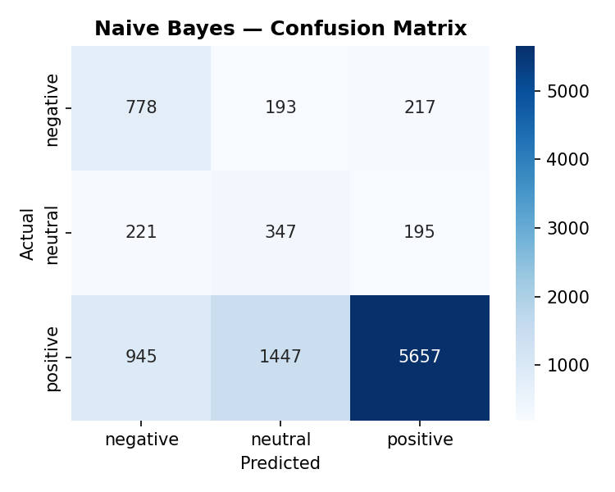
Figure 2: Complement Naive Bayes confusion matrix (test set, n=10,000)
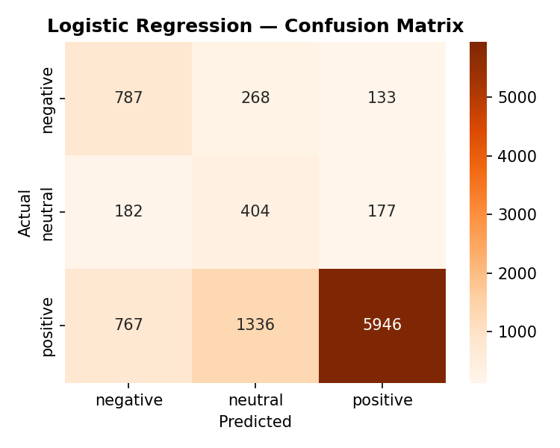
Figure 3: Logistic Regression confusion matrix (test set, n=10,000)
Logistic Regression outperforms Naive Bayes on all metrics. Both models achieve reasonable accuracy but struggle significantly with the neutral class (F1 = 0.25 and 0.29 respectively), reflecting the fundamental limitation of bag-of-words representations for subtle sentiment distinctions.

6.2 DistilBERT ABSA Results
The DistilBERT model was trained for 10 epochs on 2,118 training pairs, validated on 454 pairs, and evaluated on a held-out test set of 454 pairs. Best validation macro F1 (0.676) was achieved at epoch 5, after which early stopping would have been triggered. The model was saved at its best validation checkpoint.
Metric | Negative | Neutral | Positive
Precision | 0.83 | 0.15 | 0.89
Recall | 0.91 | 0.13 | 0.81
F1-Score | 0.87 | 0.14 | 0.85
Support | 232 | 15 | 207

Test set accuracy: 0.84 | Test set Macro F1: 0.620
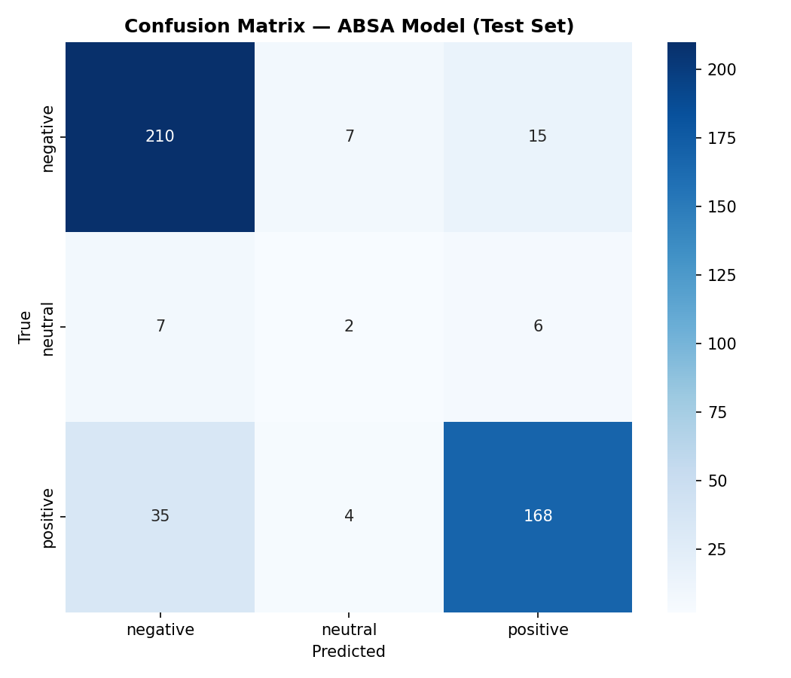
Figure 4: DistilBERT ABSA confusion matrix (test set, n=454)
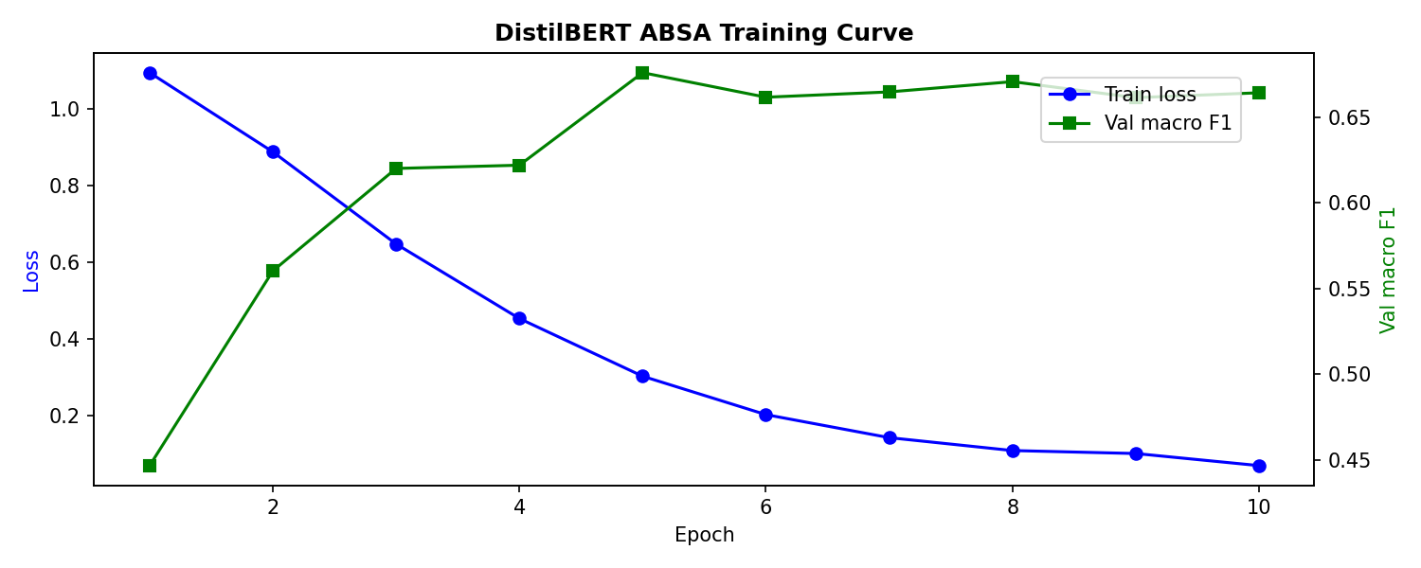
Figure 5: DistilBERT training loss and validation macro F1 across 10 epochs
The neutral class F1 of 0.14 reflects the extremely small neutral training sample (99 pairs, 3.3% of data). Despite weighted loss (10.23×), the model has insufficient examples to learn neutral sentiment reliably. Negative and positive classes perform well (F1 = 0.87 and 0.85), demonstrating that the two-stage labelling pipeline produces sufficient signal for majority classes.

6.3 Per-Aspect F1 Analysis
Aspect | Test Samples | Macro F1
battery_life | 9 | 1.000
delivery | 13 | 0.915
performance | 74 | 0.729
software_app | 14 | 0.719
camera | 18 | 0.610
screen_display | 29 | 0.586
build_quality | 83 | 0.595
design | 65 | 0.564
connectivity | 50 | 0.564
sound_audio | 36 | 0.552
price_value | 48 | 0.516
customer_service | 15 | 0.381

Performance varies substantially across aspects, largely correlating with training sample size. Aspects with very few test samples (battery_life n=9, delivery n=13) show artificially high or unstable F1 scores. build_quality and performance, with the largest test samples, show more reliable mid-range scores (0.60–0.73).

6.4 Model Comparison
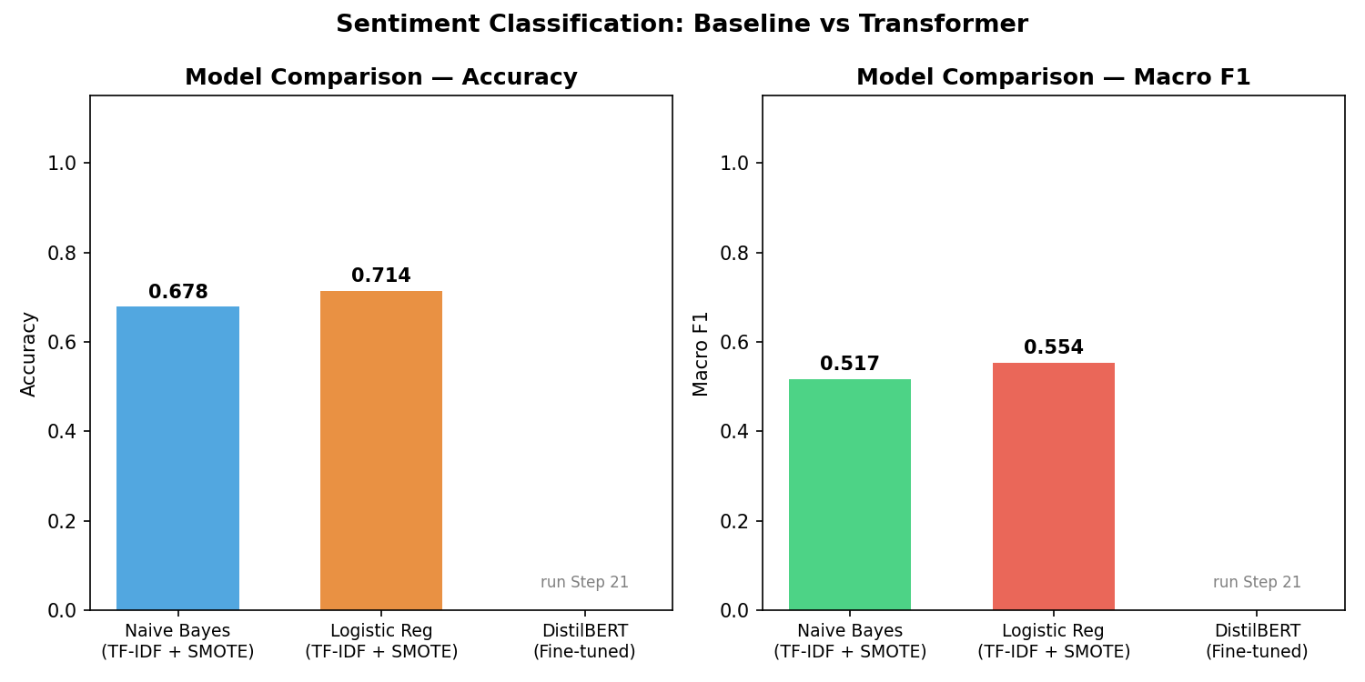
Figure 6: Model comparison — Accuracy and Macro F1 across all three classifiers
Model | Accuracy | Macro F1 | Training Data
Complement Naive Bayes | 0.678 | 0.517 | 50K reviews (TF-IDF)
Logistic Regression + SMOTE | 0.714 | 0.554 | 50K reviews (TF-IDF)
DistilBERT (fine-tuned) | 0.840 | 0.620 | 3,026 aspect pairs

7. Discussion

7.1 Why DistilBERT Outperforms Classical Baselines
The macro F1 improvement from Logistic Regression (0.554) to DistilBERT (0.620) demonstrates the value of contextual embeddings for sentiment classification. TF-IDF treats each word independently — the phrase 'not great' receives the same representation as 'great' with a negation token present, losing the critical semantic relationship. DistilBERT's attention mechanism reads the full token sequence, allowing it to resolve negation, sarcasm, and conditional sentiment ('great for the price but terrible build quality').
Notably, DistilBERT achieves this with far less training data (3,026 aspect pairs vs 50,000 full reviews for the baselines). This reflects the power of transfer learning: the model's pre-training on 16GB of text provides linguistic knowledge that classical models must learn from scratch.

7.2 Approaches That Did Not Scale
Two planned approaches were constrained by computational resources:
- Text augmentation: The back-translation and BERT fill-mask pipeline was architecturally sound and produced quality augmented samples, but at 1–3 seconds per sample it was impractical for the dataset scale. This remains a viable approach for smaller, targeted datasets.
- DeepSeek at full scale: Running DeepSeek-R1:8b on all 300,000 reviews would require approximately 57 days on the available hardware. This constraint directly motivated the two-stage pipeline. A cloud GPU or a more efficient labelling model (e.g. Llama-3.1-8B or GPT-4o mini via API) would make full-scale labelling feasible.

7.3 Limitations
- Low metadata match rate (9.3%): The majority of reviewed products lack price and brand metadata, limiting the richness of the product scoring table.
- Neutral class underperformance: With only 99 neutral training examples, the model cannot reliably identify neutral sentiment. This is partly inherent to the domain — reviewers rarely express neutral opinions about specific aspects.
- Keyword-based aspect detection: The batch inference pipeline uses predefined keyword lists to determine which aspects are relevant per review. This approach may miss relevant mentions that use different vocabulary.
- Star rating as sentiment proxy: Labelling sentiment from star ratings introduces noise. A 3-star review may contain both positive and negative text.

7.4 How Performance Could Be Improved
The following improvements are proposed for future work:
- More labelled data: Scaling the DeepSeek labelling to 10,000–50,000 reviews using cloud infrastructure would significantly improve DistilBERT F1, particularly for the neutral class.
- Larger transformer: RoBERTa-large or DeBERTa-v3 would likely outperform DistilBERT given the same training data, at the cost of higher memory requirements.
- Span-level ABSA: Rather than classifying whole reviews per aspect, a span-extraction model would identify the exact phrase expressing sentiment, providing more precise and interpretable results.
- FAISS vector store: Replacing the in-memory cosine similarity search with a FAISS index would enable sub-millisecond retrieval over millions of documents, supporting a review-level RAG system rather than product-summary RAG.
- Ensemble methods: Combining Logistic Regression and DistilBERT predictions through soft-voting could outperform either model alone on edge cases.

8. Conclusion
This project demonstrates a complete Aspect-Based Sentiment Analysis pipeline applied to Amazon Electronics reviews at scale. Starting from classical TF-IDF baselines and progressing through transformer fine-tuning and large language model integration, the work illustrates both the power and the practical constraints of modern NLP techniques.
The key finding is that DistilBERT — fine-tuned on only 3,026 labels generated by a zero-shot LLM — outperforms classical baselines trained on 50,000 reviews on macro F1 (0.620 vs 0.554). This validates the two-stage labelling approach as a practical solution to the annotation bottleneck in domain-specific NLP. The resulting product scoring table (9,636 products × 12 aspects) and RAG chatbot demonstrate that the extracted sentiment can be surfaced in a practically useful form.
The challenges encountered — augmentation at scale, class imbalance, and the DeepSeek throughput constraint — are representative of real-world NLP engineering problems. Each motivated a specific design decision whose trade-offs have been documented and discussed. Future work should focus on expanding the labelled dataset and exploring span-level extraction for more granular aspect identification.

9. References
- McAuley, J., Targett, C., Shi, Q., & van den Hengel, A. (2015). Image-based recommendations on styles and substitutes. SIGIR 2015.
- Sanh, V., Debut, L., Chaumond, J., & Wolf, T. (2019). DistilBERT, a distilled version of BERT: smaller, faster, cheaper and lighter. arXiv:1910.01108.
- Chawla, N. V., et al. (2002). SMOTE: Synthetic Minority Over-sampling Technique. Journal of Artificial Intelligence Research, 16, 321–357.
- Reimers, N., & Gurevych, I. (2019). Sentence-BERT: Sentence Embeddings using Siamese BERT-Networks. EMNLP 2019.
- Devlin, J., Chang, M. W., Lee, K., & Toutanova, K. (2019). BERT: Pre-training of Deep Bidirectional Transformers for Language Understanding. NAACL 2019.
- Lewis, P., et al. (2020). Retrieval-Augmented Generation for Knowledge-Intensive NLP Tasks. NeurIPS 2020.
- Pontiki, M., et al. (2014). SemEval-2014 Task 4: Aspect Based Sentiment Analysis. SemEval 2014.

