INTRODUCTION

We are developed this project for our society , because there are many people in our society who help others. And there are many people who need help. But both type of people not meet each others. This is big problems . we can develop this project to solve this problems. In this project donner and receiver both are present in the same platform. If donner want to donate something, so he can donate very easily with the help of this project and if any person want to this item so he can direct contact to the donner. and collect those items.

In this project we are working two important way. Ways are given below:-

1.charity:

With the use of this module , any person donate everything to the peoples ,like

a. food

b. cloth

c. furniture

d. book

2. Event :

With the use of this module, we can help to organize a event for those people who cant able to celebrate his function.

This project will help to change the way of donating completely and the donor will know, to whom has he donated .

ADVANTAGES

1. This project will helps those people who are shy to ask for something from others.
2. Nobody can fraud here.
3. Every person reach here and ask help for volunteer, and volunteer help those person as soon as possible.
4. Here ,donner and receiver both are communicate via smartphone and anydevice.
5. Donor can donate his items to anyone.

PURPOSE

The purpose of this project is to computerized the tradition way to donating. Another purpose for developing this project ,

In INDIA 33% people fall below the poverty line. INDIA ranked 100 out of 119 in terms of hungers. 526 million people are forced to eat half their stomach in Asia.

According to GHI report, 19 crore people in india are forced to sleep with hungry stomach and 3000 children die of starvation ever day. Because in INDIA peoples waste lots of food. This is a very big problems for INDIA. We can solve this problems by using this project.

OBJECTIVE

The main objective of this project is to help every person as soon as possible. If you have something extra food and unused items so donate these for others he needs it.

In others words, we can say that our project has the following objectives—

1. This application mainly consists of 2 persons – Doner and Receiver.
2. Doner and Receiver performs operations like Registration and login into the system.
3. Doner has no restriction, they donate anything to Receiver.
4. This project creates many benefits for the business and the community.
5. This project fully based on online, by taking it online it will help many people throughout the city/area/zip-area by donating food/items daily.

Software Development Life Cycle

SDLC is a process followed for a software project, within a software organization. It consists of a detailed plan describing how to develop, maintain, replace and alter or enhance specific software. The life cycle defines a methodology for improving the quality of software and the overall development process.

The following figure is a graphical representation of the various stages of a typical SDLC.

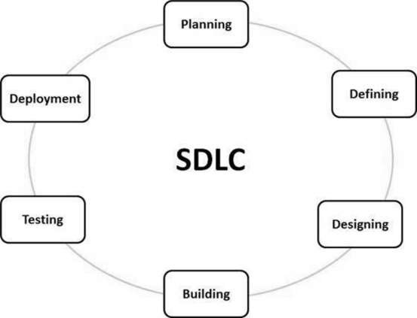

A typical Software Development Life Cycle consists of the following stages –

1. Planning and Requirement Analysis
2. Defining Requirement
3. Designing the Product Architecture
4. Building or Developing the product
5. Testing the product
6. Deployment in the market and maintenance

SYSTEM ANALSIS

Introduction :-

Analysis can be defined as breaking up of any whole so as to find out their nature, function etc. It define design as to make preliminary sketches of to sketch a pattern or outline for plan .to plan and carry out especially by artistic arrangement or in a skillful wall. System analysis and design can be characterized as a set of techniques and processes, a community of interests, a culture and an intellectual orientation.

The various tasks in the system analysis include the following :-

Understanding application

Planning

Scheduling

Developing candidate solution

Performing trade studies

Performing cost benefit analysis

Supervising, installing and maintaining the system.

PROJECT CATEGORY

FRONTEND AND BACKEND DESCRIPTION

FRONTEND:--

1. HTML(Hypertext Markup Language):-

It provide to create structured documents including images, lists and other items. It is the language understanding by browser. HTML is the standard markup language for documents designed to be displayed in a web browser. It can be assisted by technologies such as Cascading Style Sheets (CSS).

Web browsers receive HTML documents from a web server or from local storage and render the documents into multimedia wed pages. HTML describes the structure of a web page semantically and originally included cues for the appearance of the document.

1. CSS(Cascading Style Sheet) :-

It can be applied to bring the style in the web documents. CSS is a style sheet language used for describing the presentation of a document written in a markup language like HTML. CSS is a cornerstone technology of the world wide web, alongside HTML and java Script.

CSS is designed to enable the separation of presentation and content, including layout, colors and fonts. This separation can improve content accessibility, provide more flexibility and control in the specification of presentation characteristics, enable multiple web pages share formatting by specifying the relevant CSS in a separate.

The name *cascading* comes from the specified priority scheme to determine which style rule applies if more than one rule matches a particular element. This cascading priority scheme is predictable.

1. BOOTSTRAP:-

Bootstrap is a web framework that focuses on simplifying the development of informative web pages . The primary purpose of adding it to a web project is to apply Bootstrap's choices of color, size, font and layout to that project. As such, the primary factor is whether the developers in charge find those choices to their liking. Once added to a project, Bootstrap provides basic style definitions for all HTML elements. In addition, developers can take advantage of CSS classes defined in Bootstrap to further customize the appearance of their contents. For example, Bootstrap has provisioned for light- and dark-colored tables, page headings, more prominent pull quotes, and text with a highlight. Bootstrap is a free and open source CSS framework directed at responsive, mobile first front end web development. It contains CSS and (optional) Java Script based design templates for forms, buttons, navigation and other interface components.

BACKEND:

PYTHON

Python is a popular programming language. It was created by Guido van Rossum, and released in 1991.

It is used for:

* web development (server-side),
* software development,
* mathematics,
* system scripting.

What can Python do?

* Python can be used on a server to create web applications.
* Python can be used alongside software to create workflows.
* Python can connect to database systems. It can also read and modify files.
* Python can be used to handle big data and perform complex mathematics.
* Python can be used for rapid prototyping, or for production-ready software development.

Why Python?

* Python works on different platforms (Windows, Mac, Linux, Raspberry Pi, etc).
* Python has a simple syntax similar to the English language.
* Python has syntax that allows developers to write programs with fewer lines than some other programming languages.
* Python runs on an interpreter system, meaning that code can be executed as soon as it is written. This means that prototyping can be very quick.
* Python can be treated in a procedural way, an object-orientated way or a functional way.

SQLITE

* SQLITE DATABASE :--

It is used to create a database. Python provide a server for the database is called Sqlite , software that allows you to insert ,retrieve ,modify or delete the records.

SQLite is a software library that provides a relational database management system. The lite in SQLite means lightweight in terms of setup, database administration, and required resources.

SQLite has the following noticeable features: self-contained, serverless, zero-configuration, transactional.

### Serverless

Normally, an RDBMS such as MySQL, PostgreSQL, etc., requires a separate server process to operate. The applications that want to access the database server use TCP/IP protocol to send and receive requests. This is called client/server architecture.

* The following diagram illustrates the RDBMS client/server architecture:

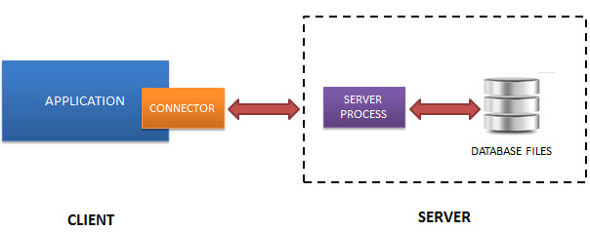

* SQLite does NOT work this way.
* SQLite does NOT require a server to run.
* SQLite database is integrated with the application that accesses the database. The applications interact with the SQLite database read and write directly from the database files stored on disk.
* The following diagram illustrates the SQLite server-less architecture:

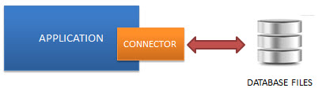

### Self-Contained

SQLite is self-contained means it requires minimal support from the operating system or external library. This makes SQLite usable in any environment especially in embedded devices like iPhones, Android phones, game consoles, handheld media players, etc.

SQLite is developed using ANSI-C. The source code is available as a big sqlite3.c and its header file sqlite3.h. If you want to develop an application that uses SQLite, you just need to drop these files into your project and compile it with your code.

### Zero-configuration

Because of the serverless architecture, you don’t need to “install” SQLite before using it. There is no server process that needs to be configured, started, and stopped.

In addition, SQLite does not use any configuration files.

### Transactional

All transactions in SQLite are fully ACID-compliant. It means all queries and changes are Atomic, Consistent, Isolated, and Durable.

In other words, all changes within a transaction take place completely or not at all even when an unexpected situation like application crash, power failure, or operating system crash occurs.

## SQLite distinctive features

SQLite uses dynamic types for tables. It means you can store any value in any column, regardless of the data type.

SQLite allows a single database connection to access multiple database files simultaneously. This brings many nice features like joining tables in different databases or copying data between databases in a single command.

* SQLite is capable of creating in-memory databases that are very fast to work with.

DJANGO

* Django(Framework):-- Django is a free, open-source Python based high level web framework. It follows the model view templates(MVT) Architectural pattern. Django provide SQLite database by default.

Django is a web development framework that assists in building and maintaining quality web applications. Django helps eliminate repetitive tasks making the development process an easy and time saving experience. This tutorial gives a complete understanding of Django.

Django is a high-level Python web framework that encourages rapid development and clean, pragmatic design. Django makes it easier to build better web apps quickly and with less code.

**Note** − Django is a registered trademark of the Django Software Foundation, and is licensed under BSD License.

## History of Django

* **2003** − Started by Adrian Holovaty and Simon Willison as an internal project at the Lawrence Journal-World newspaper.
* **2005** − Released July 2005 and named it Django, after the jazz guitarist Django Reinhardt.
* **2005** − Mature enough to handle several high-traffic sites.
* **Current** − Django is now an open source project with contributors across the world.

## Django – Design Philosophies

Django comes with the following design philosophies −

* **Loosely Coupled** − Django aims to make each element of its stack independent of the others.
* **Less Coding** − Less code so in turn a quick development.
* **Don't Repeat Yourself (DRY)** − Everything should be developed only in exactly one place instead of repeating it again and again.
* **Fast Development** − Django's philosophy is to do all it can to facilitate hyper-fast development.
* **Clean Design** − Django strictly maintains a clean design throughout its own code and makes it easy to follow best web-development practices.

## Advantages of Django

Here are few advantages of using Django which can be listed out here −

* **Object-Relational Mapping (ORM) Support** − Django provides a bridge between the data model and the database engine, and supports a large set of database systems including MySQL, Oracle, Postgres, etc. Django also supports NoSQL database through Django-nonrel fork. For now, the only NoSQL databases supported are MongoDB and google app engine.
* **Multilingual Support** − Django supports multilingual websites through its built-in internationalization system. So you can develop your website, which would support multiple languages.
* **Framework Support** − Django has built-in support for Ajax, RSS, Caching and various other frameworks.
* **Administration GUI** − Django provides a nice ready-to-use user interface for administrative activities.
* **Development Environment** − Django comes with a lightweight web server to facilitate end-to-end application development and testing.

HARDWARE AND SOFTWARE REQUIREMENTS

HARDWARE REQUIREMENTS :-

1. Ram

2. Storage capacity

SOFTWARE REQUIREMENTS :-

1. Internet

2. Browser

PROJECT MODULE

1.Admin module

a. Registration

b. Login

2. User module

a. Registration

b. Login

c. Donate

d. Receive

Data flow diagram:-

The DFD represent a System requirement in a graphical form, this led to a modular design. A DFD is also known as bubble chart has the purpose of clarifying system requirements and identifying major transformations that will become programs in system design.so it is the starting point of the design phase that functionally decomposes the requirements specifications down to the lowest level of detail. A DFD consist of a series of bubbled joined by lines. The bubbles represent data transformations and the lines represent data flow in the system.

Admin DFD

User DFD

E-R Diagram :

In this model objects of similar structures are collected into an entity set. The relationship between entity sets is represented by a named E-R relationship and is 1:1(one to one),1:N(one to many) or M:N(many to many) mapping from one entity set to another. The database structures, employing the E-R model is usually shown pictorially using entity relationship(E-R)diagrams. The E-R diagram are useful in representing the relationship among entitites. The following terms used in E-R Diagram :-

**Entity**:-An entity is a person, place , thing, event or concept about which information is recorded.

**Attribute**:-Attribute gives the characterstic of the entity. In other words, every entity has some basic attribute that characterize it.

**Entity Type**:-An entity type is defined as a collection of entities that have the **same** attributes.

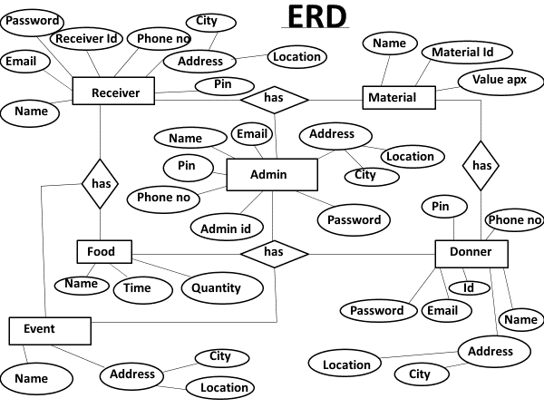

Future scope:--

Future scope of “HELPING POOL” is very good. And in other word we can say in future everyone want to use this project. This project can be updated in near future as when requirement for the same arises, as it is very flexible in terms of expansion . with the proposed software of database space manager ready and fully functional the client is now able to manage and hence run the entire work in a much better, accurate and error free manner.

BIBLIOGRAPHY:-

I really thank full to the project head for great support and help for achieving this goal and completing this project(“HELPING POOL”) for fulfilling the requirements of MCA six semester.

Reference books and websites:

<https://www.w3school.com>

<https://www.youtube.com>

<https://www.tutorialrepublic.com>

