AI ASSISTED CODING
ASSIGNMENT-7.4
Name: Shashikanth G
HT NO.:2403A51245
Batch No.: 11

Task 1:
- Introduce a buggy Python function that calculates the factorial of a number using recursion. Use Copilot or Cursor AI to detect and fix the logical or syntax errors.
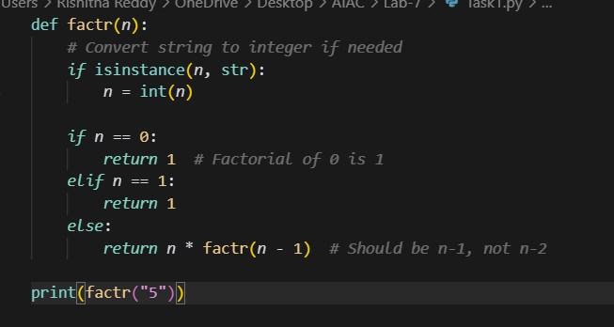
OUTPUT:

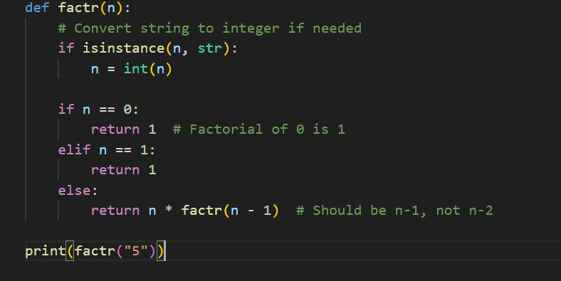
OUTPUT:

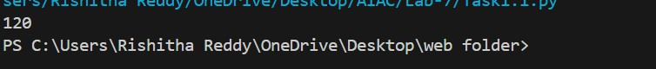

Task 2:
- Provide a list sorting function that fails due to a type error (e.g., sorting list with mixed integers and strings). Prompt AI to detect the issue and fix the code for consistent sorting.

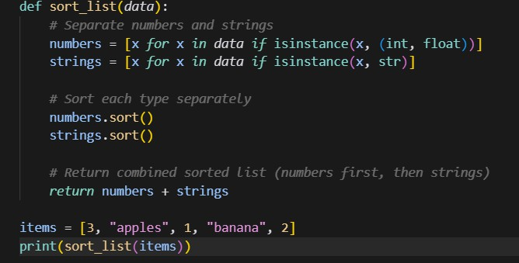
OUTPUT:
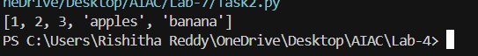

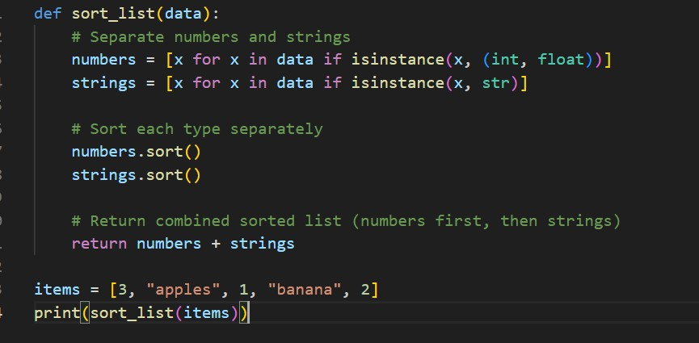
OUTPUT:
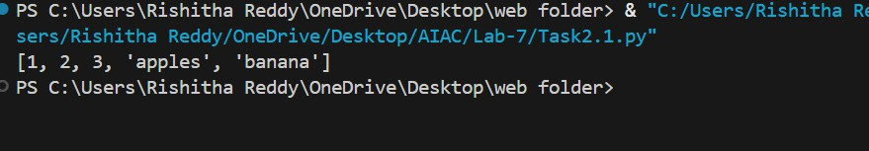

Task 3:
- Write a Python snippet for file handling that opens a file but forgets to close it. Ask Copilot or Cursor AI to improve it using the best practice (e.g., with open() block).

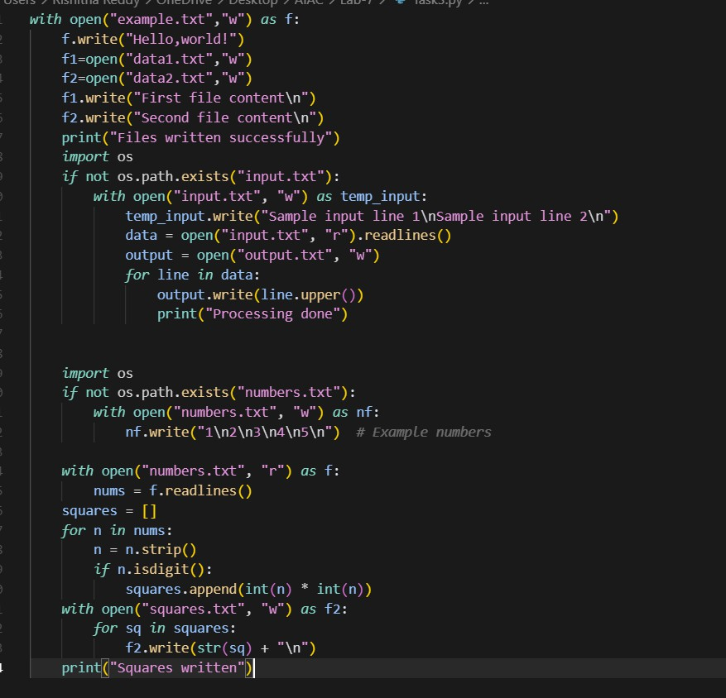

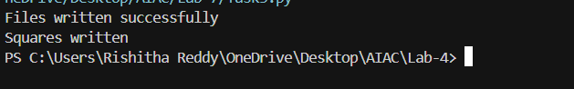
OUTPUT:

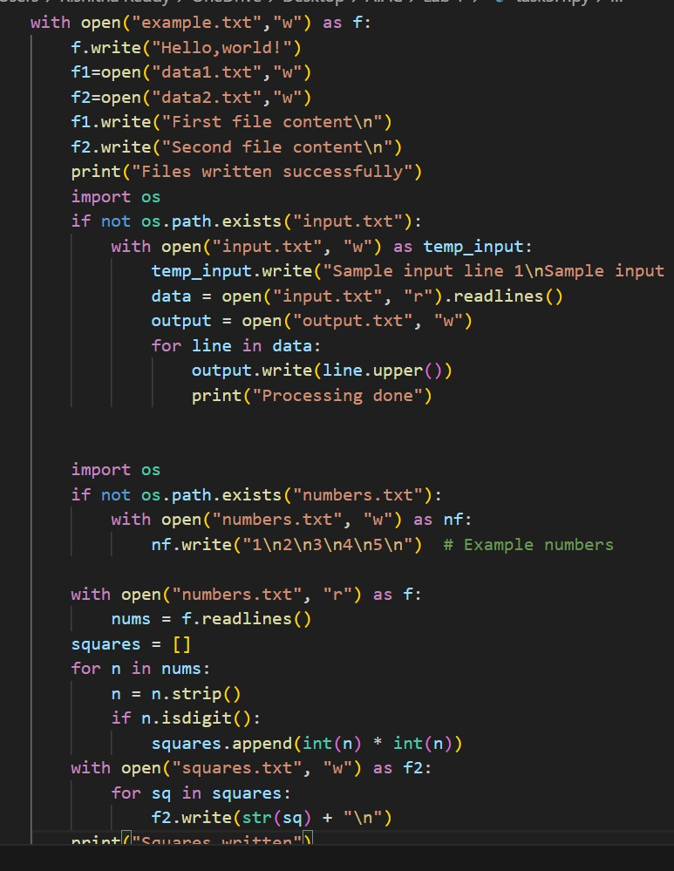
OUTPUT:
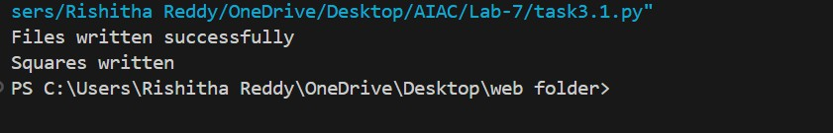

Task 4:
- Provide a piece of code with a ZeroDivisionError inside a loop. Ask AI to add error handling using try-except and continue execution safely.

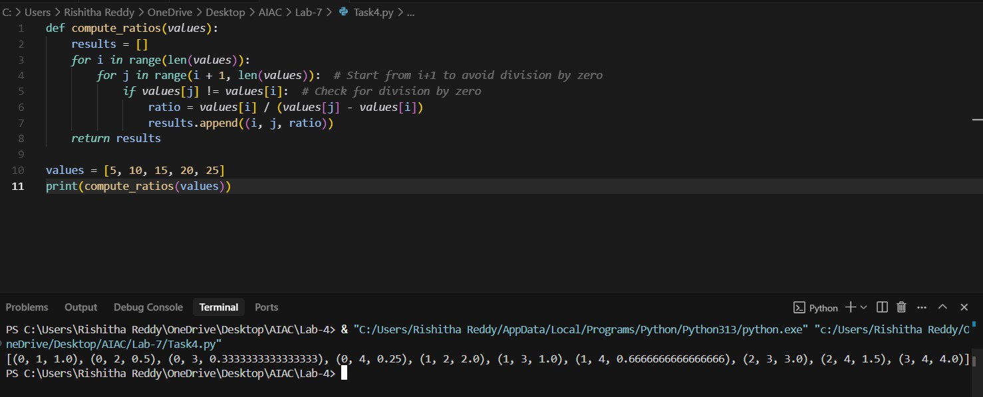

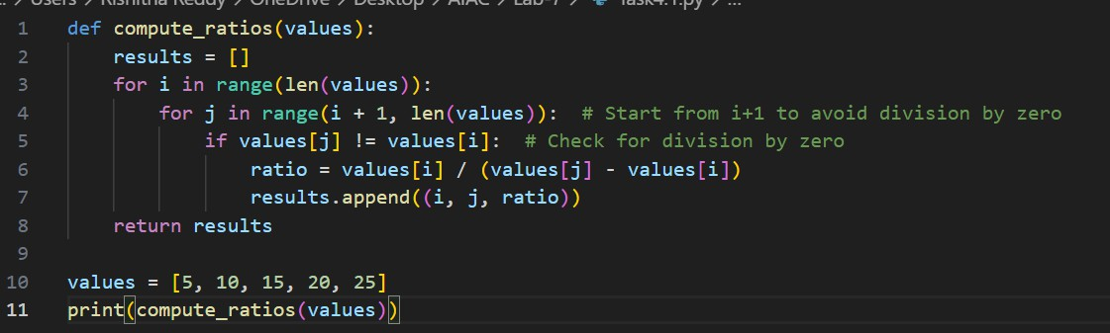
OUTPUT:

Task 5:
- Include a buggy class definition with incorrect init parameters or attribute references. Ask AI to analyze and correct the constructor and attribute usage

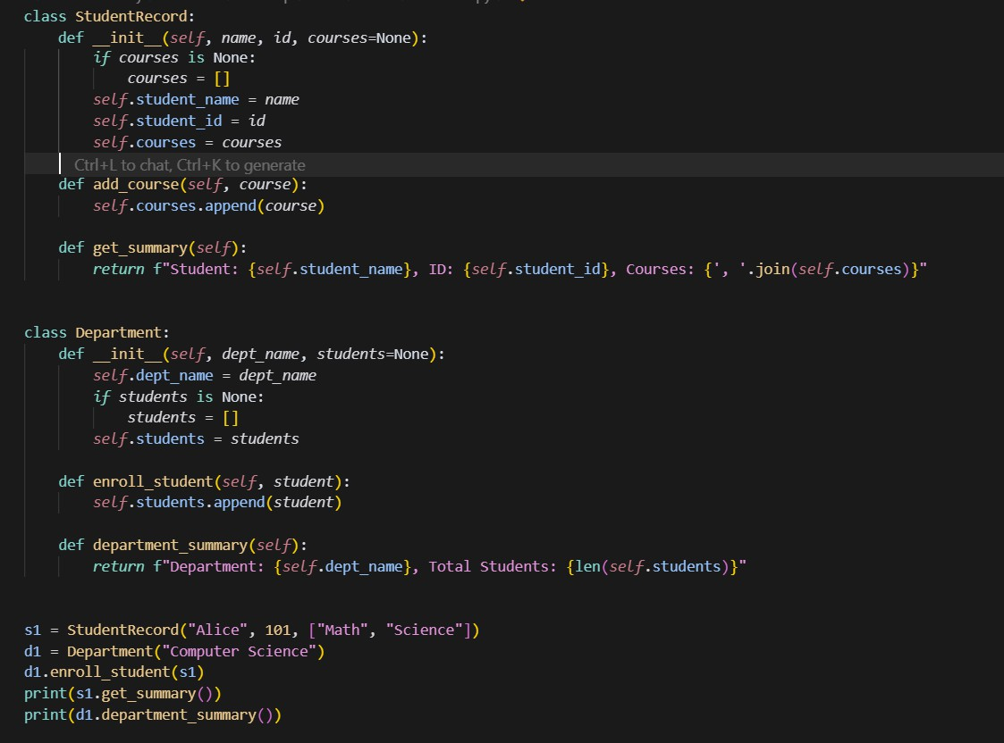
OUTPUT:
