AI ASSISTED CODING
ASSIGNMENT-4.2
Name: Shashikanth G
HT NO.:2403A51245.
Batch No.: 11
Task-1:
- Zero-shot:
- Prompt AI with only the instruction — Write a Python function to generate the Fibonacci sequence up to n terms
- 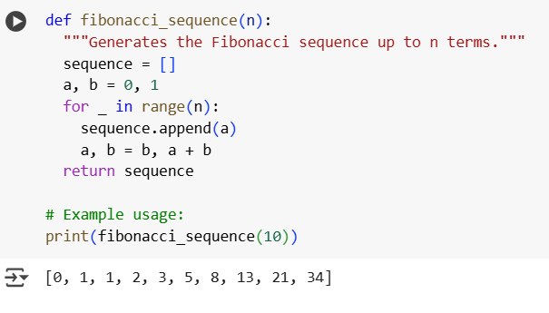

Explanation:
- def fibonacci_sequence(n):: This line defines the function named fibonacci_sequence that takes one argument, n, which represents the number of terms in the sequence you want to generate.
- """Generates the Fibonacci sequence up to n terms.""": This is a docstring, which explains what the function does.
- sequence = []: This initializes an empty list called sequence. This list will store the generated Fibonacci numbers.
- a, b = 0, 1: This initializes two variables, a and b, with the first two numbers of the Fibonacci sequence, which are 0 and 1.
- for _ in range(n):: This starts a for loop that will iterate n times. The _ is used as a variable name when you don't need to use the loop counter within the loop.
- sequence.append(a): In each iteration, the current value of a (which represents the next Fibonacci number) is added to the sequence list.
- a, b = b, a + b: This is the core of the Fibonacci logic. It updates the values of a and b for the next iteration. The new a becomes the current b, and the new b becomes the sum of the current a and b.
- return sequence: After the loop finishes, the function returns the sequence list containing the generated Fibonacci numbers.
Task-2:
- One-shot:
- Provide one example: Input: 100, Output: 37.78 to help AI generate a function that converts Fahrenheit to Celsius

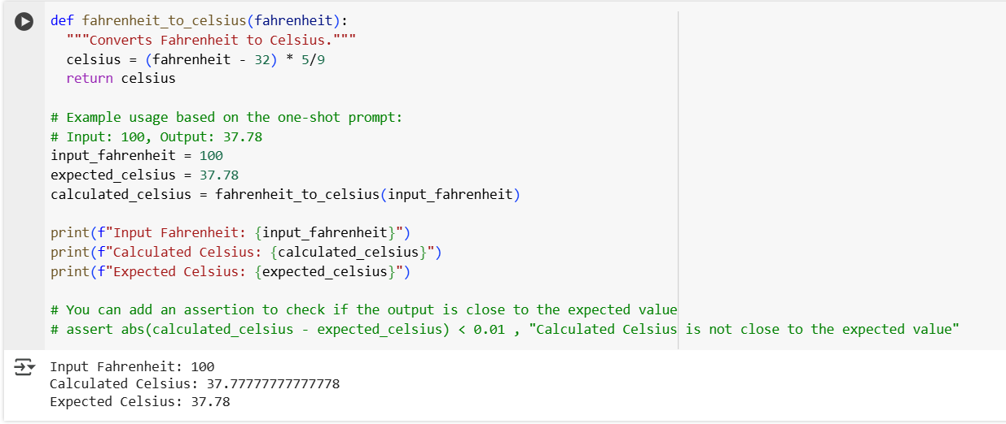

Explanation:
- def fahrenheit_to_celsius(fahrenheit):: This line defines a function named fahrenheit_to_celsius that takes one argument, fahrenheit, which is the temperature in degrees Fahrenheit that you want to convert.
- """Converts temperature from Fahrenheit to Celsius.""": This is a docstring explaining what the function does.
- celsius = (fahrenheit - 32) * 5/9: This is the core of the conversion. It applies the standard formula to convert Fahrenheit to Celsius: subtract 32 from the Fahrenheit temperature and then multiply the result by 5/9. The result is stored in the celsius variable.
- return celsius: The function returns the calculated Celsius temperature.

Task-3:
- Prompt: Few-shot:
- Give 2–3 examples to create a function that extracts the domain name from an email address.

- 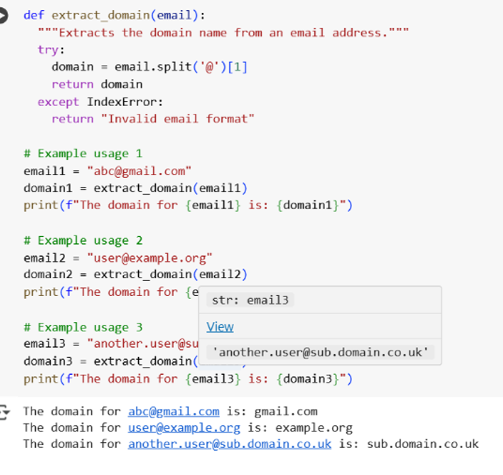

Explanation:
- def extract_domain(email):: This line defines a function named extract_domain that takes one argument, email, which is the email address as a string.
- """Extracts the domain name from an email address.""": This is a docstring explaining the function's purpose.
- try:: This starts a try block, which is used for error handling. Code within this block is attempted, and if an error occurs, the code in the except block is executed.
- domain = email.split('@')[1]: This is the core logic for extracting the domain.
  - email.split('@') splits the email string into a list of substrings using the "@" symbol as the delimiter. For example, "abc@gmail.com".split('@') would result in ['abc', 'gmail.com'].
  - [1] accesses the element at index 1 of the resulting list, which is the part after the "@" symbol (the domain name).
  - The extracted domain is stored in the domain variable.
- return domain: If the split and indexing are successful, the function returns the extracted domain.
- except IndexError:: This is the start of the except block, which catches an IndexError. An IndexError will occur if the split('@') operation does not produce a list with at least two elements (i.e., if there is no "@" symbol in the email address).
- return "Invalid email format": If an IndexError occurs (meaning the email format is invalid because it lacks an "@" symbol), the function returns the string "Invalid email format"

Task-4
Prompt:
Compare zero-shot vs few-shot prompting for generating a function that checks whether a word is a palindrome, ignoring punctuation and case

Zero-shot:
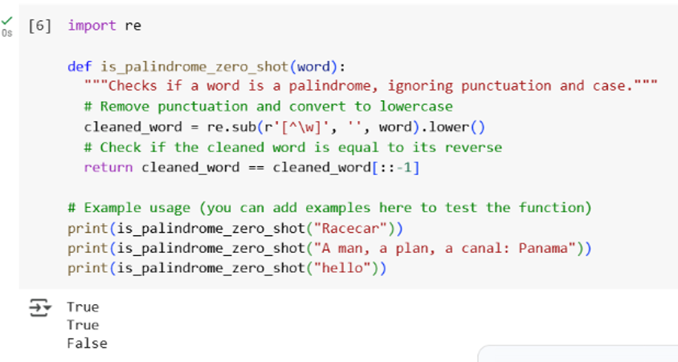

Few-shot:
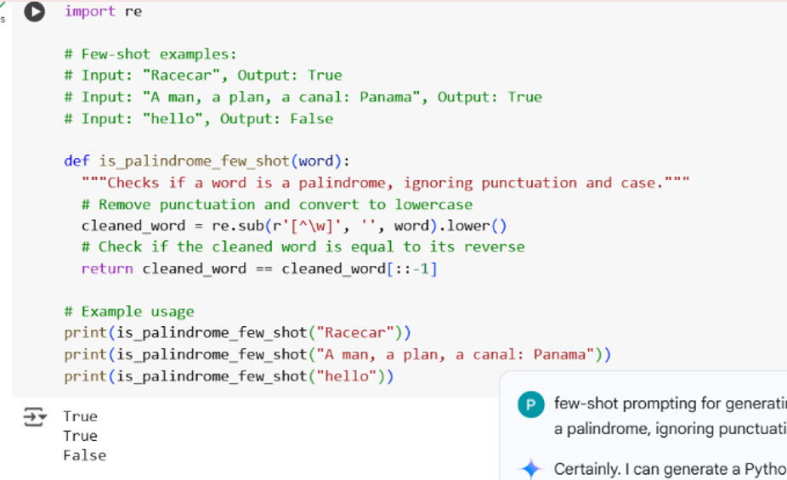
Comparision:
Feature | Zero-Shot Prompting | Few-Shot Prompting
Examples Provided | No examples of input/output are given. | A few examples of input/output are given to guide the model.
Guidance Level | Relies solely on the model's pre-training and understanding of the task description. | Provides explicit examples to demonstrate the desired behavior and output format.
Complexity of Task | More suitable for simpler, well-defined tasks where the expected output is unambiguous. | Can be more effective for complex or nuanced tasks where examples help clarify the requirements.
Outcome (in this case) | Generated a correct function for checking palindromes, ignoring punctuation and case. | Generated the same correct function for checking palindromes, ignoring punctuation and case, as the task was relatively simple.
Code Generated | is_palindrome_zero_shot function | is_palindrome_few_shot function (identical code to zero-shot in this case)

Explanation:
- The two functions to check for palindromes, one using a zero-shot prompt (is_palindrome_zero_shot) and one using a few-shot prompt (is_palindrome_few_shot).

- In this particular case, the code generated for both functions and examples is the same

Task-5:
- Prompt: Use few-shot prompting with 3 sample inputs to generate a function that determines the maximum of three numbers without using the built-in max() function.
- 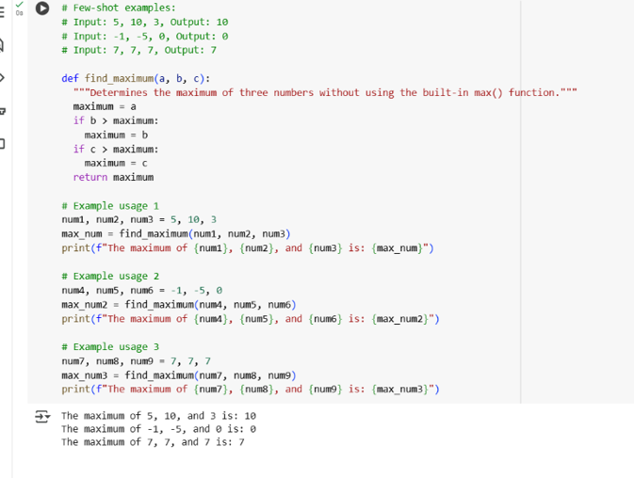

Explanation:
- def find_maximum(a, b, c):: This line defines a function named find_maximum that takes three arguments: a, b, and c, which are the three numbers you want to compare.
- """Determines the maximum of three numbers without using the built-in max() function.""": This is a docstring explaining the function's purpose.
- maximum = a: This line initializes a variable called maximum and assumes that the first number a is the maximum.
- if b > maximum:: This is a conditional statement. It checks if the second number b is greater than the current value of maximum.
- maximum = b: If b is indeed greater than maximum, the value of maximum is updated to b.
- if c > maximum:: This is another conditional statement. It checks if the third number c is greater than the current value of maximum.
- maximum = c: If c is greater than the current value of maximum, the value of maximum is updated to c.
- return maximum: After checking both b and c against the current maximum, the function returns the final value of maximum, which will be the largest of the three input numbers.

