AI ASSISTED CODING
ASSIGNMENT-6.3

Name: Shashikanth G
HT NO.: 2403A51245
Batch No.:11

Task 1
- Use AI to complete a Student class with attributes and a method.
- Check output
- Analyze the code generated by AI tool

Instructions:
- Initialize class with attributes like name, roll no, marks
- Method to display student details
- Method to calculate grade based on marks (A:>=90, B: >=75, C: >=60, else Fail)

Start Writing code and auto complete using any AI tool

Expected Output#1
- Class with constructor and display_details() method

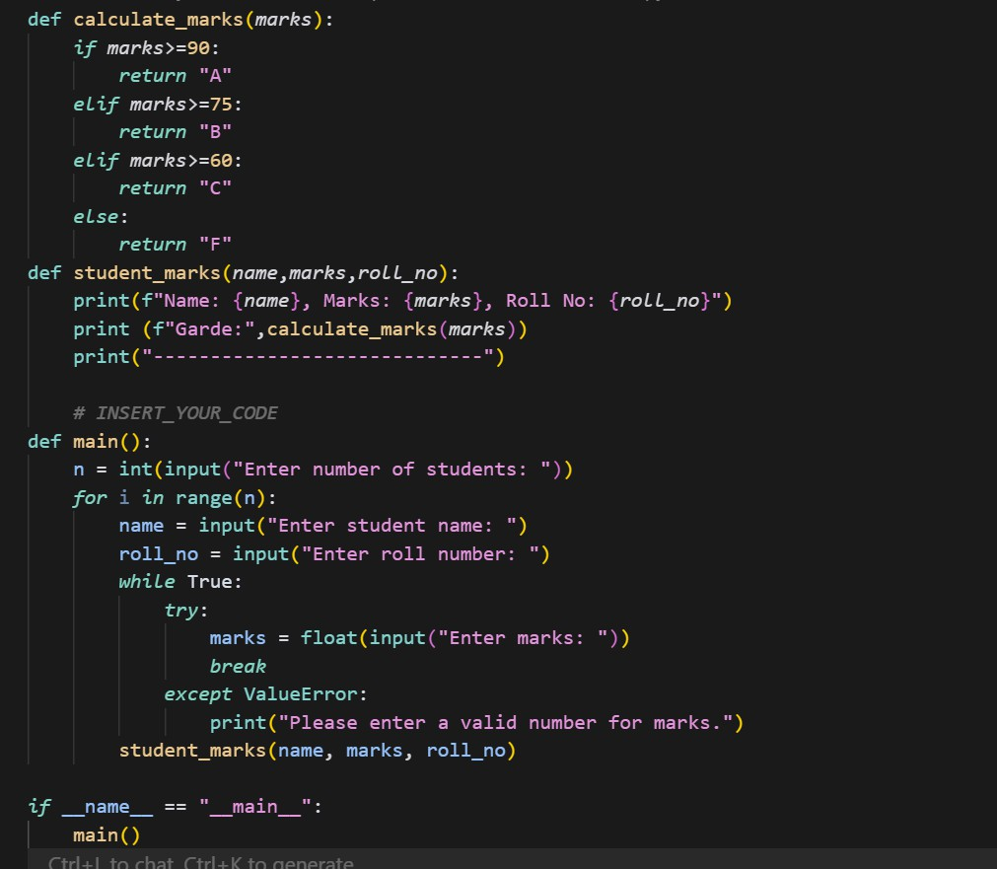

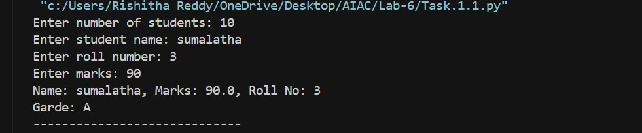
OUTPUT:

Task Description#2 (Loops)
- Prompt AI to complete a function that prints the first 10 multiples of a number using a loop.
- Analyze the generated code
- Ask AI to generate code using other controlled looping

Write code using For Loop, later complete code using While Loop

Expected Output#2
- Correct loop-based implementation

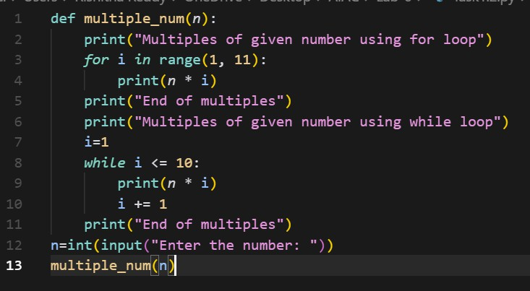

OUTPUT:

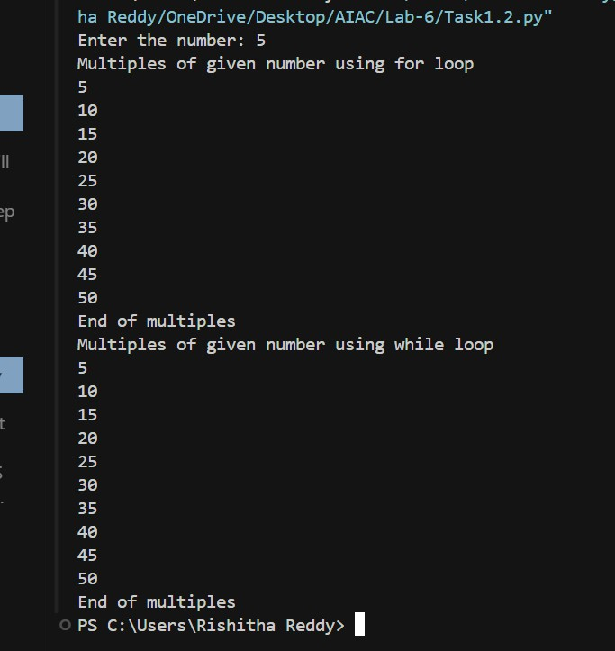

Task Description#3 (Conditional Statements)
- Ask AI to write nested if-elif-else conditionals to classify age groups.
- Analyze the generated code
- Ask AI to generate code using other conditional statements

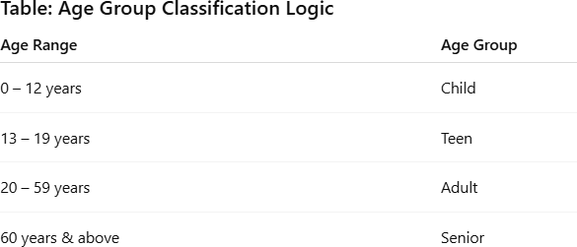
- ​
Expected Output#3
- Age classification function with appropriate conditions and with explanation

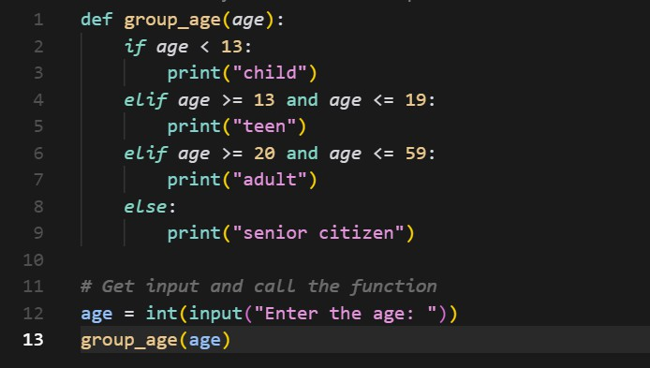

OUTPUT:
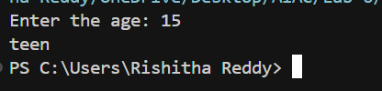

Task Description#4 (For and While loops)
- Generate a sum_to_n() function to calculate sum of first n numbers
- Analyze the generated code
- Get suggestions from AI with other controlled looping

Expected Output#4
- Python code with explanation

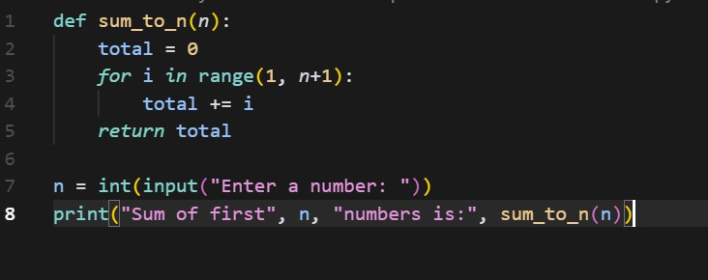

OUTPUT:
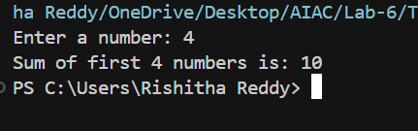

Task Description#5 (Class)
- Use AI to build a BankAccount class with deposit, withdraw, and balance methods.
- Analyze the generated code
- Add comments and explain code

Instructions
- Initialize BankAccount class with attributes like name, balance
- Method to deposit amount
- Method to withdraw amount
- Method to check balance

Expected Output#5
- Python code with explanation
- 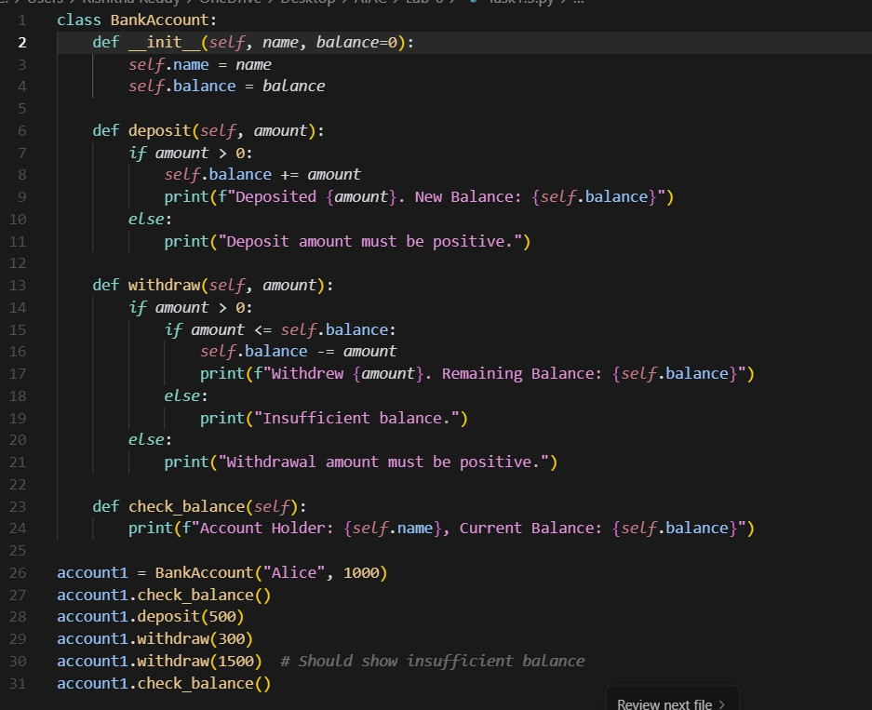
OUTPUT:
