AI ASSISTED CODDING
Assignment-8.1

NAME:Shashikanth G
HT NO:2403A51245
Batch-11

Task-1:
Apply AI to generate at least 3 assert test cases for is_strong_password(password) and implement the validator
Prompt:
Apply AI to generate at least 3 assert test cases for is_strong_password(password) and implement the validator function.
Code:
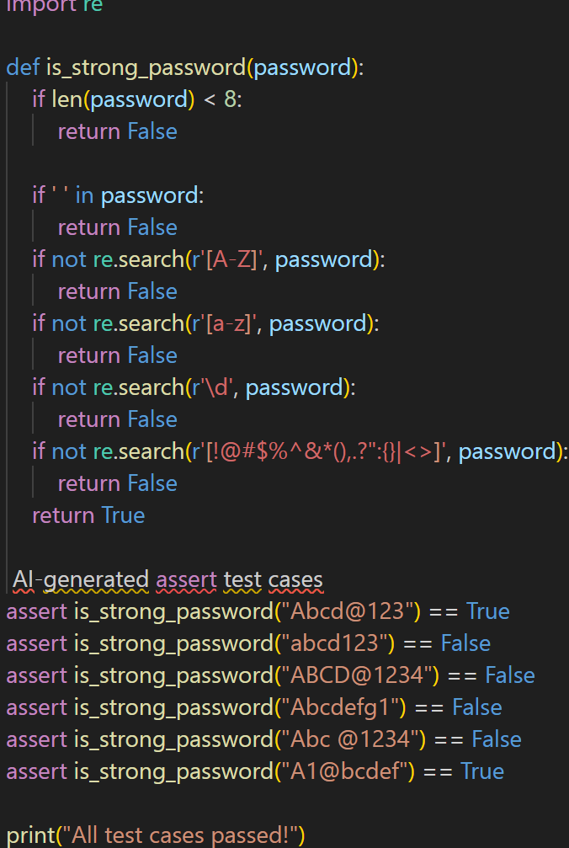
output:
All test cases passed!

Task-2:
Use AI to generate at least 3 assert test cases for a
classify_number(n) function. Implement using loops.
• Requirements:
o Classify numbers as Positive, Negative, or Zero.
o Handle invalid inputs like strings and None.
o Include boundary conditions (-1, 0, 1).
Example Assert Test Cases:
assert classify_number(10) == "Positive"
assert classify_number(-5) == "Negative"
assert classify_number(0) == "Zero"
Prompt:
Use AI to generate at least 3 assert test cases for a classify_number(n) function and implement it using loops
code:
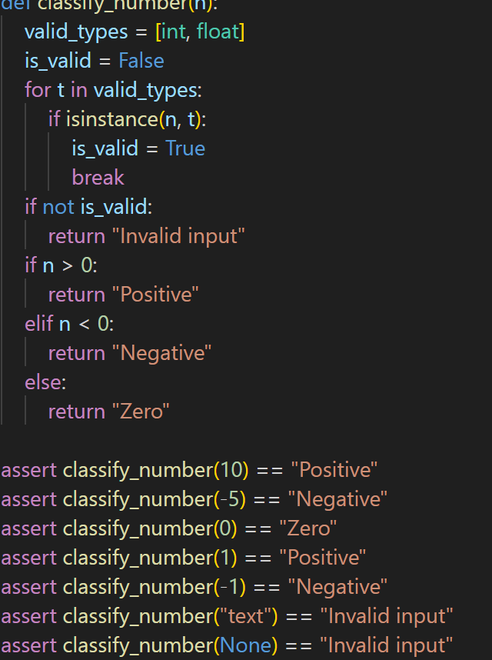
output:
All test cases passed!

Task-3:
Use AI to generate at least 3 assert test cases for
is_anagram(str1, str2) and implement the function.
• Requirements:
o Ignore case, spaces, and punctuation.
o Handle edge cases (empty strings, identical words).
Example Assert Test Cases:
assert is_anagram("listen", "silent") == True
assert is_anagram("hello", "world") == False
assert is_anagram("Dormitory", "Dirty Room") == True

Prompt:
Use AI to generate at least 3 assert test cases for an is_anagram(str1, str2) function and implement the function
Code:
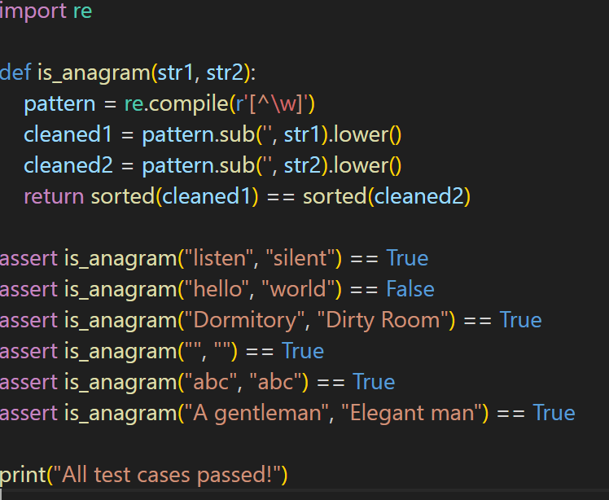
output:
All test cases passed!

Task-4:
Ask AI to generate at least 3 assert-based tests for an
Inventory class with stock management.
• Methods:
o add_item(name, quantity)
o remove_item(name, quantity)
o get_stock(name)
Example Assert Test Cases:
inv = Inventory()
inv.add_item("Pen", 10)
assert inv.get_stock("Pen") == 10
inv.remove_item("Pen", 5)
assert inv.get_stock("Pen") == 5
inv.add_item("Book", 3)
assert inv.get_stock("Book") == 3
Prompt:
Ask AI to generate at least 3 assert-based tests for an Inventory class with stock management and implement the class
Code:
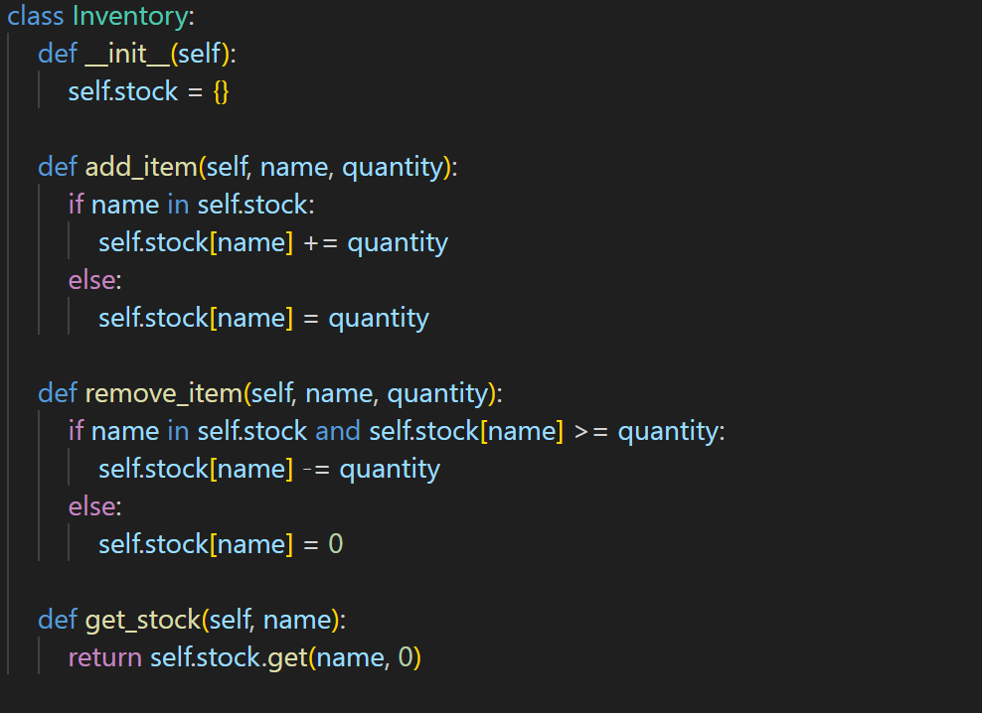

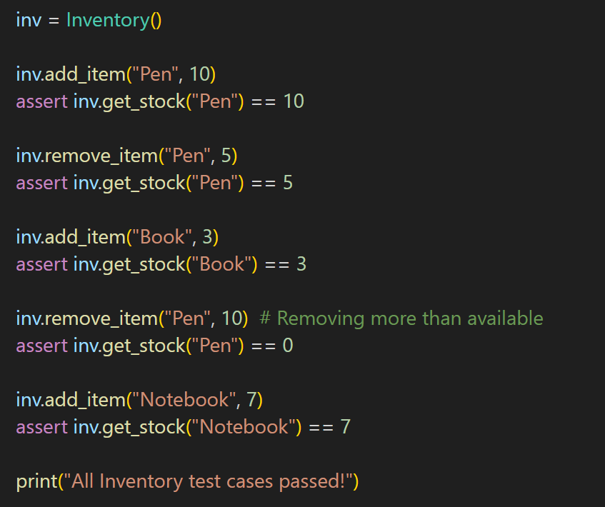
output:
All Inventory test cases passed!

Task-5:
Use AI to generate at least 3 assert test cases for
validate_and_format_date(date_str) to check and convert dates.
• Requirements:
o Validate "MM/DD/YYYY" format.
o Handle invalid dates.
o Convert valid dates to "YYYY-MM-DD".
Example Assert Test Cases:
assert validate_and_format_date("10/15/2023") == "2023-10-15"
assert validate_and_format_date("02/30/2023") == "Invalid Date"
assert validate_and_format_date("01/01/2024") == "2024-01-01"
Prompt:
Use AI to generate at least 3 assert test cases for validate_and_format_date(date_str) to check and convert dates, and implement the function.
Code:
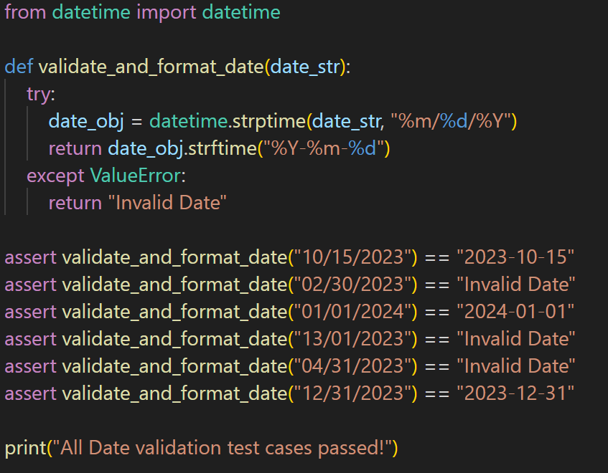
output:
All Date validation test cases passed!

