Online Appraisal System – Use Case Document
-Trupti Patil (349300)

Primary Actors
From the case study, the system has 3 main user roles:
Actor | Actions
HR | Manages employee data & initiates appraisal workflow
Manager (Appraiser) | Reviews employee information, enters appraisal comments, and finalizes CTC changes.
Employee (Appraisee) | Views manager comments, enters their own comments, edits personal info.
System | Validates login, ensures security rules (e.g., lock after 3 failed attempts

High-Level Use Cases

🔹 HR Use Cases
- UC01: Login to System
- UC02: Maintain Employee Information (Add/Update employee data)
- UC03: View Upcoming Appraisals
- UC04: Assign Appraisal to Manager

🔹 Manager (Appraiser) Use Cases
- UC05: View List of Appraisees with Upcoming Appraisals
- UC06: View Employee Personal Information
- UC07: Enter Manager Comments
- UC08: View Employee Comments (read-only)
- UC09: Enter Appraisal Status & CTC Information
- UC10: View Appraisals in Process

🔹 Employee (Appraisee) Use Cases
- UC11: Edit My Personal Information
- UC12: View My Appraisal Personal Info
- UC13: View Manager Comments
- UC14: Enter Employee Comments

UC01 — Login to System
Primary Actor(s): HR, Manager (Appraiser), Employee (Appraisee)
Supporting: System (authentication)
Preconditions
User has a valid account. (Assumption)
Account is not locked. (Lockout handled in Alt/Exc)
Trigger
User navigates to the login page and submits credentials.
MSS
System prompts for username and password.
User enters credentials and submits.
System authenticates and shows role-based options on landing/home page.
Alternate Flows
Alt-01: Invalid credentials
a) System displays an error and increments the failed-attempt counter. (Lockout after three failures—see below)
Alt-02: Account locked
a) After three consecutive invalid attempts, the system locks the account and displays a lock message (manual reactivation only).
Postconditions
Success: User is authenticated and on a role-appropriate home page.
Failure: Account remains locked (after 3 consecutive failures).
Business Rules
Lockout: 3 consecutive failed logins → lock; manual reactivation.

Role-based UI: Options shown depend on the login role.
Notes/Assumptions
Password policy and session timeout TBD. (Assumption)
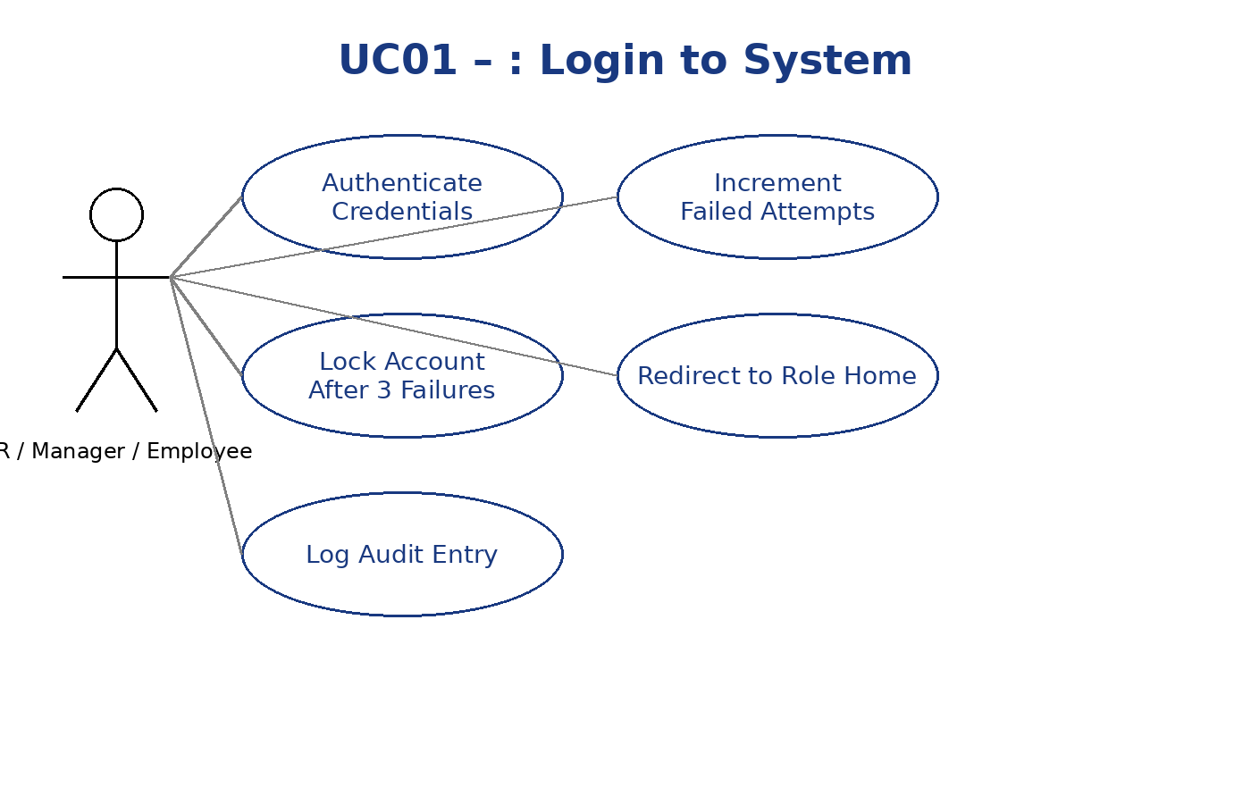

UC02 — Maintain Employee Information (Create/Update)
Primary Actor(s): HR
Preconditions
HR is logged in.
Employee record exists for update scenario. (Assumption)
Trigger
HR clicks Employee Information.
MSS
System shows fields: Name, Address, City, Personal Telephone, Mobile, Email, DOB, Gender, Marital Status, DOJ, Passport, PAN, Work Experience, Reports To, Department.
HR enters data (create) or edits existing data (update).

HR clicks Save.
System validates and stores the record. (Validation specifics TBD)
Alternate Flows
Alt-01: Validation errors
a) System highlights missing/invalid fields and prevents save. (Assumption—standard behavior)
Postconditions
Employee master data is created/updated and available for appraisal processes.
Business Rules
Look & Feel: Consistent header/footer/left nav across pages.
Notes/Assumptions
Field formats (e.g., PAN, passport) and uniqueness constraints TBD. (Assumption)
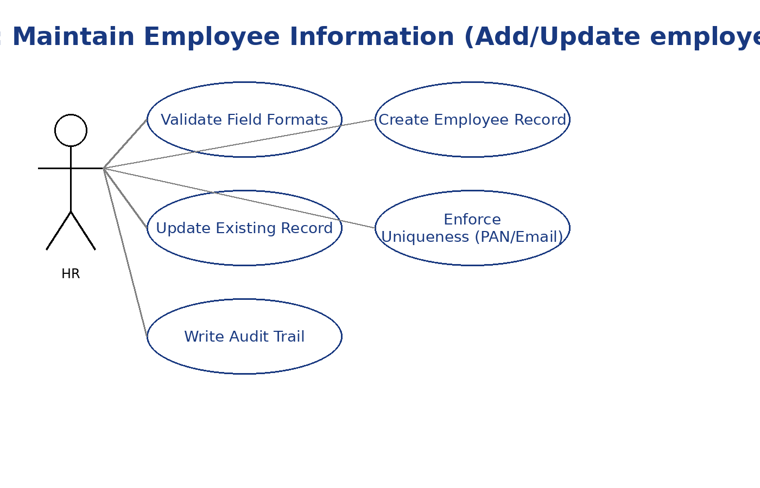

UC03 — View Upcoming Appraisals (HR)
Primary Actor(s): HR
Preconditions
HR is logged in.
Trigger
HR clicks View Upcoming Appraisals.
MSS
System lists employees with appraisals due.
HR can select a name to proceed to assignment (UC04).
Alternate Flows
Alt-01: No upcoming appraisals
a) System displays an empty state message. (Assumption)
Postconditions
HR has visibility of due appraisals; can assign to a manager next.
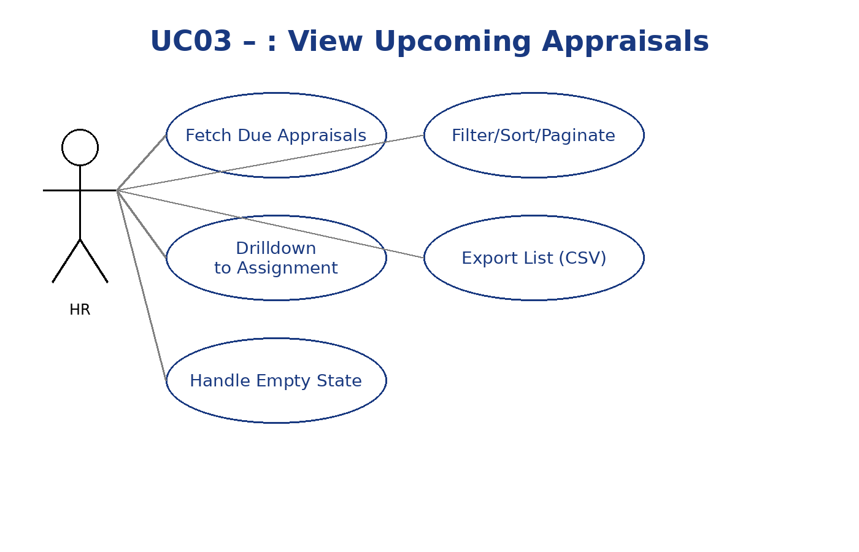

UC04 — Assign Appraisal to Manager
Primary Actor(s): HR
Preconditions
HR is logged in.
Upcoming appraisal list is visible (UC03).
Manager exists in reporting structure. (Assumption; structure maintained via HR data)

Trigger
HR selects an employee and chooses Assign to Manager.
MSS
HR chooses the appropriate Manager.
System records the assignment and (optionally) notifies the Manager. (Notification is implied; case study doesn’t specify channel)
Alternate Flows
Alt-01: No Manager found in master data
a) System shows an error; HR must correct Reports To in Employee Information. (Partly from fields list; error handling assumed)
Postconditions
The employee appears in the Manager’s “Upcoming Appraisals” list.
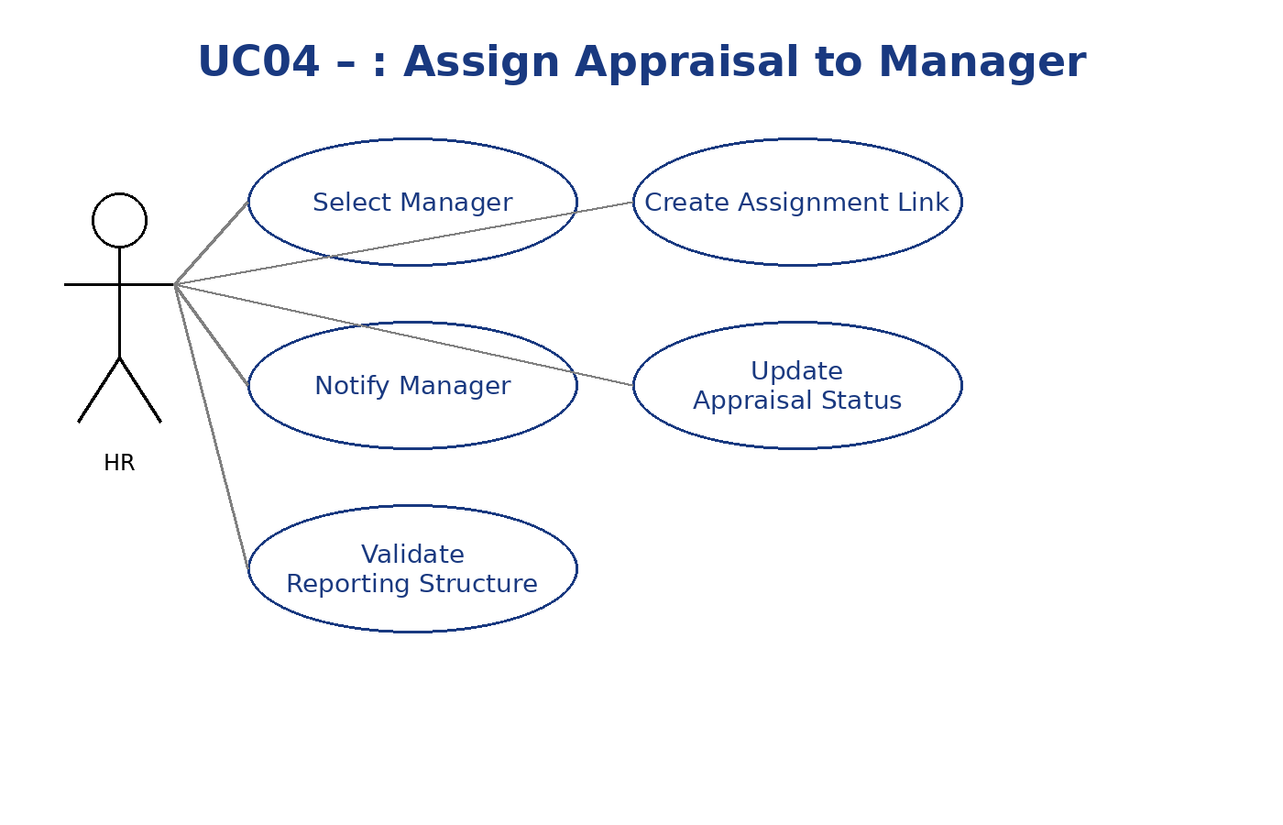

UC05 — View Upcoming Appraisals (Manager)
Primary Actor(s): Manager (Appraiser)
Preconditions
Manager is logged in.
HR has assigned at least one appraisal (UC04).
Trigger
Manager clicks View Upcoming Appraisals.
MSS
System lists employees (only those assigned by HR) who have appraisals due.
Each employee name is a link; on click, Personal Information page (UC06) opens.
Alternate Flows
Alt-01: No assigned appraisals → Empty state message. (Assumption)
Postconditions
Manager can start the appraisal for the selected employee.
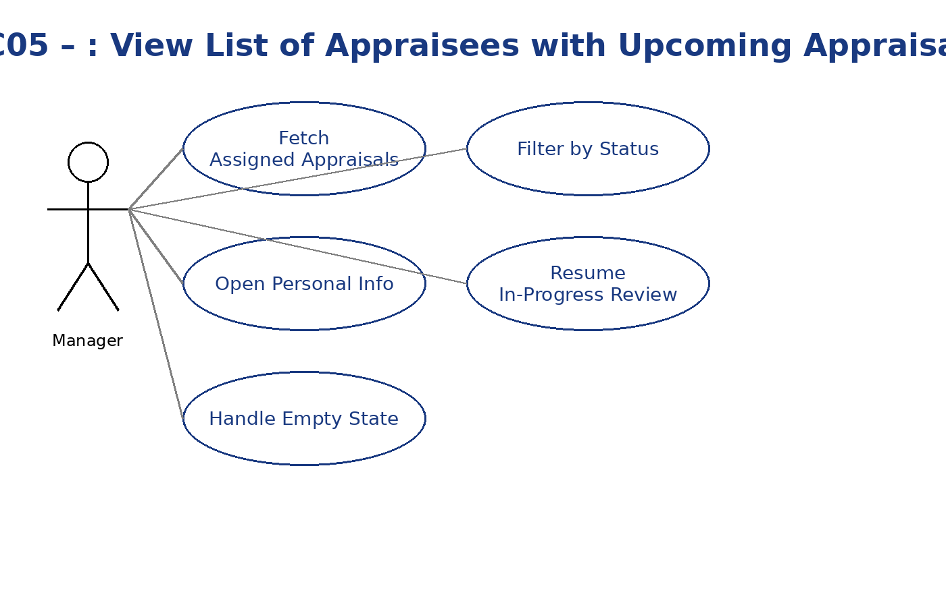

UC06 — View Employee Personal Information
Primary Actor(s): Manager, Employee
Preconditions
Actor is logged in.
Actor has access to the selected employee record (own record for Employee). (Assumption)
Trigger
Manager clicks an employee name from UC05 or Employee clicks My Appraisal (UC12 pre-step).
MSS
System displays read-only personal information: Name, Address, City, Personal Telephone, Mobile, Email, DOB, Gender, Marital Status, DOJ, Passport, PAN, Work Experience, Reports To, Department.
Actor clicks Next to continue the workflow. (Manager → UC07; Employee → UC13)
Alternate Flows
None specified.
Postconditions
Actor advances to the next appraisal step.
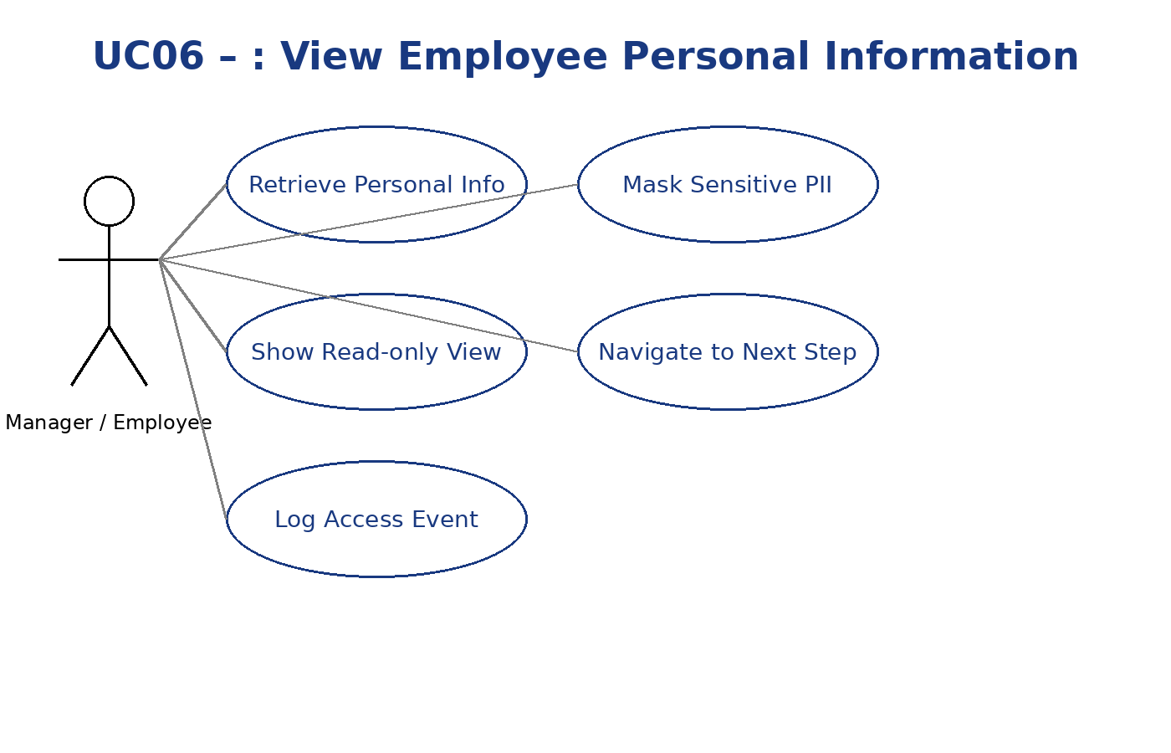

UC07 — Enter Manager Comments
Primary Actor(s): Manager (Appraiser)
Preconditions
Manager is logged in.
Employee was selected from Upcoming Appraisals (UC05).
Personal Information page was viewed (UC06).
Trigger
Manager clicks Next from Personal Information.
MSS
System shows Manager Comments with fields: Achievements, Things not achieved, Suggestions.
Manager enters comments.
Manager clicks Save; system stores comments before proceeding.
Alternate Flows
Alt-01: Employee comments not yet entered
a) Button label is Save; on click the system does not navigate to Employee Comments page yet.
Postconditions
Manager comments are stored and visible read-only to the Employee later.
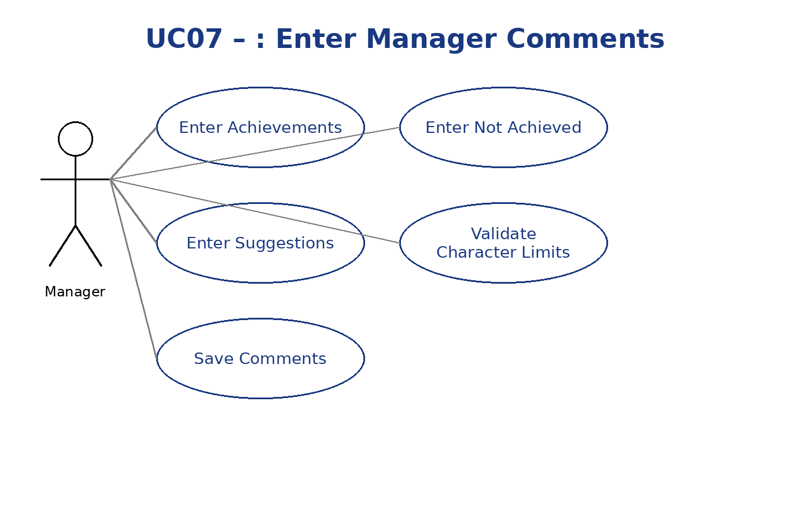

UC08 — View Employee Comments (Manager Read-only)
Primary Actor(s): Manager
Preconditions
Manager is logged in.
Employee has submitted comments (UC14). (Derived from visibility rule)
Trigger
Manager navigates to Employee Comments page (after UC07/UC14).
MSS
System displays Employee Feedback in read-only mode for the Manager.
Alternate Flows
Alt-01: No employee comments yet → System indicates employee has not provided comments. (Assumption based on readiness rule)
Postconditions
Manager can proceed to finalize (UC09).
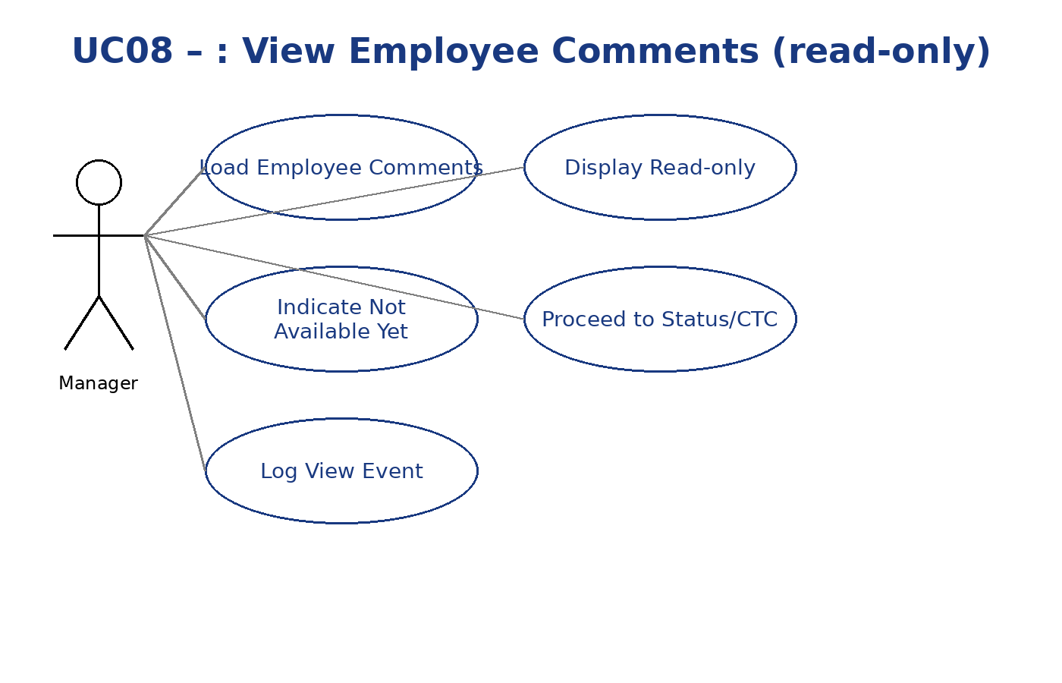

UC09 — Enter Appraisal Status & CTC Information
Primary Actor(s): Manager
Preconditions
Manager is logged in.
Employee Comments step has been reached (after UC07/UC14).

Trigger
Manager clicks Next from Employee Comments page.
MSS
System shows fields: Promoted (Yes/No), Basic Salary, Dearness Allowance, House Rent Allowance, Food Allowance, Provident Fund, Next Appraisal Date.

Manager enters values and saves.
System records status and CTC details.
Alternate Flows
Alt-01: Validation errors → System highlights invalid numeric/date fields and prevents save. (Assumption)
Postconditions
Appraisal decision and new CTC (if any) are stored.
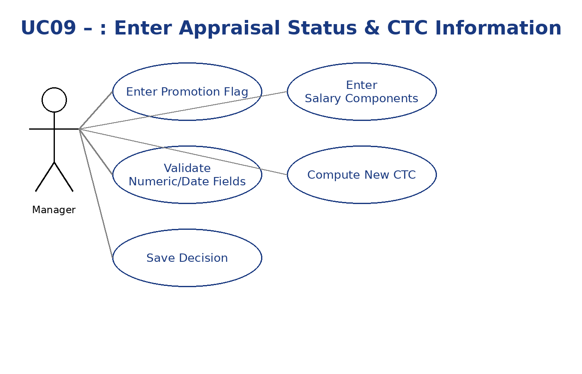

UC10 — View Appraisals in Process (Manager)
Primary Actor(s): Manager
Preconditions
Manager is logged in.
Trigger
Manager selects View Appraisals in Process.
MSS
System lists employees whose appraisal process has started.
Clicking a name opens Personal Information (UC06) to continue.
Alternate Flows
Alt-01: None in process → Empty state message. (Assumption)
Postconditions
Manager can resume any in-flight appraisal.
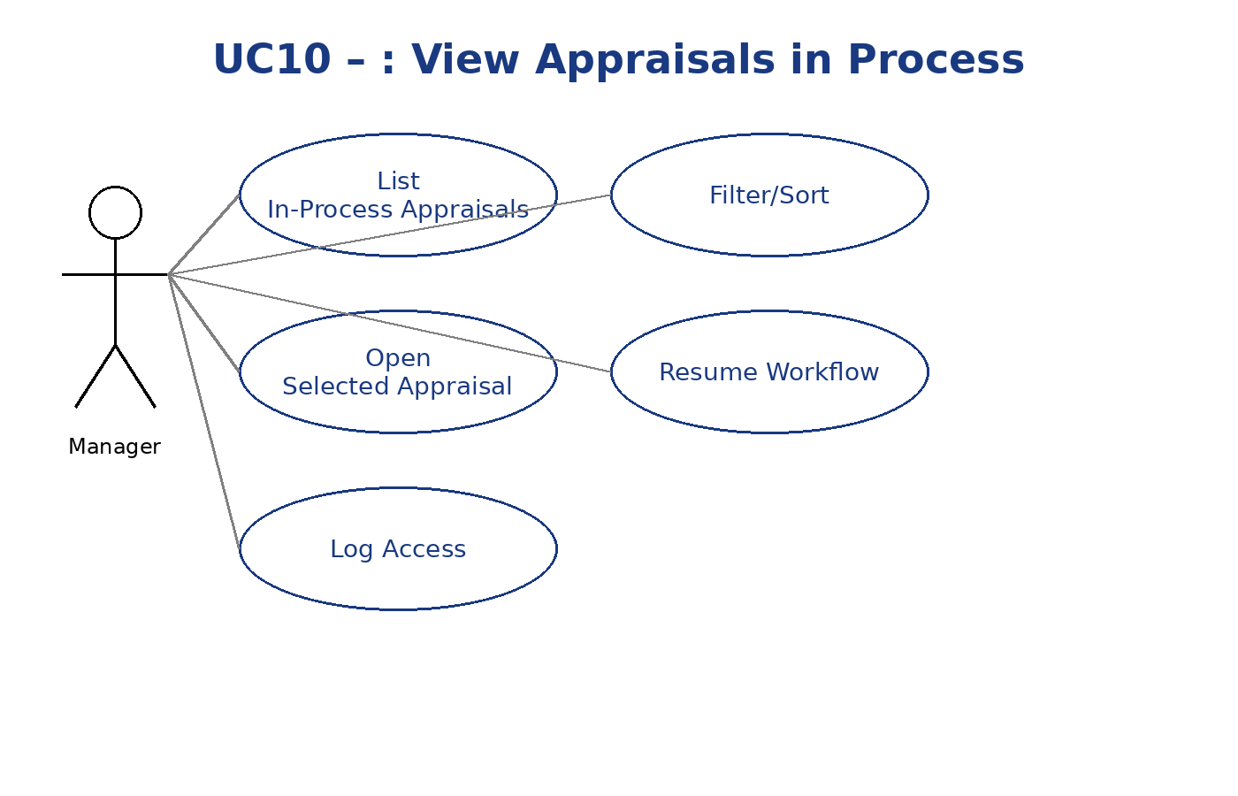

UC11 — Edit My Personal Information (Employee)
Primary Actor(s): Employee
Preconditions
Employee is logged in.
Trigger
Employee clicks My Information.
MSS
System displays Employee info with Reports To and Department as read-only; other fields are editable.
Employee edits permissible fields and clicks Save.
System validates and stores changes. (Validation specifics TBD)
Alternate Flows
Alt-01: Validation errors → System highlights missing/invalid fields and prevents save. (Assumption)
Postconditions
Employee profile is updated (with read-only fields unchanged).

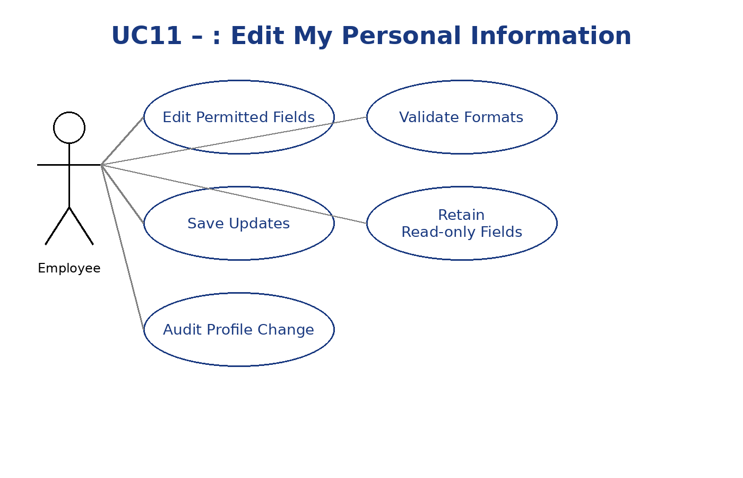

UC12 — View My Appraisal Personal Information
Primary Actor(s): Employee
Preconditions
Employee is logged in.
Trigger
Employee clicks My Appraisal.
MSS
System displays read-only personal information (same fields as UC06).
Employee clicks Next to view Manager Comments (UC13).
Alternate Flows
None specified.
Postconditions
Employee moves to UC13.
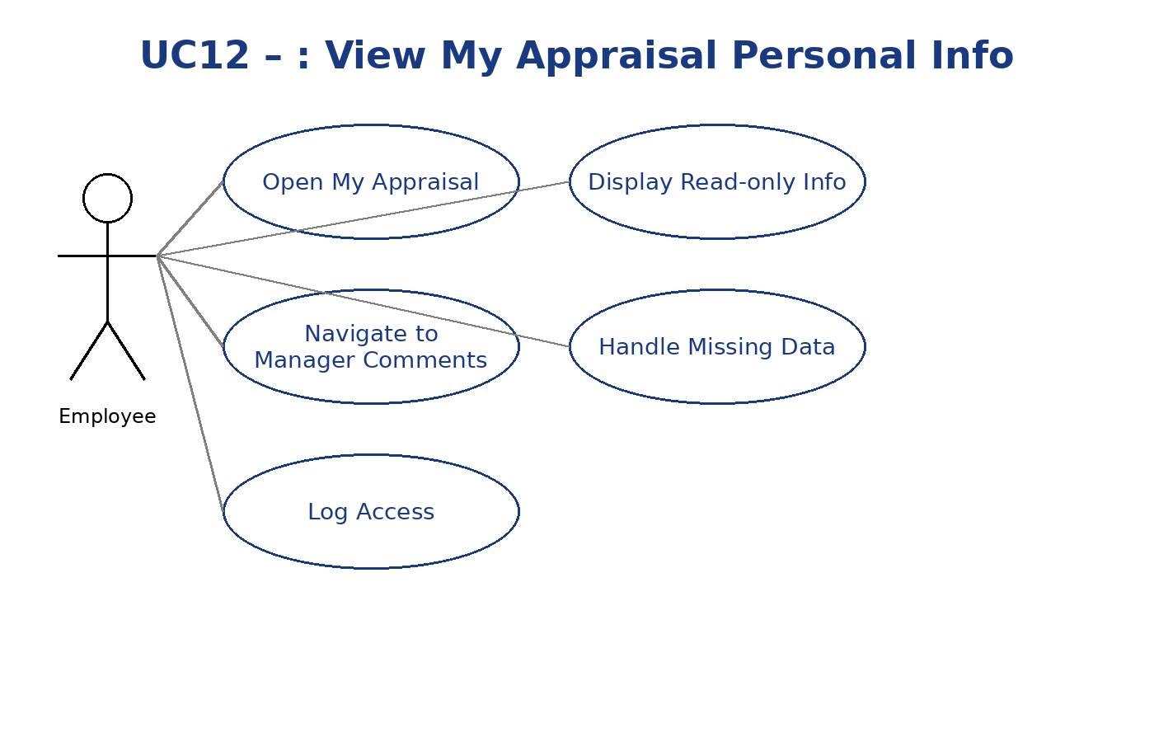

UC13 — View Manager Comments (Employee)
Primary Actor(s): Employee
Preconditions
Employee is logged in.
Manager Comments exist (UC07).
Trigger
From My Appraisal, Employee navigates to Manager Comments page.

MSS
System displays Achievements, Things not achieved, and Suggestions in read-only mode.
Employee clicks Next to go to Employee Comments (UC14).
Alternate Flows
Alt-01: Manager comments not available → System informs Employee that Manager has not entered comments yet (UC07 not done).
Postconditions
Employee is ready to provide comments in UC14.
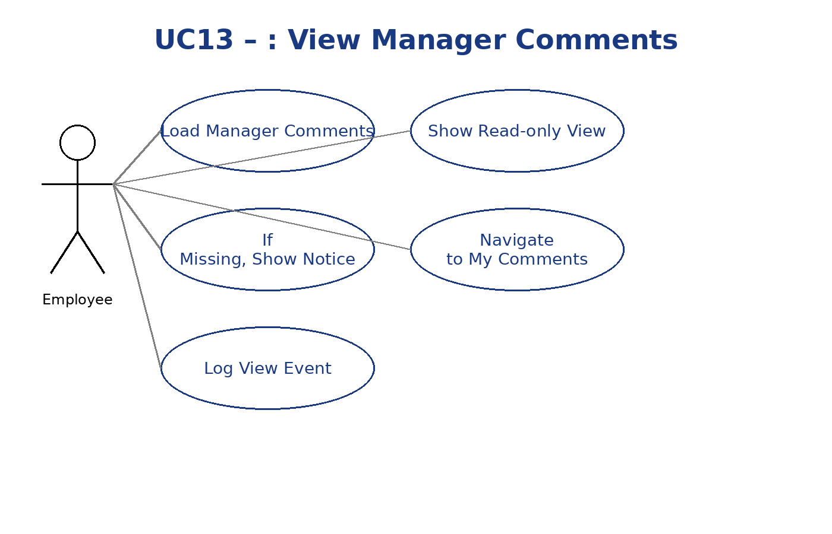

UC14 — Enter Employee Comments
Primary Actor(s): Employee
Preconditions
Employee is logged in.
Manager Comments exist (UC07). Employee can see this page only if Manager has entered comments.
Trigger
Employee opens Employee Comments page from UC13.
MSS
System shows Employee Feedback field.
Employee enters feedback and submits.

System saves employee comments; these are read-only for the Manager’s view (UC08).
Alternate Flows
None specified.
Postconditions
Employee comments are stored and visible to the Manager (read-only).
