Cognizant, India
Document Upload Portal
LLD Template
Version No: 1.0

 | - Prepared By / Last Updated By | - Reviewed By | - Approved By
- Name | Shashi Shekhar
                - Role
- Signature | Shashi Shekhar
- Date | 23-05-2026

Table of Contents
1.0 TRADEMARKS, DEFINITIONS AND ACRONYMNS 4
1.1 TRADEMARKS 4
1.2 ABBREVIATIONS, TERMS AND DEFINITIONS 4
2.0 DOCUMENT PURPOSE AND EXECUTIVE SUMMARY 4
2.1 DESIGN OBJECTIVES AND SCOPE 4
2.2 IN SCOPE 4
2.3 OUT OF SCOPE AND EXCLUSIONS 4
3.0 REQUIREMENTS 5
3.1 FUNCTIONAL REQUIREMENTS 5
3.2 NON_FUNCTIONAL REQUIREMENTS 6
3.3 ARCHITECTURAL DESIGN DECISIONS 6
4.0 DETAILED DESIGN 7
4.1 SOLUTION ARCHITECTURE 7
4.2 DETAILED DESIGN—LOGICAL 7
4.3 LOGICAL ARCHITECTURE 8
4.4 DESIGN COMPONENTS 8
4.5 SERVER ROLES 8
4.6 SERVER SIZING DETAILS 9
4.7 APPLIANCE DETAILS (ADJUST AS APPLICABLE FOR APPLIANCES) 9
4.8 SOFTWARE PRE-REQUISITES 10
4.9 EXTERNAL REFERENCES 11
4.10 COMPONENT AND CONFIGURATION DETAILS 11
5.0 ADDITIONAL DESIGN COMPONENTS 11
5.1 HIGH AVAILABILITY (OPTIONAL) 11
5.2 DISASTER RECOVERY (OPTIONAL) 11
5.2.1 HEADING 3 11
5.2.2 HEADING 4 12
5.2.3 HEADING 4 12
5.2.4 HEADING 3 12
5.3 NAMESPACE AND NUMBERING SCHEMES 13
6.0 DETAILED DESIGN – PHYSICAL 13
6.1 RACK ELEVATION DIAGRAM 13
6.2 COMPONENT PHYSICAL DETAILS 13
7.0 DETAILED DESIGN – SYSTEM INTEGRATION MODEL 14
7.1 SYSTEM INTEGRATION DETAILS 14
7.1.1 DATABASE 14
7.1.2 BACKUP REQUIREMENTS 14
7.1.3 ANTI-VIRUS 14
7.1.4 MONITORING 15
7.1.5 LOGGING 15
7.1.6 SOURCE AND DESTINATION PORTS 16
7.1.7 SERVICE ACCOUNTS 17
7.1.8 SYSTEM ADMINISTRATION 18
7.1.9 CAPACITY AND SCALABILITY MANAGEMENT 18
8.0 DOCUMENTS REFERENCED 19
9.0 LIST OF TABLES <<SAMPLE INCLUDED>> 20
10.0 Table 1. Version history 4 20
11.0 Table 2. Cognizant Review and Approvals 4 20
12.0 Table 3. Client Review and Approvals 4 20
13.0 Table 4. Distribution List <<May not be needed>> 4 20
14.0 Table 5. Trademarks 5 20
15.0 Table 6. Abbreviations 5 20
16.0 Table 7. Functional Business and Technical Requirements <<sample included>> 7 20
17.0 Table 8. Non-Functional Business Requirements <<sample>> 7 20
18.0 Table 9. Architectural Design Decisions <<sample included>> 8 21
19.0 Table 10. Server Roles 10 21
20.0 Table 11. Server Sizing Details 11 21
21.0 Table 12. Appliance Sizing Details 11 21
22.0 Table 13. Software Prerequisites Components 12 21
23.0 Table 14. External reference for design components <<this table needs to be in end of each section>> 12 21
24.0 Table 15. File and Folder Exclusions 16 21
25.0 Table 16. Monitoring Services and Parameters 17 21
26.0 Table 17. Service Accounts 19 21
27.0 Table 18. External Reference Document 19 22
28.0 Table 19. Role based account 19 22
29.0 Table 20. Reference Documents 20 22
30.0 LIST OF FIGURES <<SAMPLE INCLUDED>> 22
31.0 Change Log 23

TRADEMARKS, DEFINITIONS AND ACRONYMNS
Disclaimer: Systems or products mentioned in this document may not bear the trademarks of their Vendors or Owners. Herein, it is acknowledged that all the trademarks are the property of their respective owners. It is also acknowledged that there is no intention of breaching anybody’s copyrights, if there are extractions from any vendors’ documents.

TRADEMARKS
Brand of Product | Description | Company
Microsoft Azure | Cloud platform used for hosting the Document Upload Portal application and related services | Microsoft Corporation
ASP.NET Core | Framework used for developing Web Application and REST APIs | Microsoft Corporation
Azure SQL Database | Managed relational database service used to store image metadata | Microsoft Corporation
Azure Key Vault | Secure storage service used for storing connection strings, JWT secrets, and API keys | Microsoft Corporation
JWT (JSON Web Token) | Token-based authentication mechanism used for secure API communication | IETF Standard
Swagger / Postman | API documentation and API testing framework | SmartBear Software/Postman Inc.
Application Insights | Azure monitoring and telemetry service used for application monitoring | Microsoft Corporation
Azure Monitor | Monitoring and observability platform used for infrastructure and application monitoring | Microsoft Corporation
Docker | Containerization platform used for application packaging and deployment | Docker Inc.
Git | Source code version control system | Software Freedom Conservancy
- Trademarks

ABBREVIATIONS, TERMS AND DEFINITIONS

Abbreviation | Definition | Abbreviation | Definition
API | Application Programming Interface. | PaaS | Platform as a Service
JWT | Json Web Token | SQL | Structured Query Language
RBAC | Role Based Access Control
HLD | High Level Diagram
LLD | Low Level Diagram
- Abbreviations

DOCUMENT PURPOSE AND EXECUTIVE SUMMARY
- Purpose of Document Upload Portal
- Overview of architecture
- Secure image upload and preview workflow
- Azure-based deployment
- Metadata persistence in Azure SQL
- Local image storage strategy
- JWT + API Key + RBAC security mechanism

DESIGN OBJECTIVES AND SCOPE
- Secure Image upload
- Modular layered architecture
- Scalability using Azure App Service
- Separation of concerns
- Reusable processing services
- Secure secret management using Azure Key Vault
- Maintainable enterprise-grade architecture

IN SCOPE
The following technical solutions are considered to be in scope for this project:
- Image upload
- Image preview
- JWT authentication
- RBAC authorization
- Logging and monitoring
- API documentation via Swagger
- Azure deployment

OUT OF SCOPE AND EXCLUSIONS
- Auto-Compression
- Duplicate detection
- Watermarking
- Metadata storage in Azure SQL
- Local image storage
- Inline Preview
- API Key validation

REQUIREMENTS
The needs of CUSTOMER A stakeholders are the basis for determining requirements. The stakeholder needs, expectations, constraints, interfaces, operational concepts, and product concepts are analyzed, harmonized, refined, and elaborated for translation into a set of customer requirements. The following are the business and functional requirements that were established for the <<CUSTOMER NAME>>

FUNCTIONAL REQUIREMENTS
FR ID | Requirement | Pertinent Design Component
FR-01 | User authentication | System shall authenticate users using JWT-based authentication before allowing access to secured APIs. System shall authorize users based on Role-Based Access Control (RBAC) such as Admin, User and viewer roles
FR-02 | Image upload | System shall allow authenticated users to upload image files through the Web Application
FR-03 | Image validation | System shall validate uploaded file type and file size before processing. System shall reject unsupported file formats and oversized files
FR-04 | Duplicate image detection | System shall detect duplicate images using image hash comparison
FR-05 | Image compression | System shall compress uploaded images to optimize storage utilization
FR-06 | Watermarking | System shall apply watermarking on uploaded images for ownership protection
FR-07 | Image preview generation | System shall generate image preview for UI display
FR-08 | Image retrieval | System shall retrieve image metadata based on Image ID
FR-09 | Metadata persistence | System shall store image metadata in Azure SQL Database
FR-10 | Secure API access | System shall return JSON-based API responses for all upload and retrieval operations. System shall securely communicate between UI and API over HTTPS.
- Functional Business and Technical Requirements <<sample included>>

NON_FUNCTIONAL REQUIREMENTS
<<Details of non-functional business requirements>>
NFR ID | Requirement | Pertinent Design Component
NFR-01 | Security | System shall ensure secure communication using HTTPS for all client and API interactions. System shall implement JWT-based authentication and API Key validation for secure API access. System shall enforce Role-Based Access Control (RBAC) for authorized access to application resources.System shall securely store secrets, connection strings, JWT secrets, and API keys using Azure Key Vault
NFR-02 | Performance | System shall support response time within acceptable limits (target < 30 seconds for upload and preview operations). System shall optimize image storage and retrieval performance using image compression techniques.
NFR-03 | Scalability | System shall support scalability through modular and loosely coupled service architecture. System shall support independent scaling of Web Application and Web API components in Azure.
NFR-04 | Availability | System shall provide high availability for APIs and database services.
NFR-05 | Reliability | System shall ensure reliable image upload and metadata persistence operations.
NFR-06 | Maintainability | System shall support maintainability using layered architecture and separation of concerns
NFR-07 | Logging | System shall provide centralized logging for API requests, exceptions, and business operations.
NFR-08 | Monitoring | System shall support real-time monitoring and telemetry collection for application health and performance.
NFR-09 | Error handling | System shall provide robust exception handling and standardized error responses across all APIs.
NFR-10 | Extensibility | System shall support extensibility for adding future image processing modules without major architectural changes

ARCHITECTURAL DESIGN DECISIONS
This section documents the key decisions made while preparing the design from the architecture perspective. Each of the design decisions taken to arrive at the final solution is documented under this section.
Decision ID | Design Decision Description | Rational & Justification
AD-01 | Use of layered architecture | Ensures separation of concerns, improves maintainability, simplifies debugging, and supports modular enterprise-grade architecture
AD-02 | Azure App Service hosting | Azure App Service provides scalable, managed, highly available hosting with minimal infrastructure management overhead.
AD-03 | Azure SQL Database | Azure SQL provides managed cloud database capabilities including high availability, backup, scalability, and security.
AD-04 | Azure Key Vault for secrets | Centralized secret management improves security, prevents hardcoded credentials, and supports secure secret rotation.
AD-05 | JWT authentication | JWT enables stateless, scalable, and secure authentication suitable for distributed REST API architecture.
AD-06 | Local image storage | Local storage provides simple and fast file access suitable for the current scope and lightweight deployment model
AD-07 | Repository pattern | Repository pattern abstracts data access logic, improves testability, and supports loose coupling between business and data layers
AD-08 | Dependency injection | DI promotes loose coupling, better unit testing, maintainability, and easier service lifecycle management
AD-09 | RESTful API design | RESTful APIs provide standardized, lightweight, scalable, and interoperable communication between client and server
AD-10 | Modular processing services | Independent services improve reusability, maintainability, scalability, and future extensibility.

DETAILED DESIGN
Describing the low-level technical implementation of the Document Upload Portal solution. It provides a comprehensive view of the system architecture, component interactions, security mechanisms, database design, API communication, processing workflows, and deployment structure. The solution follows a layered architecture consisting of Presentation Layer, API Layer, Security Layer, Business/Processing Layer, Data Access Layer, and Storage Layer to ensure modularity, scalability, maintainability, and secure communication. This section also includes detailed UML diagrams such as Class Diagrams, Component Diagrams, Sequence Diagrams, Deployment Architecture, and Security Flow Diagrams to illustrate end-to-end system interactions and processing flow across all components.

APPLICATION ARCHITECTURE
APPLICATION ARCHITECTURE DISGRAM
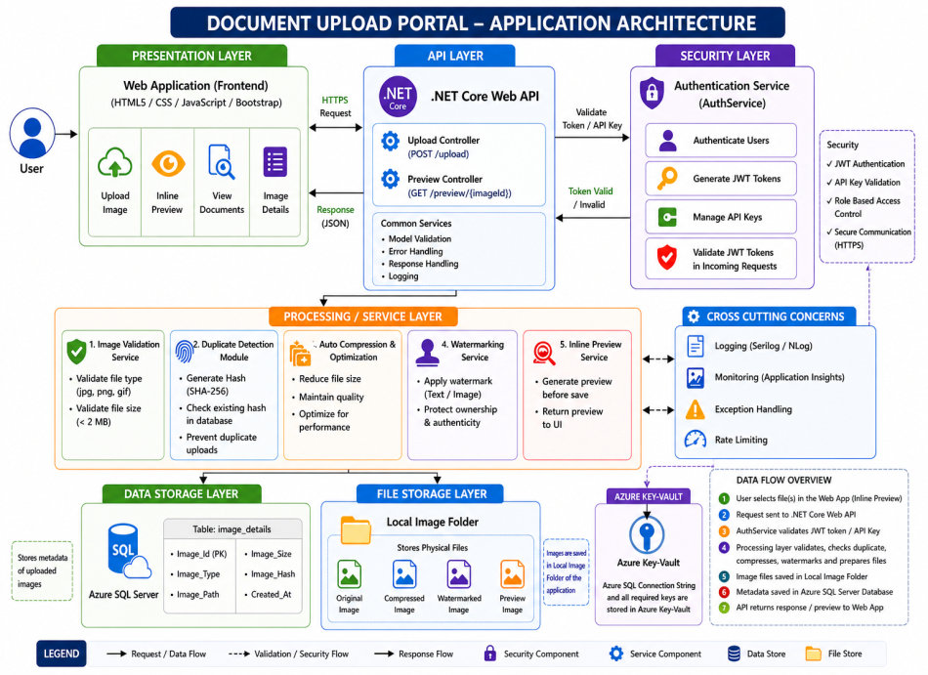
Figure 1 is a diagram of the application architecture with a brief description to set the larger context.

Text

DEPLOYMENT DESIGN ARCHITECTURE
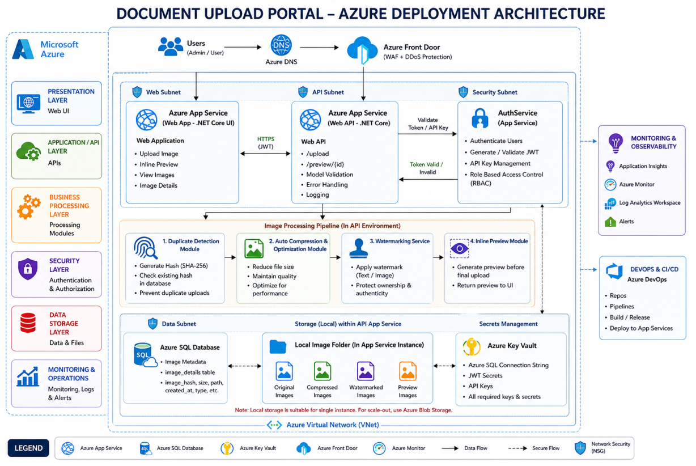

Deployment Architecture Diagram:
The Document Upload Portal is deployed on Azure using separate .NET Core Web App and .NET Core Web API services. Users access the Web UI over HTTPS to upload and preview images, while the Web API handles secured upload, preview, and metadata operations.
All API requests are protected using JWT authentication, API key validation, and RBAC authorization through the dedicated AuthService. Sensitive configurations such as SQL connection strings, JWT secrets, and API keys are stored securely in Azure Key Vault.
The backend hosts image processing modules for duplicate detection, auto-compression, and watermarking. Processed images are stored in the application’s local Image Folder, and image metadata is stored in Azure SQL Server. The API retrieves both metadata and image files to return preview details to the Web UI.

HIGH LEVEL DESIGN ARCHITECTURE
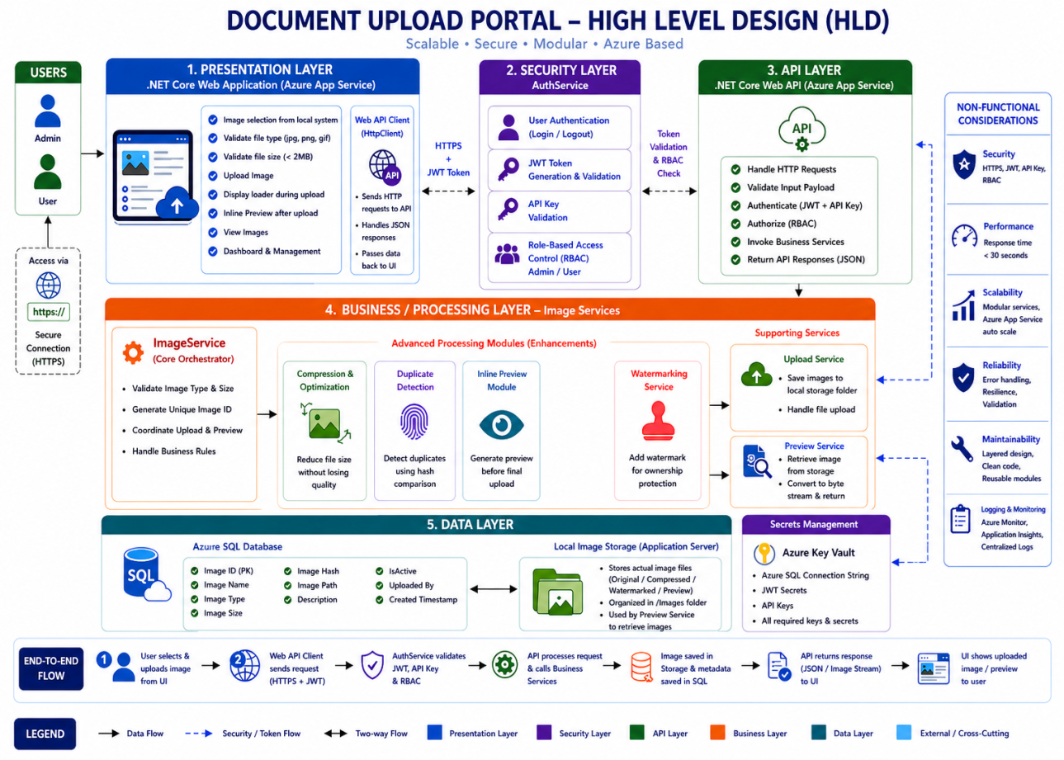

High Level Design:
The Document Upload Portal follows a layered Azure-based architecture with a .NET Core Web Application as the presentation layer and a .NET Core Web API as the backend API layer.
Users upload and preview images through the Web UI. The API validates requests using AuthService, which handles JWT authentication, API key validation, and RBAC for Admin/User roles. Secrets such as SQL connection strings, JWT secrets, and API keys are securely stored in Azure Key Vault.
The business layer processes uploads through modular services for image validation, duplicate detection, compression, watermarking, and preview generation. Processed images are stored in the local Image Folder, while metadata such as image ID, type, size, hash, path, and uploaded user details are stored in Azure SQL Server.

COMPONENTS DESIGN
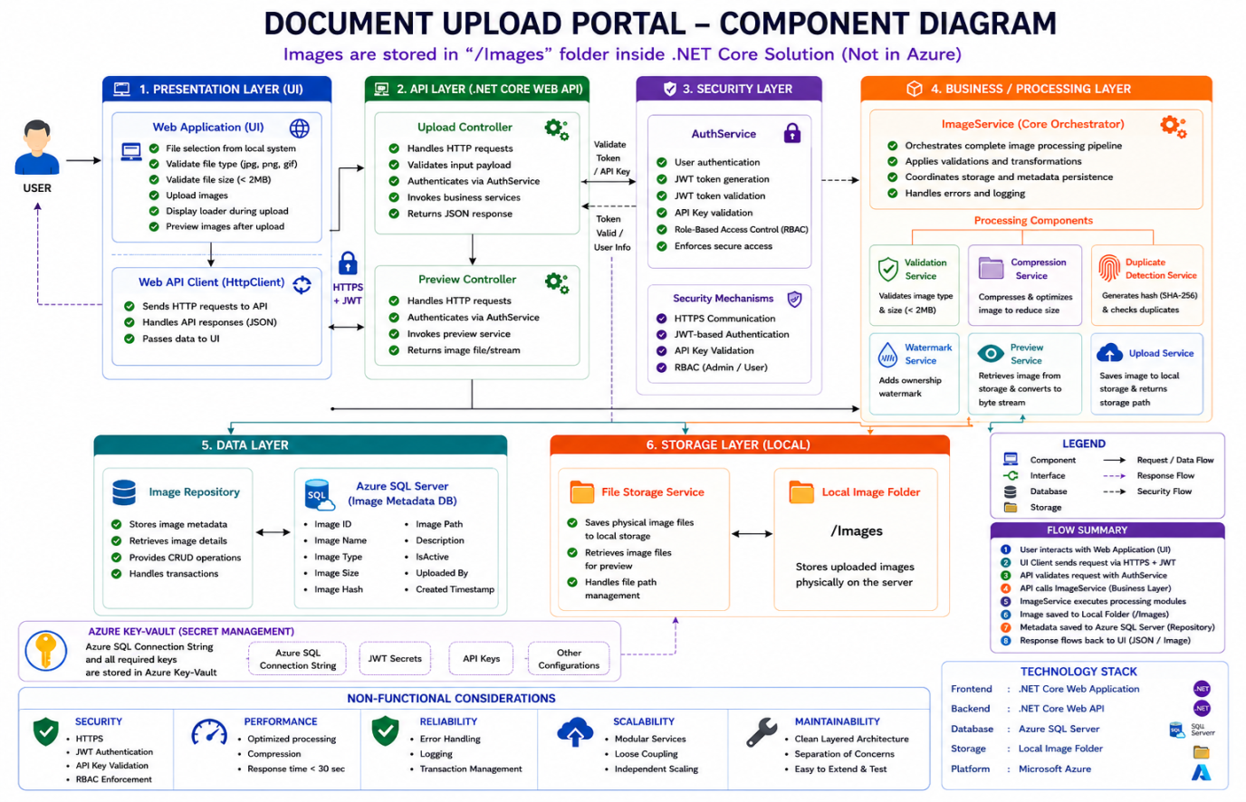

Component Design Architecture:
The Component Diagram illustrates the high-level modular architecture of the Document Upload Portal, showcasing how the Presentation, API, Security, Business Processing, Data, and Storage layers interact to support secure and efficient image upload and preview operations.
The design highlights the ImageService as the core orchestrator responsible for coordinating validation, compression, duplicate detection, watermarking, preview generation, file storage, and metadata persistence. Secure communication between the Web Application and Web API is enforced using HTTPS, JWT authentication, API Key validation, and RBAC authorization through the AuthService.
The architecture also integrates Azure SQL Server for metadata storage and Azure Key Vault for securely managing Azure SQL connection strings, JWT secrets, API keys, and application configurations. The layered and loosely coupled component structure ensures scalability, maintainability, performance optimization, and secure enterprise-grade application design.

SERVER ROLES
Server Name | Server Role | Responsibility
Azure App Service (Web UI) | Presentation Layer Hosting | Hosts Web Application UI and handles user interaction
Azure App Service (Web API) | API/Application Layer Hosting | Hosts REST APIs and business services
Azure SQL Database | Data Layer | Stores image metadata and application data
Azure Key Vault | Security Layer | Stores secrets, API Keys, JWT secrets, and connection strings
Azure Monitor | Monitoring Layer | Infrastructure and application monitoring
Application Insights | Observability & Telemetry | API tracing, logging, and performance monitoring
AuthService | Authentication & Authorization | JWT validation, API Key validation, and RBAC enforcement
- Server Roles

SOFTWARE PRE-REQUISITES
- .Net 8
- ASP.NET Core Runtime
- Visual Studio 2022
- SQL Server Management Studio
- Azure CLI
- Swagger
- Postman
- Git
- Docker (optional)

EXTERNAL REFERENCES
- Azure documentation
- JWT documentation
- ASP.NET Core documentation
- Swagger/OpenAPI docs
- Internal API specifications
- HLD reference document

COMPONENT AND CONFIGURATION DETAILS
- Azure App Service configuration
- Azure SQL configuration
- Azure Key Vault configuration
- JWT configuration
- API Key configuration
- Logging configuration
- File storage configuration
- IIS/Kestrel configuration

ADDITIONAL DESIGN COMPONENTS

CLASS DIAGRAM
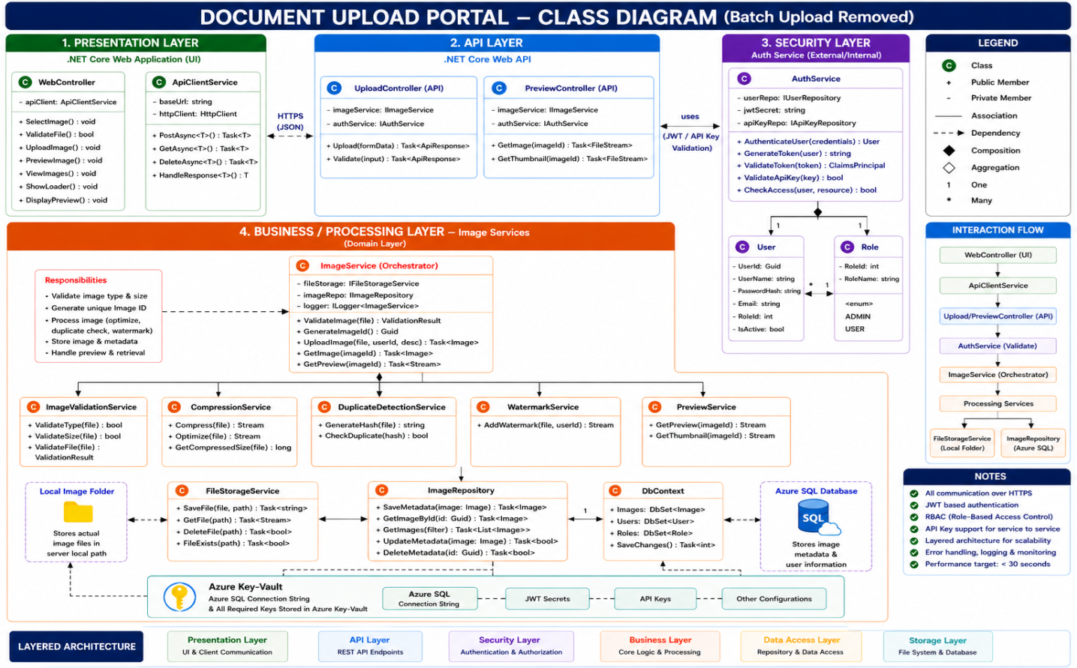
Class Diagram:
The Class Diagram illustrates the object-oriented design of the Document Upload Portal using a layered architecture approach. It represents the key classes, their responsibilities, relationships, and interactions across the Presentation, API, Security, Business Processing, Data Access, and Storage layers.
The design highlights how controllers interact with business services, how image processing modules such as compression, duplicate detection, watermarking, and preview services are orchestrated through the ImageService, and how metadata is persisted in Azure SQL Database while image files are stored in the local image folder.
The diagram also demonstrates secure integration through AuthService for JWT authentication, API key validation, and RBAC, with all secrets and Azure SQL connection strings securely managed using Azure Key Vault. The modular and layered structure ensures scalability, maintainability, reusability, and alignment with SOLID design principles.

E-R DIAGRAM
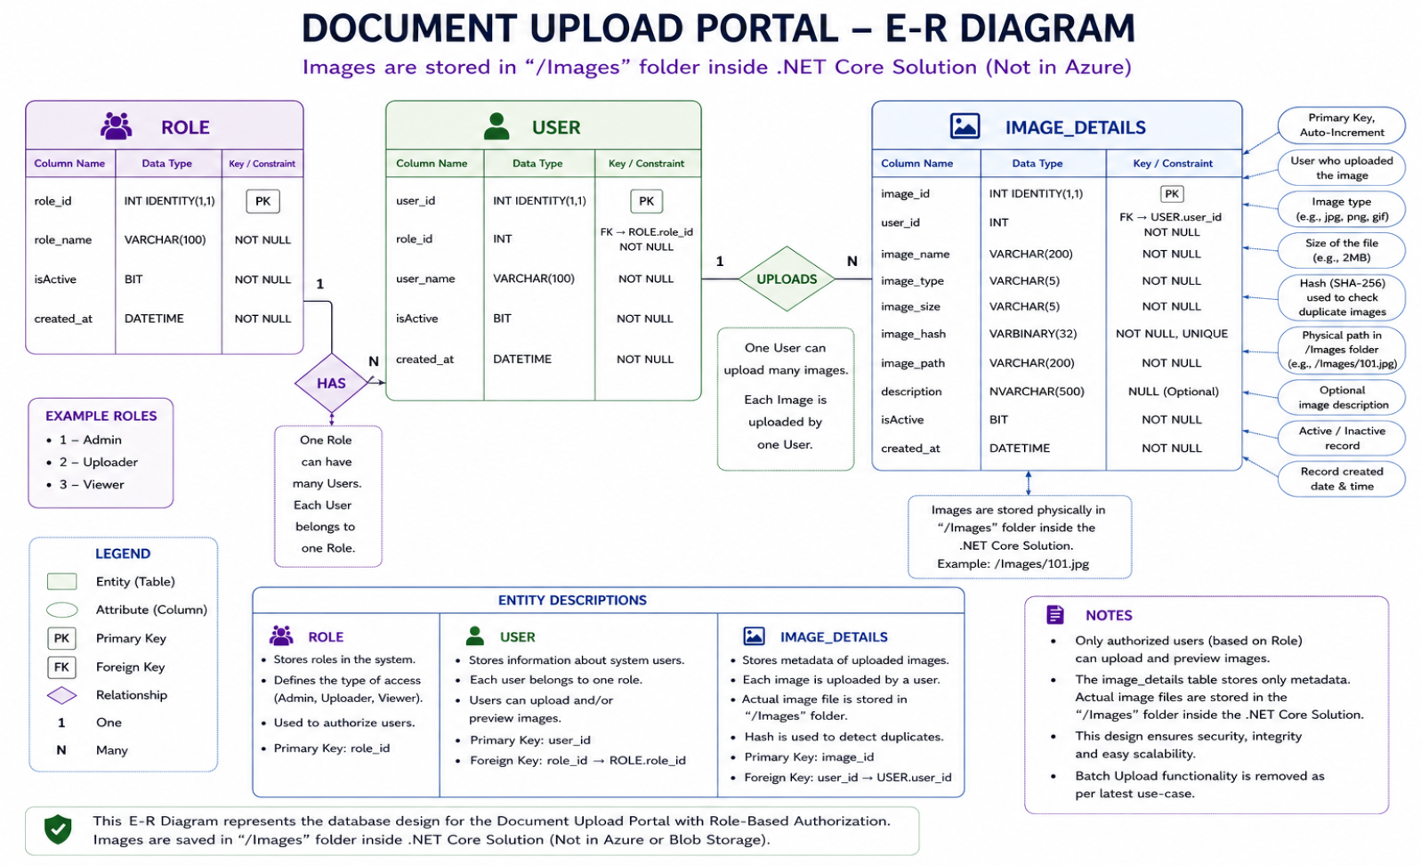

The E-R Diagram illustrates the logical database design of the Document Upload Portal system. It defines the relationships between core entities such as Users, Images, and Image Types, ensuring structured metadata management and data integrity. The design supports secure image upload, preview, retrieval, and metadata persistence while maintaining a clear separation between physical image storage in the local image folder and metadata storage in Azure SQL Database. The relational structure improves scalability, maintainability, and efficient data retrieval across the application.

DETAILED DESIGN – PHYSICAL

RACK ELEVATION DIAGRAM
The following section provides the rack elevation of compute x86, Storage, Network and Backup.
The Azure Network Diagram illustrates a secure and enterprise-grade cloud network architecture for the Document Upload Portal solution. The design uses Azure Virtual Network segmentation with dedicated subnets for Web, API, Security, and Private Endpoint layers to ensure network isolation and controlled communication flow. Network Security Groups (NSGs) enforce inbound and outbound access restrictions, while Azure Private Endpoints securely connect Azure SQL Database and Azure Key Vault without exposing them to the public internet. The architecture also incorporates Azure Front Door (WAF), JWT-based security, monitoring services, and CI/CD integration to provide a scalable, secure, and production-ready deployment model.

COMPONENT PHYSICAL DETAILS
The following section provides the Physical devices specification, physical connectivity architecture, VMware vSphere physical connectivity, vCenter components specification, physical connectivity design.
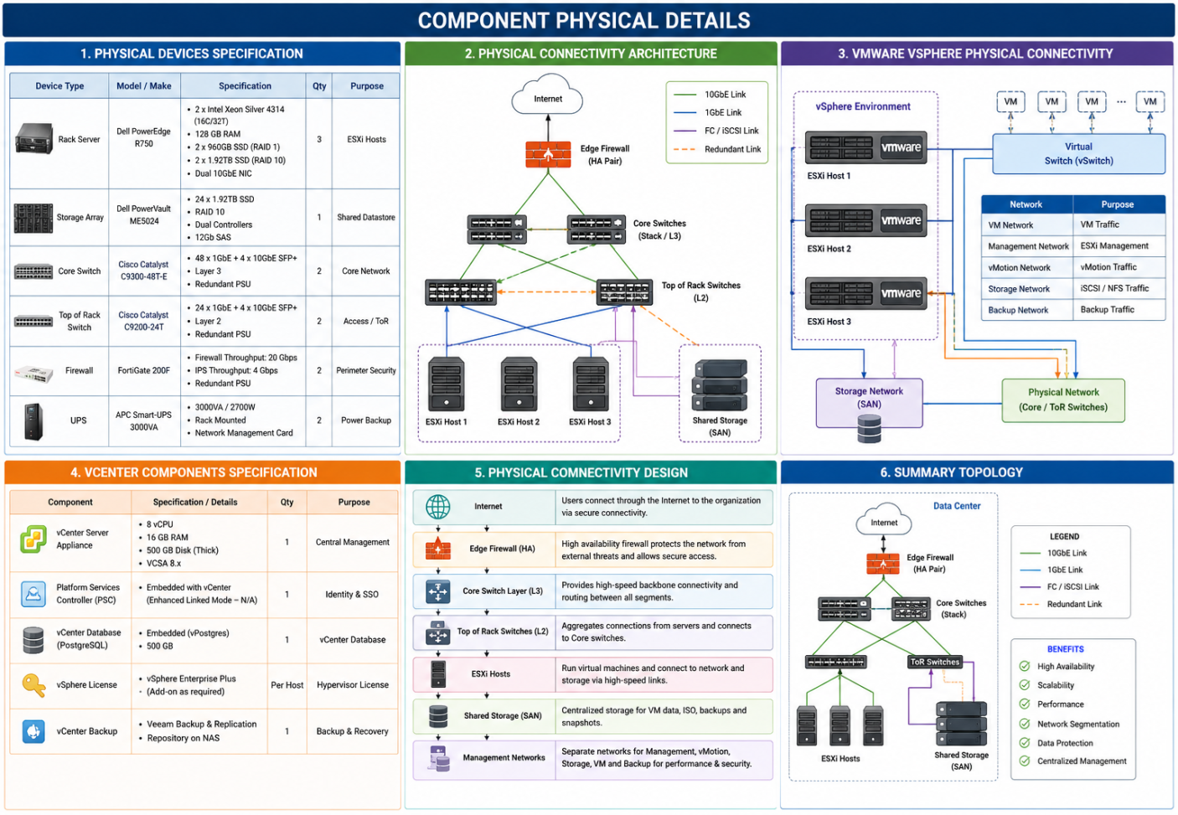

DETAILED DESIGN – SYSTEM INTEGRATION MODEL

SYSTEM INTEGRATION DETAILS
- UI ↔ API integration
- API ↔ Azure SQL
- API ↔ Key Vault
- API ↔ Local storage
- API ↔ Monitoring tools
- DATABASE
- Azure SQL schema overview
- Tables
- Relationships
- Image metadata structure
- BACKUP REQUIREMENTS
- Database backups
- File storage backup
- Retention policies

- ANTI-VIRUS
- File upload scanning strategy
- Malware validation recommendations

- MONITORING
- Azure Monitor
- App Insights
- API metrics
- Health checks

- LOGGING
- Structured logging
- Error logging
- Audit logging
- Security logging

Here is a diagram on how storage devices integrate into the centralized logging solution:
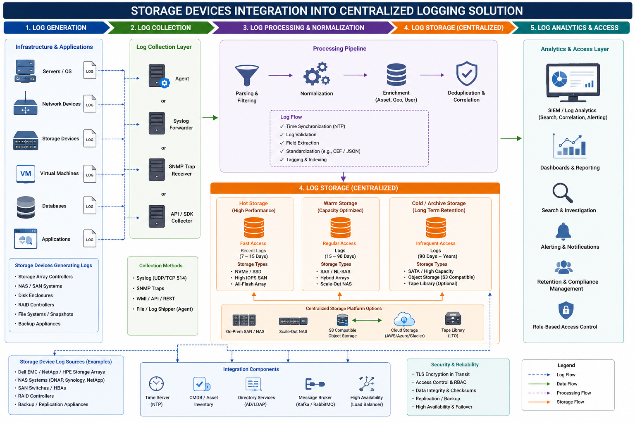

- SOURCE AND DESTINATION PORTS
The table below is for reference purpose ONLY. Include Port Number and Direction as per the requirement.
Source | Destination | Port Number
UI | API | 443
API | Azure SQL | 1433
API | Key Vault | 443
API | Local Storage | SMB/Internal
API | App Insights | 443

- SERVICE ACCOUNTS
- App Service Managed Identity
- SQL service account
- Deployment service account

- SYSTEM ADMINISTRATION
- Deployment management
- Monitoring administration
- Log management
- Role management

- CAPACITY AND SCALABILITY MANAGEMENT
- Auto-scaling
- Storage growth strategy
- Database scaling
- Concurrent user handling

DOCUMENTS REFERENCED
- HLD document
- API Specification
- Security Architecture
- Azure deployment guide
- Sequence diagrams
- Component diagrams
- Class diagrams

