CTS/Document Upload Portal
High Level Design and Architecture Document
Version No: 1.0

 | Prepared By / Last Updated By | Reviewed By | Approved By
Name | Shashi Shekhar
Role
Signature | Shashi Shekhar
Date | 24th May, 2026

.>

Table of Contents
1.0 Introduction 3
1.1 Purpose of this document 3
1.2 Scope 3
1.3 Out of scope 3
1.4 Intended Audience 3
1.5 Acronyms 3
2.0 System Architecture 3
2.1 Architectural Views 3
2.1.1 Functional View 4
2.1.2 Conceptual View 6
2.1.3 Logical View 7
2.1.4 Functional Architecture View 9
2.1.5 Technology View 11
2.1.6 Integration View 14
2.1.7 Implementation View 15
2.1.8 Data View 17
2.1.9 Deployment View 17
2.1.10 Security View 22
2.1.11 Process View 24
2.2 System Interfaces 24
2.3 Reporting 25
3.0 Prototype Design 25
3.1.1 Wireframe/ Visual Design 25
4.0 Technology, Tools and Frameworks 26
5.0 Solution Recommendations 26
5.1 Technical recommendations 26
5.2 Infrastructure recommendations 26
6.0 Reference 26
7.0 Change Log 27

- Introduction
  - Purpose of this document
Document High level Design and Architecture for Document Upload Portal.
  - Scope
This HLD & Architecture Document is designed for green field applications, This document is technical in nature and includes
- System/App architecture views depicting component layers, technology involved, integration, deployment, security, recoverability views for Document Upload Portal.
- UI/Wireframe design if not covered by the BRD.
- Image upload
- Image preview
- JWT authentication
- RBAC authorization
- Logging and monitoring
- API documentation via Swagger
- Azure deployment

  - Out of scope
- Auto-Compression
- Duplicate detection
- Watermarking
- Metadata storage in Azure SQL
- Local image storage
- Inline Preview
- API Key validation

  - Intended Audience
Internal Technical teams, Architects, Developers, IT Security, DelEx.
  - Acronyms
S. No | Acronym | Expansion
1 | BRD | Business Requirements Document
2 | DelEx | Delivery Excellence
3 | RBAC | Role Based Access Control
4 | JWT | JSON Web Token
- System Architecture
  - Architectural Views
The architecture of a system can be depicted in multiple views that makes it easy to understand from a specific perspective. Design team is free to decide and merge views as applicable to simplify diagram creation. For vendor/3rd party products some of the views may be available as part of vendor provided docs and must be explored for reuse/reference here. The following architectural views are highly suitable for the Document Upload Portal Use Case:
    - Functional View
      - Key Business Processes
- Image upload workflow
- Image validation
- Duplicate image detection
- Compression & watermarking
- Preview generation
- Metadata persistence
- Image retrieval flow
      - Architecturally Significant Use Cases/Functional Requirements
This section identifies the critical business use cases and functional requirements that have a direct impact on the overall architecture design of the Document Upload Portal. It focuses on the core functional scenarios such as secure image upload, image validation, duplicate detection, image preview, metadata persistence, authentication, authorization, and image retrieval, which significantly influence architectural decisions related to security, scalability, performance, maintainability, storage strategy, and cloud deployment. The section also captures key non-functional requirements including availability, reliability, monitoring, logging, disaster recovery, and secure communication that drive the selection of Azure services, layered architecture, JWT security model, and modular processing design. The identified use cases and requirements collectively justify and validate the proposed architecture as sufficient, scalable, secure, and aligned with enterprise solution design principles.

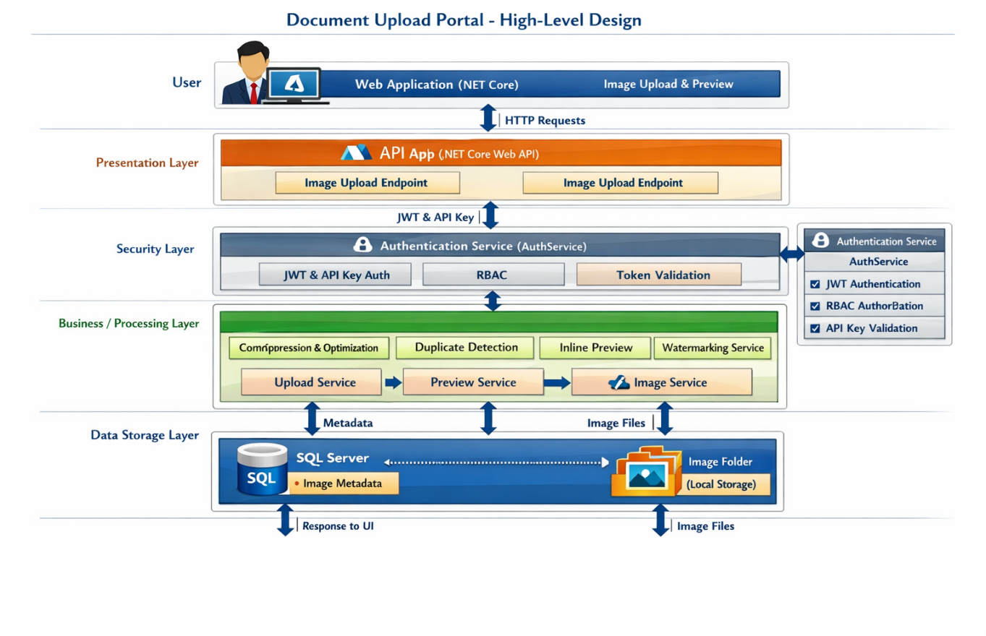
      - Functional Modules
This section explains the functional decomposition of the Document Upload Portal by breaking down the system into multiple hierarchical levels to provide a clear understanding of business processes, functional modules, sub-modules, and detailed processing flows. The purpose of this section is to represent how the overall system functionality is logically divided from a high-level business view to detailed functional components and services.
- Level 0 represents the overall system context diagram, showing the Document Upload Portal as a single enterprise system interacting with external actors such as Users, Azure Services, Storage, and Database systems. It highlights the primary inputs, outputs, and high-level business services like image upload, preview, authentication, and retrieval.
- Level 1 provides a functional breakdown of the major architectural modules including Presentation Layer, API Layer, Security Layer, Business Processing Layer, Data Layer, and Storage Layer. This level explains how the core modules collaborate to deliver end-to-end business functionality.
- Level 2 further decomposes the Level 1 modules into detailed sub-modules such as Upload Controller, AuthService, ImageService, CompressionService, DuplicateDetectionService, PreviewService, FileStorageService, and ImageRepository. This level focuses on internal processing responsibilities and module interactions.
- Level 3 represents the detailed functional workflow within each Level 2 component, including image validation flow, JWT authentication flow, image processing pipeline, metadata persistence flow, and preview generation process. This level provides a deeper technical understanding of the internal execution logic and orchestration sequence across services.
Based on the scope and complexity of the Document Upload Portal, the architecture design is primarily focused on Level 0, Level 1, and Level 2 decomposition, while selected critical workflows are elaborated in Level 3 through Sequence Diagrams and processing flow representations.

    - Conceptual View
This section provides a high-level conceptual overview of the Document Upload Portal by identifying the primary actors interacting with the system and the major system components involved in delivering business functionality. The purpose of this section is to present the overall solution architecture in a simplified and business-friendly manner that can be easily understood by both technical and non-technical stakeholders.
      - Actors
The Actors section identifies the key users, external systems, and services interacting with the Document Upload Portal. These actors may consume or provide functionality to the system. Typical actors include End Users, Administrators, Azure Services, Authentication Services, Monitoring Systems, and external infrastructure components. This section briefly explains the role, responsibility, and interaction of each actor within the overall business workflow such as image upload, authentication, image retrieval, monitoring, and administration activities.
      - System Components
The System Components section provides a conceptual representation of the major architectural building blocks of the solution, including the Web Application, Web API, Security Layer, Business Processing Services, Azure SQL Database, Azure Key Vault, Monitoring Services, and Local Image Storage. The section typically includes a high-level block diagram and a brief explanation of how these components collaborate to provide secure, scalable, and reliable image upload and preview functionality. The focus is on explaining the overall business and system interaction flow rather than low-level technical implementation details.

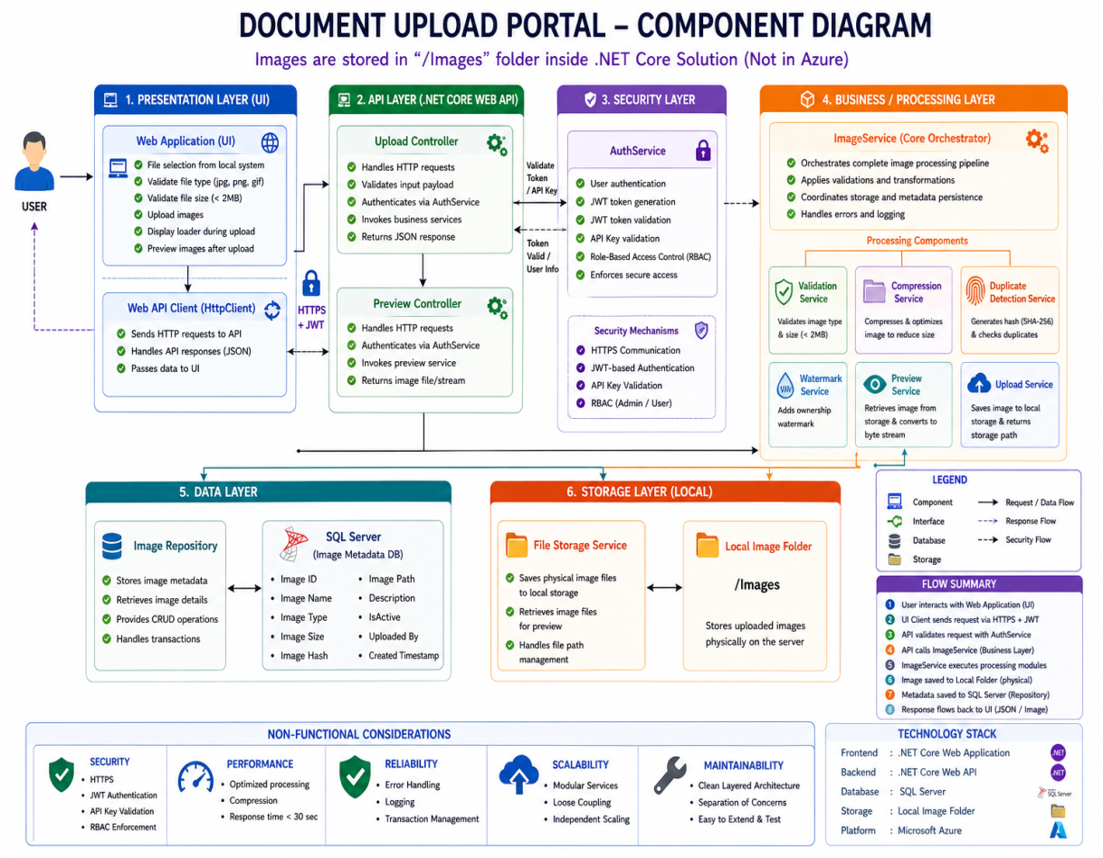

    - Logical View

The Logical View section describes the high-level logical architecture of the Document Upload Portal and explains how different application layers, components, services, and external integrations interact to deliver business functionality. This view focuses on the logical separation of concerns across the system rather than physical infrastructure deployment. It typically illustrates the interaction between Actors/Roles (Users/Admins), Client Devices or Endpoints, Presentation Layer (.NET Core Web Application), Service Layer (.NET Core Web API and Business Services), Persistence Layer (Azure SQL Database), Storage Layer (Local Image Folder), and Integration Components such as Azure Key Vault, Monitoring Services, and external Azure services.

The Logical View also highlights common cross-cutting architectural capabilities such as Security, Logging, Monitoring, Availability, Scalability, Exception Handling, and Configuration Management as vertical services applied across all layers of the system. This view helps stakeholders understand the overall functional interaction flow, modular architecture structure, security enforcement, and enterprise-level design approach in a simplified and technology-aligned manner.

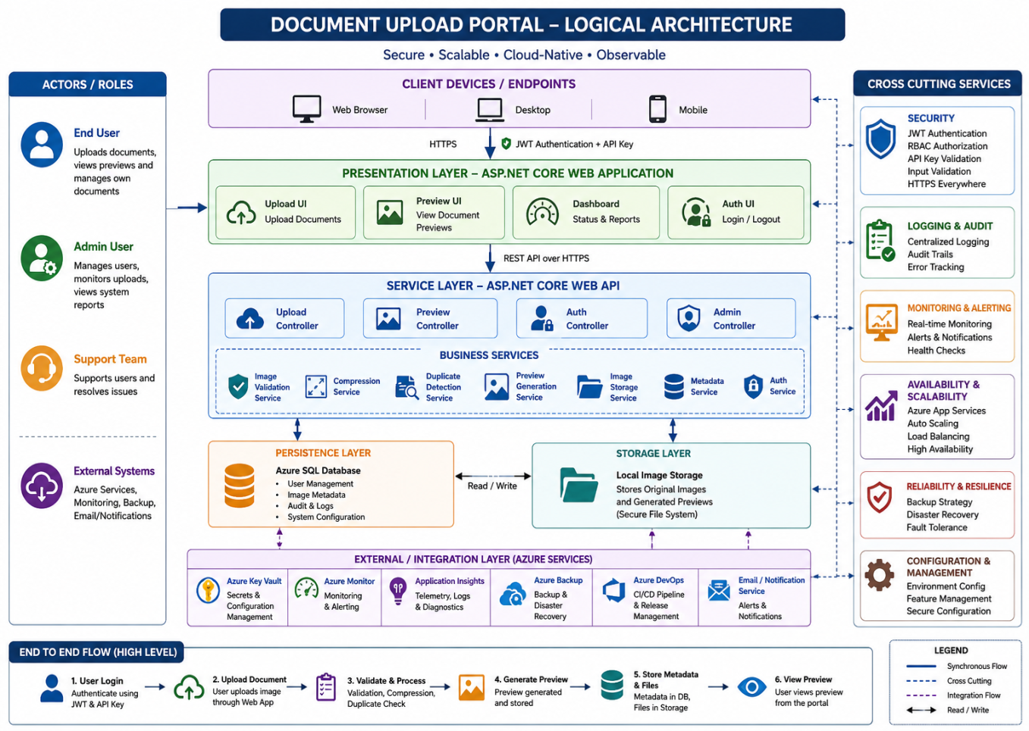

    - Functional Architecture View

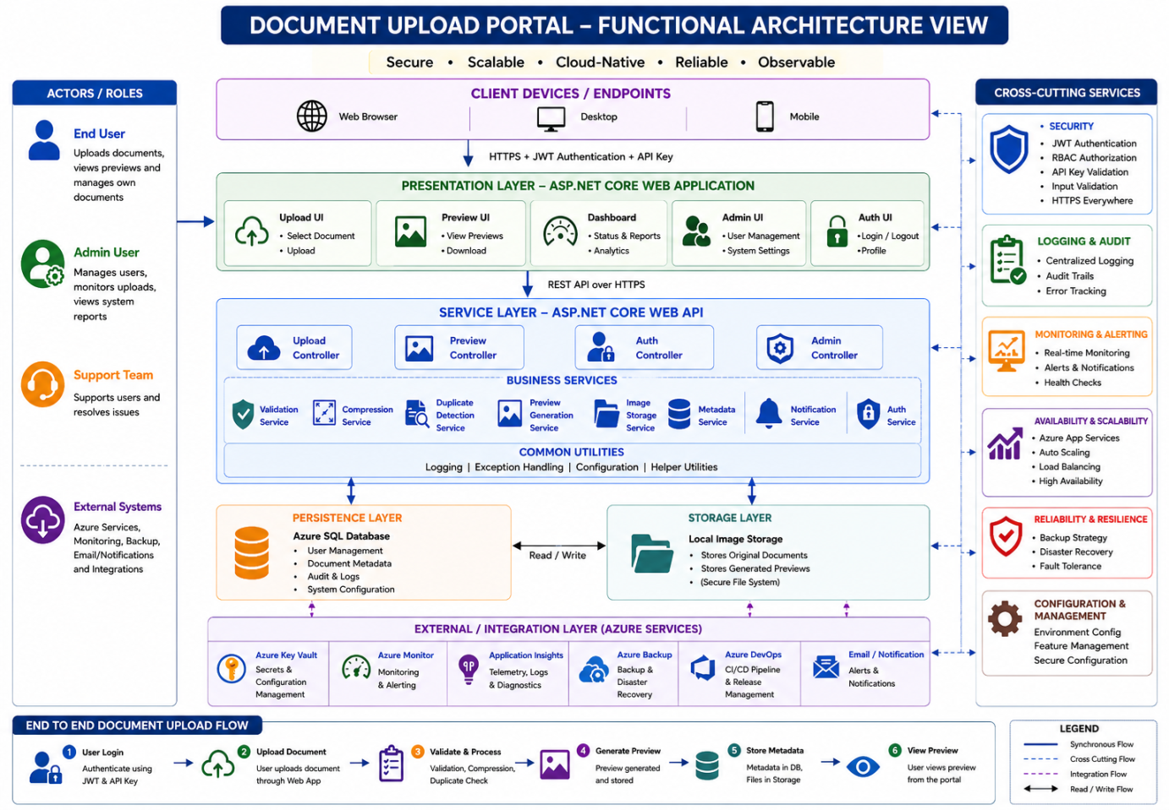

    - Technology View

The Technology View section describes the technology platforms, frameworks, infrastructure services, third-party tools, and integration components used across each architectural layer of the Document Upload Portal solution. This section maps the logical architecture components to their corresponding implementation technologies, helping stakeholders understand the technical foundation of the system. It typically includes details about the Presentation Layer, API Layer, Business Services, Database Layer, Storage Layer, Security Services, Monitoring Tools, Logging Mechanisms, Deployment Platforms, and external integrations along with their versions, protocols, authentication mechanisms, and deployment considerations.

For the Document Upload Portal, the Technology View includes technologies such as ASP.NET Core Web Application for the Presentation Layer, ASP.NET Core Web API for Service Layer implementation, Azure SQL Database for metadata persistence, Azure Key Vault for secure secret management, Local File Storage for image storage, Azure Monitor and Application Insights for monitoring and telemetry, Docker for containerization, and Azure DevOps for CI/CD automation. This section also highlights cross-cutting technologies related to Security, Logging, Monitoring, Availability, Scalability, and Caching that support enterprise-grade operational capabilities.
Component Name | Technology | Version/Comments
Presentation Layer | ASP.NET Core MVC Web Application | .Net 8
API layer | ASP.NET Core REST Web API | .Net 8
Authentication Service | JWT Authentication + RBAC | Token-Based Security
API Security | API Key Validation | Custom Middleware
Business Layer | C# Service Classes | Modular Service Architecture
Validation Service | Custom Validation Framework | File Validation Logic
Compression Service | Image Processing Library | Compression Optimization
Duplicate Detection Service | SHA-256 Hashing | Duplicate Image Detection
Preview Service | Image Preview Generator | Preview Generation
Storage Layer | Local Image Folder Storage | Secure File System
Secret Management | Azure Key Vault | Managed Identity (MSI)
Monitoring | Azure Monitor
  Infrastructure Monitoring
Logging Framework | Serilog / ILogger | Centralized Logging

Security
The Document Upload Portal relies on enterprise-grade Azure security services and platform-level security controls to ensure secure communication, authentication, authorization, and secret management. The application implements JWT-based authentication, Role-Based Access Control (RBAC), API Key validation, HTTPS encryption, and Azure Key Vault integration for secure storage of secrets, connection strings, and application credentials.

Logging
The solution uses centralized logging mechanisms through Serilog, ILogger, Azure Monitor, and Application Insights to capture application logs, audit events, exception traces, and operational activities for troubleshooting, auditing, and production support.

Monitoring
Azure Monitor and Application Insights are used for real-time application monitoring, telemetry tracking, health checks, performance analysis, infrastructure monitoring, and automated alert generation for proactive operational management.

Availability
The application is hosted on Azure App Services with scalable and highly available cloud infrastructure. Azure SQL Database, monitoring services, and backup mechanisms ensure enterprise-grade availability and resiliency.

Scalability
The solution supports horizontal and vertical scalability using Azure App Services, AKS-based deployment strategies, stateless REST APIs, and modular business services to handle increasing workloads and future expansion.

Caching
Optional Redis Cache integration can be implemented to improve application performance, reduce repeated database calls, optimize API response times, and enhance overall system scalability.

    - Integration View
The Integration View section describes how the Document Upload Portal interacts with internal enterprise systems, external services, cloud platforms, and supporting infrastructure components to exchange data and execute business operations. This section focuses on the integration mechanisms, communication protocols, interface types, authentication methods, data flow patterns, and dependency relationships between the application and other systems. It provides a clear understanding of inbound and outbound integrations, including how data is securely transmitted, processed, stored, monitored, and managed across different environments such as IT, UAT, and Production.
For the Document Upload Portal, the Integration View includes internal integrations with Azure SQL Database for metadata persistence, Local File Storage for image storage, Azure Key Vault for secret management, Azure Monitor and Application Insights for monitoring and telemetry, and Azure DevOps for CI/CD integration. External integrations may include Email/Notification Services, Identity Providers, Monitoring Platforms, and other enterprise services. The section also documents REST API communication over HTTPS, JWT authentication, API Key validation, secure ports/protocols, and environment-specific endpoints to ensure secure, scalable, and enterprise-grade system integration architecture.
- Integration Mechanisms Covered

Internal Integration
This section explains integrations within the enterprise ecosystem, including:
- Web Application ↔ Web API
- Web API ↔ Azure SQL Database
- Web API ↔ Local Image Storage
- Web API ↔ Azure Key Vault
- Web API ↔ Azure Monitor & Application Insights
- Azure DevOps ↔ Deployment Infrastructure

External Integration
This section describes integrations with external or third-party services such as:
- Authentication Providers
- Monitoring & Alerting Platforms
- Backup & Recovery Services
- Future external enterprise integrations (ERP/CRM)

Integration Matrix
The Integration Matrix provides details about:
- Source System
- Target System
- Interface Type
- Protocol (REST/HTTPS)
- Authentication Mechanism
- Data Format (JSON)
- Communication Direction (Inbound/Outbound)
- Port/Endpoint Information
- Environment-specific URLs
    - Implementation View
The Implementation View section describes the detailed technical implementation architecture of the Document Upload Portal by explaining how each application layer, component, integration adapter, and supporting service is implemented using specific technologies, frameworks, and communication mechanisms. This view focuses on the internal realization of the system design, including how requests flow through different layers, how business services are orchestrated, how integrations are performed with external systems, and how supporting infrastructural capabilities such as security, monitoring, logging, and storage are implemented. The section also identifies the integration adapters, protocols, APIs, middleware, and technology stacks used across the solution to ensure secure, scalable, maintainable, and production-ready implementation architecture.

Layer-wise Explanation

Presentation Layer
The Presentation Layer is implemented using ASP.NET Core MVC Web Application and provides the user-facing interface for image upload, image preview, authentication, dashboard management, and administrative operations. This layer communicates securely with backend APIs using REST over HTTPS and supports responsive UI interaction.

Services Façade Layer
The Services Façade Layer consists of ASP.NET Core Web API Controllers that expose RESTful API endpoints for upload, preview, authentication, administration, and image retrieval functionalities. This layer acts as the entry point for all client requests and orchestrates communication with business services.

Business Components
The Business Components layer contains the core business logic implementation using modular service classes such as ImageService, ValidationService, CompressionService, DuplicateDetectionService, PreviewService, and NotificationService. This layer is responsible for executing business workflows, image processing operations, and orchestration logic.

Data Access Layer
The Data Access Layer is implemented using Entity Framework Core and Repository Pattern to provide abstraction between business services and Azure SQL Database. This layer manages database transactions, metadata persistence, audit logging, and data retrieval operations.

Core Services
The Core Services layer provides shared infrastructural and cross-cutting capabilities including JWT Authentication, RBAC Authorization, centralized logging, exception handling, monitoring integration, configuration management, and optional caching services.

Management Services
The Management Services layer integrates Azure operational tools such as Azure Monitor, Application Insights, and Azure DevOps to provide telemetry, diagnostics, monitoring, CI/CD automation, alerting, and operational management capabilities.

Integration Adapters
The Integration Adapters layer contains adapters and connectors used for communication with external systems and infrastructure services such as Azure Key Vault, Email Services, Monitoring Services, File Storage, and Notification platforms. These adapters isolate integration logic and improve maintainability and extensibility.

Storage / External Services
This layer includes Azure SQL Database for metadata persistence, Local Image Storage for physical image storage, Azure Key Vault for secure secret management, Azure Backup services, and monitoring/notification platforms used for operational support and disaster recovery.

    - Data View
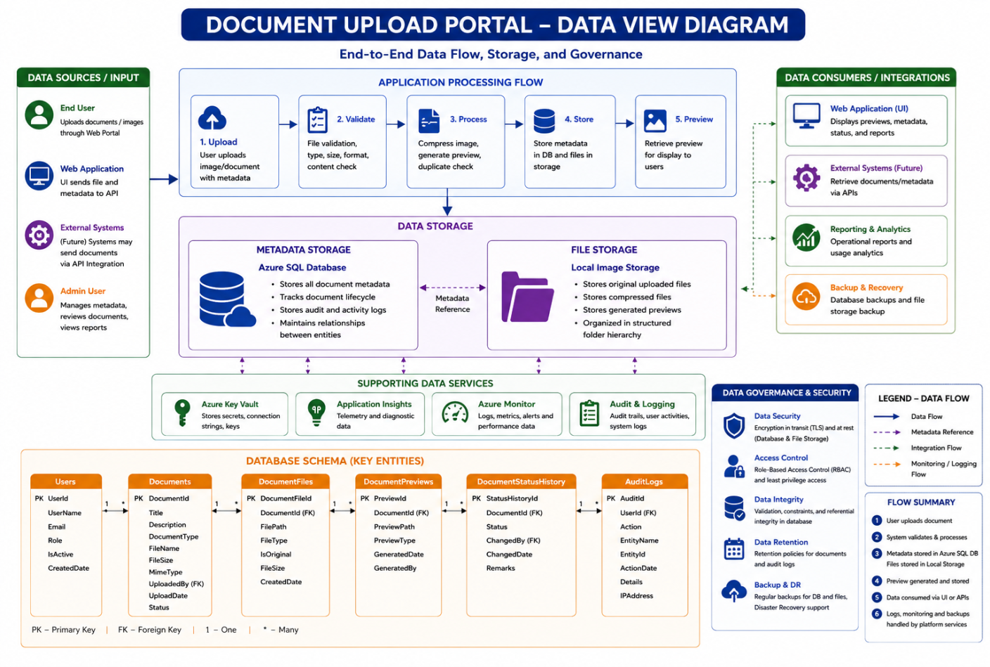

    - Deployment View

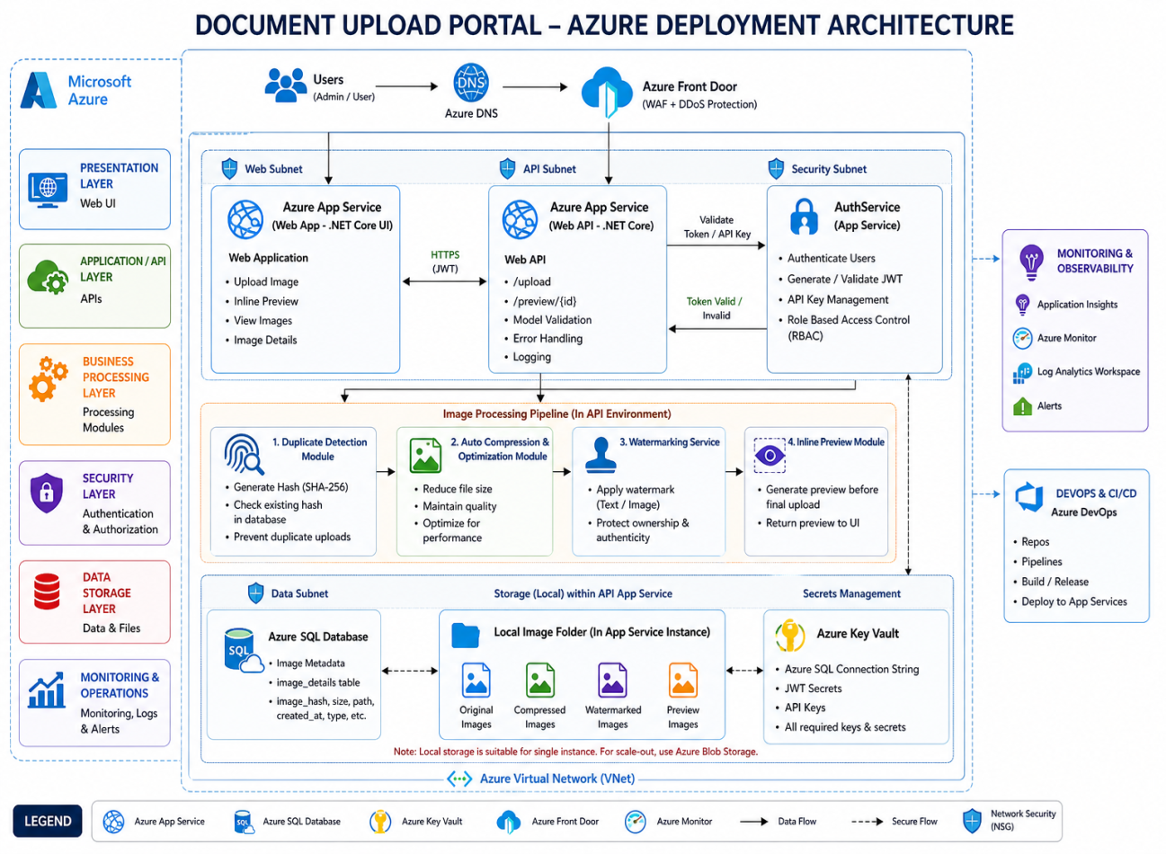
The Deployment View section describes how the Document Upload Portal solution is physically deployed across cloud-hosted infrastructure and any supporting on-premise or enterprise-managed services. This section highlights the deployment topology, environment-specific infrastructure details, hosting platforms, network segregation, FQDNs, IP ranges, OS/platform versions, Azure service dependencies, and operational integration points. It provides a clear distinction between cloud-hosted components (Microsoft Azure) and enterprise/on-premise integrations while documenting how different environments such as IT, UAT, and Production are isolated and managed.
The solution is primarily hosted on Microsoft Azure using Azure App Services, Azure SQL Database, Azure Front Door, Azure Key Vault, Azure Monitor, and Azure DevOps. The architecture is deployed within secured Azure Virtual Networks (VNETs) with subnet-level isolation for Web, API, Security, and Data components. Monitoring, CI/CD, logging, and disaster recovery capabilities are integrated using Azure-native platform services. Environment-specific differences such as FQDN naming conventions, scaling configurations, monitoring policies, and security restrictions are maintained across IT, UAT, and Production deployments.

      - Logical Infrastructure
The Logical Infrastructure View section describes the high-level logical arrangement of the infrastructure components required to support the Document Upload Portal solution without focusing on physical hardware specifications, node counts, clustering configurations, or detailed bandwidth planning. This view explains how the major infrastructure building blocks such as Web Layer, API Layer, Security Layer, Data Layer, Storage Layer, Monitoring Services, and Network Components are logically organized and interconnected within the enterprise cloud environment. It highlights the logical separation of infrastructure zones, subnet segmentation, security boundaries, communication flow, and integration with Azure platform services including Azure App Services, Azure SQL Database, Azure Key Vault, Azure Front Door, Azure Monitor, and Azure DevOps. The purpose of this section is to provide a simplified infrastructure architecture representation that helps stakeholders understand how the application components are logically deployed, secured, monitored, and connected within the cloud ecosystem while supporting scalability, availability, and operational manageability.
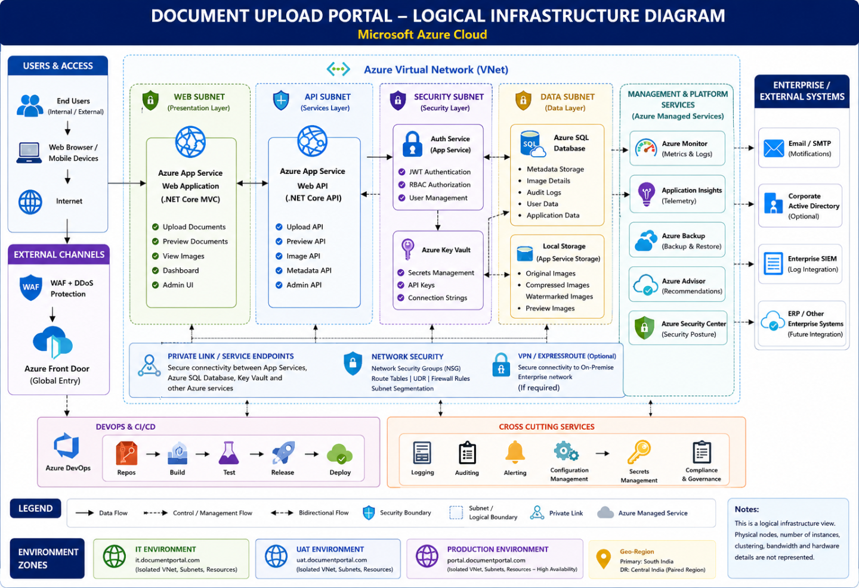

      - Physical Infrastructure
The Physical Infrastructure View section extends the Logical Infrastructure architecture into a more detailed representational deployment model by illustrating the actual physical and cloud infrastructure components used to host and run the Document Upload Portal solution. This section highlights the infrastructure tiers, network boundaries, security zones, load balancing components, proxy services, application hosting environments, database infrastructure, storage systems, clustered services, and firewall/security controls deployed across the solution landscape. The objective of this section is to provide a deployment-oriented infrastructure representation that demonstrates how the application is physically distributed, secured, scaled, and connected within the Microsoft Azure cloud environment and enterprise network ecosystem.
For the Document Upload Portal, the Physical Infrastructure View includes Azure Front Door for global traffic routing and WAF protection, Azure App Services for hosting Web and API applications, Azure SQL Database for metadata persistence, Azure Key Vault for secrets management, Local Storage/File System for image storage, Azure Monitor and Application Insights for monitoring, Azure DevOps for CI/CD deployment, and Azure Virtual Network (VNET) segmentation with dedicated Web, API, Security, and Data subnets. The section also highlights security boundaries using Network Security Groups (NSGs), HTTPS communication, private endpoints, firewall controls, secure API access, monitoring integrations, backup services, and environment isolation across IT, UAT, and Production deployments.

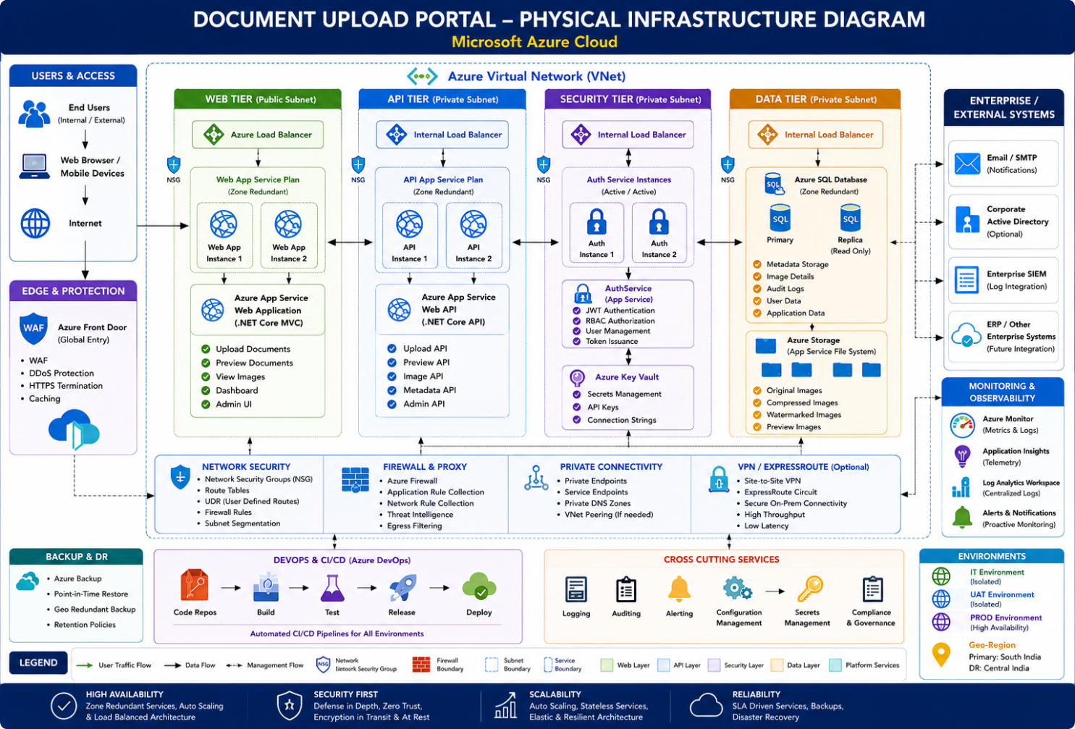

      - Product Deployment Model
The Product Deployment Model View section describes how the Document Upload Portal application components, deployable units, services, and supporting infrastructure are packaged, deployed, configured, and hosted across the target cloud environment. This section explains the deployment organization of the solution, including how the Web Application, Web API, Authentication Services, Database, Storage, Monitoring Components, and DevOps pipelines are deployed within Microsoft Azure infrastructure. It also highlights the deployment topology, environment segregation (IT, UAT, Production), deployment units, hosting platforms, service dependencies, containerization strategy, CI/CD integration, scaling configuration, and operational deployment flow.
For the Document Upload Portal, the deployable units include the ASP.NET Core Web Application deployed on Azure App Services, RESTful Web APIs hosted on Azure App Services or AKS, Azure SQL Database for metadata persistence, Local Image Storage for document storage, Azure Key Vault for secrets management, and Azure Monitor/Application Insights for operational monitoring. The deployment model also includes Azure Front Door for traffic routing and WAF protection, Azure DevOps pipelines for automated CI/CD deployment, Docker-based containerized deployment support, subnet-level environment isolation, and secure HTTPS communication across all deployment layers. The purpose of this section is to provide a deployment-oriented operational view of how the complete enterprise solution is packaged, released, deployed, scaled, and maintained in the production cloud environment.

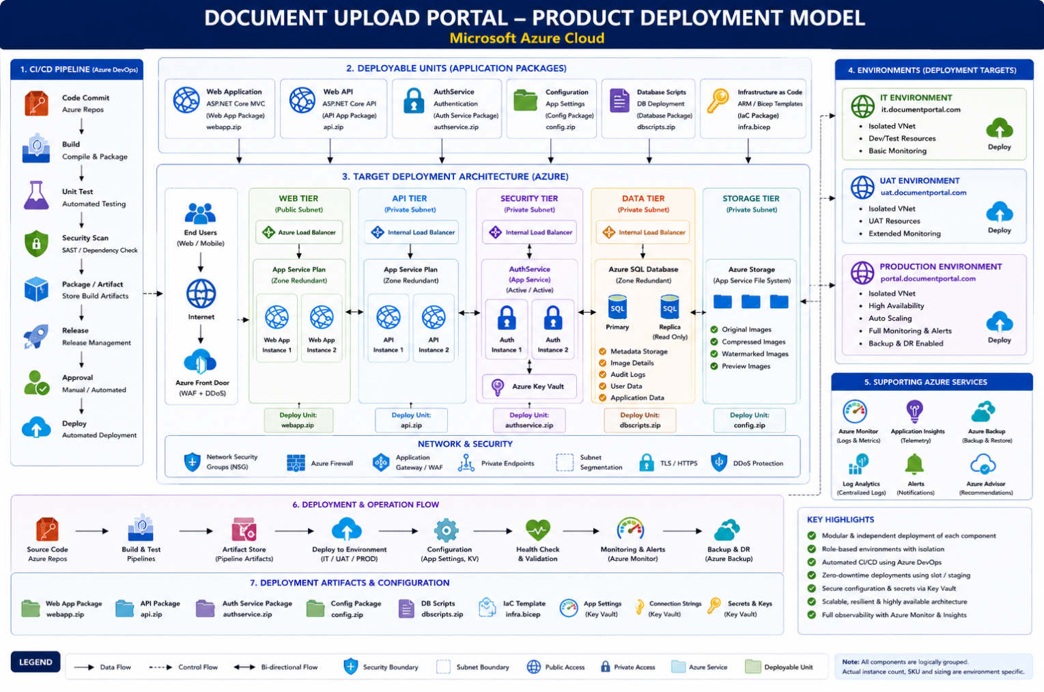

    - Security View

The Security View section describes how security controls, protection mechanisms, and governance policies are integrated into the overall architecture and application design of the Document Upload Portal from the initial design stage itself. The purpose of this section is to demonstrate that security is embedded across all architectural layers and is not treated as a post-development activity. This section explains how the application ensures secure authentication, authorization, communication, data protection, secret management, monitoring, auditing, and secure deployment practices throughout the application lifecycle.

For the Document Upload Portal, the Security View includes JWT-based authentication, Role-Based Access Control (RBAC), API Key validation, HTTPS/TLS encrypted communication, Azure Key Vault integration for secure secrets management, Network Security Groups (NSGs), Azure Front Door with WAF protection, secure API access controls, audit logging, centralized monitoring, and compliance tracking. The section also highlights secure CI/CD deployment using Azure DevOps, environment isolation, private endpoints, firewall rules, vulnerability scanning, and monitoring integrations through Azure Monitor and Application Insights. This view ensures that the solution follows enterprise-grade security principles including Defense-in-Depth, Least Privilege Access, Secure Configuration Management, and Zero Trust Architecture across all deployment environments.
      - Secure Design Considerations
The Security Design Consideration section describes the security principles, controls, standards, and architectural decisions implemented within the Document Upload Portal to ensure secure application design, secure communication, data protection, user accountability, and compliance with enterprise security standards. This section demonstrates how security is embedded across all layers of the application lifecycle including authentication, authorization, input validation, encryption, integrations, session management, auditing, infrastructure security, and privacy protection. The objective of this section is to ensure that the application follows Security-by-Design and Privacy-by-Design principles while minimizing security risks, preventing unauthorized access, protecting sensitive data, and maintaining regulatory compliance.

Authentication Design
The application implements strong authentication mechanisms using JWT-based authentication integrated with secure login workflows and optional Multi-Factor Authentication (MFA) for privileged administrative users. Authentication tokens are securely generated, validated, and expired using industry-standard security practices. All authentication communication is protected using HTTPS/TLS encryption.

Access Privilege and Authorization Design
The solution follows Role-Based Access Control (RBAC) and Least Privilege principles to ensure users receive only the minimum permissions required to perform authorized operations. Segregation of Duties (SoD) is enforced between End Users, Administrators, and Support Teams. Role and permission metadata are securely stored and protected against tampering using signed JWT tokens and secured database controls.

Input / Data Validation
The application validates all user inputs, uploaded files, API payloads, and request parameters before processing. Validation includes file type verification, file size restrictions, schema validation, sanitization, and business rule enforcement to prevent malicious input, injection attacks, and unauthorized content upload. All outputs are securely encoded before being rendered to end users.

Data Protection
Sensitive information including image metadata, credentials, API keys, and user details are protected across all data states including data-at-rest, data-in-transit, and data-in-use. HTTPS/TLS encryption is enforced for all communication channels, while Azure SQL Database encryption and secure storage mechanisms are used for persistent data protection.

Cryptography and Key Management
The solution uses secure cryptographic standards for token signing, secure hashing, API security, and encryption operations. Azure Key Vault is used for centralized key management, secure storage of secrets, connection strings, JWT signing keys, API keys, and certificate management using Managed Identity integration.

Accountability Design
Comprehensive audit logging, user activity tracking, API access logging, and operational event monitoring are implemented to maintain accountability across all user and system actions. Logs are centrally monitored using Azure Monitor, Application Insights, and Log Analytics for anomaly detection, security analysis, and compliance auditing.

Secure Integrations & Communication
All integrations between Web Application, APIs, Azure services, monitoring platforms, and external systems are secured using HTTPS/TLS encryption, REST APIs, secure tokens, API Key validation, private endpoints, and firewall controls. Secure communication standards are enforced across all inbound and outbound integrations.

Error Handling and Exception Design
The application follows the “Fail Securely” design principle by implementing centralized exception handling, secure error responses, input validation failures, and controlled logging mechanisms that prevent exposure of sensitive internal system information or stack traces to end users.

Session Management Design
Secure session management is implemented using JWT tokens with token expiration, refresh token strategies, secure cookie handling, inactivity timeout controls, and HTTPS-only session communication to prevent session hijacking, replay attacks, and unauthorized session reuse.

Security by Design
The solution incorporates security controls across Database, Network, Configuration, Application Server, and Deployment infrastructure layers. Security mechanisms include Azure Front Door with WAF, Network Security Groups (NSGs), Azure Key Vault, private endpoints, firewall rules, RBAC, secure configuration management, secure CI/CD pipelines, vulnerability scanning, and infrastructure isolation.

Privacy by Design
The application follows Privacy-by-Design principles by protecting sensitive and personally identifiable information (PII) using encryption, access control, audit trails, secure storage, and controlled data access policies. The architecture supports enterprise privacy standards, regulatory compliance requirements, and secure data lifecycle management practices.

