Cognizant, India
Document Upload Portal
LLD Template
Version No: 1.0

 | - Prepared By / Last Updated By | - Reviewed By | - Approved By
- Name | Shashi Shekhar
                - Role
- Signature | Shashi Shekhar
- Date | 23-05-2026

Table of Contents
1.0 TRADEMARKS, DEFINITIONS AND ACRONYMNS 4
1.1 TRADEMARKS 4
1.2 ABBREVIATIONS, TERMS AND DEFINITIONS 4
2.0 DOCUMENT PURPOSE AND EXECUTIVE SUMMARY 4
2.1 DESIGN OBJECTIVES AND SCOPE 4
2.2 IN SCOPE 4
2.3 OUT OF SCOPE AND EXCLUSIONS 4
3.0 REQUIREMENTS 5
3.1 FUNCTIONAL REQUIREMENTS 5
3.2 NON_FUNCTIONAL REQUIREMENTS 6
3.3 ARCHITECTURAL DESIGN DECISIONS 6
4.0 DETAILED DESIGN 7
4.1 SOLUTION ARCHITECTURE 7
4.2 DETAILED DESIGN—LOGICAL 7
4.3 LOGICAL ARCHITECTURE 8
4.4 DESIGN COMPONENTS 8
4.5 SERVER ROLES 8
4.6 SERVER SIZING DETAILS 9
4.7 APPLIANCE DETAILS (ADJUST AS APPLICABLE FOR APPLIANCES) 9
4.8 SOFTWARE PRE-REQUISITES 10
4.9 EXTERNAL REFERENCES 11
4.10 COMPONENT AND CONFIGURATION DETAILS 11
5.0 ADDITIONAL DESIGN COMPONENTS 11
5.1 HIGH AVAILABILITY (OPTIONAL) 11
5.2 DISASTER RECOVERY (OPTIONAL) 11
5.2.1 HEADING 3 11
5.2.2 HEADING 4 12
5.2.3 HEADING 4 12
5.2.4 HEADING 3 12
5.3 NAMESPACE AND NUMBERING SCHEMES 13
6.0 DETAILED DESIGN – PHYSICAL 13
6.1 RACK ELEVATION DIAGRAM 13
6.2 COMPONENT PHYSICAL DETAILS 13
7.0 DETAILED DESIGN – SYSTEM INTEGRATION MODEL 14
7.1 SYSTEM INTEGRATION DETAILS 14
7.1.1 DATABASE 14
7.1.2 BACKUP REQUIREMENTS 14
7.1.3 ANTI-VIRUS 14
7.1.4 MONITORING 15
7.1.5 LOGGING 15
7.1.6 SOURCE AND DESTINATION PORTS 16
7.1.7 SERVICE ACCOUNTS 17
7.1.8 SYSTEM ADMINISTRATION 18
7.1.9 CAPACITY AND SCALABILITY MANAGEMENT 18
8.0 DOCUMENTS REFERENCED 19
9.0 LIST OF TABLES <<SAMPLE INCLUDED>> 20
10.0 Table 1. Version history 4 20
11.0 Table 2. Cognizant Review and Approvals 4 20
12.0 Table 3. Client Review and Approvals 4 20
13.0 Table 4. Distribution List <<May not be needed>> 4 20
14.0 Table 5. Trademarks 5 20
15.0 Table 6. Abbreviations 5 20
16.0 Table 7. Functional Business and Technical Requirements <<sample included>> 7 20
17.0 Table 8. Non-Functional Business Requirements <<sample>> 7 20
18.0 Table 9. Architectural Design Decisions <<sample included>> 8 21
19.0 Table 10. Server Roles 10 21
20.0 Table 11. Server Sizing Details 11 21
21.0 Table 12. Appliance Sizing Details 11 21
22.0 Table 13. Software Prerequisites Components 12 21
23.0 Table 14. External reference for design components <<this table needs to be in end of each section>> 12 21
24.0 Table 15. File and Folder Exclusions 16 21
25.0 Table 16. Monitoring Services and Parameters 17 21
26.0 Table 17. Service Accounts 19 21
27.0 Table 18. External Reference Document 19 22
28.0 Table 19. Role based account 19 22
29.0 Table 20. Reference Documents 20 22
30.0 LIST OF FIGURES <<SAMPLE INCLUDED>> 22
31.0 Change Log 23

TRADEMARKS, DEFINITIONS AND ACRONYMNS
Disclaimer: Systems or products mentioned in this document may not bear the trademarks of their Vendors or Owners. Herein, it is acknowledged that all the trademarks are the property of their respective owners. It is also acknowledged that there is no intention of breaching anybody’s copyrights, if there are extractions from any vendors’ documents.

TRADEMARKS
Brand of Product | Description | Company
Microsoft Azure | Cloud platform used for hosting the Document Upload Portal application and related services | Microsoft Corporation
ASP.NET Core | Framework used for developing Web Application and REST APIs | Microsoft Corporation
Azure SQL Database | Managed relational database service used to store image metadata | Microsoft Corporation
Azure Key Vault | Secure storage service used for storing connection strings, JWT secrets | Microsoft Corporation
JWT (JSON Web Token) | Token-based authentication mechanism used for secure API communication | IETF Standard
Swagger / Postman | API documentation and API testing framework | SmartBear Software/Postman Inc.
Application Insights | Azure monitoring and telemetry service used for application monitoring | Microsoft Corporation
Azure Monitor | Monitoring and observability platform used for infrastructure and application monitoring | Microsoft Corporation
Docker | Containerization platform used for application packaging and deployment | Docker Inc.
Git | Source code version control system | Software Freedom Conservancy
- Trademarks

ABBREVIATIONS, TERMS AND DEFINITIONS

Abbreviation | Definition | Abbreviation | Definition
API | Application Programming Interface. | PaaS | Platform as a Service
JWT | Json Web Token | SQL | Structured Query Language
RBAC | Role Based Access Control
HLD | High Level Diagram
LLD | Low Level Diagram
- Abbreviations

DOCUMENT PURPOSE AND EXECUTIVE SUMMARY
- Purpose of Document Upload Portal
- Overview of architecture
- Secure image upload and preview workflow
- Azure-based deployment
- Metadata persistence in Azure SQL DB
- Local image storage strategy
- JWT + RBAC security mechanism

DESIGN OBJECTIVES AND SCOPE
- Secure Image upload
- Modular layered architecture
- Scalability using Azure App Service
- Separation of concerns
- Reusable processing services
- Secure secret management using Azure Key Vault
- Maintainable enterprise-grade architecture

IN SCOPE
The following technical solutions are considered to be in scope for this project:
- Image upload
- Image preview
- JWT authentication
- RBAC authorization
- Logging and monitoring
- API documentation via Swagger
- Azure deployment

OUT OF SCOPE AND EXCLUSIONS
- Metadata storage in Azure SQL DB
- Image storage in Azure BLOB Storage
- API Key validation

REQUIREMENTS
The needs of CUSTOMER A stakeholders are the basis for determining requirements. The stakeholder needs, expectations, constraints, interfaces, operational concepts, and product concepts are analyzed, harmonized, refined, and elaborated for translation into a set of customer requirements. The following are the business and functional requirements that were established for the <<CUSTOMER NAME>>

FUNCTIONAL REQUIREMENTS
FR ID | Requirement | Pertinent Design Component
FR-01 | User authentication | System shall authenticate users using JWT-based authentication before allowing access to secured APIs. System shall authorize users based on Role-Based Access Control (RBAC) such as Admin, Uploader and Viewer roles
FR-02 | Image upload | System shall allow authenticated users to upload image files through the Web Application
FR-03 | Image validation | System shall validate uploaded file type and file size before processing. System shall reject unsupported file formats and oversized files
FR-04 | Image Storage | System shall store image in Azure BLOB Storage
FR-05 | Image retrieval | System shall retrieve image metadata based on Image ID
FR-06 | Metadata persistence | System shall store image metadata in Azure SQL Database
FR-07 | Secure API access | System shall return JSON-based API responses for all upload and retrieval operations. System shall securely communicate between UI and API over HTTPS.

NON_FUNCTIONAL REQUIREMENTS
NFR ID | Requirement | Pertinent Design Component
NFR-01 | Security | System shall ensure secure communication using HTTPS for all client and API interactions. System shall implement JWT-based authentication. System shall enforce Role-Based Access Control (RBAC) for authorized access to application. System shall securely store secrets, connection strings, JWT secrets using Azure Key Vault
NFR-02 | Performance | System shall support response time within acceptable limits (target < 30 seconds for upload and preview operations).
NFR-03 | Scalability | System shall support scalability through modular and loosely coupled service architecture. System shall support independent scaling of Web Application and Web API components in Azure.
NFR-04 | Availability | System shall provide high availability for APIs and database services.
NFR-05 | Reliability | System shall ensure reliable image upload and metadata persistence operations.
NFR-06 | Maintainability | System shall support maintainability using layered architecture and separation of concerns
NFR-07 | Logging | System shall provide centralized logging for API requests, exceptions, and business operations.
NFR-08 | Monitoring | System shall support real-time monitoring and telemetry collection for application health and performance.
NFR-09 | Error handling | System shall provide robust exception handling and standardized error responses across all APIs.
NFR-10 | Extensibility | System shall support extensibility for adding future image processing modules without major architectural changes

ARCHITECTURAL DESIGN DECISIONS
This section documents the key decisions made while preparing the design from the architecture perspective. Each of the design decisions taken to arrive at the final solution is documented under this section.
Decision ID | Design Decision Description | Rational & Justification
AD-01 | Use of layered architecture | Ensures separation of concerns, improves maintainability, simplifies debugging, and supports modular enterprise-grade architecture
AD-02 | Azure App Service hosting | Azure App Service provides scalable, managed, highly available hosting with minimal infrastructure management overhead.
AD-03 | Azure SQL Database | Azure SQL provides managed cloud database capabilities including high availability, backup, scalability, and security.
AD-04 | Azure Key Vault for secrets | Centralized secret management improves security, prevents hardcoded credentials, and supports secure secret rotation.
AD-05 | JWT authentication | JWT enables stateless, scalable, and secure authentication suitable for distributed REST API architecture.
AD-06 | Image Storage | Azure BLOB Storage stores images.
AD-07 | Repository pattern | Repository pattern abstracts data access logic, improves testability, and supports loose coupling between business and data layers
AD-08 | Dependency injection | DI promotes loose coupling, better unit testing, maintainability, and easier service lifecycle management
AD-09 | RESTful API design | RESTful APIs provide standardized, lightweight, scalable, and interoperable communication between client and server
AD-10 | Modular processing services | Independent services improve reusability, maintainability, scalability, and future extensibility.

DETAILED DESIGN
Describing the low-level technical implementation of the Document Upload Portal solution. It provides a comprehensive view of the system architecture, component interactions, security mechanisms, database design, API communication, processing workflows, and deployment structure. The solution follows a layered architecture consisting of Presentation Layer, API Layer, Security Layer, Business/Processing Layer, Data Access Layer, and Storage Layer to ensure modularity, scalability, maintainability, and secure communication. This section also includes detailed UML diagrams such as Class Diagrams, Component Diagrams, Sequence Diagrams, Deployment Architecture, and Security Flow Diagrams to illustrate end-to-end system interactions and processing flow across all components.

APPLICATION ARCHITECTURE
APPLICATION ARCHITECTURE DISGRAM
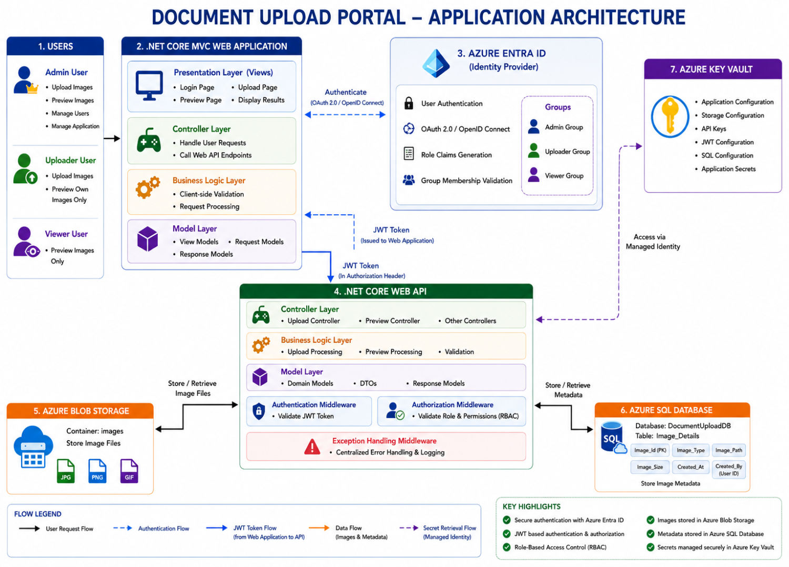
Figure 1 is a diagram of the application architecture with a brief description to set the larger context.

DEPLOYMENT DESIGN ARCHITECTURE
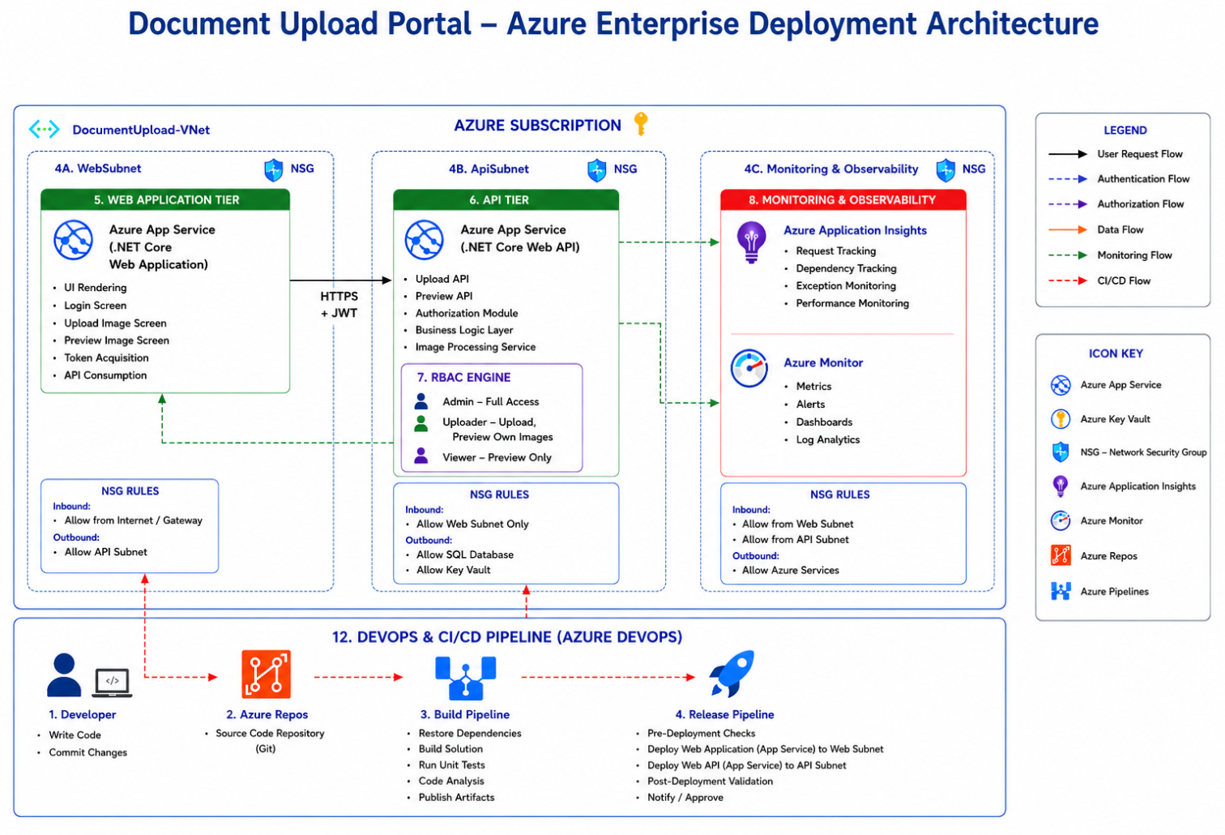

Deployment Architecture Diagram:
The Document Upload Portal is deployed on Azure using separate .NET Core Web App and .NET Core Web API services. Users access the Web UI over HTTPS to upload and preview images, while the Web API handles secured upload, preview, and metadata operations.
All API requests are protected using JWT authentication and RBAC authorization through the dedicated Azure Entra ID. Sensitive configurations such as SQL connection strings and JWT secrets are stored securely in Azure Key Vault.
Image metadata is stored in Azure SQL Server. The API retrieves both metadata and image files to return preview details to the Web UI.

HIGH LEVEL DESIGN ARCHITECTURE
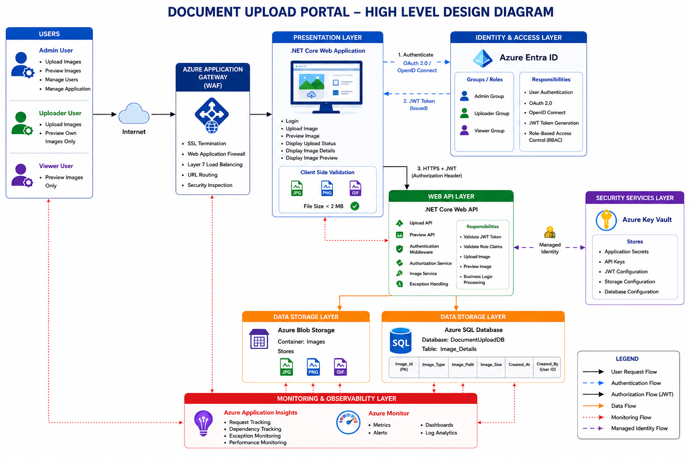

High Level Design:
The Document Upload Portal follows a layered Azure-based architecture with a .NET Core Web Application as the presentation layer and a .NET Core Web API as the backend API layer.
Users upload and preview images through the Web UI. The API validates and handles JWT authentication and RBAC for Admin/Uploader Roles. Secrets such as SQL connection strings, JWT secrets are securely stored in Azure Key Vault.
Images are stored in Azure BLOB Storage, while metadata such as image ID, type, size, path, and uploaded user details are stored in Azure SQL Server.

COMPONENTS DESIGN
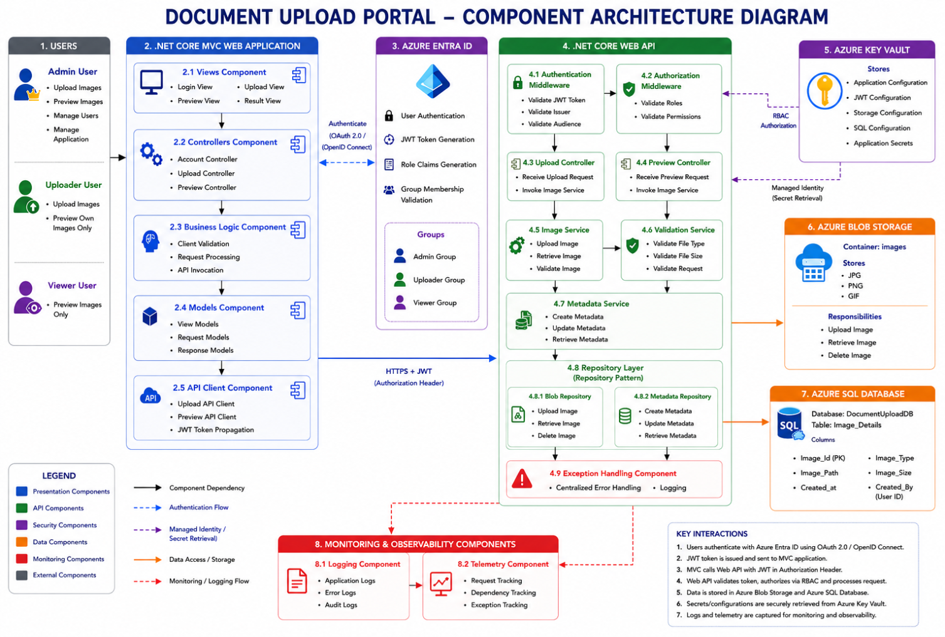

Component Design Architecture:
The Component Architecture Diagram illustrates the internal structure of the Document Upload Portal, highlighting the interaction between the .NET Core MVC Web Application, .NET Core Web API, security components, business services, repositories, and Azure platform services. The solution follows a layered monolithic architecture with clear separation of concerns, leveraging Azure Entra ID for authentication, RBAC for authorization, Repository Pattern for data access, Azure Blob Storage for image management, Azure SQL Database for metadata persistence, and Azure Key Vault for secure configuration management.

SERVER ROLES
Server Name | Server Role | Responsibility
Azure App Service (Web UI) | Presentation Layer Hosting | Hosts Web Application UI and handles user interaction
Azure App Service (Web API) | API/Application Layer Hosting | Hosts REST APIs and business services
Azure SQL Database | Data Layer | Stores image metadata and application data
Azure Key Vault | Security Layer | Stores secrets, API Keys, JWT secrets, and connection strings
Azure Monitor | Monitoring Layer | Infrastructure and application monitoring
Application Insights | Observability & Telemetry | API tracing, logging, and performance monitoring
AuthService | Authentication & Authorization | JWT validation, API Key validation, and RBAC enforcement
- Server Roles

SOFTWARE PRE-REQUISITES
- .Net 8
- ASP.NET Core Runtime
- Visual Studio 2022
- Azure SQL DB
- Swagger
- Postman
- Git
- Docker (optional)

EXTERNAL REFERENCES
- Azure documentation
- JWT documentation
- ASP.NET Core documentation
- Swagger/OpenAPI docs
- Internal API specifications
- HLD reference document

COMPONENT AND CONFIGURATION DETAILS
- Azure App Service configuration
- Azure SQL configuration
- Azure Key Vault configuration
- JWT configuration
- Logging configuration
- File storage configuration
- IIS/Kestrel configuration

ADDITIONAL DESIGN COMPONENTS

CLASS DIAGRAM
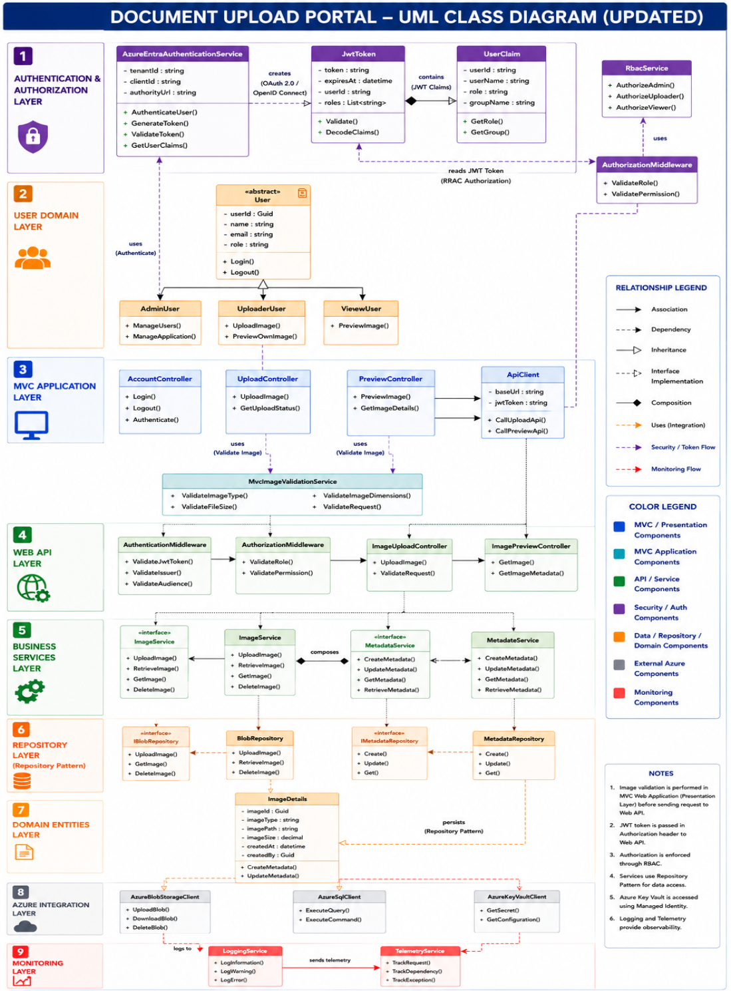

Class Diagram:
The Class Diagram provides a detailed object-oriented view of the Document Upload Portal application, illustrating the relationships between controllers, services, repositories, domain entities, authentication components, and Azure integration services. The solution follows a layered architecture and repository pattern, where the .NET Core MVC application interacts with the .NET Core Web API through an API Client using JWT-based authentication from Azure Entra ID. Business services encapsulate application logic, repositories abstract data access, and domain entities represent core business objects. Azure Blob Storage stores image files, Azure SQL Database stores image metadata, and Azure Key Vault securely manages application secrets through Managed Identity. The design adheres to SOLID principles, promotes separation of concerns, improves maintainability and testability, and provides a scalable foundation for enterprise-grade application development.

E-R DIAGRAM
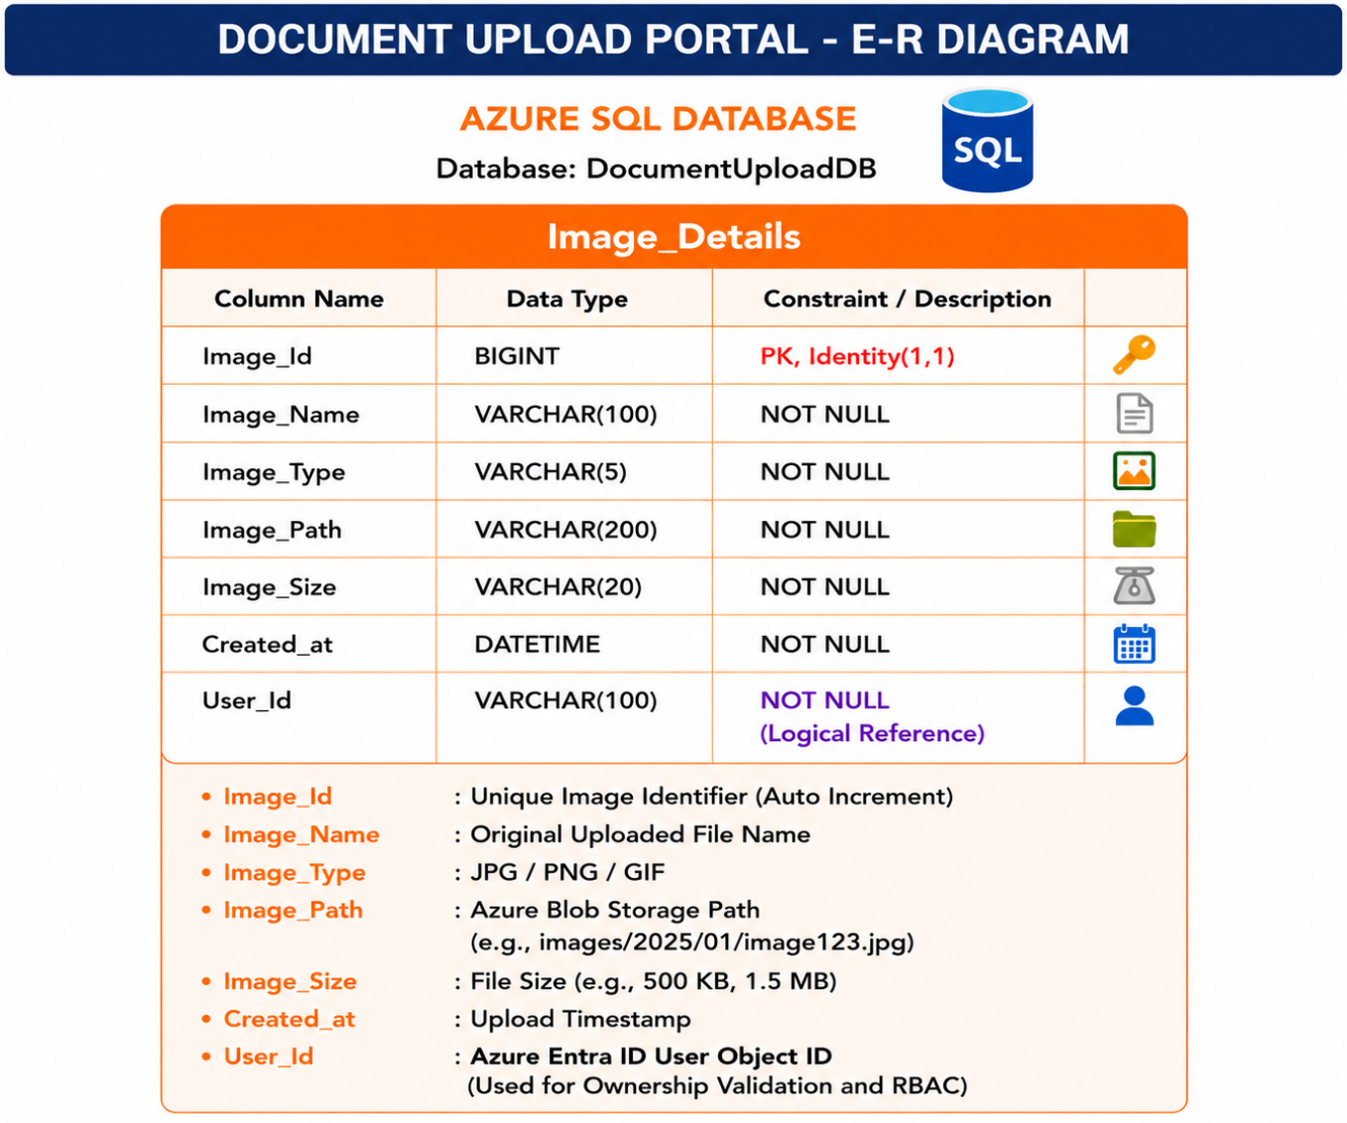

The Entity Relationship Diagram (ERD) illustrates the database design for the Document Upload Portal, where Azure Entra ID manages user authentication, authorization, roles, and group memberships, while Azure SQL Database stores only image metadata. The core entity, Image_Details, captures information such as image name, type, storage path, size, upload timestamp, and the Azure Entra ID User_Id of the uploader. Physical image files are stored in Azure Blob Storage, and the Image_Path column provides the logical reference to the stored file. The User_Id serves as a logical ownership reference, enabling Role-Based Access Control (RBAC) and image-level authorization without storing user data in the database. This simplified, cloud-native design ensures scalability, security, minimal data redundancy, and seamless integration with Azure identity and storage services.

DETAILED DESIGN – PHYSICAL

RACK ELEVATION DIAGRAM
The following section provides the rack elevation of compute x86, Storage, Network and Backup.
The Azure Network Diagram illustrates a secure and enterprise-grade cloud network architecture for the Document Upload Portal solution. The design uses Azure Virtual Network segmentation with dedicated subnets for Web, API, Security, and Private Endpoint layers to ensure network isolation and controlled communication flow. Network Security Groups (NSGs) enforce inbound and outbound access restrictions. The architecture also incorporates Azure Front Door (WAF), JWT-based security, monitoring services, and CI/CD integration to provide a scalable, secure, and production-ready deployment model.

DETAILED DESIGN – SYSTEM INTEGRATION MODEL

SYSTEM INTEGRATION DETAILS
- UI (.NET Core MVC Web Application) ↔ Web API (.NET Core Web API)
- Web API ↔ Azure SQL Database (Image Metadata)
- Web API ↔ Azure Blob Storage (Image Files)
- Web API ↔ Azure Key Vault (Secrets & Configuration)
- Web API ↔ Azure Entra ID (Token Validation)
- Web API ↔ Azure Monitor & Application Insights
- Managed Identity Integration for Azure Services
- HTTPS & JWT-based Secure Communication

- DATABASE
- Azure SQL Database (DocumentUploadDB)
- Database Schema Overview
- Image_Details Table Structure
- Primary Key & Indexing Strategy
- User Ownership Model (User_Id from Azure Entra ID)
- Logical Relationships
- Data Retention Strategy
- Metadata Storage Design
- Query & Performance Optimization

- BACKUP REQUIREMENTS & DISASTER RECOVERY
- Azure SQL Automated Backups
- Point-in-Time Restore (PITR)
- Azure Blob Storage Redundancy (LRS/GRS)
- Soft Delete & Blob Versioning
- Backup Retention Policies
- Disaster Recovery Strategy
- Recovery Point Objective (RPO)
- Recovery Time Objective (RTO)

- FILE SECURITY & ANTI-MALWARE SCANNING
- File Type Validation (JPG, PNG, GIF)
- File Size Validation (< 2 MB)
- Malware/Virus Scanning Strategy
- Microsoft Defender for Storage Integration
- Quarantine & Rejection Process
- Secure File Upload Controls
- Content Validation & Sanitization

- MONITORING
- Azure Monitor
- Azure Application Insights
- Log Analytics Workspace
- API Performance Metrics
- Request & Dependency Tracking
- Exception Monitoring
- Availability & Health Checks
- Alert Rules & Notifications
- Dashboard & Reporting
- SLA Monitoring

- LOGGING & AUDITING
- Structured Logging
- Application Logging
- Error & Exception Logging
- Audit Logging
- Security Logging
- Authentication & Authorization Logs
- User Activity Tracking
- Correlation ID Tracking
- Centralized Log Management
- Log Retention Policies

- SERVICE ACCOUNTS
- App Service Managed Identity
- SQL service account
- Deployment service account

- SYSTEM ADMINISTRATION
- Deployment management
- Monitoring administration
- Log management
- Role management

- CAPACITY AND SCALABILITY MANAGEMENT
- Auto-scaling
- Storage growth strategy
- Database scaling
- Concurrent user handling

DOCUMENTS REFERENCED
- HLD document
- API Specification
- Security Architecture
- Azure deployment guide
- Sequence diagrams
- Component diagrams
- Class diagrams

