Version No: 1.0

 | Prepared By / Last Updated By | Reviewed By | Approved By
Name | Shashi Shekhar
Role
Signature | Shashi Shekhar
Date | 24th May, 2026

.>

Table of Contents
1.0 Introduction 3
1.1 Purpose of this document 3
1.2 Scope 3
1.3 Out of scope 3
1.4 Intended Audience 3
1.5 Acronyms 3
2.0 System Architecture 3
2.1 Architectural Views 3
2.1.1 Functional View 4
2.1.2 Conceptual View 6
2.1.3 Logical View 7
2.1.4 Functional Architecture View 9
2.1.5 Technology View 11
2.1.6 Integration View 14
2.1.7 Implementation View 15
2.1.8 Data View 17
2.1.9 Deployment View 17
2.1.10 Security View 22
2.1.11 Process View 24
2.2 System Interfaces 24
2.3 Reporting 25
3.0 Prototype Design 25
3.1.1 Wireframe/ Visual Design 25
4.0 Technology, Tools and Frameworks 26
5.0 Solution Recommendations 26
5.1 Technical recommendations 26
5.2 Infrastructure recommendations 26
6.0 Reference 26
7.0 Change Log 27

- Introduction
  - Purpose of this document
Document High level Design and Architecture for Document Upload Portal.
  - Scope
This HLD & Architecture Document is designed for green field applications, This document is technical in nature and includes
- System architecture views depicting component layers, technology involved, integration, deployment, security, recoverability views for Document Upload Portal.
- UI/Wireframe design if not covered by the BRD.
- Image upload
- Image preview
- JWT authentication
- RBAC authorization
- Logging and monitoring
- API documentation via Swagger
- Azure deployment

  - Out of scope
- Metadata storage in Azure SQL
- Image Storage in Azure BLOB Storage

  - Intended Audience
Internal Technical teams, Architects, Developers, IT Security, DelEx.
  - Acronyms
S. No | Acronym | Expansion
1 | BRD | Business Requirements Document
2 | DelEx | Delivery Excellence
3 | RBAC | Role Based Access Control
4 | JWT | JSON Web Token
- System Architecture
  - Architectural Views
The architecture of a system can be depicted in multiple views that makes it easy to understand from a specific perspective. Design team is free to decide and merge views as applicable to simplify diagram creation. For vendor/3rd party products some of the views may be available as part of vendor provided docs and must be explored for reuse/reference here. The following architectural views are highly suitable for the Document Upload Portal Use Case:
    - Functional View
      - Key Business Processes
- Image upload workflow
- Image validation
- Metadata persistence
- Image retrieval flow
      - Architecturally Significant Use Cases/Functional Requirements
This section identifies the critical business use cases and functional requirements that have a direct impact on the overall architecture design of the Document Upload Portal. It focuses on the core functional scenarios such as secure image upload, image validation, metadata persistence, authentication, authorization, and image retrieval, which significantly influence architectural decisions related to security, scalability, performance, maintainability, storage strategy, and cloud deployment. The section also captures key non-functional requirements including availability, reliability, monitoring, logging, disaster recovery, and secure communication that drive the selection of Azure services, layered architecture, JWT security model, and modular processing design. The identified use cases and requirements collectively justify and validate the proposed architecture as sufficient, scalable, secure, and aligned with enterprise solution design principles.

      - Functional Modules
The Document Upload Portal provides a secure platform for users to upload, manage, and preview image documents. The system leverages Azure Entra ID for authentication and authorization, Azure Blob Storage for image storage, and Azure SQL Database for metadata management. The functional decomposition below provides a hierarchical view of the system capabilities and business processes.Level 0 represents the overall system context diagram, showing the Document Upload Portal as a single enterprise system interacting with external actors such as Users, Azure Services, Storage, and Database systems. It highlights the primary inputs, outputs, and high-level business services like image upload, preview, authentication, and retrieval.
- Level 0 – System Context
The Document Upload Portal is a centralized application that enables authenticated users to upload, store, and preview image files securely. Users access the system through a web application, authenticate using Azure Entra ID, and perform actions based on their assigned roles (Admin, Uploader, or Viewer). The system stores image files in Azure Blob Storage and maintains image metadata in Azure SQL Database.
- Primary Inputs
- User Login Request
- Image Upload Request
- Image Preview Request
- Primary Outputs
- Authentication Result
- Upload Status
- Image Preview
- Image Metadata Information

- Level 1 Major Functional Modules
The system is divided into the following major functional modules:
1. User Authentication & Authorization
Responsible for authenticating users through Azure Entra ID and enforcing role-based access control (RBAC).
2. Image Upload Management
Responsible for validating and uploading image files to Azure Blob Storage and storing image metadata in Azure SQL Database.
3. Image Preview Management
Responsible for retrieving image metadata and image files and displaying previews to authorized users.
4. Metadata Management
Responsible for creating, storing, retrieving, and managing image-related metadata.
5. Monitoring & Auditing
Responsible for tracking application activities, logging errors, monitoring performance, and maintaining audit trails.

- Level 2 Functional Decomposition
1. User Authentication & Authorization
1.1 User Authentication
    - User login using Azure Entra ID
    - JWT token generation
1.2 Role-Based Authorization
    - Validate Admin role
    - Validate Uploader role
    - Validate Viewer role
    - Enforce access permissions
2. Image Upload Management
2.1 Image Validation
    - Validate supported file types (JPG, PNG, GIF)
    - Validate file size limits
    - Validate upload request
2.2 Image Storage
    - Generate unique file name
    - Upload image to Azure Blob Storage
    - Return upload confirmation
2.3 Metadata Creation
    - Create image metadata
    - Associate image with User_Id
    - Store metadata in Azure SQL Database
3. Image Preview Management
3.1 Image Search & Retrieval
    - Retrieve image metadata
    - Retrieve image file from Blob Storage
3.2 Access Validation
    - Validate user permissions
    - Validate image ownership where applicable
3.3 Image Preview
    - Generate image preview
    - Return image preview response
4. Metadata Management
4.1 Metadata Storage
    - Save image metadata
    - Update metadata if required
4.2 Metadata Retrieval
    - Retrieve image details
    - Retrieve ownership information
5. Monitoring & Auditing
5.1 Application Monitoring
    - Request tracking
    - Performance monitoring
    - Dependency monitoring
5.2 Logging & Auditing
    - Error logging
    - Security logging
    - User activity auditing
    - Upload and preview activity tracking

- Level 3 Example Detailed Decomposition (Image Upload Management)
1.1 Image Validation
    - Validate file extension
    - Validate MIME type
    - Validate file size
    - Scan request integrity
1.2 Image Storage
    - Generate unique identifier
    - Upload file to Blob Storage
    - Verify upload completion
1.3 Metadata Creation
    - Create Image_Id
    - Store image path
    - Store image type
    - Store image size
    - Store upload timestamp
    - Store User_Id

Based on the scope and complexity of the Document Upload Portal, the architecture design is primarily focused on Level 0, Level 1, and Level 2 decomposition, while selected critical workflows are elaborated in Level 3 through Sequence Diagrams and processing flow representations.

    - Conceptual View
The Document Upload Portal is a secure web-based application that enables authorized users to upload, store, and preview image files. The system integrates with Azure Entra ID for identity and access management, Azure Blob Storage for image storage, and Azure SQL Database for image metadata management. The conceptual view provides a high-level understanding of the key actors interacting with the system and the major components that collectively deliver the required business functionality.
      - Actors

Admin User
The Admin User is responsible for managing the application and has full access to upload, preview, and manage image-related activities. Admin users can view all images available within the system.

Uploader User
The Uploader User is responsible for uploading image files and previewing images that they have uploaded. Access is restricted to their own image records based on role-based access control policies.

Viewer User
The Viewer User can preview images based on the permissions assigned to them. They do not have image upload capabilities.

Azure Entra ID
Azure Entra ID acts as the external identity provider responsible for user authentication, role management, group membership validation, and JWT token generation.

Azure Blob Storage
Azure Blob Storage acts as the external file storage service responsible for storing and retrieving image files uploaded through the application.

Azure SQL Database
Azure SQL Database acts as the metadata repository responsible for storing image information such as image type, storage path, file size, upload timestamp, and ownership details.

      - System Components

Web Application
The Web Application provides the user interface for authentication, image upload, image preview, and image management activities. It serves as the primary interaction point for all users.

Authentication & Authorization Service
This component integrates with Azure Entra ID to authenticate users and enforce role-based access control (RBAC) based on user roles and group memberships.

Image Management Service
The Image Management Service processes image upload and preview requests, validates image information, and coordinates interactions with storage and metadata services.

Metadata Management Component
This component manages image metadata operations, including creation, retrieval, and maintenance of image-related information stored in Azure SQL Database.

File Storage Component
The File Storage Component stores and retrieves image files from Azure Blob Storage while maintaining references to the associated metadata records.

Monitoring & Logging Component
This component captures application logs, audit events, performance metrics, and operational telemetry to support monitoring, troubleshooting, and compliance requirements.

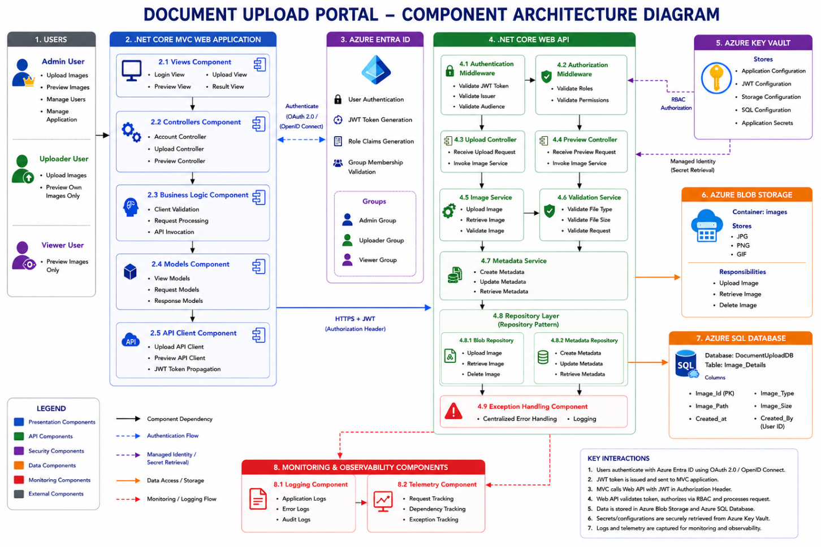

    - Logical View

The Document Upload Portal follows a layered architecture pattern that separates presentation, business processing, integration, and persistence responsibilities. Users interact with the system through a web-based user interface, where authentication and authorization are performed using Azure Entra ID. The Presentation Layer communicates with the Application Services Layer through secure API calls protected by JWT tokens. The Services Layer processes image upload and preview requests, applies business rules, validates user permissions, and orchestrates interactions with external services.

The Persistence Layer stores image metadata in Azure SQL Database, while image files are stored in Azure Blob Storage. External integrations include Azure Entra ID for identity management and Azure Key Vault for secure configuration and secret management. Cross-cutting services such as Security, Logging, Monitoring, Availability, Scalability, and Performance Management span all layers to ensure the solution remains secure, observable, reliable, and scalable. This logical separation of responsibilities improves maintainability, extensibility, and alignment with enterprise architecture best practices.
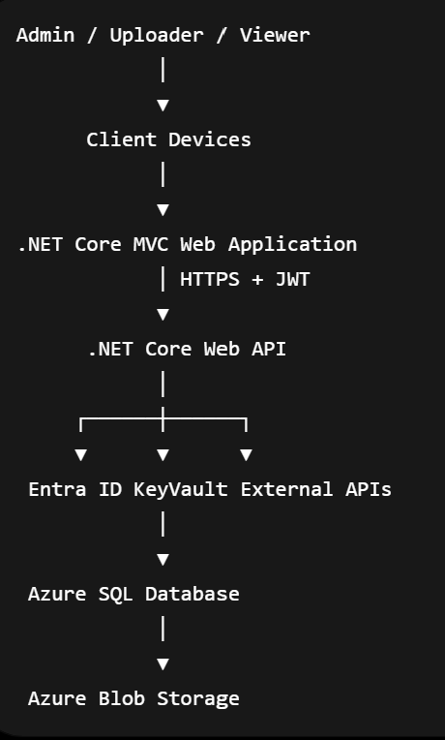

    - Functional Architecture View
Functional Architecture Diagram illustrates the major business capabilities and functional flow of the Document Upload Portal. Users authenticate through Azure Entra ID, interact with the ASP.NET Core MVC application, and perform image upload and preview operations through secured Web APIs. The solution leverages Azure Blob Storage for file storage, Azure SQL Database for metadata management, Azure Key Vault for secret management, and Azure Monitor/Application Insights for monitoring and observability, providing a secure, scalable, and cloud-native architecture.
Functional Flow (for presentation)
- User accesses the MVC Web Application.
- User authenticates through Azure Entra ID.
- Azure Entra ID issues a JWT token with role claims.
- MVC application calls Web API using HTTPS and JWT.
- Authentication and Authorization middleware validate the token.
- RBAC Engine validates user permissions.
- Image Service processes upload or preview requests.
- Azure Key Vault provides secure configuration and secrets.
- Blob Repository stores image files in Azure Blob Storage.
- Metadata Repository stores image metadata in Azure SQL Database.
- Application Insights and Azure Monitor capture logs, metrics, and telemetry.
    - Technology View

The Technology View section describes the technology platforms, frameworks, infrastructure services, third-party tools, and integration components used across each architectural layer of the Document Upload Portal solution. This section maps the logical architecture components to their corresponding implementation technologies, helping stakeholders understand the technical foundation of the system. It typically includes details about the Presentation Layer, API Layer, Business Services, Database Layer, Storage Layer, Security Services, Monitoring Tools, Logging Mechanisms, Deployment Platforms, and external integrations along with their versions, protocols, authentication mechanisms, and deployment considerations.

For the Document Upload Portal, the Technology View includes technologies such as ASP.NET Core Web Application for the Presentation Layer, ASP.NET Core Web API for Service Layer implementation, Azure SQL Database for metadata persistence, Azure Key Vault for secure secret management, Azure BLOB Storage for image storage, Azure Monitor and Application Insights for monitoring and telemetry, Docker for containerization, and Azure DevOps for CI/CD automation. This section also highlights cross-cutting technologies related to Security, Logging, Monitoring, Availability, Scalability, and Caching that support enterprise-grade operational capabilities.
Component Name | Technology | Version/Comments
Presentation Layer | ASP.NET Core MVC Web Application | .Net 8
API layer | ASP.NET Core REST Web API | .Net 8
Authentication Service | JWT Authentication + RBAC | Token-Based Security
Business Layer | C# Service Classes | Modular Service Architecture
Validation Service | Custom Validation Framework | File Validation Logic
Preview Service | Image Preview Generator | Preview Generation
Storage Layer | Azure BLOB Storage | Secure Storage System
Secret Management | Azure Key Vault | Managed Identity (MSI)
Monitoring | Azure Monitor
  Infrastructure Monitoring
Logging Framework | Serilog / ILogger | Centralized Logging

Security
The Document Upload Portal relies on enterprise-grade Azure security services and platform-level security controls to ensure secure communication, authentication, authorization, and secret management. The application implements JWT-based authentication, Role-Based Access Control (RBAC), HTTPS encryption, and Azure Key Vault integration for secure storage of secrets, connection strings, and application credentials.

Logging
The solution uses centralized logging mechanisms through Serilog, ILogger, Azure Monitor, and Application Insights to capture application logs, audit events, exception traces, and operational activities for troubleshooting, auditing, and production support.

Monitoring
Azure Monitor and Application Insights are used for real-time application monitoring, telemetry tracking, health checks, performance analysis, infrastructure monitoring, and automated alert generation for proactive operational management.

Availability
The application is hosted on Azure App Services with scalable and highly available cloud infrastructure. Azure SQL Database, monitoring services, and backup mechanisms ensure enterprise-grade availability and resiliency.

Scalability
The solution supports horizontal and vertical scalability using Azure App Services, stateless REST APIs, and modular business services to handle increasing workloads and future expansion.

Caching
Optional Redis Cache integration can be implemented to improve application performance, reduce repeated database calls, optimize API response times, and enhance overall system scalability.

    - Integration View
The Document Upload Portal integrates with several Azure services to support authentication, secure configuration management, file storage, metadata persistence, monitoring, and deployment automation. User authentication and authorization are performed through Azure Entra ID using OAuth 2.0 and OpenID Connect protocols, where JWT tokens are issued and validated by the application. The Web API securely retrieves application secrets and configuration settings from Azure Key Vault using Managed Identity. Uploaded image files are stored in Azure Blob Storage, while image metadata such as file name, type, size, upload timestamp, and user ownership information are stored in Azure SQL Database. Monitoring and operational telemetry are integrated with Azure Application Insights and Azure Monitor for logging, diagnostics, alerting, and performance tracking. Continuous Integration and Continuous Deployment (CI/CD) are implemented through Azure DevOps pipelines, which automate application build, testing, and deployment processes. All integrations use secure HTTPS communication and Azure-native authentication mechanisms, ensuring secure, scalable, and maintainable system operations.

Internal Integration
This section explains integrations within the enterprise ecosystem, including:
- MVC Web Application ↔ Web API
- Web API ↔ Azure SQL Database
- Web API ↔ Azure Blob Storage
- Web API ↔ Azure Key Vault
- Web API ↔ Azure Monitor / Application Insights
- Azure DevOps ↔ Azure App Services

External Integration
This section describes integrations with external or third-party services such as:
- Authentication Providers
- Monitoring & Alerting Platforms
- Backup & Recovery Services
- Future external enterprise integrations (ERP/CRM)

    - Implementation View

The Implementation View describes the internal implementation structure of the Document Upload Portal, including application layers, technology stack, component responsibilities, integration mechanisms, and supporting platform services. It provides a detailed view of how the solution is developed, deployed, integrated, secured, and managed within the Azure cloud environment.Layer-wise Explanation

Presentation Layer
The Presentation Layer provides the user interface for Admin, Uploader, and Viewer users. It authenticates users through Azure Entra ID, acquires JWT tokens, performs client-side validations, and communicates with the backend Web API over HTTPS.

Services Façade Layer
The Services Façade acts as the API gateway of the application. It exposes RESTful endpoints consumed by the MVC application and forwards requests to the appropriate business services.

Business Components
This layer contains the core business logic of the Document Upload Portal. It enforces business rules, validates uploaded files, processes image metadata, and implements role-based access control.

Data Access Layer
The Data Access Layer abstracts storage technologies from the business layer. Repository implementations provide a clean interface for interacting with Azure Blob Storage and Azure SQL Database.

Core Services
Core Services provide foundational capabilities shared across the application, including authentication, authorization, configuration management, and request validation.

Management Services
Management Services provide operational visibility into application health, performance, usage patterns, and failures. They support troubleshooting, diagnostics, and proactive monitoring.

Integration Adapters
Integration Adapters isolate external system dependencies from business logic and provide a consistent mechanism for interacting with Azure platform services.

Storage / External Services
This layer includes Azure SQL Database for metadata persistence, Azure BLOB Storage for physical image storage, Azure Key Vault for secure secret management, Azure Backup services, and monitoring/notification platforms used for operational support and disaster recovery.

    - Deployment View
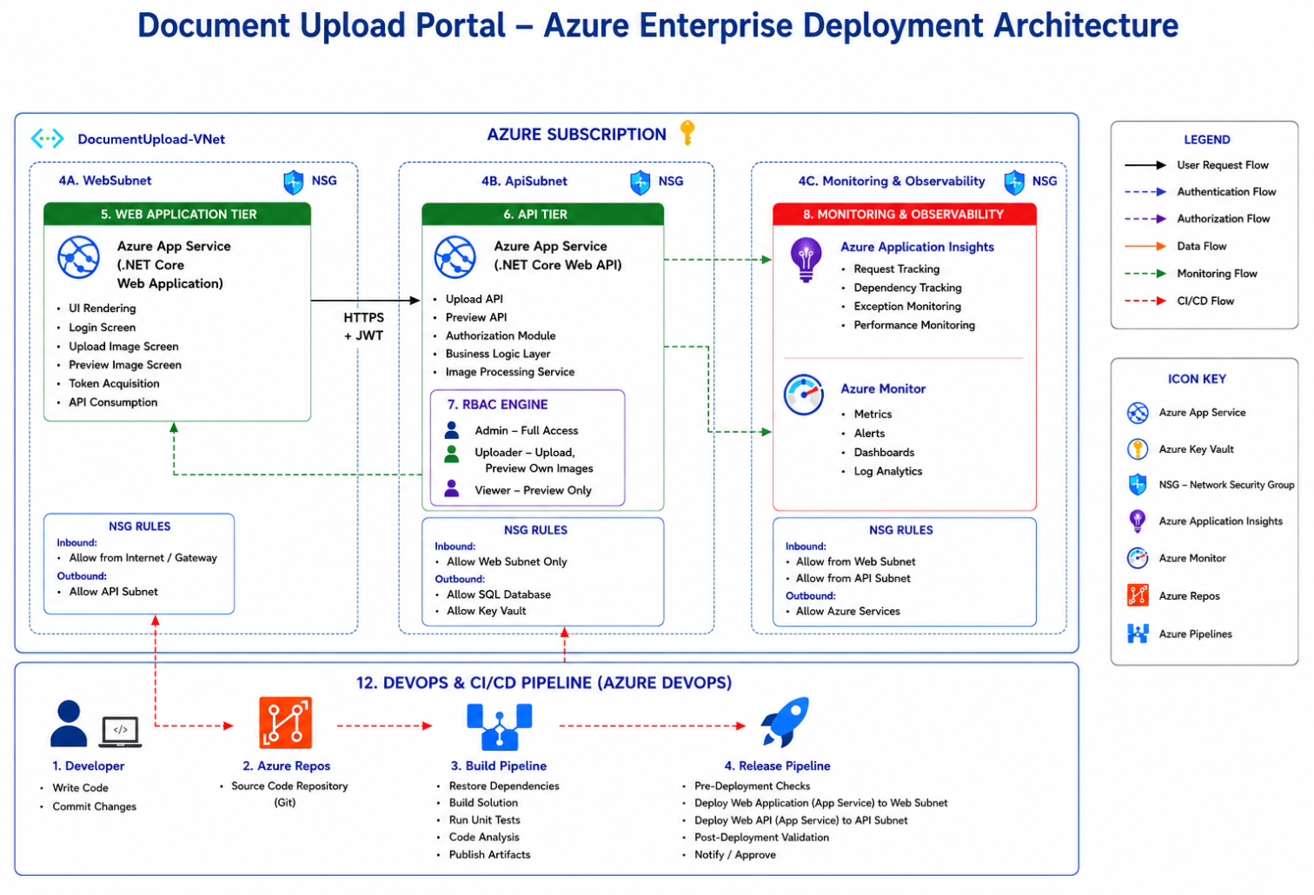

The Document Upload Portal is deployed on Microsoft Azure using a secure and scalable architecture with dedicated Web and API tiers hosted on Azure App Services within a segmented Virtual Network. Network Security Groups (NSGs) control traffic between application layers, while Azure Application Insights and Azure Monitor provide centralized monitoring, diagnostics, and operational visibility. The solution leverages Azure DevOps CI/CD pipelines for automated build, testing, and deployment, enabling reliable, repeatable, and efficient software delivery across environments.
This deployment architecture follows Azure Well-Architected Framework principles by combining Azure Entra ID for identity management, Application Gateway with WAF for edge security, VNet and NSG-based network segmentation, Azure App Services for application hosting, Managed Identity for secure resource access, Azure Blob Storage and Azure SQL Database for data persistence, Azure Key Vault for secret management, and Azure Monitor/Application Insights for enterprise-grade observability, resulting in a secure, scalable, and production-ready Azure solution.

      - Logical Infrastructure
The Logical Infrastructure Diagram illustrates the logical Azure services and infrastructure capabilities supporting the Document Upload Portal. It depicts user access through Azure Application Gateway, authentication via Azure Entra ID, application hosting using ASP.NET Core MVC and Web API, secure secret management through Azure Key Vault using Managed Identity, image storage in Azure Blob Storage, metadata persistence in Azure SQL Database, centralized monitoring through Application Insights and Azure Monitor, and automated deployments through Azure DevOps. The diagram focuses on logical service interactions and security boundaries while abstracting physical deployment details.
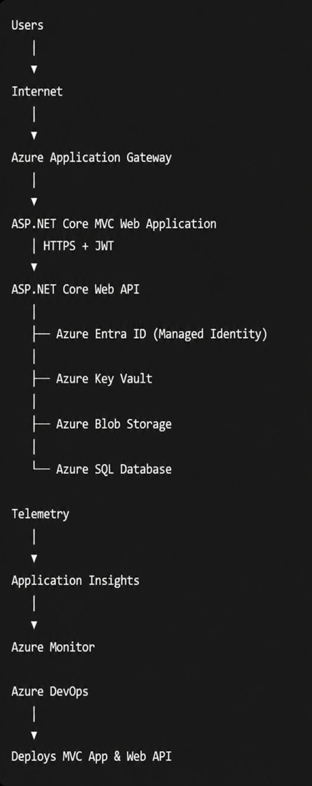

      - Physical Infrastructure

The Physical Infrastructure View section extends the Logical Infrastructure architecture into a more detailed representational deployment model by illustrating the actual physical and cloud infrastructure components used to host and run the Document Upload Portal solution. This section highlights the infrastructure tiers, network boundaries, security zones, load balancing components, proxy services, application hosting environments, database infrastructure, storage systems, clustered services, and firewall/security controls deployed across the solution landscape. The objective of this section is to provide a deployment-oriented infrastructure representation that demonstrates how the application is physically distributed, secured, scaled, and connected within the Microsoft Azure cloud environment and enterprise network ecosystem.

The Physical Infrastructure Diagram illustrates the Azure-hosted infrastructure supporting the Document Upload Portal application. The solution is deployed within a secure Azure Virtual Network (VNet) and is logically separated into Web, API, Security, Data, and Monitoring layers. Users access the application through the Web Application tier, which securely communicates with the API tier using HTTPS and JWT-based authentication. Azure Entra ID provides identity and access management, while Azure Key Vault securely manages application secrets and configuration. Image files are stored in Azure Blob Storage, and metadata is persisted in Azure SQL Database. Monitoring, logging, telemetry, backup, and CI/CD capabilities are provided through Azure Monitor, Application Insights, Azure Backup, and Azure DevOps, ensuring security, scalability, high availability, and operational excellence.

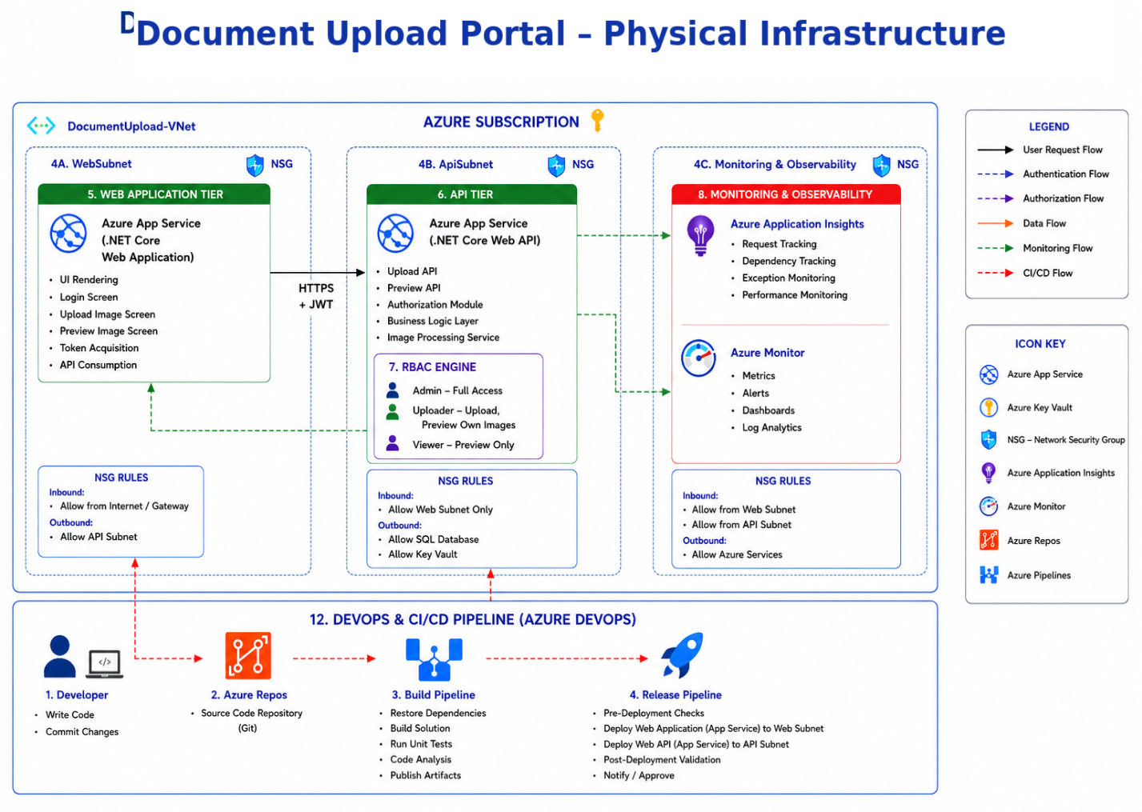

Security View

The Security View section describes how security controls, protection mechanisms, and governance policies are integrated into the overall architecture and application design of the Document Upload Portal from the initial design stage itself. The purpose of this section is to demonstrate that security is embedded across all architectural layers and is not treated as a post-development activity. This section explains how the application ensures secure authentication, authorization, communication, data protection, secret management, monitoring, auditing, and secure deployment practices throughout the application lifecycle.

For the Document Upload Portal, the Security View includes JWT-based authentication, Role-Based Access Control (RBAC), API Key validation, HTTPS/TLS encrypted communication, Azure Key Vault integration for secure secrets management, Network Security Groups (NSGs), Azure Front Door with WAF protection, secure API access controls, audit logging, centralized monitoring, and compliance tracking. The section also highlights secure CI/CD deployment using Azure DevOps, environment isolation, private endpoints, firewall rules, vulnerability scanning, and monitoring integrations through Azure Monitor and Application Insights. This view ensures that the solution follows enterprise-grade security principles including Defense-in-Depth, Least Privilege Access, Secure Configuration Management, and Zero Trust Architecture across all deployment environments.
      - Secure Design Considerations
The Security Design Consideration section describes the security principles, controls, standards, and architectural decisions implemented within the Document Upload Portal to ensure secure application design, secure communication, data protection, user accountability, and compliance with enterprise security standards. This section demonstrates how security is embedded across all layers of the application lifecycle including authentication, authorization, input validation, encryption, integrations, session management, auditing, infrastructure security, and privacy protection. The objective of this section is to ensure that the application follows Security-by-Design and Privacy-by-Design principles while minimizing security risks, preventing unauthorized access, protecting sensitive data, and maintaining regulatory compliance.

Authentication Design
The application implements strong authentication mechanisms using JWT-based authentication integrated with secure login workflows and optional Multi-Factor Authentication (MFA) for privileged administrative users. Authentication tokens are securely generated, validated, and expired using industry-standard security practices. All authentication communication is protected using HTTPS/TLS encryption.

Access Privilege and Authorization Design
The solution follows Role-Based Access Control (RBAC) and Least Privilege principles to ensure users receive only the minimum permissions required to perform authorized operations. Segregation of Duties (SoD) is enforced between End Users, Administrators, and Support Teams. Role and permission metadata are securely stored and protected against tampering using signed JWT tokens and secured database controls.

Input / Data Validation
The application validates all user inputs, uploaded files, API payloads, and request parameters before processing. Validation includes file type verification, file size restrictions, schema validation, sanitization, and business rule enforcement to prevent malicious input, injection attacks, and unauthorized content upload. All outputs are securely encoded before being rendered to end users.

Data Protection
Sensitive information including image metadata, credentials, API keys, and user details are protected across all data states including data-at-rest, data-in-transit, and data-in-use. HTTPS/TLS encryption is enforced for all communication channels, while Azure SQL Database encryption and secure storage mechanisms are used for persistent data protection.

Cryptography and Key Management
The solution uses secure cryptographic standards for token signing, secure hashing, API security, and encryption operations. Azure Key Vault is used for centralized key management, secure storage of secrets, connection strings, JWT signing keys, API keys, and certificate management using Managed Identity integration.

Accountability Design
Comprehensive audit logging, user activity tracking, API access logging, and operational event monitoring are implemented to maintain accountability across all user and system actions. Logs are centrally monitored using Azure Monitor, Application Insights, and Log Analytics for anomaly detection, security analysis, and compliance auditing.

Secure Integrations & Communication
All integrations between Web Application, APIs, Azure services, monitoring platforms, and external systems are secured using HTTPS/TLS encryption, REST APIs, secure tokens, API Key validation, private endpoints, and firewall controls. Secure communication standards are enforced across all inbound and outbound integrations.

Error Handling and Exception Design
The application follows the “Fail Securely” design principle by implementing centralized exception handling, secure error responses, input validation failures, and controlled logging mechanisms that prevent exposure of sensitive internal system information or stack traces to end users.

Session Management Design
Secure session management is implemented using JWT tokens with token expiration, refresh token strategies, secure cookie handling, inactivity timeout controls, and HTTPS-only session communication to prevent session hijacking, replay attacks, and unauthorized session reuse.

Security by Design
The solution incorporates security controls across Database, Network, Configuration, Application Server, and Deployment infrastructure layers. Security mechanisms include Azure Front Door with WAF, Network Security Groups (NSGs), Azure Key Vault, private endpoints, firewall rules, RBAC, secure configuration management, secure CI/CD pipelines, vulnerability scanning, and infrastructure isolation.

Privacy by Design
The application follows Privacy-by-Design principles by protecting sensitive and personally identifiable information (PII) using encryption, access control, audit trails, secure storage, and controlled data access policies. The architecture supports enterprise privacy standards, regulatory compliance requirements, and secure data lifecycle management practices.

