Scope and assets
Primary assets
- Customer Profile: Policy holder & dependent details (PII: name, DOB, phone, email, address).
- Policy Data: Applications, approval/rejection decisions, active policies, policy cover, premium.
- Claims Data: Claim submissions, statuses, reasons, approved amounts, cheque data.
- Credentials: Policy holder, agent, staff, admin accounts.
- Medical Documents (PHI): Age proofs, medical diagnostic reports, hospital bills.
Secondary assets
- Audit logs: Auth events, lock/unlock, application/claim state changes, cheque entries, document events.
- Configuration: Premium rules (age bands, discounts), rejection reasons, doc allowlist (types/size), rate limits.
- Reports: Operational dashboards, reconciliation/audit exports.
- Session tokens: JWTs/refresh tokens, signed URLs for documents.
- Installer/environment: .env, seed users, migrations, default security settings.
Users
- Policy holders (internet)
- Agents (internet)
- Company staff (intranet: underwriting, claims, finance)
- Administrators (intranet: IAM/config)
- Auditors (optional; read-only)
- Attackers (external)
- Malicious insiders

Trust boundaries
- Client ↔ Web server: Browser SPA to API Gateway/BFF over TLS.
- Web server ↔ App services: Auth, Policy, Claim, Document, Notification services over secure internal network (mTLS optional).
- Company portal (Intranet): Elevated access with stricter controls, IP allowlisting/network segmentation.
- Document storage: Encrypted object storage; access via time-limited signed URLs only.
- Batch jobs: Nightly archival, audit exports, config refresh; run as separate service accounts with least privilege.

Authentication and Login
User Registration / Provisioning
- Collect only necessary details (holder: name, email, phone, DOB; agent/staff: official email/role).
- Validate inputs server-side; never trust client-only validation.
- Store passwords using hashing with salt (bcrypt/Argon2).
- Policy holder credentials are issued after policy approval (activation link or temp password).
- Agents/Staff/Admin provisioned by Admin; intranet SSO (optional, future-ready).
Login
- Username + password as primary login for all roles.
- Step-up verification (optional) for sensitive actions (e.g., entering cheque details, approving high-value claims).
- After 3 failed attempts → lock account. Unlock only by Admin (intranet) with audit log.
Password Rules
- Minimum 10 characters, include letters, numbers, symbols.
- Prevent reuse of last 3 passwords.
- Forgot Password: secure reset link/SMS OTP, expires in 15 minutes, single-use.

Session Management
Session Tokens
- Internet portals: JWT access (≤ 15 min) + refresh token (≤ 7 days).
- Intranet: JWT or secure server-sessions (cookies).
Cookie & Security Flags
- Mark cookies Secure and HttpOnly.
- Use SameSite=Strict (or Lax where flows require).
- Enforce HTTPS and HSTS.
Session Timeout
- Auto logout after 15 minutes of inactivity.
- Absolute expiry after 8 hours even if active.
Session Renewal
- Regenerate session ID after login and after privilege elevation (e.g., entering Admin area).
- Invalidate access & refresh tokens on logout.
Concurrent Sessions
- Option to allow only one active session per user (stricter posture).
- Notify user on new device/location login.

Simple behavior for Login -> Session -> Logout
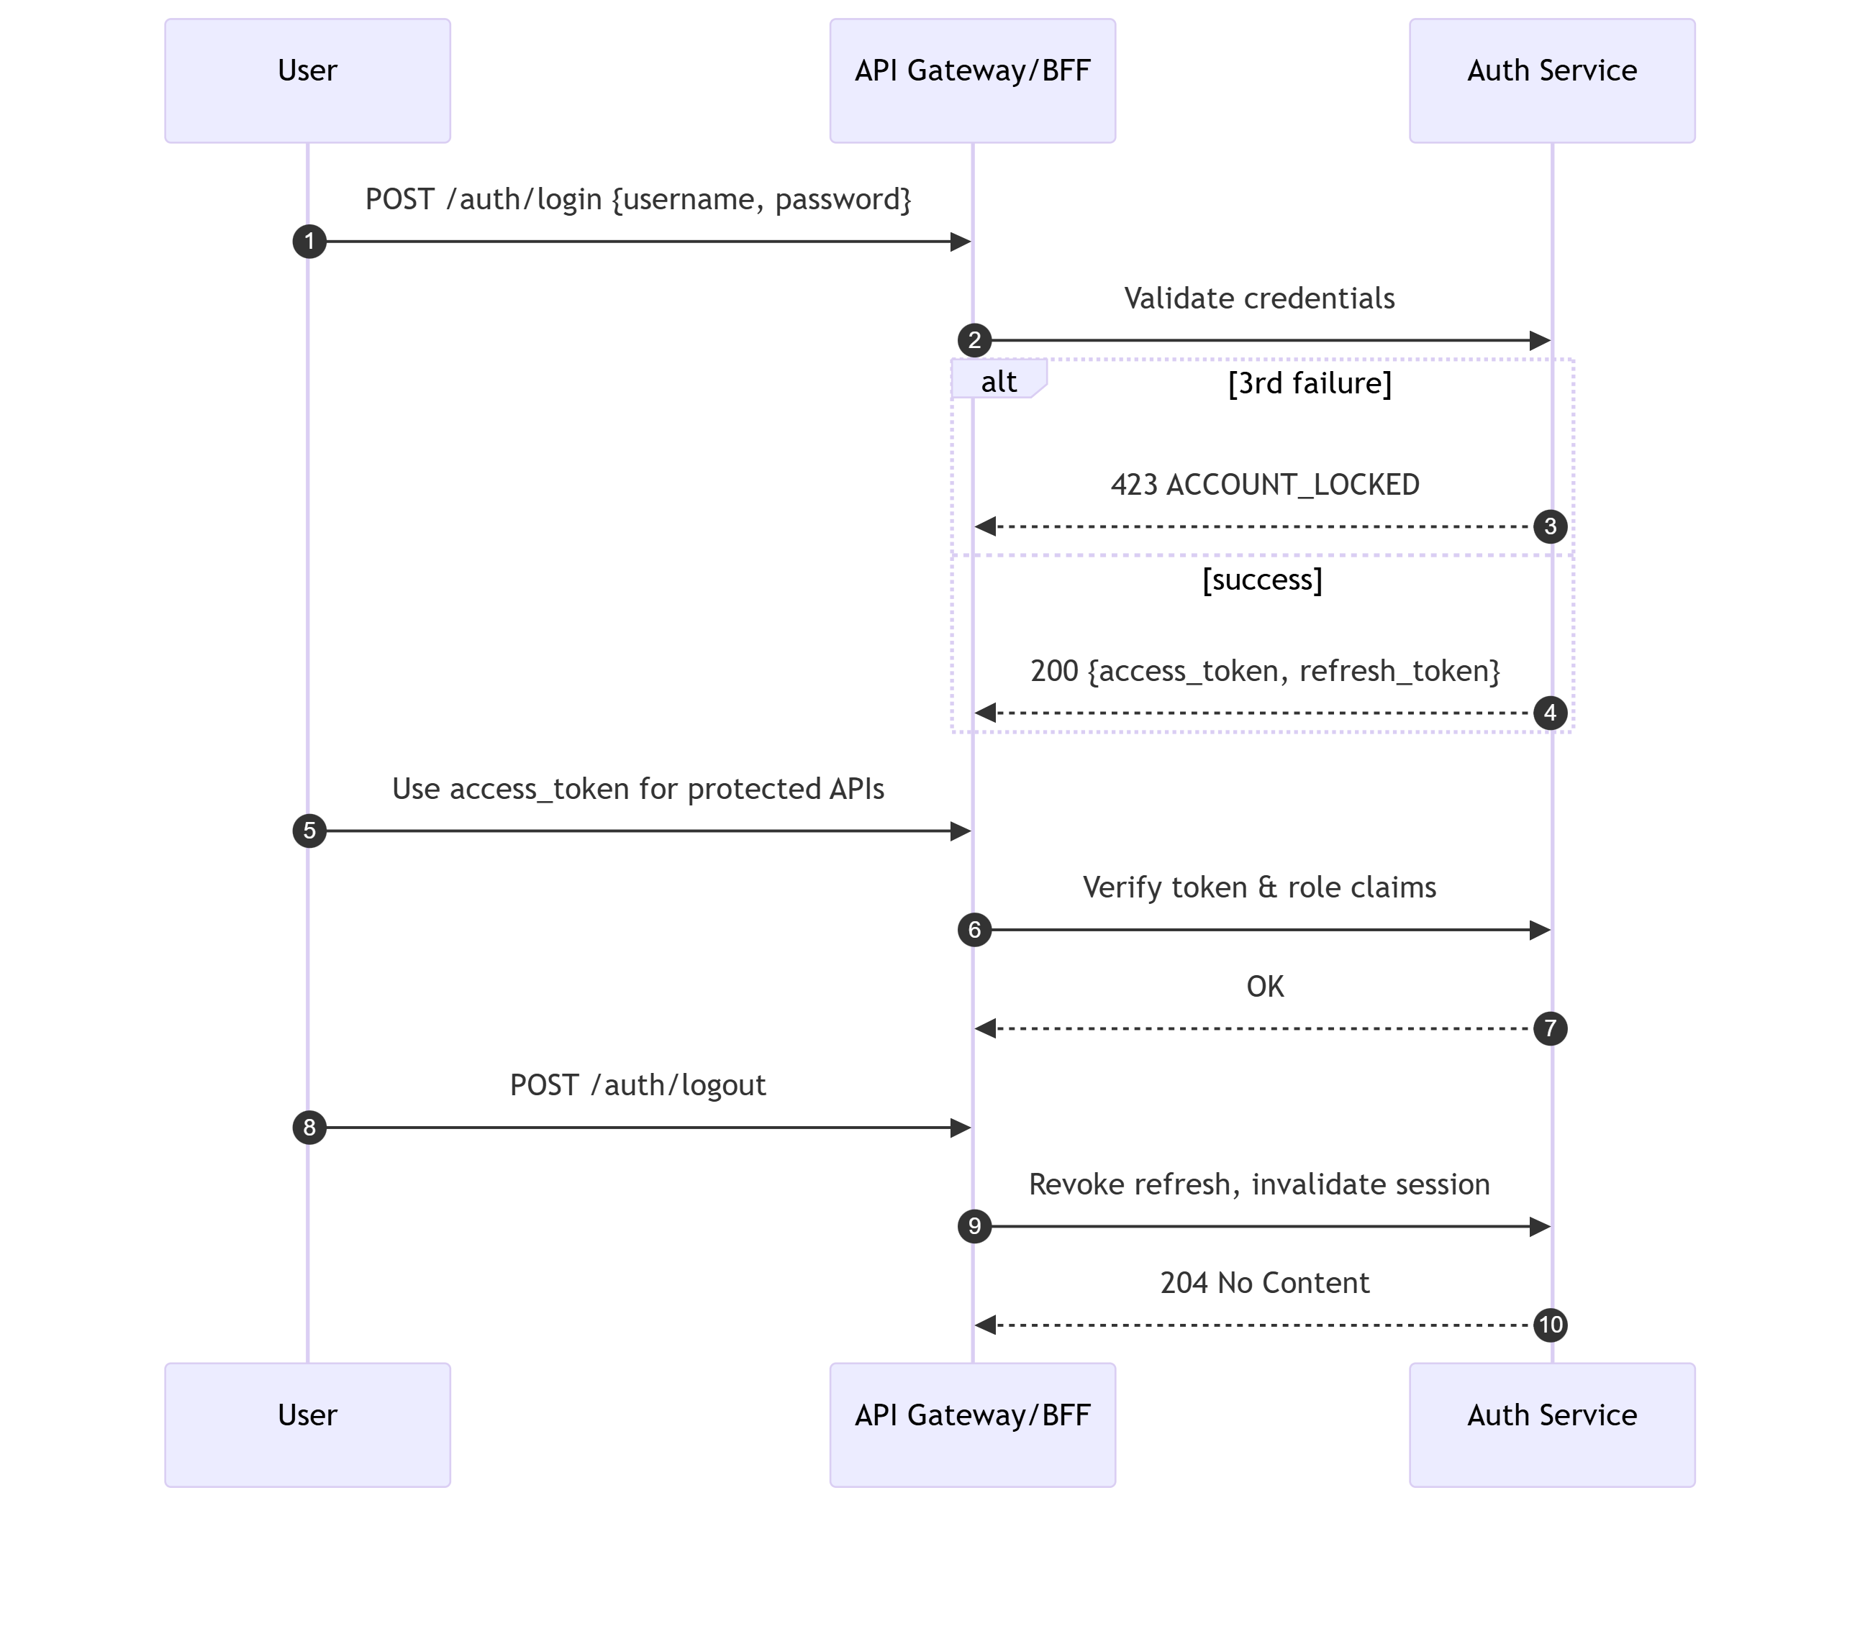

Authorization and roles
Role-based access control (RBAC)
Role | Key permissions | Constraints
Policy Holder | View personal details; view policy details; view claim statuses | Read-only; own resources only; masked PII where appropriate
Agent | Create policy applications; add members; upload documents; submit claims; view status | Access limited to their customers; strict server-side validation
Company Staff | Approve/Reject policy applications; Approve/Reject claims; enter cheque details; view documents | Intranet only; enhanced audit; optional dual control for high-risk actions
Admin | Unlock accounts; manage roles; manage premium/config tables | Intranet only; dual control for config changes; change management required
Auditor (optional) | Read-only access to logs/reports | Immutable log access; no data modification

Implementation notes
- Policy-based authorization: Enforce fine-grained policies (e.g., OwnsResource, CanApprovePolicy, CanEnterCheque, CanViewMedicalDoc) at the service layer.
- Resource scoping: Use opaque identifiers; enforce server-side ownership checks; never rely on client-supplied IDs.
- Dual control (recommended): Require two distinct Staff/Admin approvals for sensitive changes (e.g., premium rule updates, cheque entries over threshold, force status override).
- Least privilege: Separate service accounts for batch jobs and per-service DB access; default-deny network and APIs.
- Rate limiting: Apply stricter throttles to login and document upload endpoints.
- Document security (PHI):
  - Allowed types: pdf, jpg, jpeg, png; max size configurable (e.g., 10 MB/file).
  - Mandatory AV scan on upload; quarantine on fail; block submission.
  - Store in encrypted object storage; access only through signed URLs with short TTL (≤ 5 minutes).
  - Apply RBAC + ownership before issuing signed URL; audit every issue/download event.
  - Clarify policy on whether holders/agents can download medical docs (default: restricted; staff full access).
- Audit logging: Capture login success/failure, lock/unlock, submit/approve/reject (policy/claim), document upload/quarantine/link-issue, cheque entry (metadata only). Retain ≥ 1 year.
- Input/Output safety: Server-side DTO validation, parameterized queries/ORM, output encoding, CSP headers, standardized error responses (no stack traces or secrets).
- Secrets & config: No secrets in code; use environment variables or vault; rotate keys/tokens; secure defaults in installer.

