**ABSTRACT**

**FORMELY - PARLE EXPORTS Pvt. Ltd.**

**FOUNDED- 1970**

**FOUNDER- RAMESH CHAUHAN HEADQUATERS- MUMBAI ,MAHARASHTRA CEO-ANGELO GEORGE**

**PRODUCTS- MINERAL WATER, CARBONATED DRINKS**

**With a legacy of over 50 years, Bisleri International Pvt. Ltd. has grown to become one of the largest premium beverage businesses in India, including Bisleri, the country’s largest-selling packaged drinking water. The company remains true to its core value of providing consumers with pure, safe, and healthy water, following a stringent process of 114 quality tests and a 10-stage purification to produce Bisleri water. Bisleri International has a strong presence with 128 operational plants and a robust distribution network of over 6,000 distributors across India and neighboring countries.**

# TABLE OF CONTENT

**ABSTRACT**

**CHAPTER 1** - Introduction **CHAPTER 2** - Problem definition **CHAPTER 3** - Empathy map **CHAPTER 4** - Persona Perspective **CHAPTER 5** - Video scenario **CHAPTER 6** - Storyline

**CHAPTER 7** - Storyboard **CHAPTER 8** – Priority grid **CHAPTER 9** – Crafting hills

# INTRODUCTION

**To help manage Bisleri’s growth, the company built a proprietary enterprise resource planning (ERP) Windows application to plan and manage Bisleri’s unique day-to-day operations, including business-critical accounting and invoicing functions. The app was originally deployed as a local solution to the appropriate employees’ work machines, but as the company grew and opened regional branches and distributorships across India, the application that helped Bisleri to grow began to hold the company back.**

**Guwahati Food and Safety department has banned the plant after test imposed of samples of the packed drinking water revealed presence of higher fluoride content than the prescribed limit and hence company failed in terms of section 3(1) of Food Safety & Standards Act .the department asked the plant to stop storage ,distribution, & sale of the product in the market for a period of 30 immediately.**

**COMPETITORS:**

* **KINLEY – Product of Coca – Cola Company**
* **Aquafina – Product of PepsiCo Beverages**
* **Himalayan Natural Mineral Water**

### PROBLEM DEFINITION: (HOW MIGHT WE STATEMENT)

* 1. Tough being the giant in mineral water they failed to be successful in capturing the market in soft drinks.
  2. Competitors like COCA-COLA and Pepsi have deeply penetrated the market.
  3. . Even the pricing of these products was slightly high.
  4. They were unable to target the right customer for their products.
  5. Audience didn't accept them as a soft drinks.

### EMPATHY MAP:

An empathy map serves as a valuable tool in design thinking and user experience design, assisting teams in gaining deeper insights into their users or customers. It provides a clear framework divided into different aspects of the user's experience, such as their thoughts, emotions, observations, and actions.

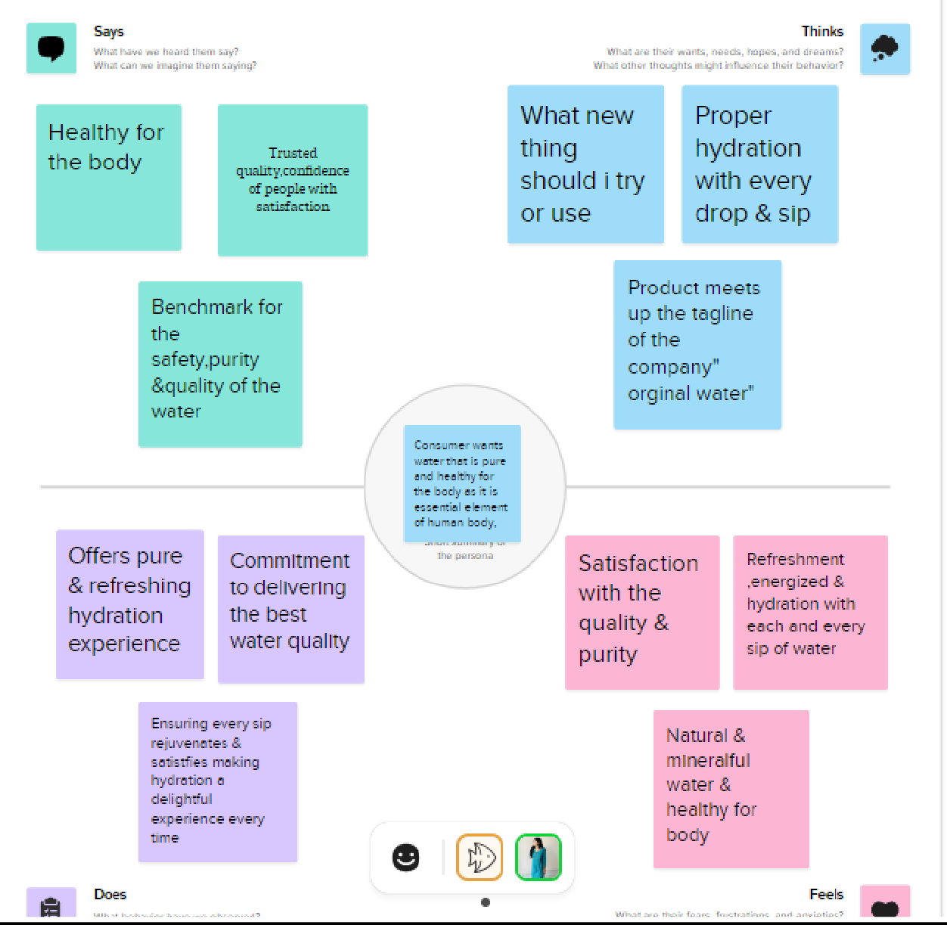

### PERSONA PERSPECTIVE

Personas represent fictional characters that embody various types of users who might engage with a product, service, or system.

These personas are constructed using data from real users and assist design teams in envisioning and understanding the desires, goals, and behaviors of their target audience.

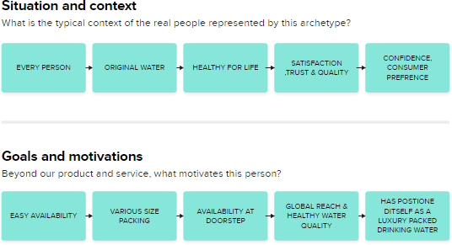

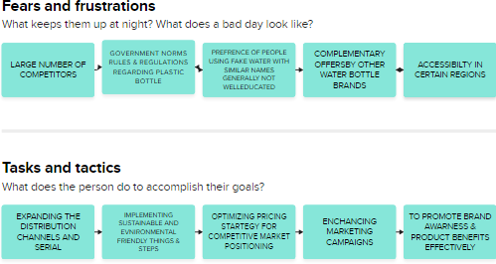

**VIDEO SCENERIO**

Teams can leverage MURAL's digital canvas to create storyboards that outline the sequence of events in a video. Each frame represents important moments or scenes. MURAL facilitates the integration of visuals such as images, icons, and shapes, helping to visualize actions and interactions. Moreover, teams can add text notes to provide context or additional information.

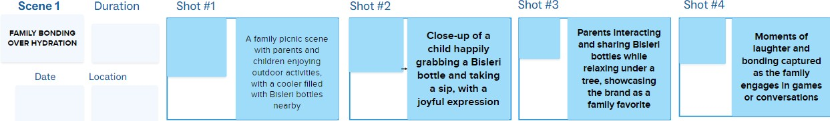

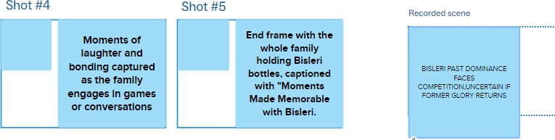

# STORYLINE

Utilizing MURAL's digital canvas to visually map out the narrative of a story, encompassing the creation of a timeline, identifying key plot points, and organizing scenes or chapters. Exploring interactive storytelling techniques in MURAL, such as branching narratives or choose-your-own-adventure plots, by creating interactive prototypes to evaluate different story pathways and outcomes.

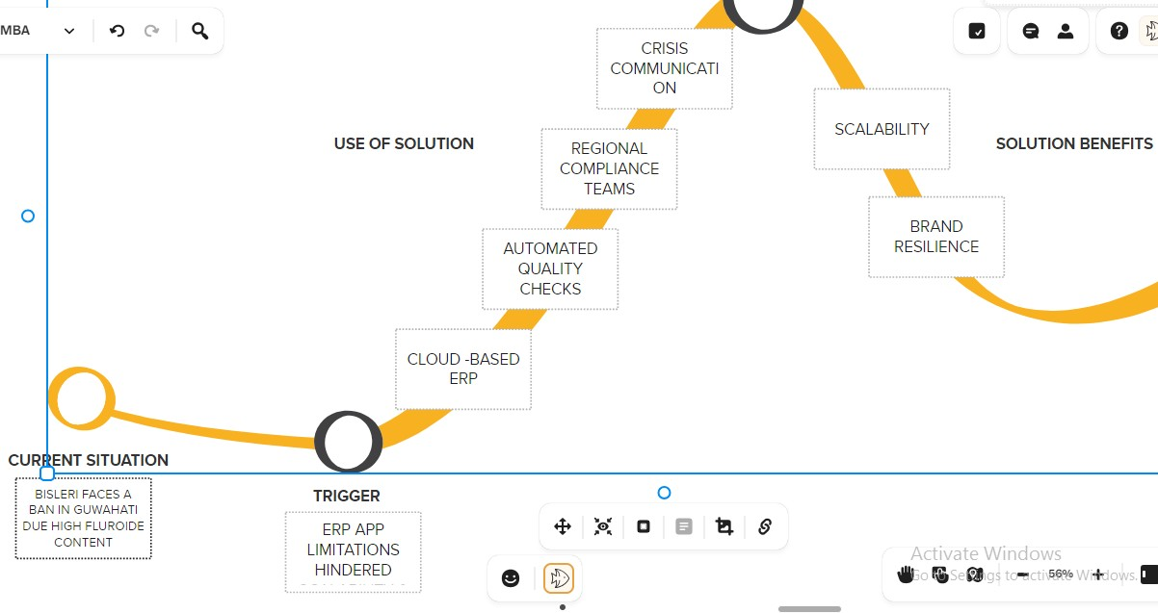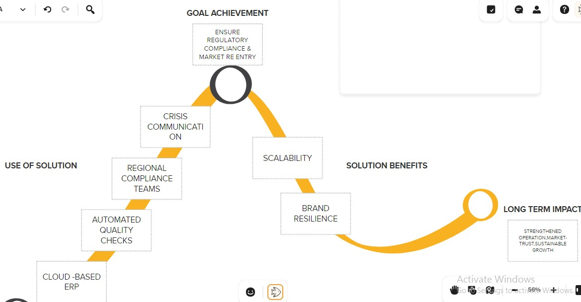

## STORYBOARD

Crafting a storyboard for a narrative or visual project using MURAL, which may entail sketching scenes, framing shots, and organizing visual elements to steer the storytelling process. Experimenting with interactive storytelling methods within MURAL, like branching narratives or choose-your-own-adventure scenarios

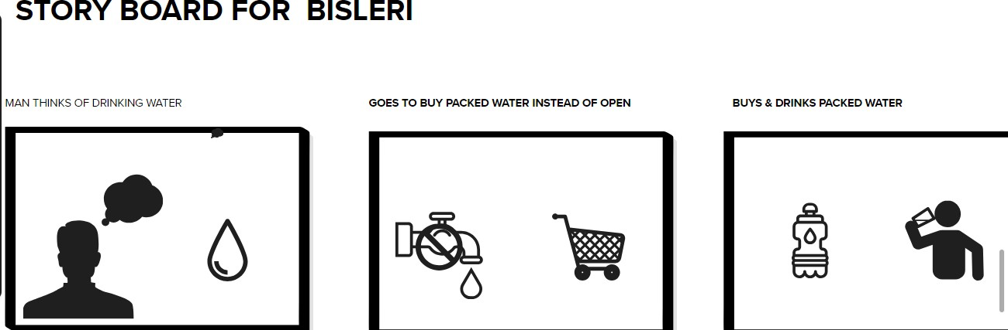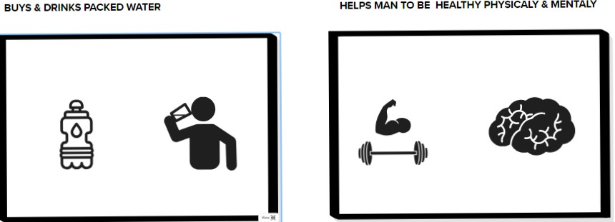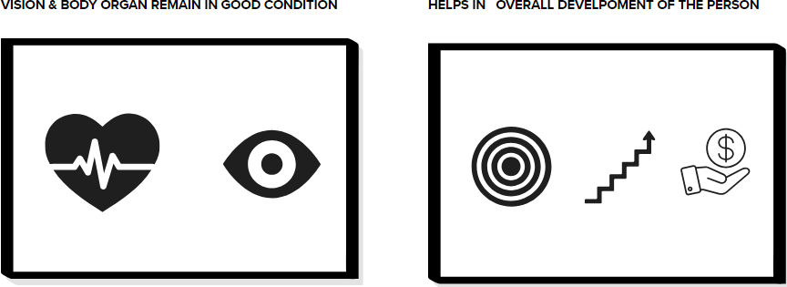

# PRIORITY GRID

A prioritization matrix serves as a useful tool for assessing and ranking projects, tasks, or goals. It aids in the evaluation and comparison of different factors such as risks, benefits, costs, and stakeholder considerations

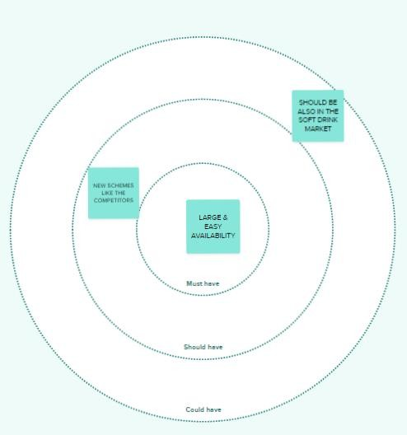

# CRAFTING HILLS

The "Crafting Hills" methodology is a strategic planning approach designed to help organizations set ambitious goals and break them down into manageable tasks. When implemented using the MURAL tool, "Crafting Hills" likely involves leveraging MURAL's digital canvas and collaborative features to execute this strategic planning method effectively

