AI for Good Sandbox Hackathon – “Aabyss” – ResultRelay
ResultRelay — an agent that will not call a critical lab result communicated without evidence a person received it
Team leader: Priya Singh
Team members: Priya Singh (team leader), Shashwat Srivastava, Divyansh Vishwakarma, Anushka Gupta
Contact details: via the submission to aiforgoodlab@itu.int (omitted from the public repository)
Github link: github.com/<your-username>/resultrelay
Synthetic data, hackathon exercise only. Not a safety, clinical or legal determination.
- Introduction and overview of the agentic solution
- A critical laboratory result is useless until the patient or clinician actually has it. Messages are marked 'sent' when a gateway accepts them; corrected reports leave stale messages queued; a callback does not prove identity.
- ResultRelay is a working prototype for walk-in laboratories licensed by the Dubai Health Authority. It tracks evidence of communication — attempted, transport-accepted, delivery-unknown, delivered, acknowledged, documented — and refuses false closure.
- Why it matters and why agents: the US ONC SAFER Guide (2025) calls missed or delayed follow-up of test results 'a significant cause of adverse events that harm patients'; we found no published UAE figure for failed patient-direct notifications, itself a gap. The rules that decide one message sit with three authorities (DHA, TDRA, the federal health-data law); agents read each case against each authority's own clauses and surface where they diverge, which fixed rules cannot do for an unseen case.
- Agent roles: policy & legal adviser (a Policy Evidence Analyst, DHA lens), institutional participant (a TDRA-lens analyst, invoked when transport evidence is unresolved) and multi-agent coordination (an adversarial reviewer on a different model family, independent assurance in code, and a deterministic orchestrator). Language models are used only where reasoning is needed; the deterministic gate (the Y.3172 P node) decides every transition and the agents can only escalate to a person.
- Every model proposal passes a containment guard first: data residency (Federal Law 2/2019 Art. 13), grounding (it may cite only what it was shown) and jurisdiction (a foreign rule may inform a human, never underwrite an action).
- Synthetic patients, results, channels and a simulated asynchronous transport; no real messages, EHR or diagnosis.
- What is the role played by AI?
- The analysts give typed judgments with the clause relied on: where the duty to communicate stands (DHA ST-28 §11.1.3, §13.4), whether the binding clauses settle the step, which policy gap it exposes, and whether any telecom clause covers delivery to a person (TDRA Mobile Spam §1-23; Telecom Law Art. 13; ETSI TS 123 040).
- Against hallucination: the reviewer challenges every claim and raises typed objections; code checks each claim and objection against the case record and rejects a comparator cited as governing; a failing claim gets one revision (CORRECTED / UPHELD / DISPUTED). Any LLM per role: Ollama, Mistral, OpenAI-compatible or Jev.
- Hybrid retrieval: BM25 fused with a ChromaDB store built by the ITU reference ingest (Ollama nomic-embed-text), filtered by applicability so an Abu Dhabi clause cannot bind a Dubai case.
- Not the AI's role: deciding closure, choosing a channel without an approved fallback, diagnosing, or interpreting a result.
- Description of the use case
A walk-in lab receives a result already flagged critical by a separate authorised process. DHA ST-28 (Clinical Laboratory Services, Issue 2, effective 17 July 2023) §11.1.1–11.1.3 requires clear reporting, advice to seek medical care and a communication record; §13.4 routes genetic results to the referring physician. Critical-result products notify clinicians inside hospitals; the gap ResultRelay tests is patient-direct communication, where acceptance by a gateway, delivery to a handset and acknowledgment by a person are routinely collapsed into 'sent'.
- Use case requirements
- These requirements are domain-level: they hold for any critical-result communication under any health regulator. DHA ST-28 is the jurisdiction tested; UK RCPath G158, US CLIA §493.1291 and Abu Dhabi DoH are the comparators.
- It is critical that a case is never closed on a transport acceptance; delivery needs a matched receipt and acknowledgment must bind to the current result revision [DHA ST-28 §11.1.3; ETSI TS 123 040 §9.2.3.15].
- It is critical that a result the governing rules route to a clinician is never messaged to the patient, and that a send that cannot be carried out is escalated, not dropped [DHA ST-28 §13.4; US CLIA §493.1291(g)].
- It is critical that a timeout is UNKNOWN, not failure, and that an attempt is reconciled before any retry.
- It is critical that health data is not processed by a model outside the jurisdiction without a lawful basis [UAE Federal Law 2/2019 Art. 13; comparator Saudi PDPL Art. 29].
- It is expected that an acknowledgment is accepted only if what the person said is consistent with it (scenario S9).
- It is expected that a corrected report cancels pending old-version messages and opens a reviewed correction task.
- It is expected that only a source that binds the case jurisdiction can block an action; comparators are labelled.
- It is of added value that every quotation is machine-checked against the page it claims, and that the audit chain is re-verified when read.
- Mapping with ITU-T Y.3172, Readiness 2.0 Report and domain-specific policies
Node | Use case (implemented) | Readiness 2.0 dimension | Documents (policies, strategies, standards)
SRC | Synthetic result revisions, contacts and channels; verified corpus | Data/Model Marketplace (1); Contextualization and Regional Impact (4) | DHA ST-28 §11.1 (walk-in tests)
C | Staged transport, patient and supervisor event streams | Level of Integration of AI in Workflows (5) | DHA ST-28 §11.1.1–3
PP | Normalised states; report version, action id and provenance kept | AI & Policies (10) | HL7 FHIR R5 Task; IHE XDW (comparators)
M | Policy analyst, TDRA-lens analyst, adversarial reviewer; hybrid retrieval | Collaboration with AI (8); Impacts of Humans in AI Integration (9) | DHA AI policy PP-09 §4.3.1, §4.4.2; UAE AI Charter
P | Gate: scope, version binding, reconcile-before-retry, no false closure | AI & Policies (10); Strategy Alignment (7) | DHA ST-28 §11.1, §13.4
D | Transport separating acceptance, delivery, acknowledgment; idempotency keys | Digital Infrastructure (13); Granular Priorities (12) | Law 2/2019 Arts. 4, 13; TDRA Mobile Spam §1-23
SINK | Supervisor queue, console, hash-chained audit re-verified on read | Human Interface (6); AI for Inclusion (11) | DHA ST-28 §11.1.3; NABIDH Audit §3.2.10–11; Law 2/2019 Art. 20
Readiness 2.0 dimension names and numbers follow the ITU AI Readiness Report 2.0 (13 dimensions). Y.3172 node definitions follow §8.1; MLFO is the orchestrator that chains the nodes per incident.
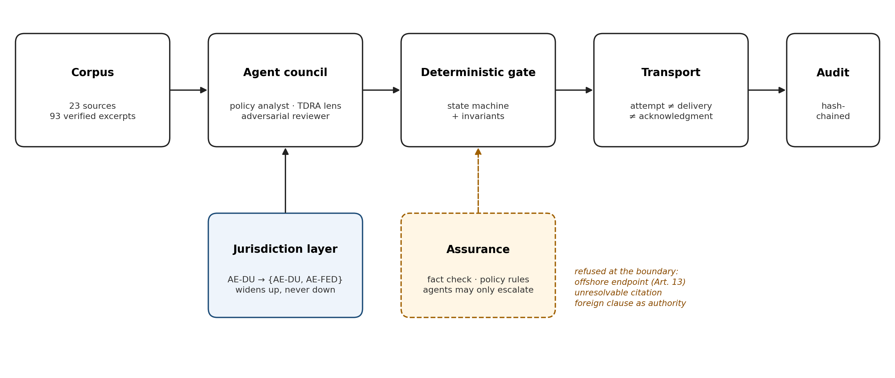
Figure 1. Pipeline: the agent council advises, assurance checks it in code, the deterministic gate decides; agents may only escalate.
- Demo and error scenarios (python run_demo.py)
- Step-1 (normal): a genetic result is routed to the referring physician by the retrieved §13.4 clause and documented: COMMUNICATION_DOCUMENTED / COMPLIANT.
- Step-2 (failure): the primary channel is down and no approved fallback exists. ResultRelay escalates to the named supervisor (INSUFFICIENT_EVIDENCE); the policy-blind baseline invents a channel and reports DELIVERY_CONFIRMED.
- Step-3 (failure): a corrected report arrives after the patient acknowledged version 1; the old acknowledgment cannot close version 2. The correction task runs and the corrected result is acknowledged; the policy-blind baseline ends in escalation.
- Step-4 (controversy): the generic walk-in rule is retrieved for a genetic result and both baselines message the patient. ResultRelay routes it to the physician (ST-28 §13.4), finds no physician channel, logs the failed send and escalates — the obligation is never silently dropped.
- Step-5 (failure): the gateway accepts the SMS and nothing else happens. Policy-blind and retrieval-only record DELIVERY_CONFIRMED; ResultRelay escalates to a person when the configured window passes (INSUFFICIENT_EVIDENCE).
- Step-6 (agents): the SMS is delivered and 'acknowledged' from a verified number, but the reply says it is the patient's daughter. Rules and the policy-blind baseline close the case; the reviewer reads the words, raises TEXT_CONTRADICTS_RECORD and the orchestrator escalates. Reuse: the same gate runs an Abu Dhabi case by swapping the jurisdiction profile; a real case on an offshore model endpoint is refused (Law 2/2019 Art. 13).
Results: 10 scenarios × 12 configurations = 120 runs; fully safe = all assertions and an allowed end state. Rules + council 10/10; rules alone 9/10 and a competent hand-written rules engine 9/10 (both miss S9); retrieval-only 3/10; policy-blind 2/10. ResultRelay's edge over rules on structured events is provenance (every decision cites a verified clause: 1.00 vs 0.00). Council (Mistral ministral-14b analysts, Jev reviewer; 18 decision points): 15 analyst claims flagged, 7 corrected after feedback; 13 reviewer objections, 10 rejected by code as contradicting the case record, 3 acted on — including S9, the case rules close. One recorded run per model; same team wrote scenarios and engine.
- Policy gaps and standards gaps derived from the mapping exercise
Gap (type) | How the prototype handles it | Global policy example (status checked Nov 2026)
Coordination (health ↔ telecom): TDRA's Mobile Spam policy defines 'delivery' only for marketing SMS, as network delivery to the subscriber (§1-23, §8-1); DHA ST-28 §11.1.3 needs a record of communication. Nothing joins them or assigns responsibility for an accepted-but-lost clinical SMS | Acceptance ≠ delivery ≠ acknowledgment; escalation on silence (S8) | UK RCPath G158 (2026) §5: alerts need feedback on whether 'received, read, understood'; 3GPP TS 23.040 status reports prove handset delivery only
Conflict between objectives: DHA ST-28 §11.1 provides for walk-in results to the patient, with no acknowledgment standard for a lay recipient of a critical value | Revision-bound acknowledgment; silence escalates | UK RCPath G158 §8: critical results 'only communicated with the requesting clinical team'; US CLIA 42 CFR 493.1291(g) alerts the requester
Standards ambiguity: is the communication record an audit log (NABIDH Audit Policy §3.2.11: 3 years) or health data (Federal Law 2/2019 Art. 20: 25 years)? | retain_until from the longer floor | RCPath G158 §7 names the record's fields but leaves retention to local policy
AI governance gap: DHA PP-09 requires agreed accountability, independent validation and AI-incident reporting, but names no default owner, validator or deadline; its revision date (1 July 2026) has passed | Model never decides; every judgment logged in the hash chain | EU AI Act (Reg. 2024/1689) Art. 14 human oversight, Art. 26 deployer duties, Art. 73 serious-incident reporting deadlines
AI governance / residency gap: the exceptions to the UAE ban on processing health data abroad sit in Ministerial Resolution 51/2021, which no official portal served; none names AI inference | Residency guard refuses a real case offshore; exceptions go to a person | Saudi PDPL Art. 29 (GCC): lists transfer purposes in the law and delegates the rest to Regulations
- Knowledge base, auditability and limits
- Knowledge base: 96 quotations from 24 documents — DHA establishment law, DHA ST-28, DHA AI policy PP-09, NABIDH Audit Policy, DHA data policies, Federal Law 2/2019, Telecom Law (Decree-Law 3/2003), PDPL, UAE AI Charter, TDRA Mobile Spam policy, DoH Abu Dhabi, ITU Y.3172 and Readiness 2.0; comparators RCPath G158 (UK), US CLIA, EU AI Act, Saudi PDPL, ETSI TS 123 040, Joint Commission, ONC, HL7 FHIR, IHE. 74 checked against official downloads on the declared page (misquote = rejected), 2 against a mirror, 7 against third-party copies, 13 against transcriptions; links for manual retrieval in kb/sources/MANUAL_RETRIEVAL.md. Exported in the ITU InputDocs format and ingested with the ITU ingest.py into ChromaDB (nomic-embed-text); Arabic questions map to the English clauses.
- Auditability: hash-chained audit log re-verified on read; a per-step reasoning trace — every agent message, tool call, fact-check finding, critique, revision and coordinator resolution, with cited clause and probability, then the gate's conditions, invariant and transition. Every model answer is recorded and replays offline.
- Limits: synthetic data; author-written scenarios with no independent validation (DHA PP-09 §4.3.3 requires it before deployment); hosted models for synthetic cases only and the 14B local reference model not yet run (needs ITU Lab compute); one assurance rule was changed after a recorded run; the UAE AI Strategy 2031 and MR 51/2021 could not be retrieved by script.

