

## Image

**Driver’s Drowsiness Detection System**

**By:-**

**Name-Shashwat Mishra**

**Course-B.Tech**

**Branch- Computer**

**Engineering**

**Roll no.2017374**



**CERTIFICATE**

This is to certify that the project report entitled “Driver’s Drowsiness Detection System” is a bonafide project work carried out by Shashwat Mishra , roll no- 2017374. in partial fulfillment of award of degree of B- tech of Graphic Era Deemed University, Dehradun during the academic year 2021-2022. It is certified that all corrections/suggestions indicated for internal assessment have been incorporated. The project has been approved as it satisfies the academic requirements

associated with the degree mentioned.

**Dr. Narayan Chaturvedi**

**ACKNOWLEDGEMENT**

Here by I am submitting the project report on **“Driver’s Drowsiness Detection System”** as per the scheme of Graphic Era Deemed University, Dehradun.

I would like to express my sincere gratitude to **Dr. Narayan Chaturvedi** for providing a congenial environment to work in and carry out our project.

Finally I am very much thankful to all the faculty members of the Department of Computer Science and Technology, friends and our parents for their constant encouragement, support and help throughout the period of project conduction.

Shashwat Mishra

Roll no. 2017374

***Driver’s Drowsiness Detection System***

By: Shashwat Mishra

Problem Statement→

## I have made a responsive Driver’s Drowsiness Detection System detecting the driver drowsiness by estimating vision system of him. This paper presents an automatic drowsy driver monitoring and accident prevention system that is based on monitoring the changes in the eye blink duration.

Motivation→

Main motive of me behind doing this project was to approach towards automobile safety and security with autonomous region primarily based on automatic automotive system. The development of technologies for detecting or preventing drowsiness at the wheel is a major challenge in the field of accident avoidance systems. Because of the hazard that drowsiness presents on the road, methods need to be developed for counteracting its effect. Drowsiness detection is one of those common problem needed to be solved to prevent road accidents.

Introduction→

Driver drowsiness detection system is a car safety technology which prevents accidents when the driver is getting drowsy. Various studies have suggested that around 20% of all road accidents are fatigue-related, up to 50% on certain roads, driver fatigue is a significant factor in a large number of vehicle accidents. Unlike driver distraction, driver drowsiness involves no triggering event but, instead, is characterized by a progressive withdrawal of attention from the road and traffic demands. Both driver drowsiness and distraction, however, might have the same effects, that is decreased driving performance, longer reaction time, and an increased risk of crash involvement

Techniques involved→

#### EYE TRACKING AND DETECTION OF FACE THROUGH VIDEOS

We are first trying to generate a preview of the driver through the web camera of the laptop. The driver’s preview image is being captured simultaneously by the web camera and the camera forms to give us a preview image. The camera now starts to record the video and automatically saves it in the backend so that it can be analyzed. The recorded video is in grey, HSV color and original form. These different types of recording is because it helps to give us data in all the frames- grey scale or black and white, colored frame and original frame. After the images, videos, frames are being recorded and saved, the eyes are detected from them and then tracked.

**SOUNDING THE ALARM**

If the eyes are drowsy the alarm gets sound and the driver is given an alert through that sound.

#### EYE TRACKING AND PLOT GENERATION

The eye tracking involves to calculate the value for the eye aspect ratio and gives the figures and plots to detect the data being recorded.

Methodology→

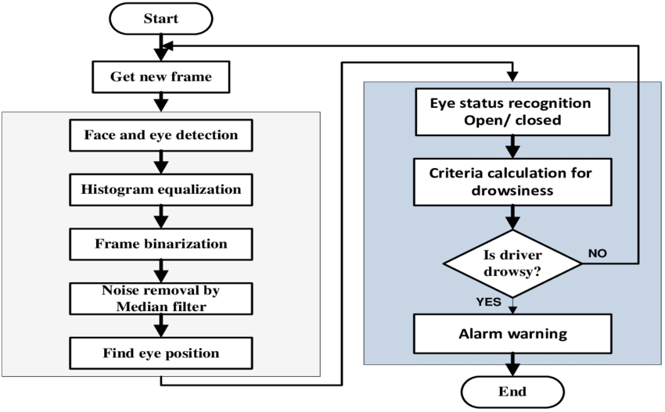

**Step 1-** Look for faces in the input video being recorded.

**Step 2** - Test the input faces and capture them as images for processing them.

**Step 3 -** If the eyes get little drowsy sound an alarm.

**Step 4** - Keep the eyes tracked through the video being saved at the backend.

Image

**MRL EYE DATASET**

Tools Used→

* **PYTHON-**

It is used for:

* web development (server-side)
* software development
* mathematics
* system scripting
* **OPENCV-**

It plays a major role in real-time image processing and computer vision tasks which is a necessity for modern applications. OpenCV makes use of NumPy, which is a highly optimized python library for numerical computations. All of the OpenCV array structures are converted to and from NumPy arrays.

* **TENSORFLOW-**

It is a software library or framework, designed by the Google team to implement machine learning and deep learning concepts in the easiest manner. It combines the computational algebra of optimization techniques for easy calculation of many mathematical expressions.

Conclusion→

Hence driver drowsiness detection system is a very important part for the driver while he drives the car. So every driver should have a drowsiness detection system in his vehicle so that he can be almost safe and secure from road accidents, deaths from road accidents. A sleep of even a second can take the life of the driver. Then why to take any risk? This risk can be prevented when the driver uses the drowsiness detection system. The truck drivers, car passengers, taxi drivers, all can be aware about this system. They can manage to get help through it. Also they must be tracked on every route where they are driving to prevent any mishappening.

References→

Sources for the theory used in this report→

<https://en.wikipedia.org/wiki/Driver_drowsiness_detection>

<https://www.youtube.com/watch?v=qwUIFKi4V48&ab_channel=DeepLearning_by_PhDScholar>

Drowsiness Detection Using Image Processing book by Hanojhan Rajahrajasingh

<https://hackernoon.com/driver-drowsiness-detection-system-a-python-project-with-source-code-hc223yeh>